

Safeguarding Policy
(Including Low level Concerns Policy)

Published on School website | Yes
Statutory | Yes
Author | Headteacher
Approved by | FGB
Date approved | September 2025
Date of next review | September 2026

Contents
School Record of Safeguarding Training: 4
Introduction 5
1. The Legal Framework & related guidance 5
3. Statutory Safeguarding-Related Policies in Schools (KCSIE 2025) 6
4. Roles and Responsibilities 7
5. Educating & Safeguarding Pupils 8
6. Safer Recruitment 8
7. Allegations Against Staff 8
8. Whistleblowing 8
9. Early Help and Thresholds 8
10. Gender-Questioning Children (KCSIE 2025) 8
11. Online Safety 9
12. Child-on-Child Abuse 9
13. Prevent 9
14. Staff Training & Induction 9
15. Confidentiality, Consent and Information Sharing 9
16. Summary procedures for identification and reporting of safeguarding concerns: 10
17. Summary procedures for allegations against staff: 12
Appendix 1 Indicators of abuse and neglect. 13
Appendix 2 Further Guidance and Resources: 14
Appendix 3 Safeguarding Procedures at Aldermaston CE – Including Low Level Concerns Policy 15

Key Contacts
Role: | Name / Details: | Contact:
Designated Safeguarding Lead (DSL) | Sophie Mosher | headteacher@aldermaston.w-berks.sch.uk
Deputy Designated Safeguarding Lead (DDSL) | Katherine Makepeace | SENCO@aldermaston.w-berks.sch.uk
Nominated Governor for Safeguarding / Child Protection | Chris Laney | claney@aldermaston.w-berks.sch.uk
Chair of Governors | Charlotte Watchorn | Cwatchorn@aldermaston.w-berks.sch.uk
Director of Children Services | Annmarie Dodds | annmarie.dodds1@westberks.gov.uk
Director of Education | Neil Goddard | Neil.goddard1@westberks.gov.uk
Principle Education Welfare & Safeguarding Officer | Melissa Perry | EWSS@westberks.gov.uk  CME@westberks.gov.uk  ehe@westberks.gov.uk
Principle Advisor for School Improvement | Barbara Hunter | Barbara.hunter1@westberks.gov.uk
Education Safeguarding Lead Officer | Jatinder Matharu | edsafeguarding@westberks.gov.uk
Youth Justice Support team | David Wraight | Yjst@westberks.gov.uk
Local Authority Designated Officer (LADO) | Fiona Goussard | CAAS on 01635 503190  LADO on 01635 503153  LADO.LADO@westberks.gov.uk  or  LADO.LADO@westberks.gov.uk
Prevent Team |  | Preventreferrals@thamesvalley.pnn.police.uk
Integrated Front Door | Contact, Advice & Assessment Service (CAAS) | Contact number: 01635 503090 or Emergency Duty Team (outside of office hours) Tel: 01344 351999 child@westberks.gov.uk
Police | In an emergency  For non-emergency but possible crime | 999  101
Whislteblowing |  | Whistleblowing advice line is available for all workers.  0800 028 0285  help@nspcc.org.uk

School Record of Safeguarding Training:
Type of Training: | Date completed: | Next due date:
Whole School Safeguarding Training | Please see office records for all training information.
Designated Safeguarding Lead (DSL)
(Due every 2 years)

Deputy Senior DSLs (Due every 2 years)
Whole School Staff Refresher/updates
(Annual)
Safer Recruitment Training
(Due every 5 years)
Governor Training
Annual DSL Prevent Training Update (for DSLs to disseminate to ALL staff)
KCSIE Part 1 for all staff (yearly)
Prevent Level 1 for all staff
Prevent Level 2 DSL/DDSL

Introduction
Safeguarding and promoting the welfare of children is a fundamental responsibility of every school. This policy outlines our commitment to creating a safe, supportive, and inclusive environment where all pupils feel protected, valued, and heard. In line with Keeping Children Safe in Education (KCSIE) 2025, we recognise that safeguarding is everyone’s responsibility, and that timely, informed action can prevent harm and transform lives. Our approach is rooted in vigilance, compassion, and collaboration with families and external agencies to ensure that every child has the opportunity to thrive free from abuse, neglect, exploitation, or harm. Our staff understand their responsibilities and act in the best interest of the child.
This policy applies to all members of staff at Aldermaston CE School, including all permanent, temporary and support staff, governors, volunteers, contractors and external service or activity providers.
OUR ETHOS:

We believe that our school should provide a caring, positive, safe and stimulating environment that promotes the
social, physical, spiritual and moral development of the individual child; enabling all children to thrive.

We recognise the importance of providing an environment within our school that will help children feel safe and respected. We recognise the importance of enabling children to talk openly and to feel confident that they will be listened to. We recognise that both mental and physical health are relevant to safeguarding and the welfare of children.

We recognise that all adults within the school, including permanent, supply staff, temporary staff, volunteers, parents and governors, have a full and active part to play in protecting our pupils from harm.

We will work proactively with parents to build a solid understanding of the school’s responsibilities to ensure the welfare of all children, including the need for referrals to other agencies in some situations.

1. The Legal Framework & related guidance
- Section 175 The Education Act 2002
- Section 10 of the Children Act 2004
- Section 14B of the Children Act 2004
- Human Rights Act 1998
- Equality Act 2010
- Working together to safeguard children (December 2023)
- Keeping Children Safe in education: Statutory guidance for Schools and Colleges (July 2025)
- Berkshire west Safeguarding Partnership Child Protection and Safeguarding Policies and Procedures

3. Statutory Safeguarding-Related Policies in Schools (KCSIE 2025)
Policy | Statutory Requirement | All these policies are available on Aldermaston CE School Website:
Child Protection and Safeguarding Policy | Yes | Core safeguarding policy outlining procedures for identifying and responding to concerns.
Behaviour Policy | Yes | Includes measures to prevent bullying, child-on-child abuse, and promote a safe environment.
Staff Behaviour Policy (Code of Conduct) | Yes | Sets expectations for staff conduct, including boundaries and reporting concerns.
Health and Safety Policy | Yes | Ensures physical safety of pupils and staff, including risk assessments.
Relationships, Sex and Health Education (RSHE) Policy | Yes (for maintained schools) | Supports safeguarding through education on consent, healthy relationships, and online safety.
Special Educational Needs and Disabilities (SEND) Policy | Yes | Addresses safeguarding of vulnerable pupils with additional needs.
Attendance Policy | Yes | Supports identification of children missing education, a known safeguarding risk.
Supporting Pupils with Medical Conditions Policy | Yes | Ensures safe care for pupils with health needs, including emergency procedures.
First Aid Policy | Yes | Ensures appropriate response to injuries and medical emergencies.
Complaints Policy | Yes | Provides a route for raising safeguarding concerns or dissatisfaction with safeguarding responses.
Whistleblowing Policy | Yes | Enables staff to report safeguarding failures or misconduct confidentially.
Safer Recruitment Policy | Yes | Ensures all staff and volunteers are appropriately vetted.
Online Safety Policy | Yes (as part of safeguarding) | Protects pupils from online harm, including grooming, exploitation, and cyberbullying.
Allegations Against Staff Policy | Yes (within safeguarding) | Details procedures for managing concerns about adults working with children.

4. Roles and Responsibilities
The Designated Safeguarding Lead (DSL) is a senior leader with responsibility for safeguarding. Deputy DSLs provide cover as needed. All staff must be trained to identify and respond to concerns. The governing body ensures compliance with statutory guidance.
Role | Key Responsibilities
All Staff | - Understand safeguarding policies and procedures  - Be alert to signs of abuse and neglect  - Report concerns to the DSL immediately  - Maintain appropriate confidentiality
Designated Safeguarding Lead (DSL) | - Take lead responsibility for safeguarding and child protection  - Provide support and training to staff  - Liaise with local authority and other agencies  - Maintain detailed, secure records of concerns and referrals
Deputy DSL(s) | - Support the DSL and act in their absence  - Be trained to the same standard as the DSL  - Assist with referrals, record-keeping, and staff support
Executive Headteacher  Head of Schools | - Ensure policies are implemented and followed  - Allocate sufficient time and resources to the DSL  - Ensure all staff are aware of their safeguarding duties
Governing Body / Proprietor | - Ensure compliance with statutory guidance  - Appoint a DSL and ensure they are on the leadership team  - Oversee safeguarding training and policy reviews  - Ensure safer recruitment practices are followed
Nominated Safeguarding Governor | - Champion safeguarding at governance level  - Liaise with the DSL and headteacher  - Monitor safeguarding practices and compliance
Volunteers / Contractors | - Follow the schools’ safeguarding procedures  - Report concerns to the DSL  - Undergo appropriate checks and training as required
Local Authority Designated Officer (LADO) | - Manage allegations against adults working with children  - Provide advice and guidance to employers  - Liaise with police and other agencies as needed

5. Educating & Safeguarding Pupils
Aldermaston CE School is committed to equipping pupils with the knowledge, skills, and confidence to keep themselves safe both in and outside of school. Through a carefully planned curriculum—including PSHE, RSHE, and online safety education—we teach children how to recognise risks, build healthy relationships, and seek help when needed. We foster an environment where pupils feel safe, respected, and empowered to speak up. Staff are trained to listen, respond sensitively, and act swiftly to protect children from harm. We also work closely with families and external agencies to ensure a coordinated approach to safeguarding that supports the whole child.

6. Safer Recruitment
We are committed to recruiting staff and volunteers who are safe to work with children. All recruitment processes follow safer recruitment practices, including enhanced DBS checks, prohibition checks, and verification of identity and qualifications. At least one member of every interview panel is trained in safer recruitment. Job descriptions and advertisements clearly outline safeguarding responsibilities. We also ensure that third-party providers and contractors meet the same rigorous standards.

7. Allegations Against Staff
Any allegation made against a member of staff, volunteer, or visitor is taken seriously and managed in accordance with statutory guidance and local procedures. The school works closely with the Local Authority Designated Officer (LADO) to ensure concerns are investigated appropriately and promptly. We also have procedures in place for managing low-level concerns (see appendix 3) and ensuring staff understand the importance of maintaining professional boundaries. Safeguarding the welfare of children is our priority throughout any investigation.

8. Whistleblowing
Aldermaston CE School is committed to the highest standards of openness, integrity, and accountability. All staff have a duty to raise concerns about where they believe safeguarding practices are not being followed or where the behaviour of colleagues may place children at risk. Whistleblowing is a vital mechanism for ensuring that safeguarding remains robust and transparent. Staff are encouraged to report concerns to the headteacher, chair of governors, or the Local Authority Designated Officer (LADO) without fear of reprisal. We ensure all staff are aware of the NSPCC Whistleblowing Advice Line and our internal procedures, which are clearly outlined in our Whistleblowing Policy.

9. Early Help and Thresholds
We recognise that early intervention is key to preventing harm and promoting positive outcomes for children and families. Staff are trained to identify emerging concerns and refer to the Designated Safeguarding Lead (DSL) for support. The school works in partnership with local agencies to provide early help and follows the West Berkshire Safeguarding Children Partnership thresholds for intervention. We aim to build resilience and reduce the need for statutory involvement by acting early and collaboratively.

10. Gender-Questioning Children (KCSIE 2025)
In line with KCSIE 2025, our school is committed to supporting gender-questioning children in a safe, respectful, and inclusive environment. Staff are trained to respond sensitively and appropriately, recognising the importance of listening to the child and considering their welfare. We ensure that any support provided is in line with statutory guidance and involves parents, carers, and relevant professionals where appropriate. Our approach is child-centred, non-judgemental, and focused on safeguarding and wellbeing.

11. Online Safety
Our school recognises the importance of safeguarding children in the digital world. We implement robust filtering and monitoring systems to protect pupils from harmful content and online threats. Pupils are taught how to use technology safely and responsibly through the curriculum, including PSHE and RSE. Staff receive regular training on emerging online risks such as cyberbullying, grooming, and sextortion. We work closely with parents to raise awareness and ensure consistent messaging about online safety both at school and at home.

12. Child-on-Child Abuse
We recognise that children can be both victims and perpetrators of abuse. Peer-on-peer abuse can take many forms, including bullying, sexual harassment, physical abuse, and online abuse. Our schools have a zero-tolerance approach to such behaviour and is committed to creating a culture where all forms of abuse are identified, addressed, and never normalised. Staff are trained to recognise the signs of peer-on-peer abuse and respond appropriately. Pupils are taught about respectful relationships, consent, and how to report concerns. All incidents are investigated thoroughly, and support is provided to both victims and those displaying harmful behaviours.

13. Prevent
As part of our statutory safeguarding responsibilities, we are fully committed to the Prevent Duty under the Counter-Terrorism and Security Act 2015. This duty requires all education providers and local authorities to have due regard to the need to prevent individuals from being drawn into terrorism. We work proactively with schools, families, and partner agencies to identify and support individuals at risk of radicalisation. Staff are trained to recognise early warning signs and understand referral pathways, ensuring that concerns are addressed promptly and appropriately through the Channel process or other safeguarding mechanisms. We are committed to ensuring that staff are aware of their responsibilities under the Prevent Duty and that appropriate training and procedures are in place. The Designated Safeguarding Lead (DSL) and any deputies are familiar with the revised Prevent Duty guidance for England and Wales, particularly paragraphs 141–210, which are relevant to education and childcare settings. The DSL and deputies are aware of and follow local procedures for making a Prevent referral where there are concerns that a student may be at risk of radicalisation or being drawn into terrorism.

14. Staff Training & Induction
Ensuring that all staff are confident and competent in safeguarding is essential to protecting children. Our school provides comprehensive induction for all new staff, including training on recognising signs of abuse, responding to disclosures, and understanding safeguarding procedures. Ongoing professional development ensures that staff remain up to date with statutory guidance, including Keeping Children Safe in Education (KCSIE) 2025, and emerging safeguarding risks. Designated Safeguarding Leads (DSLs) receive enhanced training every two years, and all staff participate in annual updates. This commitment to training fosters a culture of vigilance and ensures that safeguarding is embedded in every aspect of school life.

15. Confidentiality, Consent and Information Sharing
Safeguarding children requires a culture of openness, trust, and professional responsibility. While we respect the confidentiality of all pupils and families, staff understand that safeguarding concerns must be shared with the Designated Safeguarding Lead (DSL) or deputies without delay. Information is only shared with those who need to know to protect the child. We follow statutory guidance on information sharing, including the Data Protection Act 2018 and UK GDPR, and ensure that all staff are trained to understand when and how to share information lawfully. Where appropriate, we seek consent to share information; however, where a child is at risk of harm, we may share information without consent in the best interests of the child’s safety and welfare.
Accurate and timely record keeping is essential to effective safeguarding. All concerns, disclosures, and decisions made must be documented clearly and securely. Records should include a summary of the concern, actions taken, outcomes, and the rationale behind decisions. These records are maintained in a separate safeguarding file for each child and are accessible only to those with designated responsibilities. Staff must report concerns immediately to the Designated Safeguarding Lead (DSL) or their deputies, using the school’s agreed reporting procedures. Information is shared on a need-to-know basis, in line with data protection legislation and statutory guidance, to ensure the safety and welfare of the child. The Federation uses the CPOMS to record and secure all records.

16. Summary procedures for identification and reporting of safeguarding concerns:
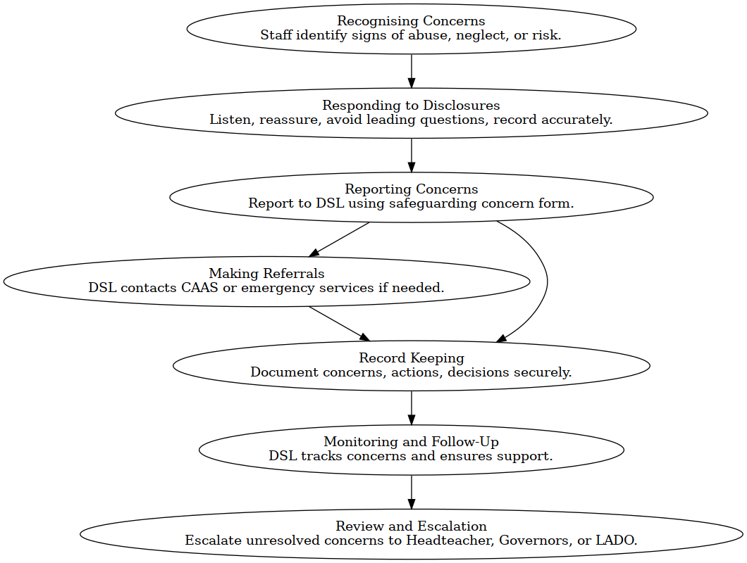

Recognising Concerns
- All staff are trained to identify signs of abuse, neglect, exploitation, and other safeguarding risks, including online harm and peer-on-peer abuse.
- Staff are expected to maintain professional curiosity and act on any concern, no matter how small.

Responding to Disclosures
- If a child discloses abuse, staff must:
  - Listen carefully and reassure the child.
  - Avoid asking leading questions or promising confidentiality.
  - Record the disclosure accurately using the child’s own words.
  - Report the concern immediately to the Designated Safeguarding Lead (DSL) or Deputy DSL (DDSL) after completing the details on CPOMS.

Reporting Concerns
- All concerns must be reported to the DSL using the school’s safeguarding concern form on CPOMS. Please also notify a DSL or DDSL in person.
- The DSL will assess the concern and decide on the appropriate course of action, including whether to refer to the Contact, Advice & Assessment Service (CAAS).

Making Referrals
- The DSL will contact CAAS without delay if a child is at risk of significant harm.
- In emergencies, staff should contact the police (999) or CAAS out of hours (01344 351999).
- Parents are usually informed unless doing so would place the child at greater risk.

Record Keeping
- All safeguarding concerns, actions, and outcomes are recorded in a secure, confidential safeguarding file on CPOMS.
- Records include a clear summary, actions taken, decisions made, and the rationale behind them.
- Files are transferred securely when a child moves to a new school.

Monitoring and Follow-Up
- The DSL monitors ongoing concerns and ensures appropriate support is in place.
- Attendance and welfare are closely tracked, especially for vulnerable pupils or those with a history of safeguarding concerns.

Review and Escalation
- If a staff member feels a concern has not been addressed appropriately, they are encouraged to escalate it to the headteacher, chair of governors, or the Local Authority Designated Officer (LADO).

17. Summary procedures for allegations against staff:
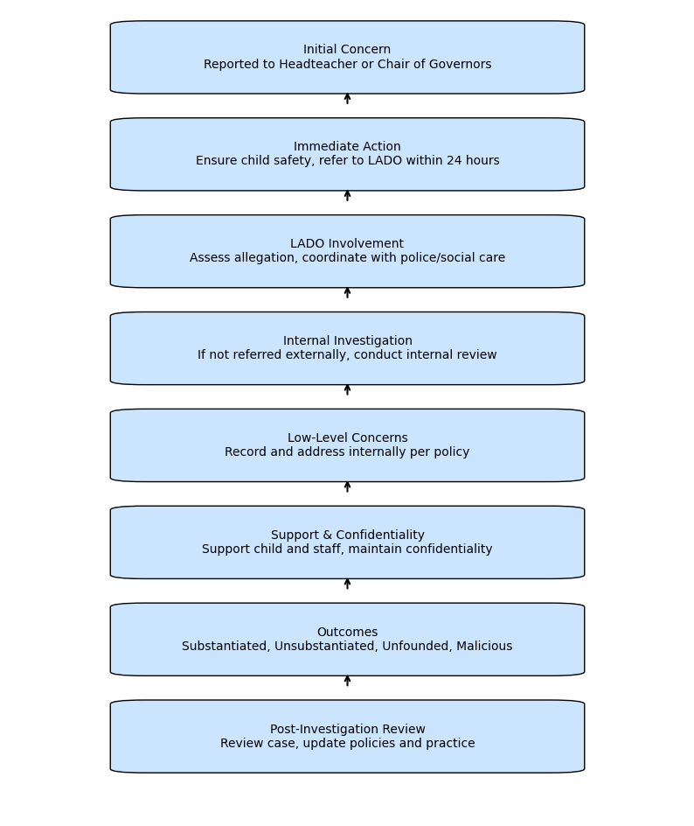

Appendix 1 Indicators of abuse and neglect.
Abuse: a form of maltreatment of a child. Somebody may abuse or neglect a child by inflicting harm or by failing to act to prevent harm. Harm can include ill treatment that is not physical as well as the impact of witnessing ill treatment of others. This can be particularly relevant, for example, in relation to the impact on children of all forms of domestic abuse, including where they see, hear or experience its effects. Children may be abused in a family or in an institutional or community setting by those known to them or, more rarely, by others. Abuse can take place wholly online, or technology may be used to facilitate offline abuse. Children may be abused by an adult or adults or by another child or children.
Physical abuse: a form of abuse which may involve hitting, shaking, throwing, poisoning, burning or scalding, drowning, suffocating or otherwise causing physical harm to a child. Physical harm may also be caused when a parent or carer fabricates the symptoms of, or deliberately induces, illness in a child. 26. Emotional abuse: the persistent emotional maltreatment of a child such as to cause severe and adverse effects on the child’s emotional development. It may involve conveying to a child that they are worthless or unloved, inadequate, or valued only insofar as they meet the needs of another person. It may include not giving the child opportunities to express their views, deliberately silencing them or ‘making fun’ of what they say or how they communicate. It may feature age or developmentally inappropriate expectations being imposed on children. These may include interactions that are beyond a child’s developmental capability as well as overprotection and limitation of exploration and learning or preventing the child from participating in normal social interaction. It may involve seeing or hearing the ill treatment of another. It may involve serious bullying (including cyberbullying), causing children frequently to feel frightened or in danger, or the exploitation or corruption of children. Some level of emotional abuse is involved in all types of maltreatment of a child, although it may occur alone.
Sexual abuse: involves forcing or enticing a child or young person to take part in sexual activities, not necessarily involving violence, whether or not the child is aware of what is happening. The activities may involve physical contact, including assault by penetration (for example rape or oral sex) or non-penetrative acts such as masturbation, kissing, rubbing, and touching outside of clothing. They may also include non-contact activities, such as involving children in looking at, or in the production of, sexual images, watching sexual activities, encouraging children to behave in sexually inappropriate ways, or grooming a child in preparation for abuse. Sexual abuse can take place online, and technology can be used to facilitate offline abuse. Sexual abuse is not solely perpetrated by adult males. Women can also commit acts of sexual abuse, as can other children. The sexual abuse of children by other children is a specific safeguarding issue in education and all staff should be aware of it and of their school or college’s policy and procedures for dealing with it.
Neglect: the persistent failure to meet a child’s basic physical and/or psychological needs, likely to result in serious impairment of the child’s health or development. Neglect may occur during pregnancy, for example, as a result of maternal substance abuse. Once a child is born, neglect may involve a parent or carer failing to: provide adequate food, clothing and shelter (including exclusion from home or abandonment); protect a child from physical and emotional harm or danger; ensure adequate supervision (including the use of inadequate caregivers); or ensure access to appropriate medical care or treatment. It may also include neglect of, or unresponsiveness to, a child’s basic emotional needs.
Educational Neglect: Educational neglect is a form of child neglect that occurs when a parent or carer fails to ensure a child receives an appropriate education. This includes persistent failure to send a child to school regularly, not addressing barriers to attendance, or failing to engage with support offered by the school or local authority. Educational neglect can significantly impact a child’s development, wellbeing, and future opportunities. It may be an indicator of wider safeguarding concerns and should always be taken seriously. Schools have a duty to identify patterns of poor attendance, assess the underlying causes, and take appropriate action, including referrals to Early Help or Children’s Social Care where necessary.

Appendix 2 Further Guidance and Resources:
- Public Sector Enquiry
- Data Protection
- Sharing nudes and semi-nudes - Advice for education settings working with children
- Harmful online challenges
- Safeguarding & remote education
- Working together to Improve School Attendance (Aug 2024)
- Domestic Abuse - How to get help
- Use of reasonable force in schools
- What to do if you’re worried a child is being abused
- Criminal records checks for overseas applicants
- Check for teacher prohibition
- Concerned about an Adult Working with Children
- information Sharing Advice
- Whistleblowing: guidance and code of practice for employers
- Guidance for parents/carers on using after school clubs
- Safeguarding in Sport
- When to call the police
- Education inspection framework (EIF)
- Searching, screening and confiscation
- Reducing the need for restraint
- Alternative Provision
- Arranging education for pupils with health needs

Appendix 3 – Safeguarding Procedures at Aldermaston (Including Low Level Concerns Policy)

RATIONALE
Aldermaston CE School takes seriously its responsibilities and statutory duties to protect and safeguard the welfare of children and young people in its care. We recognise that;
‘Safeguarding and promoting the welfare of children is everyone’s responsibility. Everyone who comes into contact with children and their families has a role to play. In order to fulfil this responsibility effectively, all practitioners should make sure their approach is child centred. This means that they should consider, at all times, what is in the best interests of the child.’
(Keeping Children Safe in Education, 2025)

This appendix to the adopted WBC policy seeks to give clear direction to staff and others about the steps we take as a school when dealing with child protection issues through good practice and sound procedures in order to ensure that concerns, referrals and monitoring are handled sensitively, professionally and in ways that support the needs of our children.

In order to protect our children, the school is committed to the safeguarding principles and prompt actions in order to promote the welfare of children, as described in Keeping Children Safe in Education, 2025. This appendix reflects that guidance.

KEY CONTACTS
Role: | Name / Details: | Contact:
Designated Safeguarding Lead  (DSL) | Sophie Mosher | headteacher@aldermaston.w-berks.sch.uk
Deputy Designated Safeguarding Lead (DDSL) | Katherine Makepeace | SENCO@aldermaston.w-berks.sch.uk
Nominated Governor for Safeguarding/Child Protection | Chris Laney | claney@aldermaston.w-berks.sch.uk

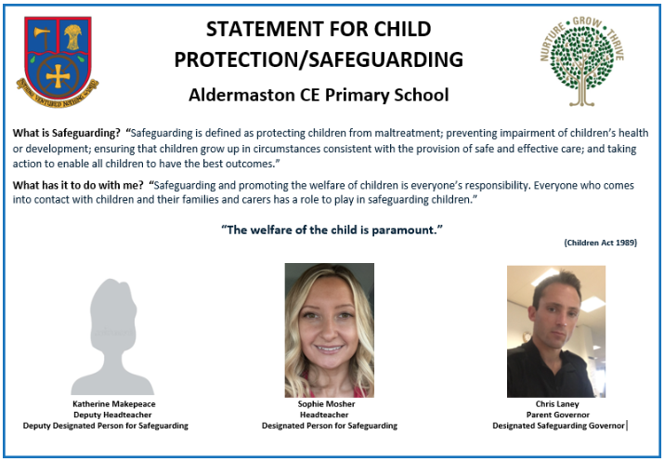

IMPLEMENTATION
This appendix to our policy applies to all staff, governors, volunteers, contractors and visitors to Aldermaston CE School.
The school recognises it is responsible for making contacts and referrals rather than making enquiries and investigating in cases of suspected abuse.
It is recognised that school staff are able to identify concerns early and provide help for children. The school is committed to notice when things are troubling our children, to listen, understand and take action, whilst ensuring on-going support to the child as an individual and acting as their advocate when needed.

GUIDANCE
Everyone who comes into contact with children and families has a role to play in safeguarding. Aldermaston CE School does this in the following ways:
Information
  - All staff are required to read Keeping Children Safe in Education 2025, signing to say that they have done so. This record will be held by the office.
  - All Governors are required to read Keeping Children Safe in Education 2025, and to confirm to the Clerk to the Governors that they have done so.
  - Staff receive regular safeguarding updates to keep their skills and knowledge up to date.
  - All safeguarding procedures are in line with the guidance set out in Keeping Children Safe in education 2025 and the Pan Berkshire Child Protection Procedures with links to these policy and procedures available to all staff through as a shortcut on their laptop Desktops.
Ethos
  - Maintaining a child centred approach in all aspects of safeguarding, which means keeping the child in focus when making decisions about their lives and working in partnership with them and their families.
  - Establishing a physically as well as a psychologically safe environment in which our children can learn and develop and where they know they can talk and be listened to. This is achieved by the creation of a positive school ethos, excellent teaching, and the pastoral support offered to children. It is also achieved through the use of effective de-escalation techniques. Reasonable force, including restraint, is only used in strict accordance with the legislative framework and in line with the Behaviour Policy to protect our children and those around them. All incidents are reviewed, recorded and monitored.
  - Children know that there are adults within the school who they can approach if they are worried or are in difficulty. Staff are to be aware that children may not feel ready or know how to tell someone they are being abused.
Curriculum
  - Ensuring curriculum activities and opportunities for Personal Health & Social Education (PHSE) in our life skills lessons, equip children with the skills they need to stay safe from all forms of abuse such as bullying, homophobic behaviour, racism, sexism and extremism through promoting fundamental British values and our own school Values. Any discriminatory behaviours are challenged and help and support are given to children about how to treat others with respect.
  - Leaders oversee the safe use of technology when children are in their care and act immediately if they are concerned about bullying or a child’s well-being. The required policies regarding the safe use of mobile phones and cameras in the schools are implemented.
Record-Keeping
  - Ensuring that written records are made in a timely way on our CPOMs System and held securely. These records are shared appropriately and, where necessary, with consent.
  - Any member of staff receiving a disclosure of abuse or noticing signs or indicators that the positive welfare of a pupil is at risk and/or deteriorating, must make an accurate record in CPOMs as soon as possible, noting what was said or seen, putting the event in context, giving the date, time and location. Making the record should not delay referring the disclosure to the Designated Safeguarding Lead/Deputy DSL or appropriate authority.
  - The school follows the guidance set out in the government document: Information Sharing: Advice for practitioners providing services to children, young people, parents and carers, July 2018. Fears about sharing information must not be allowed to stand in the way of the need to promote the welfare and safety of our children.
  - If a pupil transfers from the school, these files, where appropriate, will be forwarded to the pupil’s new school marked ‘confidential’ and for the attention of the receiving school’s Designated Safeguarding Lead. Where a school also uses the ‘CPOMS’ software, the safeguarding record will be transferred electronically.
  - Ensuring that a record of any referral is retained and there is evidence that any agreed action following the referral has been taken promptly to protect the child from further harm.
  - Our Safeguarding Team meets together fortnightly to review all referrals and open cases. Our Safeguarding governor joins these meetings, when possible, asks questions and reports back (anonymously) the overview at each FGB.
Safer Recruitment
  - Ensuring the schools practises Safer Recruitment processes in line with national legislation by using at least one suitably trained recruiter on all interview panels.
  - Safeguarding policies and procedures are in place and are reviewed regularly to ensure children are kept safe.

Whistle Blowing and Low-Level Concerns
  - Whistle blowing procedures are understood by children and staff. Staff are advised to maintain an attitude of ‘it could happen here’ where safeguarding is concerned.
  - Low level concerns about staff are reported using the form at the end of this Appendix, following the Low-Level Concerns Policy.
  - All visitors to the school sign-in to Reception and are required to wear a visitor’s badge and lanyard. They are provided with security information – a quick-read guide to our safety and safeguarding procedures.

Sensitivity
We recognise that children whose welfare is threatened and have difficult contexts in which to live, may find it difficult to develop a sense of self-worth. They may feel helplessness, humiliation and some sense of blame. The school may be the only stable, secure and predictable element in the lives of children at risk. When at school, their behaviour may be challenging and defiant or they may be withdrawn. Good lines of communication will be important.

Child on Child Abuse
The school recognises that Child on Child abuse can take many forms, as outlined in Keeping Children Safe in Education 2025 and in the Ofsted Review of Sexual Abuse in Schools and Colleges. Incidents of abuse can happen both in person and online.
The school adopts a zero-tolerance approach to harassment and violence whilst remaining clear that incidents like these could happen within our school and wider community. Staff remain vigilant and challenge harmful behaviours if they arise.
Staff take all allegations of abuse seriously, investigating incidents and acting proportionately so that the victim and alleged perpetrator are appropriately supported. This might involve working with external agencies, like the Police or Children’s Services.
E-Safety
Our school has a separate E-safety Policy for staff and children which should be considered in line with this policy and appendix.
Children may expose themselves to danger, whether knowingly or unknowingly, when using the internet and other technologies. Additionally, some children may find themselves involved in activities which are inappropriate or possibly illegal. The federation, therefore, recognises its responsibility to educate children, teaching them the appropriate behaviours and critical thinking skills to enable them to remain both safe and legal when using the internet and related technologies.
While teachers have the power to inspect files where it is believed there may be sexual imagery, this should only ever be done where the DSL believes it is necessary.

Single Central Record
A Single Central Record of employment checks is held by each school and checked termly by the Safeguarding Governor. The Single Central Record covers the following people:
- All staff (including supply staff, and teacher trainees on salaried routes) who work at the school.
- All others who work in regular contact with children in the school, including volunteers.
- All members of the Governing Board.

Professional boundaries for staff and code of conduct
The school’s Code of Conduct for Staff and Volunteers is made freely available to staff. This allows everyone to understand our expectations of staff and to be able to identify any behaviour that may be inappropriate.
Use of social networking sites by staff is also covered in our Staff Code of Conduct and staff handbook.

Complaints
In the event of a complaint against the Designated Safeguarding Lead, Deputy Safeguarding Lead, the Headteacher or a Governor, the procedures noted in the Complaints Policy and Procedure should be followed. A copy of the policy is available on the website or from the school, by speaking with a member of office staff, or by contacting the Clerk to the Governors.

School Closure
In the case of future full or partial closure, or a return to a blended learning model, the Leadership Team will issue specific guidance to all staff regarding live lessons and communications with children during the school closures. While there may be updates to this guidance as we respond to the changing nature of any closure, it will be underpinned by safeguarding procedures to protect both children and staff.
All email communication with children and families must be done through the school email system which remains subject to our filtering and monitoring software while accessed remotely.

The DSL/DDSL will be available to be contacted via phone or online video when working from home. The staff with responsibility for leading Safeguarding will continue to engage with social workers, and other professionals as needed during any period of remote working.
Where staff have a concern about the welfare of a pupil, they should continue to follow the process outlined in the School’s Safeguarding & Child Protection Policy and report those concerns to the DSL/DDSL. It is essential that concerns are reported immediately, remote working should not delay escalation of concerns. Where staff have a concern about the welfare of another member of staff, they should contact a member of the Leadership Team.
The school will continue to provide on-site provision in line with government guidance, with a focus on supporting vulnerable children.

The Governing Board
Section 175 of the Education Act 2002 places a statutory responsibility on the Governing Board to have policies and procedures in place that safeguard and promote the welfare of children who are children of the school. It is also the responsibility of the Governing Body to remedy without delay any deficiencies or weaknesses in regard to safeguarding arrangements that are brought to the attention of the school management or Governing Board.

Safeguarding will be discussed at Governing Board meetings, and the Safeguarding Governor will use this as an opportunity to feed back any relevant information.

It will also be the role of the Governing Body to ensure that any member of staff found not suitable to work with children will be notified to the Disclosure and Barring Service (DBS) for consideration for barring, following resignation, dismissal or when we cease to use their service as a result of a substantiated allegation, in the case of a supply teacher, contractor or volunteer.
If concerns arise then action should be taken in a prompt and timely manner.
“Governing bodies and proprietors should ensure there are appropriate policies and procedures in place in order for appropriate action to be taken in a timely manner to safeguard and promote children’s welfare”.
EVALUATION
- The number of open Child Protection cases dealt with by the school will be anonymously reported to the Governors on a termly basis.
- Anonymous information regarding safeguarding will also be provided in the HTs termly report for the Governing Board detailing any changes to the policy and procedures and any other relevant issues.
- The school will complete the Annual LA Audit of Safeguarding in Schools. The findings of the audit will then be reported to the Pan Berkshire School’s Safeguarding Officer.
- The school will complete the LA Safeguarding ‘Peer Reviews’ as part of a triad of schools and feed back to the West Berkshire Safeguarding Officer.

LOW-LEVEL CONCERNS POLICY – The Aldermaston School
This policy does not cover those allegations that may meet the harm threshold (please see KCSIE p93 for information).
This policy does cover concerns / allegations that do not meet the harm threshold – referred to for the purposes of this guidance as ‘low-level concerns’.
Section below refers directly to the information in KCSIE 2025 (p107)
As part of the whole school approach to safeguarding, schools should ensure that they promote an open and transparent culture in which all concerns about all adults working in or on behalf of the school (including supply teachers, volunteers and contractors) are dealt with promptly and appropriately. Creating a culture in which all concerns about adults are shared responsibly and with the right person, recorded and dealt with appropriately, is critical.
If implemented correctly, this should:
• enable schools and colleges to identify inappropriate, problematic or concerning behaviour early
• minimise the risk of abuse, and
• ensure that adults working in or on behalf of the schools are clear about professional boundaries and act within these boundaries, and in accordance with the ethos and values of the institution.

What is a low-level concern?
The term ‘low-level’ concern does not mean that it is insignificant. A low-level concern is any concern – no matter how small, and even if no more than causing a sense of unease or a ‘nagging doubt’ - that an adult working in or on behalf of the schools may have acted in a way that:
• is inconsistent with the staff code of conduct, including inappropriate conduct outside of work, and
• does not meet the harm threshold or is otherwise not serious enough to consider a referral to the LADO.

Examples of such behaviour could include, but are not limited to:
• being over friendly with children
• having favourites
• taking photographs of children on their mobile phone, contrary to school policy
• engaging with a child on a one-to-one basis in a secluded area or behind a closed door, or
• humiliating children.

Such behaviour can exist on a wide spectrum, from the inadvertent or thoughtless, or behaviour that may look to be inappropriate, but might not be in specific circumstances, through to that which is ultimately intended to enable abuse.
Low-level concerns may arise in several ways and from a number of sources. For example: suspicion; complaint; or disclosure made by a child, parent or other adult within or outside of the organisation; or as a result of vetting checks undertaken. It is crucial that all low-level concerns are shared responsibly with the right person and recorded and dealt with appropriately. Ensuring they are dealt with effectively should also protect those working in or on behalf of schools from becoming the subject of potential false low-level concerns or misunderstandings.
Staff code of conduct and safeguarding policies
Schools can achieve the purpose of their low-level concerns policy by:
• ensuring their staff are clear about what appropriate behaviour is, and are confident in distinguishing expected and appropriate behaviour from inappropriate, problematic or concerning behaviour, in themselves and others
• empowering staff to share any low-level safeguarding concerns (see below)
• addressing unprofessional behaviour and supporting the individual to correct it at an early stage
• handling and responding to such concerns sensitively and proportionately when they are raised, and
• helping identify any weakness in the school’s safeguarding system.

Sharing low-level concerns
All members of staff should inform the Headteacher of any low-level concerns in a timely fashion according to the nature of each particular low-level concern. The HT should be the ultimate decision maker in respect of all low-level concerns, although it is recognised that depending on the nature of some low-level concerns the HT may wish to consult with the DDSL and take a more collaborative decision-making approach.
Low-level concerns which are shared about supply staff and contractors should be notified to their employers, so that any potential patterns of inappropriate behaviour can be identified.
If there is any doubt as to whether the information which has been shared about a member of staff as a low-level concern in fact meets the harm threshold, the HT should consult with their LADO.
Self-Referral
Schools should ensure they create an environment where staff are encouraged and feel confident to self-refer, where, for example, they have found themselves in a situation which could be misinterpreted, might appear compromising to others, and/or on reflection they believe they have behaved in such a way that they consider falls below the expected professional standards.
Recording low-level concerns
All low-level concerns should be recorded in writing. The record should include details of the concern, the context in which the concern arose, and action taken. The name of the individual sharing their concerns should also be noted, if the individual wishes to remain anonymous then that should be respected as far as reasonably possible.
These records must be kept confidential, held securely and comply with the Data Protection Act 2018 and the UK General Data Protection Regulation (UK GDPR).
Records should be reviewed so that potential patterns of inappropriate, problematic or concerning behaviour can be identified. Where a pattern of such behaviour is identified, the schools should decide on a course of action, either through its disciplinary procedures or where a pattern of behaviour moves from a low-level concern to meeting the harm threshold, in which case it should be referred to the LADO.
Consideration should also be given to whether there are wider cultural issues within the school that enabled the behaviour to occur and where appropriate policies could be revised, or extra training delivered to minimise the risk of it happening again. It is for schools to decide how long they retain such information, but it is recommended that it is retained at least until the individual leaves their employment.
References
Schools should only provide substantiated safeguarding concerns/allegations (including a group of low-level concerns about the same individual) that meet the harm threshold in references. Low-level concerns should not be included in references unless they relate to issues which would normally be included in a reference, for example, misconduct or poor performance.
Responding to low-level concerns
If the concern has been raised via a third party, the HT should collect as much evidence as possible by speaking:
• directly to the person who raised the concern, unless it has been raised anonymously, and
• to the individual involved and any witnesses.

The information collected will help them to categorise the type of behaviour and determine what further action may need to be taken. This information needs to be recorded in writing along with the rationale for their decisions and action taken.

Creating a Safe Working Culture;
Do
- Be mindful it could happen here
- Always model respectful behaviour
- Follow the staff code of conduct
- Challenge unsafe working practices
- Inform HT immediately of any concerns
- Know the whistleblowing policy and be confident to use if necessary
- Listen to and report all concerns from children
Do not
- Make inappropriate disclosures about your private life to children or give out personal details/contact details
- Arrange to meet the children you work with outside work or invite them to your home
- Disclose personal information about a child, unless where permitted by law
- Provoke a child through your own poor behaviour
- Use sarcastic, threatening, offensive or abusive words
- Act in anger or malice with a child
- Hit, grab, slap or push a child
- Engage in any sexual relationship with a child

Aldermaston CE School Low Level Concern Reporting Form
Please use this form to share any concern – no matter how small, and even if no more than a ‘nagging doubt’, that an adult may have acted in a manner which:
- is not consistent with our Staff Code of Conduct, and/or
- relates to their conduct outside of work which, even if not linked to a particular act or omission, has caused a sense of unease about that adult’s suitability to work with children.

You should provide a concise record – including brief context in which the low-level concern arose, and details which are chronological, and as precise and accurate as possible – of any such concern and relevant incident(s) (and please use a separate sheet if necessary). The record should be signed, timed and dated.

Please see next page for form;


The Aldermaston School
Low Level Concern Reporting Form
Thank you for reporting your concerns; we are grateful to you for taking the safety and welfare of our pupils seriously. Please fill in the below form, including as much detail as you can, and return it directly to the Headteacher. Please refrain from discussing this concern with anyone other than the HT until the matter has been dealt with. We ask that you keep all details confidential, including the name of the staff member to whom the concern pertains.
Your details
Name (optional)
Role
Date and time of completing this form
Details of individual whom the concern is about
Name
Role
Relationship to the individual reporting the concern, e.g. line-manager, colleague
Details of concern
Please include as much detail as possible. Think about the following: What behaviour and/or incident are you reporting? What exactly happened? Why does the behaviour and/or incident worry you? Why do you believe the behaviour and/or incident is not consistent with our Staff Code of Conduct?

Details of any children or young people involved
Name(s)
Do you believe there is a risk of harm to the above children or young people, either now or in the future, as a result of the individual’s behaviour? Explain your answer.
Next steps
What would you like to see happen in response to your concern?
Please state any other information that you believe is relevant to the processing of this concern.

Signature
For use by Headteacher upon receipt of concern
Date and time concern received
Signature of HT
Investigation Notes:

Actions to be taken (e.g. no action/reclassification as allegation meeting the harms threshold.)
Record of any discussion with the LADO:
Final outcome including any re-training completed:

