Aldermaston C of E junior School
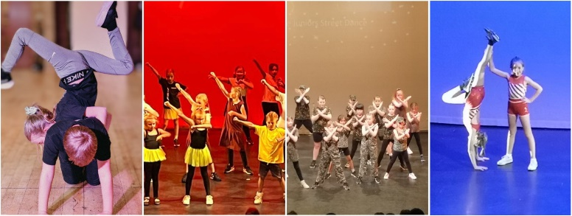
Please see the classes we offer at Aldermaston School.
Type | Start date | End date | Times | Year groups
Acrobatics | Tuesday 8th September | Tuesday 8th December | 08:00-08:45 | All years
Street dance | Friday 11th September | Friday 11th December | 08:00-08:45 | All years
We are very excited to be offering Acrobatics on a Tuesday morning, in these classes we work on floor work such as handstands, forward roll, cartwheels, bridges, forward walk overs, standing to bridge just to name a few skills. We use the acrobatics arts syllabus and are very proud to have qualified teachers within this skill.
We will also continue to run our street dance classes on a Friday morning, this class is full of energy, fun, we work on dances to show parents, lifts and break dancing just to name a few skills.
We also offer public classes on a Monday after school in Tadley, these classes include singing and drama.
Aldermaston School demonstration is Saturday 12th December!
Summer Holiday workshop –
10% discount code for early booking SGQ127
Please Use this link to book
https://breaking-barriers-theatre-company.classforkids.io

Summer Show in a week!  Trolls Jr  Tadley | Monday 3rd – Friday 7th August  09:00-16:00  Performance on the Friday at 3pm | Ages 5-14  Put into groups | £32.50 per day | Space available  Childcare vouchers accepted
Summer Show in a week  The Greatest Showman  THATCHAM | Monday 27th – Friday 31st July  09:00-16:00  Performance on the Friday at 3pm | Ages 5-14  Put into groups | £32.50 for the day | Space available  Childcare vouchers accepted
We also run classes every Monday at Tadley community centre, acrobatics, drama, singing and street dance!

Kindest Regards
Natalie Collins
nataliebreakingbarriers@outlook.com
07883107404

