

Behaviour and Mental Health Policy

Published on School website | Yes
Statutory | Yes
Author | Headteacher
Approved by | FGB
Date approved | January 2025
Date of next review | January 2026

Behaviour Principles Written Statement – Governing Board
This statement is not policy or practice, rather it is an intent to set out the schools’ broad principles and values with regard to behaviour that is both expected and promoted within the school.
Actual, practical applications of these principles are the responsibility of the Headteacher who will view each case in light of these principles and any relevant policies.
The governing board is aware and approves of this statement, believing it accurately reflects the school’s ethos and that effective learning and development relies on good standards of behaviour.
This is why, at Aldermaston CE School, we seek to uphold high standards of behaviour that are guided by the principles within this statement.

Our Behaviour Principles
Every pupil has the right to feel safe, valued and respected, and to learn free from disruption, discrimination or fear.
All members of the school community are treated with dignity and respect. Discrimination, harassment or bullying of any kind are not tolerated.

Staff and volunteers model pro-social behaviour, promoting kindness, empathy, self-regulation and forgiveness.
Positive relationships and restorative practice underpin our approach. Pupils are supported to reflect, repair and learn from their actions.

Rewards, consequences and reasonable force (where necessary for safety) are used consistently and proportionately, focusing on teaching and supporting positive behaviour.
The Behaviour and Mental Health Policy is clearly communicated to ensure shared understanding and consistent expectations.

Exclusion is only used as a last resort and always followed by reintegration and support planning.
Pupils are encouraged to take responsibility for their behaviour and understand its impact on others through PSHE, regular teaching of our behaviour policy and restorative conversations.

Parents and carers are valued partners in promoting positive behaviour through open and supportive communication.
Commitment to Safety and Wellbeing
Violence, threatening behaviour or abuse - by pupils, parents or staff - will not be tolerated under any circumstances.
We are committed to safeguarding the wellbeing of all members of our community and promoting a culture of love, courage and wisdom in every interaction.

Policy Statement
Our school’s Christian ethos, vision and values provides a strong foundation for everything we do at Aldermaston School.
All staff support pupils through positive learning experiences: promoting self-esteem and self-worth through recognition of potential and effort, development of positive relationships with the pupils and use of positive behaviour management strategies.

All staff understand and recognise that positive emotional well-being leads to higher levels of emotional engagement and attainment.

While this behaviour policy is for all pupils, it will be applied in different year groups depending on pupils’ ages and stages of development. It may also be applied differently depending on individual pupils’ SEND needs or it may need a more flexible approach at times of anxiety and change.

Our School Rules
Be Ready


Be Respectful


Be Safe


Please see appendix 1 for examples of our school rules in action.

Our School Vision and Values

We are a Church of England school with strong links to our parish and a Christian vision and values based on the Parable of the Sower, which was developed in collaboration with our wider school community.


At our school we want everyone to feel respected, accepted and able to make a difference by living their values.

Aldermaston C.E. Primary School focus on a different Christian value each term as part of a two-year programme. For 2025-2026 we are on Year B.
 | Autumn (1) | Autumn (2) | Spring (1) | Spring (2) | Summer (1) | Summer (2)
Year A | Friendship | Courage | Peace | Wisdom | Perseverance | Truthfulness
Year B | Compassion | Hope | Forgiveness | Trust | Justice | Thankfulness

We also use these opportunities for spiritual and personal development to strengthen children’s understanding of British values and the key skills they will need to succeed and reach their potential in life.

Purpose
At Aldermaston C.E. Primary School our role is to develop the whole child. We prepare them for their role as an active citizen, contributing positively to their community now and in the future.

Aims
To provide simple, practical procedures for staff and learners that:
- Ensure that there is an inclusive environment for all learners where positive behaviour is recognised
- Provide clear guidance for staff members and our school community, by establishing clear boundaries regarding acceptable behaviour to ensure consistency throughout the school.

Roles and responsibilities
At Aldermaston C.E. Primary School, all adults will model and teach children pro-social behaviours.
We promote increasing independence and self-discipline so that each child learns to accept responsibility for his/her own behaviour and learning.
The Headteacher and Senior Leaders are responsible for:
- Ensuring that the school has a behaviour policy and procedures in place that are in accordance with Government guidance.
- Making the Behaviour and Mental Health Policy available to parents.
- Ensuring all staff undertake appropriate behaviour training.
- Monitoring the effectiveness of the policy.
- Promptly addressing behaviour considered to be ‘dangerous’ to provide protection to all members of the school community.
- Promoting self-regulation amongst all members of the school community.
- Recognising bullying and unkindness when they occur and taking the necessary steps immediately to deal with unacceptable behaviour constructively (see Anti-Bullying Policy).

The Governors are responsible for:
- Participating in learning walks to monitor how the children’s behaviour in school reflects our vision and values.
- Monitoring data on behaviour incidents and exclusions.
- Convening a governors’ disciplinary meeting if required.

Parents are responsible for:
- Accepting and supporting the school’s Behaviour and Mental Health Policy and Anti Bullying Policy.
- Recognising and understanding the context and need for equity in the school and the benefits it can have for all.
- Making children aware of appropriate behaviour in all situations, offering encouragement and sanctions where appropriate
- Keeping the school well informed about situations at home that could affect their child’s behaviour in school.
- Attending meetings when requested.

Pupils are responsible for:
- Being ready for their own learning.
- Being respectful to the school community and environment.
- Being safe, taking responsibility for their own actions and knowing the consequences they will have.

Recognition
We recognise and celebrate pro-social behaviours through a range of age-appropriate approaches, including verbal praise, recognition boards, house points, Headteacher’s Award stickers, weekly Class Champion certificates, and termly Learning Heroes certificates.

Consequences
All children need support in developing pro-social skills. As a school, we are supported by West Berkshire’s Therapeutic Thinking approach, to ensure that our children receive provision matched to their individual needs (see appendix 1- behaviour policy in practice). Children who exhibit unsocial and antisocial (difficult or dangerous) behaviours will be supported in the form of appropriate consequences.
At Aldermaston Primary School there are two types of consequences which are used in tandem:
- Protective consequences (definition)
Removal of, or limited freedom to manage harm to self or others.
- Educational consequences (definition)
The learning, rehearsing or teaching so the freedom can be returned.

Reporting Behaviour Incidents
Behaviour incidents will be recorded using CPOMS when support other than class level intervention is required. Anonymised data will be shared with the full governing body. We will work with parents to provide our pupils with the right support at the right time, and keep them updated about their child’s behaviour. This might include letting them know if the pupil has broken the school rules, for example, as well as celebrating successes and improvements in behaviour.

School Exclusions
Exclusions may be required for the safety of children and adults, and to allow time for school staff to create a new plan to support the child.
Depending on the levels of behaviour and severity of specific incidents, the Headteacher may consider a fixed term exclusion at any time. While they are excluded, staff will plan how the child will be supported upon their return to school. If the child chooses to continue with unacceptable behaviour, and have further fixed term exclusions, then we may decide that a permanent exclusion is necessary. (See the school’s Exclusion’s Policy)

Mental Health and Behaviour
We recognise that both anti-social and unsocial behaviours can be a sign of mental health needs. The staff, including the Headteacher, SENDCo and ELSAs (see below) work together to regularly analyse behaviours and review and improve support for children.
At our school, we recognise the value of Mental Health and Behaviour in Schools as an important document to help staff understand and support children who might be at risk of experiencing mental health difficulties.
We have a layered approach to supporting pupil mental health and emotional wellbeing at Aldermaston C.E. Primary School, and it may be appropriate for a pupil experiencing mental health difficulties to engage with the support of our specialist trained staff. Our school offer comprises of different levels of trained professionals.
At class level, through PSHE and spirituality sessions, an awareness of self-regulation is taught to pupils.
For those pupils requiring further individualised support, timetabled sessions with our ELSA (Emotional Literacy Support Assistant) may be provided. Our School works in collaboration with external agencies, including West Berkshire service providers who can offer pupil or parent support. Referral for support from external professionals will require completion of a referral form and/or parental consent.

Reflect and Re-set
After a behaviour incident involving difficult behaviours, a pupil will be given the opportunity to reflect and suggest a way forwards in an age-appropriate way. Children will have an opportunity to communicate their feelings, the impact of their behaviours and suggestions for how to move forwards.

Restorative Practice
After any antisocial behaviour, a restorative conversation will need to be held for everybody to explain how the situation made them feel and agree a way forwards. This is important for all people involved.

Bullying
At Aldermaston C.E. Primary School, we have a zero-tolerance policy regarding bullying. Please see the separate Anti Bullying Policy for further information.

Behaviour Offsite
A pupil’s behaviour outside school, for example on school trips, or away sporting fixtures, is subject to this policy. Behaviour in such circumstances will be dealt with as if it had taken place in school.

Monitoring and Evaluation
This policy will be reviewed regularly and will be updated in response to new guidance, legislation and/or development to the approach as necessary.
The Headteacher reports termly to the Governing Board to enable them to monitor and evaluate the impact of the school’s policies, practices, and procedures.

Review
Leaders should ensure the policy is reviewed annually.

Appendix 1 Behaviour Policy in Practice

Our School Rules
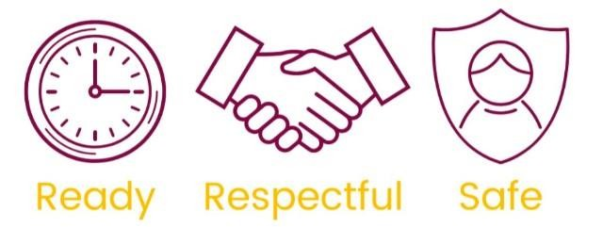

Ready | Respectful | Safe
We are on time | We listen to others and expect to be listened to | We use equipment safely
We wear our school uniform | We are polite and remember our manners | We move around the school sensibly
We take care of our belongings | We take care of our school and its resources | We act and speak kindly
We follow instructions first time | We include everyone | We keep ourselves safe online and in our community
We join in and try our best | We respect differences | We take risks safely
These are displayed using various imagery throughout the school.

Relentless Routines
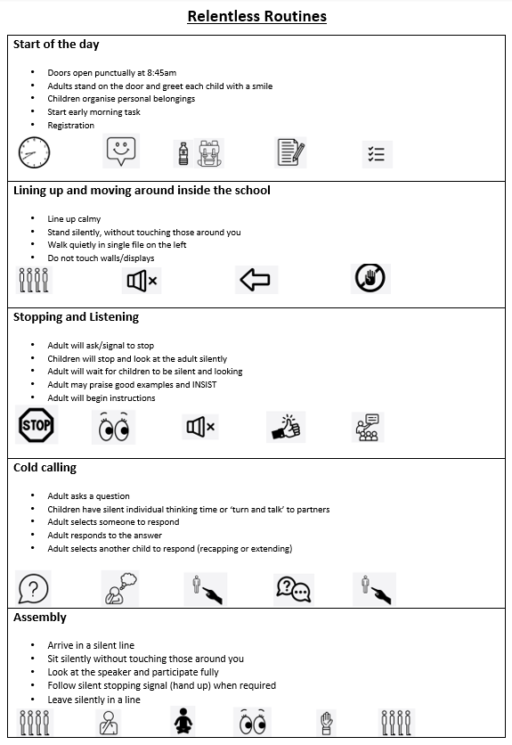

Equity and Equality

Equality is treating everybody the same.
Equality aims to promote fairness, but it can only work if everyone starts from the same place and needs the same help.
Equity is giving everyone what they need to achieve success.
Equity focuses on eliminating differences between groups when those differences can be addressed.
At Aldermaston Church of England School, we advocate for each child to receive the resources, experiences, appropriate interventions, and support in their learning to achieve their full potential. We aim to address differences in a positive and supportive manner, removing barriers and supporting pupils to achieve and succeed.

Appendix 2 Consequences

Protective consequences:
Removal of, or limited, freedom to manage harm to self or others. These are actions taken by staff to ensure all pupils and adults feel safe in the school environment.

These may include:
- An increased staff ratio and specific staff support given at break and work requiring completion to be completed at break times or sent home, and supported by parents/carers
- Adaptation of access to outside space, day or residential trips, or extra-curricular activity
- Access to a calm room/space
- Escorted in social situations
- Differentiated teaching space
- De-escalating language
- Whilst all measures will be taken to support the child to avoid exclusion, there may be a time when exclusion from an area or school is necessary

Educational consequences:
These are consequences put in place by staff to help the child to learn, rehearse or teach about their actions and the effect of anti-social behaviour, and to aid internalisation of pro-social actions to avoid repetition.

These may include:
- Third person role play to understand peer/adult feelings
- Social stories
- Completing or re-doing tasks to the expected standard for the child, to be completed at break times or sent home
- Restorative meetings with child and parent/carer
- Assisting with repairs or the planning for repairs/conversation and exploration

Appendix 3 Pro-social and Anti-Social behaviour

Pro-social behaviour
- Relating to behaviour which is positive, helpful, and intended to promote social acceptance.
- Pro-social behaviour is characterised by a concern for the rights, feelings, and welfare of other people.

Pro-social behaviour can be taught in various ways:
- Personalised PSHE curriculum
- Positive relationships
- Role modelling
- Advocacy of the school values
- Consistency of therapeutic language, scripted where appropriate
- Routine
- Prioritising pro-social behaviour
- Planning alternatives to anti-social behaviour e.g., pro-social ways of accessing rest breaks for those who need to leave the classroom.
- Feedback and recognition (decide what this will look like in your context)
- Comfort and forgiveness
- Praise and encouragement are widely used in managing children's behaviour in order to promote positive self-esteem

Unsocial and anti-social behaviour
- Behaviour that causes harm to an individual, a group, to the community or to the environment
- Behaviour that is likely to cause injury, harassment, alarm or distress. • Behaviour that violates the rights of another person

Appendix 4 Aldermaston C.E. Primary School Behaviour Blueprint

