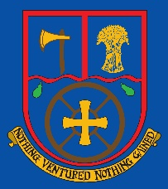

Terms of Reference Community Committee
Aldermaston CE Primary School

Version: 1

Reviewed by: Full Governing Body

Date adopted by FGB: September 2022

Review by: September 2023 (1 year)

Role | Signature | Date
Headteacher | Mrs M Higgs  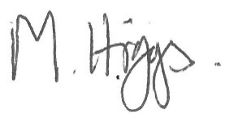 | September 2022
Chair of Governing Board | Mrs S Chaventre | September 2022

MEMBERSHIP
Membership of the Committee will be no fewer than three Governors plus a member of Senior Leadership Team (SLT).

QUORUM
The quorum for each meeting will be four Governors, including one SLT member.

MEETINGS
The Committee is to meet termly, and otherwise as required using the TOR as a guide to setting the agenda.
The Chair will be responsible for arranging meetings, taking and distributing Minutes and relevant papers if
required, and for following up agreed actions.

FUNCTIONS
To evaluate and improve the impact of the Spiritual, Moral, Social and Cultural development across the school community and wider community.

- To advise the FGB on developing and maintaining a high quality of communication and engagement between the school, parents, Church, Diocese and wider community.
To monitor, develop and evaluate:
- The wellbeing of pupils and all stake holders.
- Training, CPD and all Professional development and Staff Wellbeing
- Allocated Policies annually as delegated by the FGB.
- Provision regarding Spiritual, Moral, Social and Cultural including British Values
- A positive approach to Marketing the school to all stakeholders.

POWERS
The committee has delegated powers to make its own decisions on behalf of, and without reference to, the Full Governing Body, except where the subject matter requires the FGB’s consideration by Law or in accordance with the FGB’s Standing Orders.

REPORTING BACK
The Chair will report back to each meeting of the FGB.

REVIEW
These TOR will be reviewed annually by this Committee and submitted to the Full Governing Body for ratification.

