
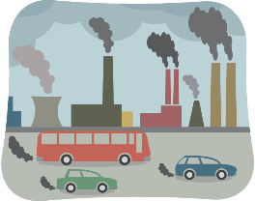
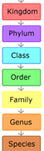
Home Learning Tasks - Autumn Term Two

Date due: W/C 04.01.27
Be a Regular Reader!   Please read every day. Read a range of books. Make sure that you read aloud too as this is a different skill and you can practice making it interesting for the listener. You will need to make a note of what you have read under each day in your reading record. Remember when you have finished a book, write a review or tell us about it.  All reading records need to be in everyday and will be checked weekly, thank you. | Be a Word Whizz!  Practise the spellings from the 3-6 statutory spelling list. We will have a test on a Friday as a dictation. | Be a Mathematician!  Log on to TIMES TABLE ROCK STARS and answer a minimum of 100 questions a week. If you have trouble accessing this at  home, you can use an I Pad at break or lunch times. We will monitor your progress by completing times table quizzes at least once a week in class.
Be a writer  Research information about Emily Davison. Using your research write a diary entry or newspaper report about her. Can you use a semi-colon or a relative clauses correctly? | Be a writer  Research further about the impact cars have on air pollution. Write a report to persuade people to purchase an electric car or vehicle. Can you use a modal verb or a rhetorical question correctly? | Be a writer  Complete research on Carl Linnaeus and his classification system. Write a fact file about him. Can you include fronted adverbials and pronouns to build cohesion in your writing?
Be an historian  Create a timeline of the event leading up to women  finally getting the vote. | 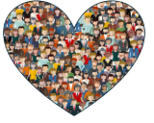  Be a geographer  Choose two major cities in the world. Research and  compare the air pollution.  What is causing the high levels of pollution in these areas? Can you record some of your findings in a graph? What could they do or are they already doing to help the environment and human health? | 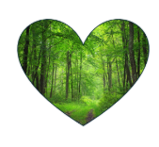  Be a Scientist  Research the different types of invertebrates. Using this research,  conduct an investigation outdoors in different micro-habitats  Record your findings in a table (as shown below) and a graph.

e

The homework grid should be completed within the half term. The compulsory tasks ( ) must be completed each week. You then need to complete at least one additional task from each coloured column by the end of the half term.

- All work needs to be completed in your homework books, photos should be taken and stuck in or drawings and explanations written of models etc.
- Work can be handed in for marking W/C 04.01.27



