Class 1 Reading List 2025- 2026
Term | Core Texts | Vocabulary | Author | Wider Reading
 | The Diddle That Dummed  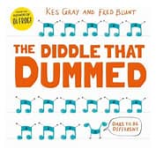 | SCRIBE  EXCEPTIONAL  HALT  ROARED  LEAPED  PONDERED  EUREKA  SEARCHING | KES GRAY AND FRED BLUNT | The Hungry Caterpillar by Eric Carle  Lost and Found by Oliver Jeffers  Whatever Next by Jill Murphy  The Gruffalo by Julia Donaldson  The Story of the Little Mole by Werner Holzwarth  Dear Zoo by Rod Campbell  Shark in the Park by Nick Sharratt  Bears Don’t eat Egg sandwiches by Julie Fulton  I Really Want to Shout! by Simon Philip and Lucia Gaggiotti  How to Catch a Star by Oliver Jeffers  In the Night Kitchen by Maurice Sendak  The Jolly Postman by Janey & Allan Ahlberg  Elmer by David McKee  Supertato by Sue Hendra  Pumpkin Soup by Helen Cooper  What the Ladybird Heard by Julia Donaldson & Lydia Monks  Mr Big by Ed Vere  How many Legs by Kes Gray, Jim Field  Aliens Love Underpants by Claire Freedman  Oi! Get Off Our Train by John Burningham
 | Mixed  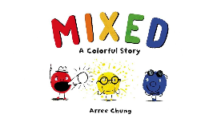 | HARMONIOUS  TRIPLE  INTELLIGENT  BOASTFUL  SQUABBLE  DIVIDED  UNIQUE  POPULATED | ARREE CHUNG
 | 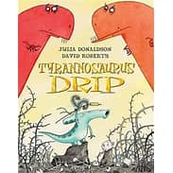  Tyrannosaurus Drip | PROWEL  SCREECH  GHASTLY  HESITATING  FLAKY  EAGER  GUZZLE  PLUMMET | JULIA DONALDSON
 | The Christmas Pine  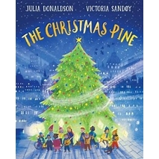 | ANCIENT  IRIDESCENNT  SOARING  REMOTE  JOURNEYED  GAPE  WARBLE  ABSENT | JULIA DONALDSON
 | Hansel & Gretel  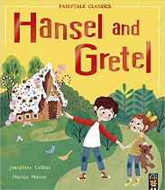 | CONFECTIONARY  WICKED  DOUBLE  SCARY  CAULDRON  SWISH  PIERCING  INNOCENT
 | Billy’s Bucket  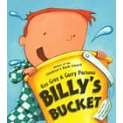 | INCESSANT  PERMISSION  IMAGINATION  PEERING  MOCKING  CARTIVATED  IGNORE  ASTONISHED | KES GRAY
Spring 1 | Rapunzel  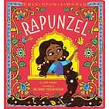 | ENCHANTRESS  CLAMBER  ASCEND  DESCEND  CLUTCH  VENOMOUS  TOWER  DESPAIR | CHLOE PERKINS
Spring 1 | Je M’habille et….  Je Te Croque  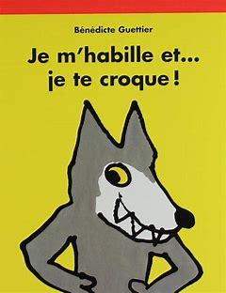 | GREEDY  VISCIOUS  GARMENTS  SNEAK  FAMISHED  SLLY  POINTY  FERAL | BENJAMIN GUETTIER
Spring 1 | The Darkest Dark  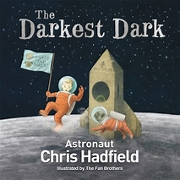 | BUMPY  DISAPPEAR  COSTUME  DELIGHTED  ADVENTURE  TERRIFIED  GRAVITY  TREMBLE | CHRIS HADFIELD
Spring 1 | Oi Frog  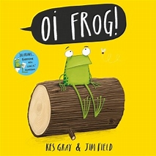 | BONE IDLE  EXHAUSTED  EJECT  STELTHY  STUNNED  QUIZICAL  CULTIVATE  BIG CHEESE | MARTIN WADDELL
Spring 2 | A Little Bit Brave  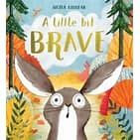 | ADVENTUROUS  PETRIFYING  COURAGEOUS  MARCHED  COMFUSED  HOLLERED  DEVOUR  STUPENDOUS | NICOLA KINNEAR
Spring 2 | Lost and Found  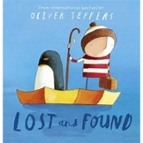 | CONFUSED  ACCOMPANY  DEJECTED  MIPLACED  CONSULTED  MINITURE  CONSTRUCTED | OLIVER JEFFERS
Spring 2 | The Odd Egg  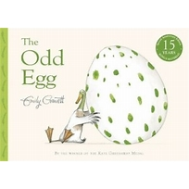 | EMERGE  INCUBATE  DEMOLISH  ARMOUR  FRACTURE  FLOURISH  PLUME  CHERISH | EMILY GRAVETT
Summer 1 | Are You a Snail?  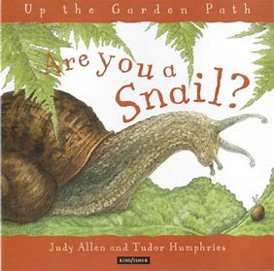 | SLIMY  HATCH  TRAIL  DAMP  ROUGH  DRIBBLE  SQUASHED  HIBINATE | JUDY ALLEN
Summer 1 | The Hundred Decker Bus  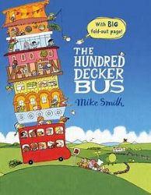 | NAVIGATE  INFLATE  EXTENSION  UNCERTAINTY  CREW  LAYER  EXPANDING  MECHANICAL  ASCENDING | MIKE SMITH
Summer 1 | Little Red Riding Hood  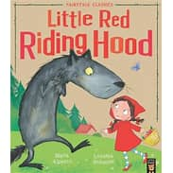 | TRAIPSE  CRAFTY  DISGUISED  CONCEALED  MENACING  RESCUE  FLEE  GRATITUDE
Summer 2 | Jack and the Beanstalk  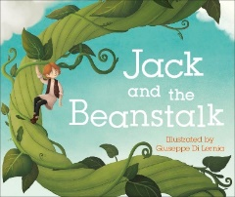 | CLAMBERING  BOOMING  DESCENDING  GLITTERING  GINORMOUS  SHOCKING  SLINKING  CHOPPING
Summer 2 | Tiddler  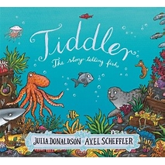 | TRAIPSING  DAYDREAMING  TARDY  CONVERSING  ENSNARED  ABANDONED  REUNITED  CELEBRATING | JULIA DONALDSON
Summer 2 | The Fox and the Hen  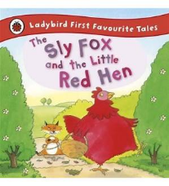 | FORTY WINKS  LOADED  SNOOZE  ESCAPE  SIMILAR  IGNITE  FLAMING  DEVIOUS

