Class 2 Reading List 2025-2026
Term | Core Texts | Wider Reading | Author Focus
Autumn 1 | 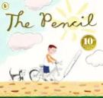  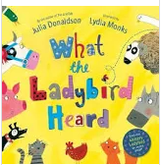  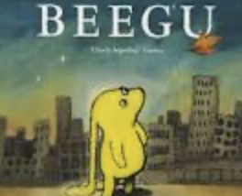  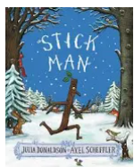 | Zim, Zam, Zoom – James Carter  The Puffin Book of Fantastic First Poems – June Crebin  Wild Animals of the North – Dieter Braun | Allan Ahlberg  Shirley Hughes  James Carter
Autumn 2 | 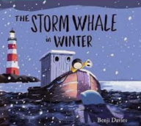  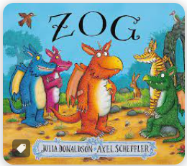  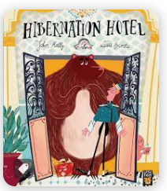  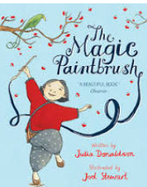 | A Great Big Cuddle – Michael Rosen  The Ice Bear – Jackie Morris  A First Book of Animals – Nicola Davis  The Forest Romp, Tim Mitton | Benjamin Zephaniah  Jill Murphy
Spring 1 | 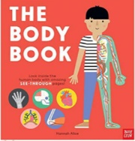  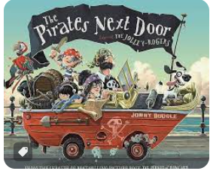  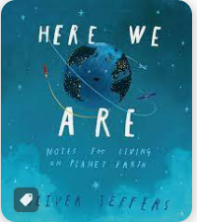  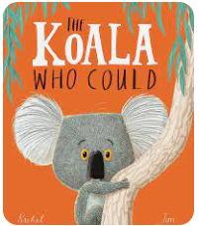 | Shuffle and Squelch – Julia Donaldson  A First Book of Nature – Nicola Davis  Tidy, Emily Gravett | Beatrix Potter  Emily Gravett
Spring 2 | 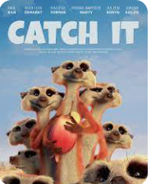  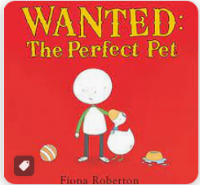  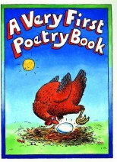 | Read Me: A Poem for Every Day of the Year – Gaby Morgan  Over and Under the Pond – Kate Messner | Emma Chichester-Clark  Anthony Browne
Summer 1 | 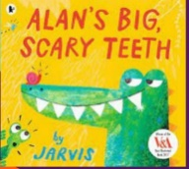  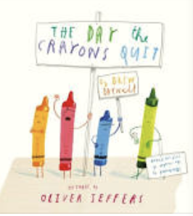  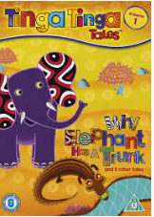 | Classic Poems for Young Children – Nicola Baxter  The Book of Bees – Piotr Socha | Judith Kerr  Mini Grey
Summer 2 | 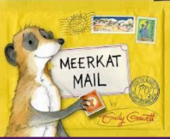  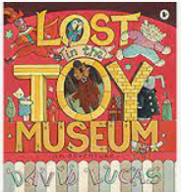  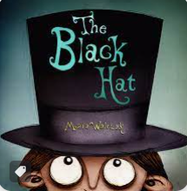 | My Life as a Goldfish – Rachel Rooney  Jelly Boots, Smelly Boots – Michael Rosen  The Big Book of Bugs – Yuval Zommer | Oliver Jeffers  A.A. Milne

