

All Saints Ranton Primary School

Progression document of Phonics from Nursery – Year 2

**Term-by-term Progression**

**Nursery** [Planning | Monster Phonics](https://monsterphonics.com/resources-foundations/foundations-in-phonics/foundations-in-phonics-landing/planning/)

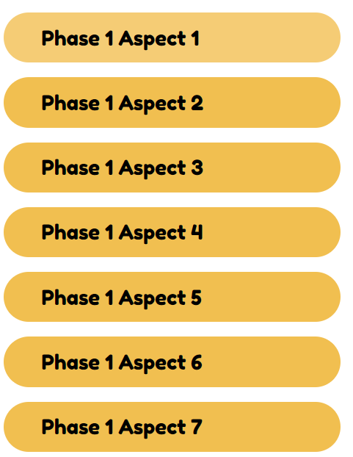

There is significant overlap in terms of skills and knowledge across the seven aspects. This creates a high level of flexibility for the practitioner to plan and deliver activities which best met the developing needs, abilities and interests of the children in the setting. Each of the first six aspects should be dipped into by teaching the activities provided, rather than teaching the aspects in order throughout the year. Aspect 7 can be taught once children have had opportunity to develop their sound discrimination skills. Each activity can be taught over two or more sessions. Your planning and choice of activities should support the children with the development of their communication and language skills. Below is an example planning grid.

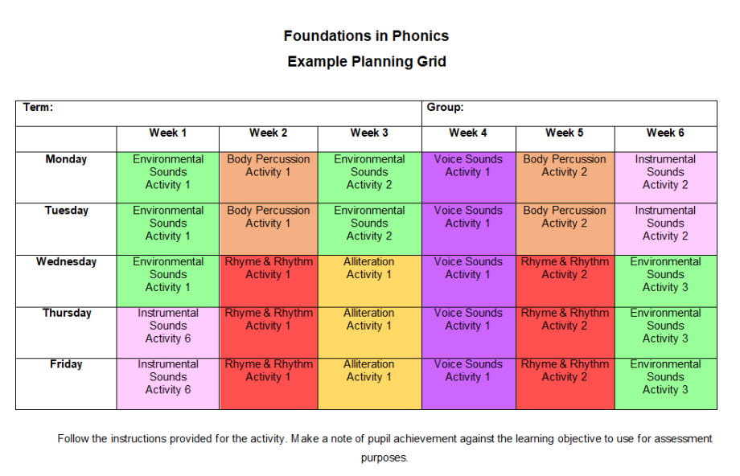

**Aspect 1 activities use environmental sounds to:**

**1. Tune into sounds**

To develop children’s listening skills and awareness of sounds in the environment.

**2. Listen and remember sounds**  
Further development of vocabulary and children’s identification and recollection of the difference between sounds.

**3. Talking about sounds**  
To make up simple sentences and talk in greater detail about sounds.

Here is an overview of activities that teach this aspect.

**Activity 1: Monster Phonics Land Sound Game**

To identify and discuss everyday sounds.

To match a sound to a corresponding image.

**Activity 2: The Black Cats’ Sound Walk**

To go on a sound walk with the black cats.

To identify sounds that you can hear in different environments.

**Activity 3: Tricky Witch’s Mysterious Places**

To use descriptive vocabulary when discussing an object or place.

To create environmental sounds using our voices.

**Activity 4: Shopping with Miss Oh No**

To discuss an experience of a supermarket.

To identify different sounds that may be heard in this environment.

To match different items to complete Miss Oh No’s Shopping list.

**Aspect 2 activities use instruments to:**

**1. Tune into sounds**  
To develop children’s listening skills and awareness of sounds in the environment.

**2. Listen and remember sounds**  
To further develop vocabulary and children’s identification and recollection of the difference between sounds.

**3. Talk about sounds**  
To make up simple sentences and talk in greater detail about sounds.

Here is an overview of activities that teach this aspect.

**Activity 1: Miss Oh No’s Weather Forecast**

To identify different types of weather.

To discuss the different sounds you can hear in different weathers.

To use musical instruments to create weather sound effects.

**Activity 2: The Black Cats’ Favourite Tunes**

To identify different types of weather.

To discuss the different sounds you can hear in different weathers.

**Activity 3: A Day at the Fun Fair**

To share an experience of a fun fair.

To listen to and share thoughts about different pieces of music.

To discuss different types of musical instrument.

**Activity 4: Brown Owl investigates Music Dynamics**

To investigate the dynamics of music.

To explore loud and quiet sounds

To play a musical instrument in different ways to change the sound

**Aspect 3 activities focus on using body sounds and movements to:**

**1. Tune into sounds**  
To develop awareness of sound and rhyme.

**2. Listen and remember sounds**  
To distinguish between sounds and to remember patterns of sound.

**3. Talk about sounds**  
In particular, to talk about the sounds we make with our bodies and what the sounds mean.

Here is an overview of activities that teach this aspect.

**Activity 1: Tricky Witch’s Musical Movements**

To copy a set of movements.

To create a sequence of movements as a group.

To know what body percussion is and how to use it.

**Activity 2: Angry Red A Meets the Grand Old Duke**

To listen to a nursery rhyme.

To think of some movements to accompany the rhyme.

To perform actions to the rhyme.

**Activity 3: Yellow I is Full of Happiness**

To join in with a familiar rhyme.

To add body percussion actions to the rhyme.

To perform the rhyme as part of a group.

**Activity 4: Black Cat Says…**

To listen carefully and follow a set of instructions.

To react and change a movement.

**Aspect 4 activities develop an awareness of alliteration.**

**1. Tuning into sounds**  
To experience and appreciate rhythm and rhyme and to develop awareness of rhythm and rhyme in speech.  
**2. Listening and Remembering Sounds**  
To increase awareness of words that rhyme and to develop knowledge about rhyme.  
**3. Talking about sounds**  
To talk about words that rhyme and to produce rhyming words.

Here is an overview of activities that teach this aspect.

**Activity 1: The Black Cats’ Rhyming Bingo**

To know that rhyming words are words tend with the same sound.

To begin to recognise words that rhyme.

To identify two words that rhyme.

**Activity 2: Tricky Witch’s Rhyming Potion**

To identify rhyming pictures.

To match the image’s rhyme with a given object.

To recognise rhyming patterns.

To complete a rhyming string.

**Activity 3: Zooming Through the Universe with U-Hoo**

To recite a familiar rhyme.

To identify the rhyming words.

To play an instrument in time to a rhyme, keeping the beat.

**Activity 4: Angry Red A’s Rhyming Train**

To complete a rhyming string by collecting a set of rhyming pictures.

To match the rhyming pictures to correct stations.

To find the rhyming pictures that match each of Angry A’s trains.

**Aspect 5 activities use speech to:**

**1. Tune into sounds**  
To develop understanding of alliteration

**2. Listen and remember sounds**  
To listen to sounds at the beginning of words and hear the differences between them.

**3. Talk about sounds**  
To explore how different sounds are articulated, and to extend understanding of alliteration.

Here is an overview of activities that teach this aspect.

**Activity 1: Green Froggy’s Hand Jive**

To repeat a sound to the beat of music.

To say words that begin with the given sound, by listening and repeating.

To suggest words which begin with a particular sound.

**Activity 2: Angry Red A Explores Tongue Twisters**

To explore a selection of tongue twisters with Angry Red A.

To attempt to say the tongue twisters aloud.

**Activity 3: Cool Blue’s Animal Alliteration**

To discuss what different animals look like.

To share some words to describe a particular animal.

To match an animal name to a describing word that begins with the same letter.

**Activity 4: Black Cat’s Name Game**

To create silly sentences based on the children’s names.

**Aspect 6 activities use voice sounds to:**

**1. Tune into sounds**  
To distinguish between the differences in vocal sounds, including oral blending and segmenting.

**2. Listen and remember sounds**  
To explore speech sounds.

**3. Talk about sounds**  
To talk about the different sounds that we can make with our voices.

Here is an overview of activities that teach this aspect.

**Activity 1: A Visit to the Ghosts’ Castle**

To know and recognise some of the sounds that you might hear at home.

To use their voices to mimic the sounds of household items.

To experiment with different ways of making sounds using their voices.

**Activity 2: Miss Oh No’s Sound Bingo**

To identify an object by its sound.

To listen carefully to a voice sound.

To copy a voice sound.

**Activity 3: Tricky Witch’s Broomstick**

To begin to sound out simple words by copying an adult.

To say the initial sound of a word.

To practise segmenting.

**Activity 4: U-Hoo’s Intergalactic Exploration**

To use your voice to create alien sounds.

To copy a voice sound.

To observe how my mouth moves when I make silly voice sounds.

**Aspect 7 activities develop oral blending and segmenting skills.**

**1. Tune into sounds**  
To develop oral blending and segmenting of sounds in words.

**2. Listen and remember sounds**  
To listen to phonemes within words and to remember them in the order in which they occur.

**3. Talk about sounds**  
To talk about the different phonemes that make up words.

Here is an overview of activities that teach this aspect.

**Activity 1: Body Blending**

To segment and blend the sounds in words linked to our bodies.

To listen to and repeat a set of sounds which form a word.

To practise blending sounds to make simple words.

**Activity 2: Tricky Witch’s Magic Box**

To work out which object is in the box, by listening to the sounds in a word.

To practise orally segmenting and blending sounds.

To take turns to segment and blend letter sounds.

**Activity 3: Angry Red A’s Farmyard Animals**

To segment farm animal name words.

To identify an animal by its picture and attempt to segment and blend the animal name.

**Activity 4: Monster Number Plates**

To segment and blend simple words on the Monster’s number plates, with adult support.

To listen to the sounds in order and then copy them aloud.

Pre-Phase 2

This optional Pre-Phase 2 Section can be used with children in Term 3 who have completed Phase 1 and are ready to recognise and say letter sounds.

Pre-Phase 2 in our Foundations Programme has a slower pace than Phase 2 teaching in Reception. Pre-Phase 2 covers only one letter each week.  Lessons and resources are provided to teach the first 8 letters taught in Phase 2: s, a , t, p, i, n , m and d.

|  |
| --- |
|  |

**Reception**

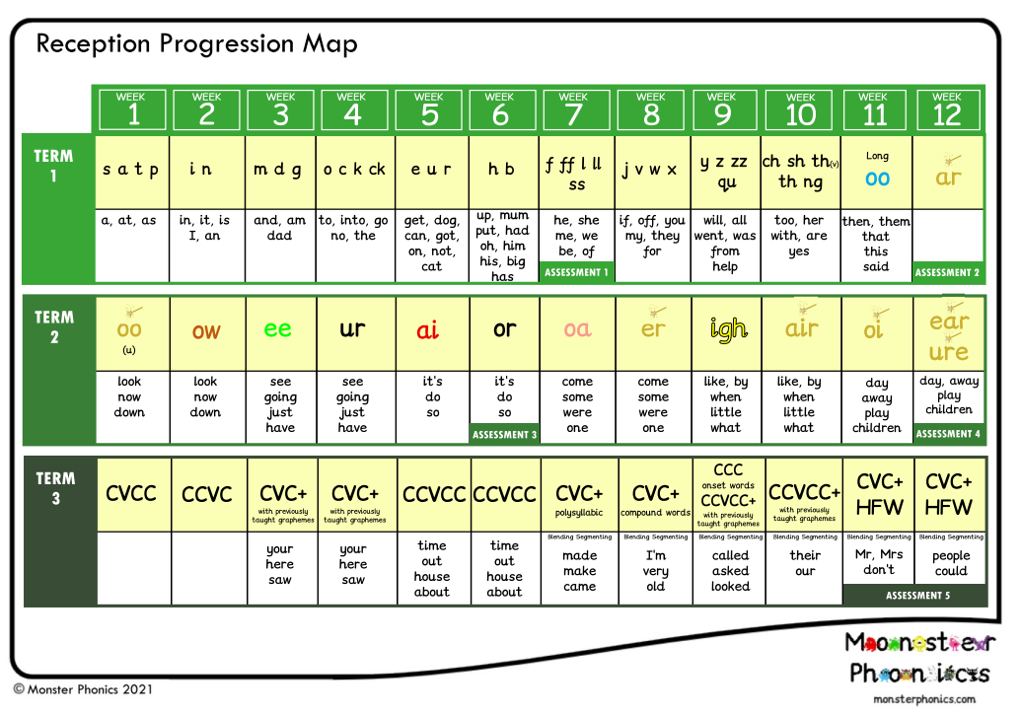

**Year One**

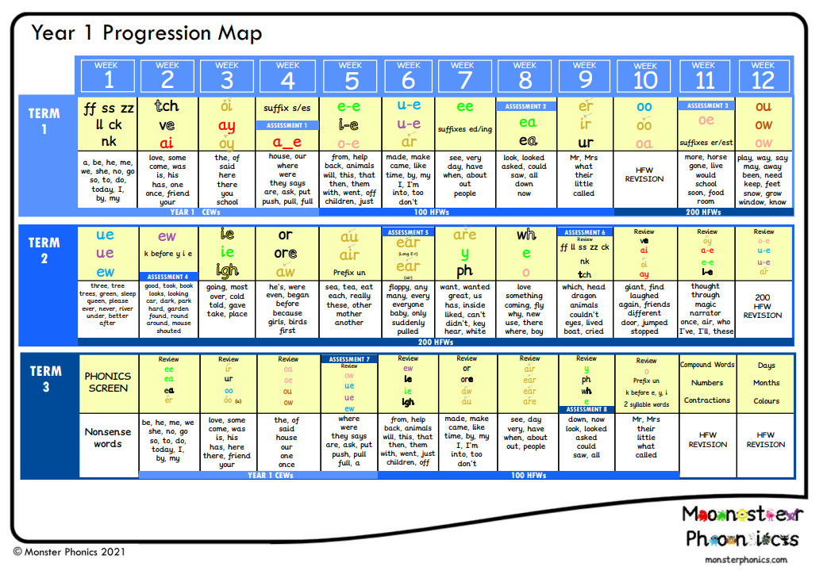

**Year Two**

Children will be taught the next phase through the programme *spelling shed.* Children learn Year 2 spelling rules and cover the next 200 high frequency words and common exception words.

