DfE – essential to note including statutory requirements

Department for Education
The DfE updates its ‘School reports on pupil performance guide for headteachers’
This guidance has been updated for the 2021/2022 academic year to remove reference to temporary arrangements introduced for the coronavirus (COVID-19) pandemic and to reflect the publication of the Schools White Paper. It includes details of the ‘Parent Pledge’, which states that any pupil who falls behind in English or maths should receive support to help with catch up and that schools communicate this work and the progress made to parents.
………………………………………………………………………………………………………………………………………………………………………………..
Sustainability and climate change strategy
The DfE’s strategy for sustainability and climate change for the education and children’s services systems.
Published: 21 April 2022
Education Secretary speech at the Natural History Museum
Education Secretary Nadhim Zahawi delivered a speech at the Natural History Museum to mark the launch of the Sustainability and Climate Change Strategy.
……………………………………………………………………………………………………………………………………………………………………………….
Education recovery guidance available for governors and trustees
The DfE has updated its ‘Education recovery support’ guidance and also published ‘Education recovery: guidance for governors and trustees’, which is intended to support governors and trustees to have effective discussions about education recovery plans within their school or trust.
……………………………………………………………………………………………………………………………………………………………………………….
Several new guidance articles available on the Early Career Framework (ECF)
The DfE has published six new articles as part of its collection ‘Induction, training and support for early career teachers (ECTs)’. These cover changes to statutory ECT induction, funding and eligibility for ECF-based training, and guidance for schools, ECTs and mentors. The new guidance reflects the changes that were implemented in September 2021.
……………………………………………………………………………………………………………………………………………………………………………..
School-led tutoring grant
How schools and academy trusts should plan and deliver the national tutoring programme’s school-led tutoring to help pupils catch up on missed learning.
Updated 4 April 2022: a ‘School-led tutoring guidance’ document to support this new option for schools,
The funds can be used for all pupils who would benefit from further tuition support and aim to:
- Provide more support to pupils taking exams this Summer.
- Offer tuition in July and August.
- Support pupils transitioning from primary to secondary school.
Updated 20 April 2022: clarification that additional funding is for schools to deliver tuition within the 2021 to 2022 academic year.
………………………………………………………………………………………………………………………………………………………………………………
Pupil premium
Information on pupil premium funding, how school leaders can use it effectively and pupil premium strategy statements.
Updated 6 April 2022: Added statement template and an example document, created for a fictitious primary school. Its purpose is to help you populate the DfE pupil premium template:
PP_Blank_Template_.docx
Example_Pupil_Premium_Statement__Primary_.docx
………………………………………………………………………………………………………………………………………………………………………………..
School attendance: guidance for schools
Updated 4 April 2022: ‘Addendum’ to show that schools are no longer advised to record pupils who are not attending school for reasons related to coronavirus using Code X (not attending in circumstances related coronavirus).
Pupils who have symptoms of coronavirus should follow the UKHSA guidance about when they should stay at home. Where a pupil is not attending school because they have symptoms or have had a positive test, this should be recorded using Code I (illness) unless another more appropriate absence code applies. Schools can continue to use the sub-code (I02) to record illness due to a suspected case of coronavirus, although they are not required to.
…………………………………………………………………………………………………………………………………………………………………………………
Health and safety: advice for schools
Updated 5 April 2022: removal of COVID-19 advice and updated links to Health and Safety Executive’s guidance and the UKHSA guidance for public health incidents.
………………………………………………………………………………………………………………………………………………………………………………..
Induction for newly qualified teachers during the coronavirus (COVID-19) pandemic
Guidance about additional funding for those currently undertaking induction.
Updated: 20 April 2022- details of a one-off payment now available to all state-funded schools that have, or had, an NQT who completed their induction between the summer term of 2021 and the spring term of 2022.

Ofsted
Ofsted updates ‘School inspection handbook’
w/b 11 April, Ofsted updated the ‘School inspection handbook’; however, this was just a minor update to say that where an LA or trust is required to prepare a statement of action, Ofsted will no longer review it. The statement will form part of the evidence base for the first monitoring visit of that school, along with the school’s own improvement plan.
………………………………………………………………………………………………………………………………………………………………………………..
A Spotlight on Ofsted: What Governors Need to Know
Schools Alliance for Excellence > Governance Support > Governance Resources > Webinars
Presentation by Ruth Murton: National Leader of Governance/ Schools Alliance for Excellence- Governance Consultant/ Previously Special Adviser to the DfE
Be prepared (approx. 57 mins): what governors will need to show during inspection that they know, understand and do
Emerging themes (approx. 1hour 23mins onwards): really useful for governors to be aware of.
……………………………………………………………………………………………………………………………………………………………………………...
Ofsted Quotes on ‘Working Memory’ Are Dangerous!
Reading Time: 4 minutes Can we trust what is written in Ofsted reports?
…………………………………………………………………………………………………………………………………………………………………………………
Questions that Ofsted asked a subject leader during a Deep Dive conversation
http://www.collaborativelearning.org/03coordinator.pdf
It’s not just about the knowledge and skills that the children retain. It’s about your role as subject leader and your knowledge of the entire curriculum for your subject from when pupil start and when they leave the school. Getting past the general to the specific

Leadership and Management (curriculum/subject leadership)
Ten Top Tips for Being an Effective Subject Leader in a Primary School (focus-education.co.uk)
There are a few different routes into subject leadership. You may be a subject leader because you have a passion for that subject, a wealth of experience in that curriculum area and your higher qualifications are in that subject. Or you may be the subject leader because you were the last one into the staff meeting when the roles were given out. And no one else wanted music. Or you may be a teacher in a small school, balancing four or five subject ‘hats’ whilst teaching a mixed age class…
……………………………………………………………………………………………………………………………………………………………………………….
Schools Alliance for Excellence > Supporting Pedagogy > Primary > Foundation Subject Leaders
Some resources from Surrey: an independent not-for-profit school improvement organisation that is owned and governed by schools (80%) in partnership with Surrey Local Authority and the six Dioceses in Surrey.
Action plan template
Audit template (Ofsted framework)
New subject leader audit template
Pupil voice questions
Learning walk questions
Deep dive questions
Subject leader crib sheet
Subject leader standards for job description
Roles and responsibilities of a subject leader
………………………………………………………………………………………………………………………………………………………………………………..
Subject leadership in primary schools – how to be a great leader (teachwire.net)
From associations and curriculum to Ofsted and observations, Matthew Lane talks us through the what, why and how of subject leadership...
Matthew Lane (Y6 teacher, RE land worldviews lead, Hethersett CEVC Primary, Norfolk)

NB The school was awarded a Gold RE Quality Mark. He describes the process and its value in this article: Quality mark – Celebrate the areas your school excels in (teachwire.net)

Education Endowment Fund (EEF)
NEW: Pupil premium support resource for schools
EEF has released a new evidence brief, which identifies robust research that schools can use to guide their decision-making around how to use their pupil premium funding.
Download resources

F.A.O Early years lead
EEF: HIGH QUALITY INTERACTIONS IN THE EARLY YEARS The ‘ShREC’ approach
eef-guidance-reports/literacy-early-years/High_quality_interactions_in_the_Early_Years_
The aim of the ShREC approach is to provide early years professionals with a simple, memorable set of specific evidence informed strategies that can be embedded into everyday practice.
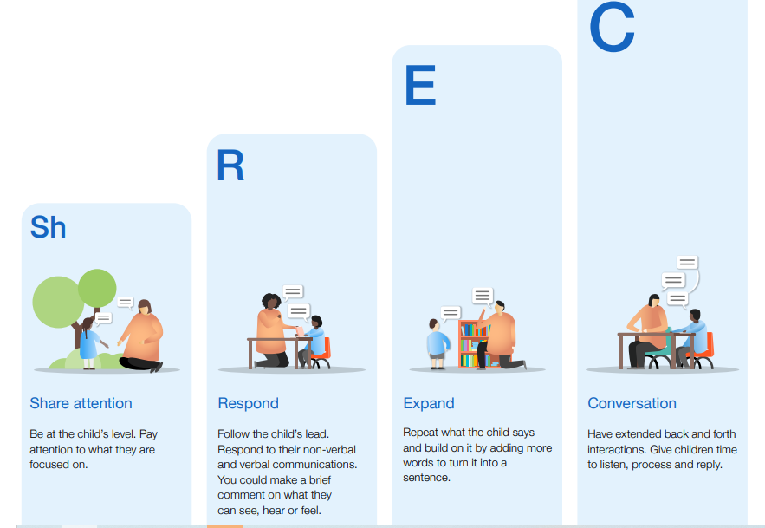
………………………………………………………………………………………………………………………………………………………………………………..
Learn - Explore - Debate
NCB recently worked with the Department for Education (DfE) to deliver the latest round of Learn - Explore - Debate events. Unlike previous events, these were held specifically for school-based early years practitioners in England.
The first session focused on COVID-19 recovery and the EYFS reforms, including presentations from the DfE, a Q&A session and a case study from Whiteknights School in Reading. Please note, you can find the EYFS profile exemplification videos and information note mentioned by the DfE in their presentations here.

In the second session, Wendy Ratcliff, HMI and Phil Minns, HMI from Ofsted presented on inspections under the revised EYFS, followed by a brief Q&A session.

……………………………………………………………………………………………………………………………………………………………………………..
Developing Neurodiversity-Affirming Practice in the Early Years
(SEN)
This is an hour-long webinar, from February 2022, that can be watched on demand following this link:
Developing Neurodiversity-Affirming Practice in the Early Years
Neurodiversity is not simply a replacement label for “conditions” such as Autism, ADHD, and Dyslexia. It’s the acknowledgement that while we may identify children who have developmental delays, we will also be caring for and educating children whose development itself is neurologically different. Understanding the potential pathways of development, means that we can truly meet children where they are, and provide experiences that help them to thrive.
The Celebratory Framework (52 mins) and its prompts is a great resource, built on Pen Green’s work. It can be downloaded for free from the speaker’s website.
F.A.O The Arts leads
Artsmark
Artsmark is the only creative quality standard for schools, accredited by Arts Council England.
Refreshing the Artsmark process and making it easier for schools to become involved has been an investment priority. New resources now offer additional guidance recognising the impact Covid-19 may have had on your Artsmark journey. Read more: recent Artsmark changes
“Let’s Create”, the new strategy for culture and creativity across England until 2030, places opportunities for children and young people at its heart. Find out more: explore our strategy for the next 10 years.
Getting started with Artsmark is quick and easy.
- Register online
- Attend Artsmark Development training – essential CPD to kickstart your Artsmark journey
- Start planning and delivering your Artsmark journey
- Access the support and resources any time

Visit artsmark.org.uk for more info.
………………………………………………………………………………………………………………………………………………………………………………….
Sky Arts Access All Arts Week
6-10 June 2022
Theme: Reimagine- Inspiration for your classroom
accessallarts.skyarts.uk
Resources are free for everyone and will be made available in the Resource Centre by May 2022.
“We believe there is an artform out there for everyone and we’re excited to help people find it. But we also know that not all schools can easily access the arts.
We want to change this. That’s why we’ll be joining forces with leading artists and art organisations to help bring the arts to every child in every primary school across the UK and Ireland.”
Teachers will be given access to five modules, built around five forms of artistic expression:
Marks – Words – Sounds – Moves – Images
Within each module, schools will have the option to explore two different artforms.

You can find out more and register at https://accessallarts.skyarts.uk/theme#registrationModal

F.A.O Assessment lead
National Dataset Report – March 2022
One of the largest reports into the impact of the disruption caused by the pandemic on primary school children.
junipereducation national-dataset-report-march-2022.pdf
KEY FINDINGS
Primary school children’s attainment has dropped between autumn 2019
and autumn 2021.
• Year 3 children – who were in Year 1 in 2019 – suffered the biggest drops
in attainment during the pandemic.
• Writing was the subject hardest hit by the pandemic.
• The gap between disadvantaged and non-disadvantaged pupils has widened
over the course of the pandemic.
• The gap between younger children with SEN and their classmates has
widened during the pandemic.
This report also provides a strong evidence base from which schools can direct their strategy and resources to support the pupils in greatest need. Leaders may find it useful to analyse performance against these findings- especially where pupils fall into overlapping groups and are especially vulnerable, e.g., Y3+SEN+disadvantaged+summer born.
……………………………………………………………………………………………………………………………………………………………………………….
Primary accountability measures - update March 2022 (publishing.service.gov.uk)
Information about how progress will be measured from KS1 to KS2 for pupils this year.
In 2021/22, the progress measures will be the first for a cohort with KS1 outcomes reported against the new assessment frameworks (in 2018). Intention is to create prior attainment groups for the 2021/22 measures, keeping the methodology broadly similar to previous years (ie combination of WTS/EXS/GDS assessments in reading, writing and maths to indicate which prior attainment group a pupil sits in- especially tricky where a pupil has a mixed profile of results). The data in summer 2022 will be needed before they will confirm how KS1 outcomes reported against the new assessment frameworks will be assigned to prior attainment groups.
Ofsted will use any statutory assessment from this year including phonics etc with caution, apparently: “We will strongly discourage users of the data from drawing conclusions based on direct comparisons with performance data from earlier years. We will also advise caution when comparing a school’s performance with national or local authority averages, or with other schools.”

…………………………………………………………………………………………………………………………………………………….
Primary assessments: future dates
Future dates for key stage 1 and key stage 2 tests (commonly referred to as SATs), phonics screening check, multiplication tables check and reception baseline assessment.
7 April 2022- change made:
Line added to the information about the KS1 tests for the 2023/24 academic year
……………………………………………………………………………………………………………………………………………………..
guidance-reporting-to-parents-at-the-end-of-key-stages-1-and-2
Guidance for schools on writing statutory end of year reports for parents.
Updated: 21 April 2022- to confirm reporting requirements following the return to a full programme of assessments in 2021 to 2022.
………………………………………………………………………………………………………………………………………………………
The Dynamics of Questioning….agile, responsive, nimble, purposeful.
Blog: Tom Sherrington https://teacherhead.com/
Lots of subtle aspects of questioning that can be codified, worked on and deployed at key moments.

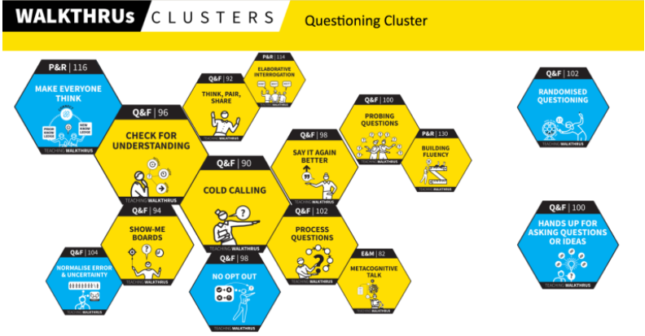

F.A.O Safeguarding Lead/ DSL
‘Guidance for safer working practice for those working with children and young people in education settings’ This has recently been updated in consultation with representatives from Child Protection in Education, LAs and stakeholders. This non-statutory guidance can be helpful when developing a staff code of conduct.
……………………………………………………………………………………………………………………………………………………………………………….
Senior mental health lead training
Updated 5 April 2022 for the 2022 to 2023 financial year.
Find out how to apply for a grant and access DfE quality assured training to help develop a whole school or college approach to mental health and wellbeing.

F.A.O Mathematics lead
NCETM
Professional text-based chat about teaching maths: from the comfort of your sofa!
If you haven’t been to one of the Twitter chats yet, catch up with the summaries, or join in this term. Recent topics include exam prep, oracy, enrichment, mathematical exploration and more.
Discover

Bespoke: latest news from the Maths Hubs Programme
Not sure what Maths Hubs are all about or just want to catch up with what’s been going on this year? The latest edition of Bespoke gives a flavour.
Read

New for primary: Four ways to create better maths talk in your classroom
Suggestions, experience and resources from primary teachers discussing mathematical oracy.
Read

Maths in pictures
If you like to use images to help pupils see the maths around them, there are now hundreds available from the International Day of Mathematics website.
Read

F.A.O English lead
EEF blog: Reading Fluency Practice in the Primary Classroom
https://educationendowmentfoundation.org.uk/news/eef-blog-reading-fluency-practice-in-the-primary-classroom
Rob Laight explains how to develop reading fluency practice using the gradual release of responsibility model.
………………………………………………………………………………………………………………………………………………………………………………
Leading Literacy… And Perennial Problems
In Closing the Reading Gap, Closing The Vocabulary Gap, The Confident Teacher, Uncategorized, Writing Gap by Alex Quigley24/04/2022
This short series is targeted at literacy leaders – either Literacy Coordinators, Reading Leads, or Curriculum Deputies etc. – with a key role in leading literacy to ensure that pupils access the curriculum and succeed in meeting the academic demands of school.
The Confident Teacher is a blog by teacher and author, Alex Quigley (@HuntingEnglish)

F.A.O SENCo/ Governors
Ambitious reform for children and young people with SEND - GOV.UK (www.gov.uk)
Published 29 March 2022: Press release.
Green paper will consult on a stronger national system for children with special educational needs and disabilities (SEND), boosting parent confidence. DfE plans to simplify EHCP process and make mainstream schools 'more inclusive', more than two years after launch of SEND review.

The DfE has released materials summarising the proposals which can be shared with parents and pupils to explain what the SEND review means for them – access them here.

Here’s another useful summary from the TES:
https://www.tes.commagazinenewsspecialist-sector-send-green-paper-everything-you-need-to-know

Not the overhaul that many were hoping for…hopefully, the article below will stimulate your inclusion thinking!
………………………………………………………………………………………………………………………………………………………..
inco14 | – be a cannon. (wordpress.com)
A short but powerful read. Lots to take away and share with colleagues to stimulate discussion and change. Here’s a key point the author makes…
“The only conversations about inclusion that will move inclusion forward are the ones that happen within the conversations about every single other aspect of school life. The conversation about staffing in maths has to be about staffing in a way that reaches and teaches every child, not just most. The talks about routines at lunch time or break time need to be talks about how those times are going to work for all students, not just most. This may mean that the decisions made result in more change than we are usually comfortable with, but that is what this is; the current design – even with tweaks and add-ons – does not work for every student. It doesn’t work for the students who need it to work the most. We either want it and we are willing to work for it, or we don’t and we aren’t. Change on this level won’t happen overnight, there’s a lot to do and there’s a lot to undo, but change can start straight away.”
…………………………………………………………………………………………………………………………………………………………………………………
National Autistic Society: Free learning resources for schools
This World Autism Acceptance Week, 28 March - 3 April, produced a suite of free resources for all age groups to help colleagues and pupils learn about autism and better understand their classmates. You can download Early Years and Primary resources below and watch the videos.
Free learning resources for your school (autism.org.uk)
…………………………………………………………………………………………………………………………………………………………………………………
CPD: Inclusive classrooms from Driver Youth Trust (DYT)
nasen: external message on behalf of Driver Youth Trust
Online Learning - Driver Youth Trust
Improve understanding of inclusive literacy with Quick Courses or embed practical, accessible strategies into your lessons with Action Courses.
CPD courses are entirely self-directed and use video tutorials, quizzes, audio content and more to fully embed your new knowledge.

