ALPSIT
School Improvement Partner Service

  - Handbook

Contents
Page

Welcome to your Archdiocese of Liverpool Primary School Improvement Trust SIP Handbook.
We hope all the information you need to understand and engage with the service is included in this document.
Should there be any omissions or additional questions please do not hesitate to get in touch.
ALPSIT SIP Service is led by the Primary Trust Advisor.
The Trust advisor is responsible for supporting, training and quality assuring all ALPSIT School Improvement Partners (SIPs) and their work.
Klare Rufo: k.rufo@rcaol.co.uk

1: Introduction to the service. Page 3
2: The Role of the ALPSIT SIP Page 4
3: What is the report used for? Page 11
4: Data Page 12
5: Information for Governors Page 14
6: Improving my SIP service Page 15
7: Frequently asked questions Page 16

Introduction to the service
1

Introduction to the Service
In order to promote the efficiency and effectiveness of educational institutions providing primary education and the efficient and effective application of resources for such purposes including by promoting and disseminating models of good practice and by the delivery of support services generally to such institutions, ALPSIT has established a SIP service.
ALPSIT are committed to ensuring all Archdiocesan schools have their own SIP. This does not mean that it must be an ALPSIT SIP. We are working closely with Local Authorities who provide a SIP service, so we can share this information. In addition, we are happy for you to share this handbook and paperwork with your self-appointed SIP. In addition, we extend an offer to all external SIPS to attend our training if you feel this is necessary/appropriate.

Your Membership
As you are aware the provision of a SIP is now separate to your ALPSIT annual membership. The ALPSIT membership cost remains at £750 + VAT per year.
The cost of the SIP service remains at £2250 + VAT. This ensures you are allocated 3 face to face days of SIP support. The SIP will be allocated an additional 2 days to research your school, plan their visits and write three reports per year (Autumn, Spring and Summer)

DBS and recruitment checks
All SIP engagement is subject to the provisions of the Rehabilitation of Offenders Act 1974 (Exceptions) Order 1975 and a Disclosure and Barring Service (DBS) Check. In addition, all SIPS undergo appropriate recruitment checks

The SIPS
We have a range of very experienced SIPs and are regularly adding people to this team. Our SIPs include consultants, recently retired headteachers and current serving headteachers. You can find an up to date list on our website.
https://www.alpsit.org.uk/sip/sip-handbook/sip-pen-portraits

Recruitment of ALPSIT SIPs
2

The Role of your ALPSIT SIP

All ALPSIT SIPs undergo a robust application and interview process. The process differs slightly between external consultant applicants and internal serving headteacher applicants.
Serving Primary Headteacher SIP Recruitment Process
All internal / serving headteachers are checked against the following eligibility criteria before they make an application. If a headteacher meets the criteria they are then able to apply using the ALPSIT SIP application form to demonstrate how they meet the Person specification. The Primary headteacher eligibility has been approved by the ALPSIT Trust Board.
A Headteacher will be eligible to be an ALPSIT School Improvement Partner if they meet both the overarching criteria:
At least 5 years Headship experience

Their current school is Good or outstanding

And in addition, can demonstrate least one of the following:
Their current school is Good or Outstanding (obtained whilst they were in post as headteacher
Their previous School was Good or Outstanding (obtained whilst they were in posts as headteacher)
They have current NLE Status
They are currently serving as an Ofsted Inspector
They have current LLE Status
They can demonstrate significant impact through already delivered school to school support.

Headteacher Application Process

*There must be at least one board member and DSO present at all SIP Interviews
External Consultant Applications
All external applicants are asked to apply using the ALPSIT SIP application form to demonstrate how they meet the Person specification.

Training
All ALPSIT SIPs undergo an initial full day training and attend a half termly SIP meeting led by the Trust advisor to ensure quality and consistency. Training and updates are also included in these meetings.

Skills audit
Each year the skills of the SIP team will be audited to ensure that the ongoing training throughout the year is addressing development needs and knowledge gaps and identifying areas of strength and expertise.
What is an ALPSIT SIP and what will they do?
The ALPSIT SIP will work closely with you to provide an external opinion on the progress of you school as measured against the priorities in your school development plan and outcomes in your School self-evaluation document (or equivalent). If there is a discrepancy between your view and the SIP’s view you will work together to resolve and identify areas together.
It is the opportunity for you, as a headteacher to litmus test the judgements you have made about your school and demonstrate that all judgements can be evidenced enough to be verified by an external partner.
How is an ALPSIT SIP allocated?
The SIP is allocated to each school by the Trust Advisor. This is done in partnership with the school and starts with the Trust advisor speaking directly to the headteacher / governors to discuss the schools’ requirements for their SIP. The Trust Advisor then maps the schools needs to the SIPs in the team.
The following elements are usually taken into consideration.

How does the SIP fit in with other support the school is receiving?
If your school is in receipt of other support (local authority, Local system leadership support, External funded support or your own self sourced support). We would advise you to talk through with your SIP the role you see them taking as part of this. The SIP role could be very specific in one area or may be able to support you in measuring the overall impact the support is having. If you have significant concerns in this area you may want to talk with you Diocesan Schools officer about hosting a partnership meeting with all partners involved
Can a school ask the SIP to talk with Ofsted/attend feedback?
Yes, if you would like your SIP to speak to Ofsted during the inspection, we would be keen to support the SIP to meet this request. This can be included within your SIPs allocated time. However, it is important to note that this offer is in ADDITION to the statutory attendance of the Local Authority Rep and the Diocesan Schools Officer attendance, not in place of it.
The Number of Visits
ALPSIT SIPs are commissioned for 5 days work per school. A minimum of 3 of these days are to be used for face to face support in the school. The other two days will be used to plan and write the reports.

Suggested Annual Schedule
On the first page of the SIP report proforma there is a suggested annual schedule. This is intended as a guide only, it is for you in discussion with your SIP to decide what areas you wish to cover.
TERM | SUGGESTED AGENDA FOR THIS  ACADEMIC YEAR | SUGGESTED INFO FOR EACH VISIT
Autumn | - Evaluation of summer data for EYFS, Phonics, Y2 and Y6  - Review Key areas of focus and improvement priorities for the year  - What other external support is the school receiving  - Agree school priorities for SIP visits  - Agree any short-term actions for next visit  - Ofsted readiness (considering the new framework)  - Curriculum mapping/review  - Governor readiness
Spring | - Progress against agreed actions from previous visit  - Review school development plan  - Review progress against Key areas of focus and improvement priorities for the year  - Review Attendance and Governance  - Subject Leadership readiness  - Curriculum progress
Summer | - Progress against agreed actions from previous visits  - Review school evaluation document  - Review progress against current targets and predictions for end of year outcomes  - Review progress against Key areas of focus and improvement priorities for the year linked to curriculum priorities  - Curriculum review/changes.  - Finance

The Paperwork
We have recently reviewed the paperwork used by ALPSIT SIPS and redesigned the forms to ensure they are short and focused. All SIPS have been trained to make focused observations and support you to keep all targets SMART. For consistency all ALPSIT SIPS will be working on this proforma.
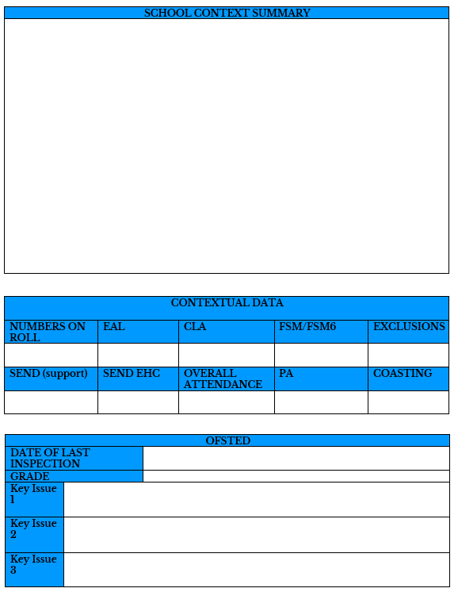
This section is the last Ofsted information and Key priorities that were identified then.

The SIP will complete contextual information that is relevant to the school. This section will be completed in the Autumn term visit.
This section is important for the SIP to be able to reflect properly on the school. It also helps the Trust draw comparisons to similar schools for peer to peer work

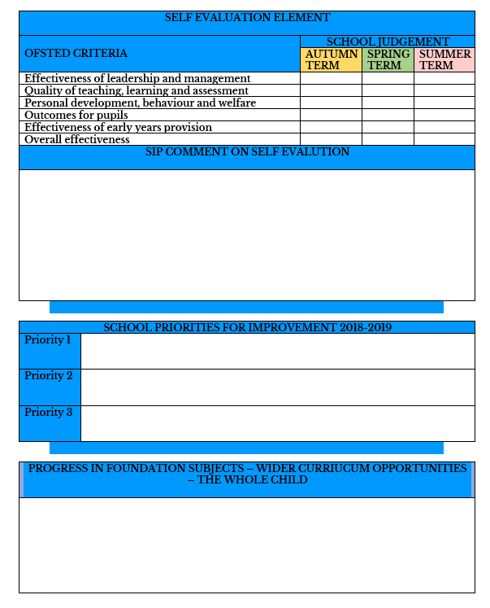
This section allows you to reflect on the foundation curriculum and the whole child.
This section is your opportunity to highlight your current Self-evaluation against the Ofsted Criteria. The SIP will have the opportunity to comment. Any gaps between your judgements and the SIPs will be focused upon throughout the year to ensure judgements are being properly evidenced.
The Schools own priorities (if different to Ofsted priorities on previous page or additional focus areas)
And not to forget about you? What are your own CPD and wellbeing needs?
This section encourages you to reflect on all the amazing work that is going on. It is an important section for the Trust to be able to understand the multitude of strengths we have in our schools irrelevant of Ofsted Gradings.
These are the termly visit forms. The first part of the form (pages 1-3) will be completed in the First visit. There will be an addition visit for each remaining term.

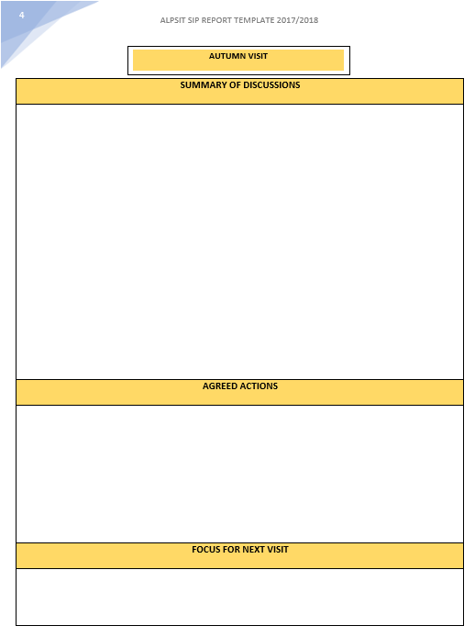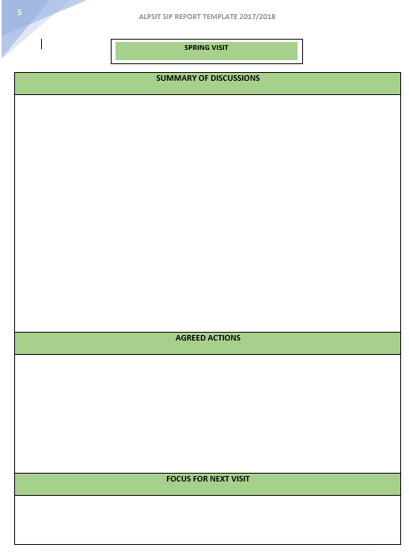
3

What happens to my SIP report

What is the report used for?

*If you are not comfortable with this arrangement could you please contact Klare Rufo.

What if the report raises concerns about my school?
Step 1: If the SIP has concerns about your school they will discuss them directly with you.
Step 2: They will inform the Trust Advisor of any significant concerns, so any appropriate support can be brokered.
Step 3: The Trust Advisor will share concerns with the Diocesan Schools Officers to ensure they can fully support you pastorally.
Step 4: Significant concerns will be discussed with The Director for Schools and Colleges

The SIPS attend 6 SIP team meetings a year and meet with Diocesan Schools officers during this time. Any additional concerns will be discussed confidentially here too.

Data
4

What data will the SIP use?
From September we will be working in Partnership with Wigan Education Business Intelligent Unit (EBIU). The EBIU will be providing a summary report for each school within ALPSIT. These reports will contain Nationally available data from the statistical releases in July and December and will be used by the SIPs and The Trust Advisor to support schools and develop appropriate school to school opportunities. You are required to sign a consent form to allow this data sharing.
2018 Key Stage 2 attainment and progress headlines
(available July)
% achieving expected standard or higher in reading
% achieving expected standard or higher in writing
% achieving expected standard or higher in maths
% achieving expected standard or higher in RWM
Reading progress
Writing progress
Maths progress
Average scaled score in reading
Average scaled score in writing
Average scaled score in maths
Average KS1 starting position
Cohort numbers

2018 Key Stage 2 contextual attainment and progress headlines
(available Dec)
% achieving expected standard or higher in reading
(broken down by girls, boys, disadvantaged, other)
% achieving expected standard or higher in writing
(broken down by girls, boys, disadvantaged, other)
% achieving expected standard or higher in maths
(broken down by girls, boys, disadvantaged, other)
% achieving expected standard or higher in RWM
(broken down by girls, boys, disadvantaged, other)
Reading progress (broken down by girls, boys, disadvantaged, other)
Writing progress (broken down by girls, boys, disadvantaged, other)
Maths progress (broken down by girls, boys, disadvantaged, other)
Average scaled score in reading
Average scaled score in writing
Average scaled score in maths
Average KS1 starting position
Cohort numbers

An example of the Reports provided to each school
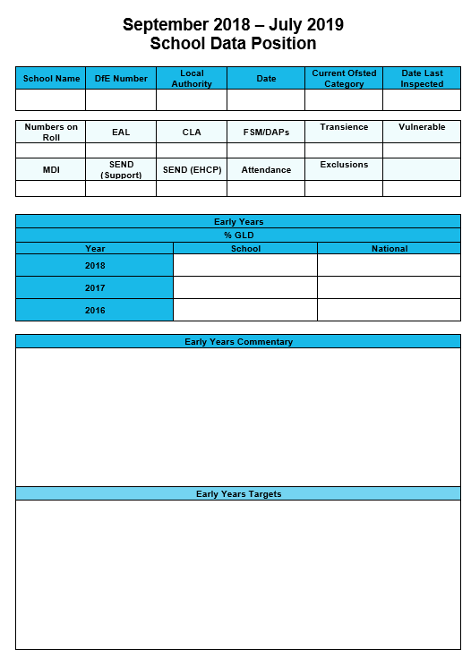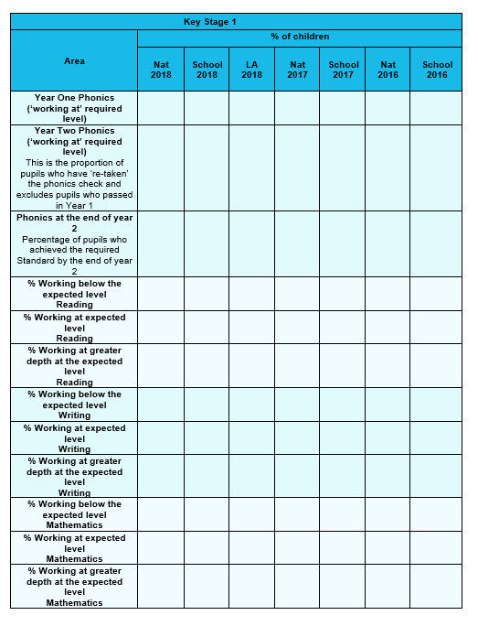
An Example of the layout of the school report
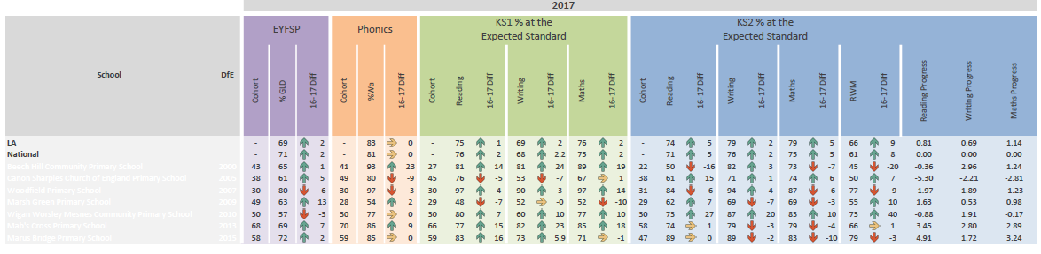

What additional Data / Information will I be expected to provide.
Information and data to be provided is a conversation between yourself and your SIP. The data report has boxes for narrative to be provided by your SIP based on conversations you have had. In addition, there are additional spaces for you to complete and review in year / current data for Early Years, Key stage 1 and Key Stage 2. These are free text boxes allowing you the opportunity to cut and paste from your existing tracking tools for ease.
In addition, we will ask you to provide the most current attendance data as published data in this area is significantly more retrospective than other data.

Information for Governors
5

Info for Governors
Choosing a SIP for the school is a partnership decision between the Headteacher and the Chair of Governors. If governors wish any additional information about their SIP, please do not hesitate to contact the Trust advisor.
The report is expected to be shared with governors directly from Your headteacher. It is good practice to have the SIP report as a standing item on your governing body meeting agendas.
SIPs are sometimes asked to feedback to the Governing body on the progress of the school against its School development plan and/or School Self Evaluation. The Trust are happy to support these requests.

Headteacher Appraisal / Performance Management
Several ALPSIT SIPS are already trained to support Headteachers Performance Management / Appraisal. If this is something you would like your SIP to do can you please discuss it with the Trust Advisor so we can be certain your SIP has been trained in this area.
Please note not all SIPS will be delivering this service. If your SIP does not deliver this service and you want it, we can facilitate a different SIP to do this as part of your overall SIP Package.
Headteacher appraisal/performance management can be included as part of your 3 face to face days. It can also be added on at an additional charge.

Additional Services offered by ALPSIT SIPS
With a service of over 20 SIPS we are an ever-growing wealth of support. Many of the SIPS are self-employed and have additional capacity to deliver other things for your school if you have used up all your allocated days. You can have this conversation directly with your SIP.
If you want to speak directly with the Trust Advisor re other services the SIPs can deliver please do not hesitate to get in touch.

What do I do if I am having problems with my SIP or the Service I am receiving?
6

Improving the SIP service
We sincerely hope you are happy with the service but on the rare occasion that something goes wrong there is a process to support you to get the issues resolved.

This section of the handbook will be updated to reflect the questions that are asked by more than one headteacher. In addition, we will cover these questions in the FAQ’s on the website.
7

Frequently asked Questions

