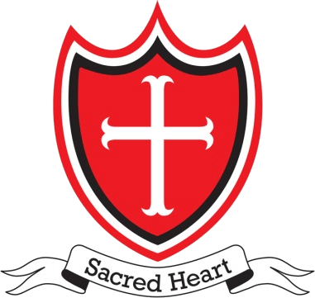
Sacred Heart RC Primary School Wigan
Using the New Resources and Toolkits

Case Study
Introduction
In collaboration with 4 other local primary schools, Sacred Heart purchased these new resources from Promoting Excellence in the summer of 2020. They represent excellent value for money.
With the on-going COVID-19 situation and the associated lockdowns, uncertainty and the critical health and safety priorities we face, like all schools we have had to focus on the operational and getting through these unprecedented and difficult times. Bearing all this in mind, Sacred Heart is planning to use these resources and toolkits when circumstances allow.
Our planning is emerging along the following lines:
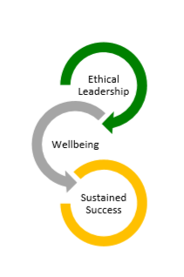
- Sequence
1. New Beginnings and Re-engagement
2. Ethical Leadership
3. Wellbeing
4. Sustainable Success

- Timeline
This will obviously depend on the on-going COVID-19 crisis,
especially regarding social distancing restrictions.

Summer Term 2021
Firstly, in consultation with SLT, we will plan to use these sections of New Beginnings and Re-engagement:
The Importance of Vision, Direction and Purpose
Advice, Guidance and Tips for Leaders
Navigating the Way Forward
Personal Thoughts and Reflections
A National Leaders’ Survey
The main strategic objectives for the summer term will be to:
- Build consensus, awareness and consistency within the SLT and the Governing Body
- Evolve greater engagement with all staff as COVID-19 situation evolves focusing upon:
- Before you start what to consider with SLT
- Are we prioritising the right things?
- Have we got everything in place?
- Using the Stockdale Paradox “Realistic Optimism” as a basis for the school’s approach and full reopening
- To consult staff in a compassionate and inclusive way:
e.g. What have been your experiences? What lessons have you learnt? What would you like Sacred Heart to build upon? What advice would you give to others?
We see the National Leaders’ Survey will be a useful resource for staff and Governors. There is a constructive, short group task on Key Behaviours and Capabilities which is thought provoking and positive and could be used with SLT and Governors and then groups of staff. There is also potential to use the resources to engage more fully with parents.
Autumn Term 2021
- The main strategic objectives will be to build upon progress made in the Summer Term.
- To consider developing a Sacred Heart Ethical Leadership Framework bespoke to the school.
- To continue to focus upon promoting and embedding staff and pupil wellbeing
The new resources will be extremely helpful in achieving these objectives, especially the Ethical Leadership and Wellbeing toolkits. We are considering arranging an SLT and Governors’ Workshop on “Ethical Leadership and Wellbeing: Governors and Senior Leaders Playing their Part.” The resources include a useful PowerPoint to support this.
In addition, we are exploring holding a Whole Staff Event - “The Importance of Vision, Mission and Aspirations.” Again, the materials provided, such as, “A New Start for Everyone: Be Brave” should prove to be especially useful and practical.
This event could be at the end of the summer term or the beginning of the autumn with these main aims:
- To say Thank You
- To further rebuild upon a whole school community spirit
- To consult and engage with all stakeholders about the vision, mission and ethos for our school.

Spring and Summer terms of 2022.
We think our focus will be on the resources which include:
- Wellbeing and Resilience
- Sustaining Success and Growing Our Own Talent
Chris Mason
Headteacher March 2021

.

