**How to make an appointment**

**Step 1**

On your web browser, enter the following website address

[**https://alsop.schoolcloud.co.uk/**](https://alsop.schoolcloud.co.uk/)

**Step 2**

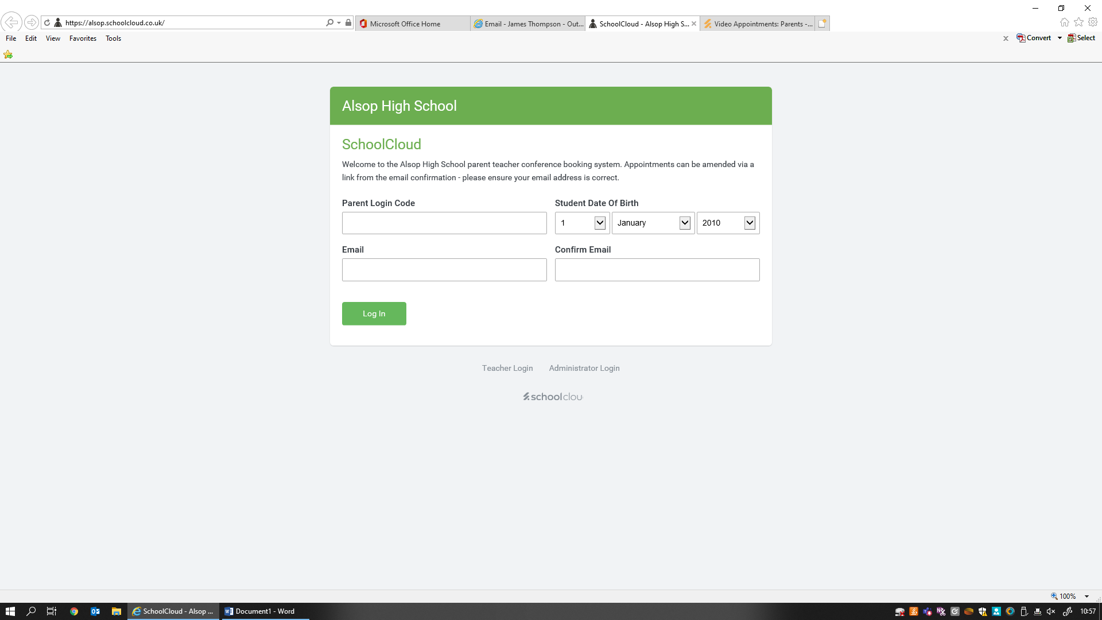

Enter your details that are included in the letter

**Select Log In when all details are entered**

**Enter the email included in the letter here, and confirm here. If you have not provided us with an email address, then the section on the letter will be blank and you may leave this blank also.**

**Enter your child’s date of birth here**

**Enter the Parent Login Code here**

**Step 3**

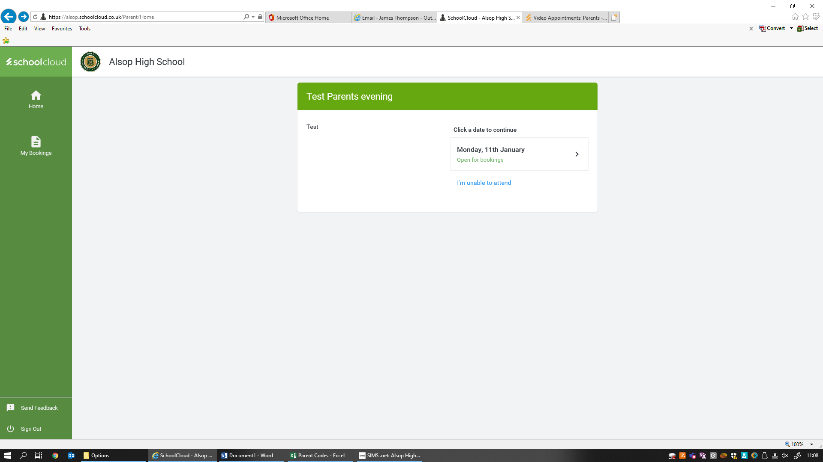

Click on the date to continue which will be the actual date of the parents evening. You may also inform us at this point if you are unable to attend.

**Step 4**

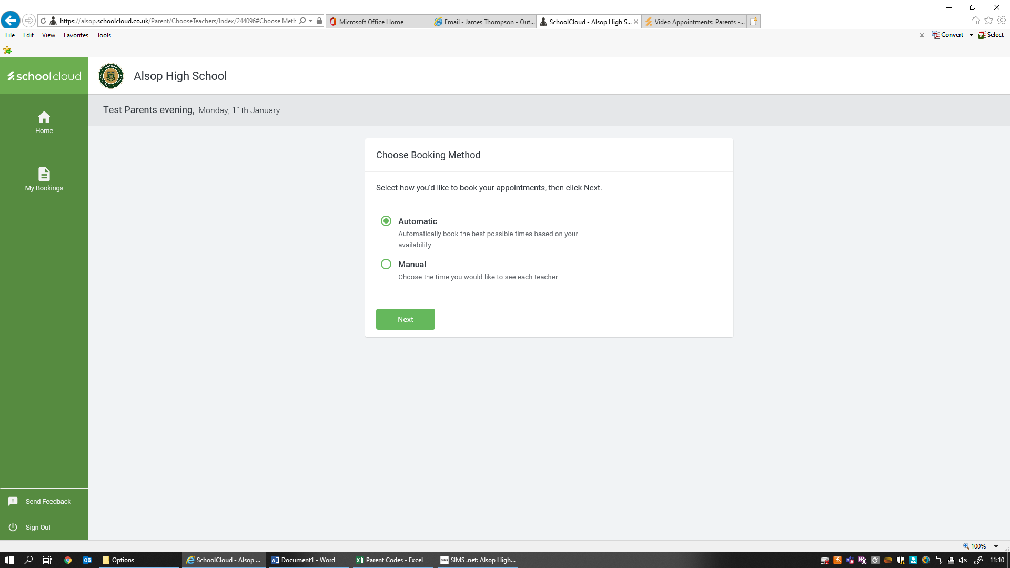

You can select whether to manually choose a suitable time or automatically book the best possible times based on your availability.

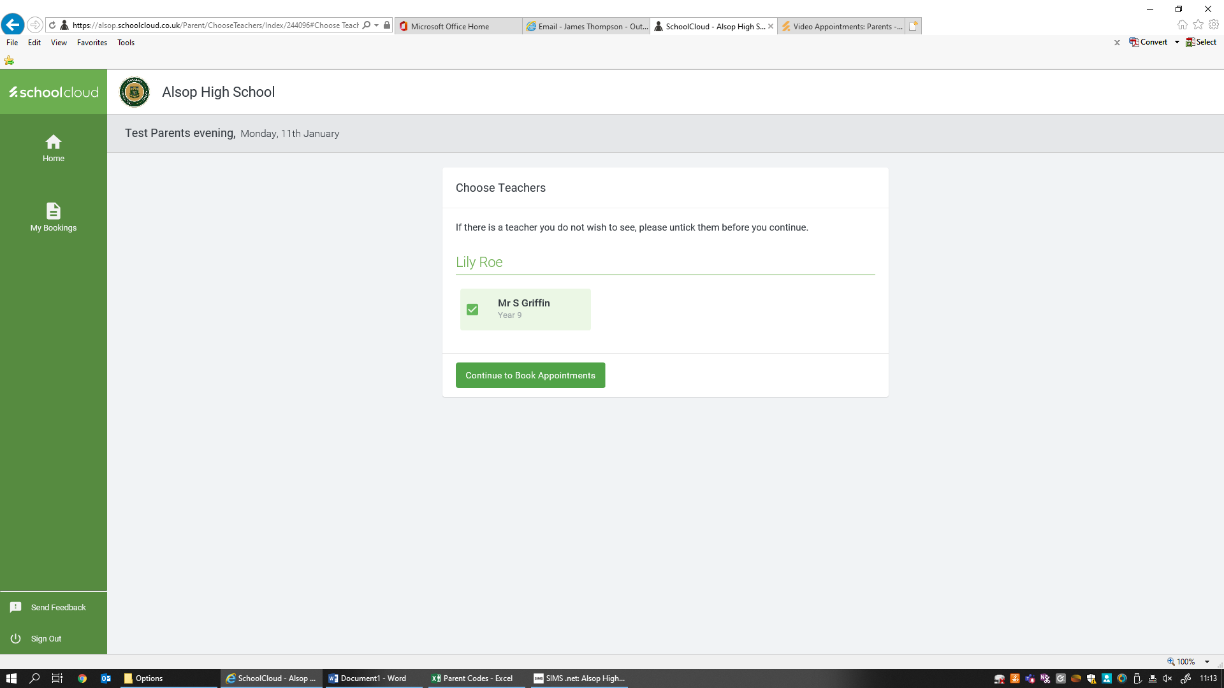**Step 5**

From the list, select the teachers you wish to see. Once you have selected, click on



**Step 6**

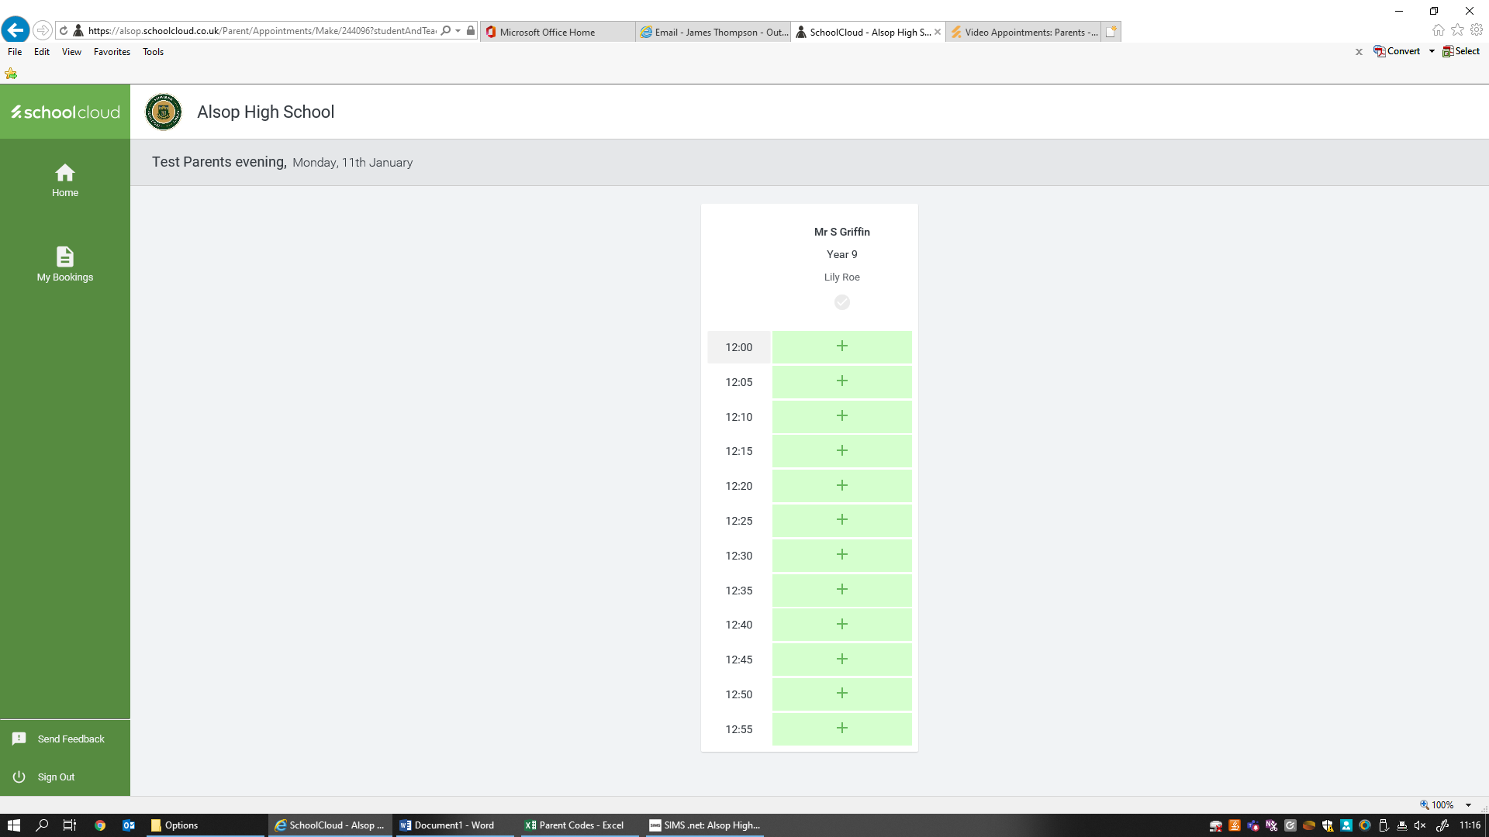

Select a time from the available slots. They are allocated on a first come first served basis.

Once you have selected a time, there is an option to send the staff member a message. After this, select Save.

You can then continue to make other appointments as necessary in the same format.

You can print/save your appointments, and you will receive an email to confirm your times.