A-level Biology
3.1 Biological Molecules

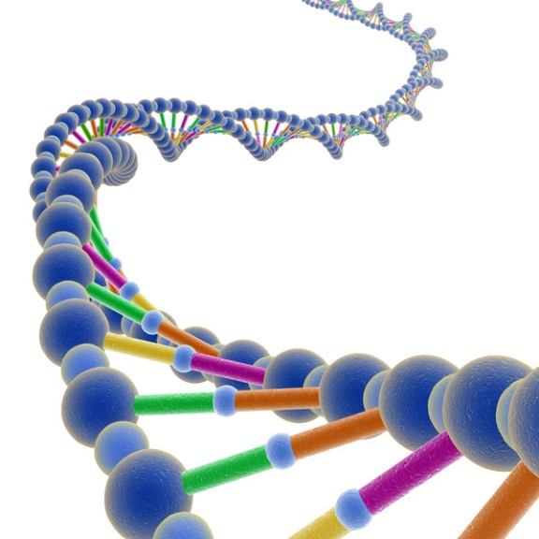

Name ……………..…….…………
Lesson Date(s) | Topic | Learning Outcomes From Specification | Key Words & Equations | Notes  (Revision tips, exam technique tips, priorities for revision etc.)
 | 3.1.1  Monomers & Polymers | - The variety of life, both past and present, is extensive, but the biochemical basis of life is similar for all living things.  - Monomers are the smaller units from which larger molecules are made.  - Polymers are molecules made from a large number of monomers joined together.  - Monosaccharides, amino acids and nucleotides are examples of monomers.  - A condensation reaction joins two molecules together with the formation of a chemical bond and involves the elimination of a molecule of water.  - A hydrolysis reaction breaks a chemical bond between two molecules and involves the use of a water molecule.
 | 3.1.2  Monosaccharides  & Disaccharides | - Monosaccharides are the monomers from which larger carbohydrates are made. Glucose, galactose and fructose are common monosaccharides.  - A condensation reaction between two monosaccharides forms a glycosidic bond.  - Disaccharides are formed by the condensation of two monosaccharides:  - maltose is a disaccharide formed by condensation of two glucose molecules  - sucrose is a disaccharide formed by condensation of a glucose molecule and a fructose molecule  - lactose is a disaccharide formed by condensation of a glucose molecule and a galactose molecule.  - Glucose has two isomers, α-glucose and β-glucose, with structures:
 | 3.1.2  Polysaccharides | - Polysaccharides are formed by the condensation of many glucose units.  - Glycogen and starch are formed by the condensation of α-glucose.  - Cellulose is formed by the condensation of β-glucose.  - The basic structure and functions of glycogen, starch and cellulose.  - The relationship of structure to function of these substances in animal cells and plant cells.  - Biochemical tests using Benedict's solution for reducing sugars and non-reducing sugars and iodine/potassium iodide for starch.
 | 3.1.3  Lipids | - Triglycerides and phospholipids are two groups of lipid.  - Triglycerides are formed by the condensation of one molecule of glycerol and three molecules of fatty acid.  - A condensation reaction between glycerol and a fatty acid (RCOOH) forms an ester bond.  - The R-group of a fatty acid may be saturated or unsaturated.  - In phospholipids, one of the fatty acids of a triglyceride is substituted by a phosphate-containing group.  - The different properties of triglycerides and phospholipids related to their different structures.  - The emulsion test for lipids.  - Students should be able to:  - recognise, from diagrams, saturated and unsaturated fatty acids  - explain the different properties of triglycerides and phospholipids.
 | 3.1.4.1  General Properties of Proteins | - Amino acids are the monomers from which proteins are made. The general structure of an amino acid as: where NH₂ represents an amine group, COOH represents a carboxyl group and R represents a side chain.  - The twenty amino acids that are common in all organisms differ only in their side group.  - A condensation reaction between two amino acids forms a peptide bond.  - Dipeptides are formed by the condensation of two amino acids.  - Polypeptides are formed by the condensation of many amino acids.  - A functional protein may contain one or more polypeptides.  - The role of hydrogen bonds, ionic bonds and disulfide bridges in the structure of proteins.  - Proteins have a variety of functions within all living organisms. The relationship between primary, secondary, tertiary and quaternary structure, and protein function.  - The biuret test for proteins.  - Students should be able to:  - relate the structure of proteins to properties of proteins named throughout the specification.
 | 3.1.4.2  Enzymes | Each enzyme lowers the activation energy of the reaction it catalyses.  The induced-fit model of enzyme action.  The properties of an enzyme relate to the tertiary structure of its active site and its ability to combine with complementary substrate(s) to form an enzyme-substrate complex.  The specificity of enzymes  The effects of the following factors on the rate of enzyme controlled reactions – enzyme concentration, substrate concentration, concentration of competitive and of non-competitive inhibitors, pH and temperature.  Students should be able to:  appreciate how models of enzyme action have changed over time  appreciate that enzymes catalyse a wide range of intracellular and extracellular reactions that determine structures and functions from cellular to whole-organism level.  Required practical 1  Investigation into the effect of a named variable on the rate of an enzyme-controlled reaction.
 | 3.1.5.1  Structure of DNA & RNA | Deoxyribonucleic acid (DNA) and ribonucleic acid (RNA) are important information-carrying molecules. In all living cells, DNA holds genetic information and RNA transfers genetic information from DNA to the ribosomes.  Ribosomes are formed from RNA and proteins.  Both DNA and RNA are polymers of nucleotides. Each nucleotide is formed from a pentose, a nitrogen-containing organic base and a phosphate group:  The components of a DNA nucleotide are deoxyribose, a phosphate group and one of the organic bases adenine, cytosine, guanine or thymine.  The components of an RNA nucleotide are ribose, a phosphate group and one of the organic bases adenine, cytosine, guanine or uracil.  A condensation reaction between two nucleotides forms a phosphodiester bond.  A DNA molecule is a double helix with two polynucleotide chains held together by hydrogen bonds between specific complementary base pairs.  An RNA molecule is a relatively short polynucleotide chain.  Students should be able to:  appreciate that the relative simplicity of DNA led many scientists to doubt that it carried the genetic code.
 | 3.1.5.2  DNA Replication | The semi-conservative replication of DNA ensures genetic continuity between generations of cells.  The process of semi-conservative replication of DNA in terms of:  unwinding of the double helix  breakage of hydrogen bonds between complementary bases in the polynucleotide strands  the role of DNA helicase in unwinding DNA and breaking its hydrogen bonds  attraction of new DNA nucleotides to exposed bases on template strands and base pairing  the role of DNA polymerase in the condensation reaction that joins adjacent nucleotides.  Students should be able to:  evaluate the work of scientists in validating the Watson–Crick model of DNA replication.
 | 3.1.6  ATP | A single molecule of adenosine triphosphate (ATP) is a nucleotide derivative and is formed from a molecule of ribose, a molecule of adenine and three phosphate groups.  Hydrolysis of ATP to adenosine diphosphate (ADP) and an inorganic phosphate group (P_{i}) is catalysed by the enzyme ATP hydrolase.  The hydrolysis of ATP can be coupled to energy-requiring reactions within cells.  The inorganic phosphate released during the hydrolysis of ATP can be used to phosphorylate other compounds, often making them more reactive.  ATP is resynthesised by the condensation of ADP and Pi. This reaction is catalysed by the enzyme ATP synthase during photosynthesis, or during respiration.
 | 3.1.7  Water | Water is a major component of cells. It has several properties that are important in biology. In particular, water:  is a metabolite in many metabolic reactions, including condensation and hydrolysis reactions  is an important solvent in which metabolic reactions occur  has a relatively high heat capacity, buffering changes in temperature  has a relatively large latent heat of vaporisation, providing a cooling effect with little loss of water through evaporation  has strong cohesion between water molecules; this supports columns of water in the tube-like transport cells of plants and produces surface tension where water meets air.
 | 3.1.8  Inorganic Ions | Inorganic ions occur in solution in the cytoplasm and body fluids of organisms, some in high concentrations and others in very low concentrations.  Each type of ion has a specific role, depending on its properties.  Students should be able to:  recognise the role of ions in the following topics: hydrogen ions and pH; iron ions as a component of haemoglobin; sodium ions in the co-transport of glucose and amino acids; and phosphate ions as components of DNA and of ATP.

