A-level Biology
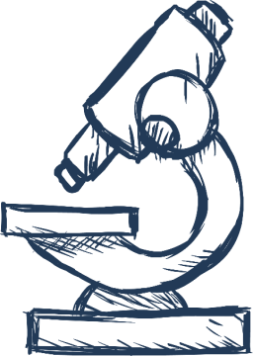

3.3 Organisms & Exchange

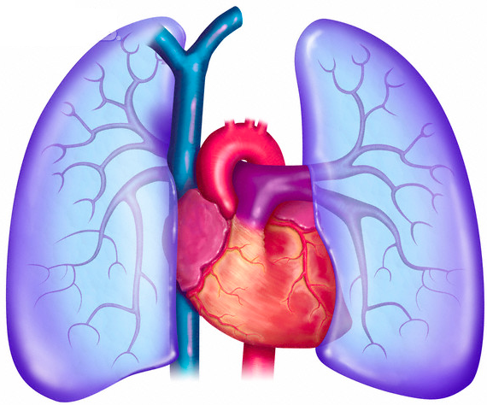

Name ……………..…….…………
Lesson Date(s) | Topic | Learning Outcomes From Specification | Key Words & Equations | Notes  (Revision tips, exam technique tips, priorities for revision etc.)
 | 3.3.1  Surface Area to Volume Ration | The relationship between the size of an organism or structure and its surface area to volume ratio.  Changes to body shape and the development of systems in larger organisms as adaptations that facilitate exchange as this ratio reduces.  Students should be able:  appreciate the relationship between surface area to volume ratio and metabolic rate.
 | 3.3.2  Adaptations of gas exchange surfaces | Adaptations of gas exchange surfaces, shown by gas exchange:  across the body surface of a single-celled organism  in the tracheal system of an insect (tracheae, tracheoles and spiracles)  across the gills of fish (gill lamellae and filaments including the counter-current principle)  by the leaves of dicotyledonous plants (mesophyll and stomata).In addition, many prokaryotic cells have:  Structural and functional compromises between the opposing needs for efficient gas exchange and the limitation of water loss shown by terrestrial insects and xerophytic plants.
 | 3.3.2  Human Gas Exchange System | The gross structure of the human gas exchange system limited to the alveoli, bronchioles, bronchi, trachea and lungs.  The essential features of the alveolar epithelium as a surface over which gas exchange takes place.  Ventilation and the exchange of gases in the lungs. The mechanism of breathing to include the role of the diaphragm and the antagonistic interaction between the external and internal intercostal muscles in bringing about pressure changes in the thoracic cavity.  Students should be able to:  interpret information relating to the effects of lung disease on gas exchange and/or ventilation  interpret data relating to the effects of pollution and smoking on the incidence of lung disease  analyse and interpret data associated with specific risk factors and the incidence of lung disease  evaluate the way in which experimental data led to statutory restrictions on the sources of risk factors  recognise correlations and causal relationships.
 | 3.3.3  Digestion & Absorption | During digestion, large biological molecules are hydrolysed to smaller molecules that can be absorbed across cell membranes.  Digestion in mammals of:  carbohydrates by amylases and membrane-bound disaccharidases  lipids by lipase, including the action of bile salts  proteins by endopeptidases, exopeptidases and membrane-bound dipeptidases.  Mechanisms for the absorption of the products of digestion by cells lining the ileum of mammals, to include:  co-transport mechanisms for the absorption of amino acids and of monosaccharides  the role of micelles in the absorption of lipids.
 | 3.3.4.1  Haemoglobin | The haemoglobins are a group of chemically similar molecules found in many different organisms. Haemoglobin is a protein with a quaternary structure.  The role of haemoglobin and red blood cells in the transport of oxygen. The loading, transport and unloading of oxygen in relation to the oxyhaemoglobin dissociation curve. The cooperative nature of oxygen binding to show that the change in shape of haemoglobin caused by binding of the first oxygens makes the binding of further oxygens easier. The effects of carbon dioxide concentration on the dissociation of oxyhaemoglobin (the Bohr effect).  Many animals are adapted to their environment by possessing different types of haemoglobin with different oxygen transport properties.
 | 3.3.4.1  Human Circulatory System | The general pattern of blood circulation in a mammal. Names are required only of the coronary arteries and of the blood vessels entering and leaving the heart, lungs and kidneys.  The gross structure of the human heart. Pressure and volume changes and associated valve movements during the cardiac cycle that maintain a unidirectional flow of blood.  The structure of arteries, arterioles and veins in relation to their function.  The structure of capillaries and the importance of capillary beds as exchange surfaces. The formation of tissue fluid and its return to the circulatory system.  Students should be able to:  analyse and interpret data relating to pressure and volume changes during the cardiac cycle  analyse and interpret data associated with specific risk factors and the incidence of cardiovascular disease  evaluate conflicting evidence associated with risk factors affecting cardiovascular disease ecognise correlations and causal relationships.  Required practical 5: Dissection of animal or plant gas exchange system or mass transport system or of organ within such a system.
 | 3.3.4.2  Mass Transport in Plants | Xylem as the tissue that transports water in the stem and leaves of plants. The cohesion-tension theory of water transport in the xylem.  Phloem as the tissue that transports organic substances in plants. The mass flow hypothesis for the mechanism of translocation in plants. The use of tracers and ringing experiments to investigate transport in plants.  Students should be able to:  recognise correlations and causal relationships  interpret evidence from tracer and ringing experiments and to evaluate the evidence for and against the mass flow hypothesis.

