A-level Biology
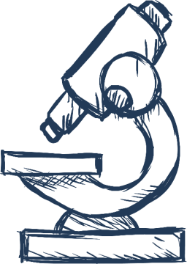

3.4 Genetic Information, Variation & Relationships

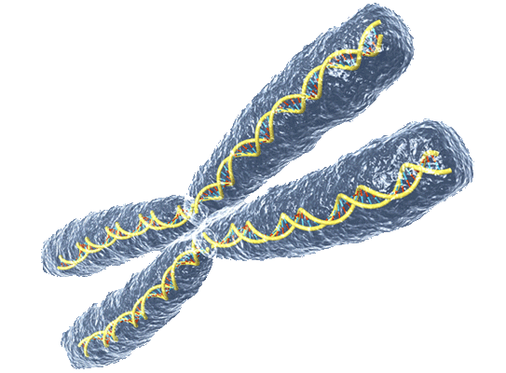

Name ……………..…….…………
Lesson Date(s) | Topic | Learning Outcomes From Specification | Key Words & Equations | Notes  (Revision tips, exam technique tips, priorities for revision etc.)
 | 3.4.1  DNA, Genes & Chromosomes | In prokaryotic cells, DNA molecules are short, circular and not associated with proteins.  In the nucleus of eukaryotic cells, DNA molecules are very long, linear and associated with proteins, called histones. Together a DNA molecule and its associated proteins form a chromosome.  The mitochondria and chloroplasts of eukaryotic cells also contain DNA which, like the DNA of prokaryotes, is short, circular and not associated with protein.
 | 3.4.1  The Genetic Code | A gene is a base sequence of DNA that codes for:  the amino acid sequence of a polypeptide  a functional RNA (including ribosomal RNA and tRNAs)  A gene occupies a fixed position, called a locus, on a particular DNA molecule.  A sequence of three DNA bases, called a triplet, codes for a specific amino acid. The genetic code is universal, non-overlapping and degenerate.  In eukaryotes, much of the nuclear DNA does not code for polypeptides. There are, for example, non-coding multiple repeats of base sequences between genes. Even within a gene only some sequences, called exons, code for amino acid sequences. Within the gene, these exons are separated by one or more non-coding sequences, called introns.
 | 3.4.2  DNA & Protein Synthesis | The concept of the genome as the complete set of genes in a cell and of the proteome as the full range of proteins that a cell is able to produce.  The structure of molecules of messenger RNA (mRNA) and of transfer RNA (tRNA).  Transcription as the production of mRNA from DNA. The role of RNA polymerase in joining mRNA nucleotides.  In prokaryotes, transcription results directly in the production of mRNA from DNA.  In eukaryotes, transcription results in the production of pre-mRNA; this is then spliced to form mRNA.  Translation as the production of polypeptides from the sequence of codons carried by mRNA. The roles of ribosomes, tRNA and ATP.  Students should be able to:  relate the base sequence of nucleic acids to the amino acid sequence of polypeptides, when provided with suitable data about the genetic code  interpret data from experimental work investigating the role of nucleic acids.  Students will not be required to recall in written papers specific codons and the amino acids for which they code.
 | 3.4.3  Gene Mutations | Gene mutations involve a change in the base sequence of chromosomes. They can arise spontaneously during DNA replication and include base deletion and base substitution. Due to the degenerate nature of the genetic code, not all base substitutions cause a change in the sequence of encoded amino acids. Mutagenic agents can increase the rate of gene mutation.
 | 3.4.3  Meiosis & Chromosome Mutations | Mutations in the number of chromosomes can arise spontaneously by chromosome non-disjunction during meiosis.  Meiosis produces daughter cells that are genetically different from each other.  The process of meiosis only in sufficient detail to show how:  two nuclear divisions result usually in the formation of four haploid daughter cells from a single diploid parent cell  genetically different daughter cells result from the independent segregation of homologous chromosomes  crossing over between homologous chromosomes results in further genetic variation among daughter cells.  Students should be able to:  complete diagrams showing the chromosome content of cells after the first and second meiotic division, when given the chromosome content of the parent cell  explain the different outcome of mitosis and meiosis  recognise where meiosis occurs when given information about an unfamiliar life cycle  explain how random fertilisation of haploid gametes further increases genetic variation within a species.
 | 3.4.4  Genetic Diversity & Adaptation | Genetic diversity as the number of different alleles of genes in a population.  Genetic diversity is a factor enabling natural selection to occur.  The principles of natural selection in the evolution of populations.  Random mutation can result in new alleles of a gene.  Many mutations are harmful but, in certain environments, the new allele of a gene might benefit its possessor, leading to increased reproductive success.  The advantageous allele is inherited by members of the next generation.  As a result, over many generations, the new allele increases in frequency in the population.  Directional selection, exemplified by antibiotic resistance in bacteria, and stabilising selection, exemplified by human birth weights.  Natural selection results in species that are better adapted to their environment. These adaptations may be anatomical, physiological or behavioural.  Students should be able to:  use unfamiliar information to explain how selection produces changes within a population of a species  interpret data relating to the effect of selection in producing change within populations  show understanding that adaptation and selection are major factors in evolution and contribute to the diversity of living organisms.  Required practical 6: Use of aseptic techniques to investigate the effect of antimicrobial substances on microbial growth.
 | 3.4.5  Species & Taxonomy | Two organisms belong to the same species if they are able to produce fertile offspring. Courtship behaviour as a necessary precursor to successful mating. The role of courtship in species recognition.  A phylogenetic classification system attempts to arrange species into groups based on their evolutionary origins and relationships. It uses a hierarchy in which smaller groups are placed within larger groups, with no overlap between groups. Each group is called a taxon (plural taxa).  One hierarchy comprises the taxa: domain, kingdom, phylum, class, order, family, genus and species.  Each species is universally identified by a binomial consisting of the name of its genus and species, eg, Homo sapiens.  Recall of different taxonomic systems, such as the three domain or five kingdom systems, will not be required.  Students should be able to:  appreciate that advances in immunology and genome sequencing help to clarify evolutionary relationships between organisms.
 | 3.4.6  Biodiversity Within a Community | Biodiversity can relate to a range of habitats, from a small local habitat to the Earth.  Species richness is a measure of the number of different species in a community.  An index of diversity describes the relationship between the number of species in a community and the number of individuals in each species.  Calculation of an index of diversity (d) from the formula  where N = total number of organisms of all species  and n = total number of organisms of each species.  Farming techniques reduce biodiversity. The balance between conservation and farming.
 | 3.4.7  Investigating Diversity | Genetic diversity within, or between species, can be made by comparing:  the frequency of measurable or observable characteristics  the base sequence of DNA  the base sequence of mRNA  the amino acid sequence of the proteins encoded by DNA and mRNA.  Students should be able to:  interpret data relating to similarities and differences in the base sequences of DNA and in the amino acid sequences of proteins to suggest relationships between different organisms within a species and between species  appreciate that gene technology has caused a change in the methods of investigating genetic diversity; inferring DNA differences from measurable or observable characteristics has been replaced by direct investigation of DNA sequences.  Knowledge of gene technologies will not be tested.  Quantitative investigations of variation within a species involve:  collecting data from random samples  calculating a mean value of the collected data and the standard deviation of that mean  interpreting mean values and their standard deviations.  Students will not be required to calculate standard deviations in written papers.

