AQA English Language Paper 1 Revision Guide

Name:
Teacher:

Paper Overview
Read Q4 first- it will help you understand what happens in the extract
Section A (1 hour)

You will be given an extract from the 20th or 21st Century

Q1. List 4 things. 4 marks and 5 minutes
Q2. Analysis of language. 8 marks and 10-12 minutes
Q3. Analysis of structure. 8 marks and 10-12 minutes
*Q4. Evaluate the validity of a statement. 20 marks and 25 minutes.
Section B (45 minutes)

You will be given a choice of two questions. It could be a choice of narrative or description (it could be two narratives or two descriptions)

*Q5. Creative writing. 40 marks and 45 minutes. 24 marks for content and 16 marks for SPaG

*these two questions count for 60/80 marks for Paper 1. Make sure you spend enough time on them.

Question 1: List 4 Things
What?
Question: List 4 things we learn about…
How?
- Put a box around the correct line numbers
- Start or end each answer with the focus of the question
- Once answer per line
- Can split a quote that contains more than one answer into separate responses

Example?

The old man is a fisherman
The old man fished alone
The old man had a boy with him
The old man had not caught a fish in 84 day
Have a go…

Check your answers

Question 2 Analysis of Language
What: How does the writer use language to…?
How?
- Answer the actual question
- Aim to write 2 analytical paragraphs
- Include a clear point that is linked to the question, methods, evidence and how these link to your point. Zoom in on individual words and the reason the writer has chosen them and the effect they have on the reader (FITUKDL)
- Make sure you select judicious evidence
- Use evaluative language to show you know these are choices by the writer (deliberately, purposefully, effectively)
- Try to reinforce your answer by selecting extra evidence/words that could support your points.

Method | Definition
Simile | Comparing one thing to another using the words ‘like’ or ‘as’ The teacher was like a snarling lion.
Metaphor | Describing something by saying it is something else. The teacher is a snarling lion
Personification | Giving human characteristics to something that is non-human The evil wind laughed in my face
Imperatives | An order or command. Sit down and be quiet!
Emotive language | Language that has an emotional effect on the reader and makes them feel strong emotions. The starving boy wiped the tears from his dirty face
Rhetorical questions | A question designed to make the reader think carefully about the answers. What do you want from life? Success? Happiness?
Triplet | A number of connected items or words – commonly adjectives. The clouds were plump, dense and a miserable grey.
Juxtaposition | Two ideas that contrast each other. It was the best of times, it was the worst of times
Semantic field | A set of words (or lexemes) related in meaning. E.G Sailing: they will surely use words such as ocean, waves, sea, tide, blue, storm, wind, sails, mast etc.
Symbolism | An object representing another, to give an entirely different meaning that is much deeper and more significant. E.G. A dove is not just a white bird. It symbolises peace and purity.
Repetition | When a word, phrase or idea is deliberately repeated for effect

Noun | Naming words that might refer to a person, place, thing or idea
Adjective | Describe a noun or pronoun.
Verb | Action/doing words
Adverb | Words which give extra information or describe a verb
Pronoun | A word used to replace a noun e.g. She, he, it, them.
Alliteration | A number of words, having the same first consonant sound, occur close together in a sentence

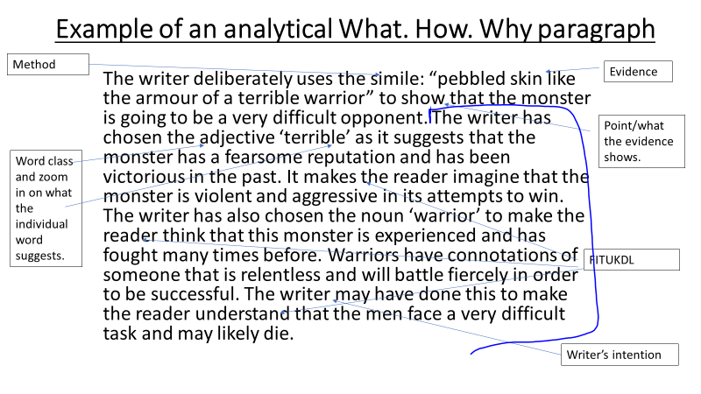
Example

Have a go…

Check
• extended metaphor to convey the size, power and strength of the Tyrannosaurus Rex
• use of personification E.G. ‘great evil god’ to suggest power
• use of battle terminology such as ‘terrible warrior’ to imply the lengths the Tyrannosaurus Rex will go to in a fight and its invincibility

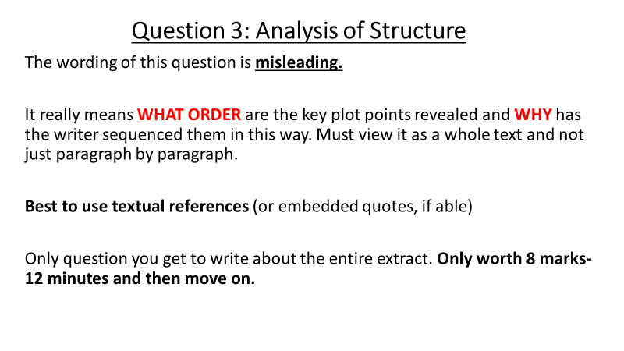
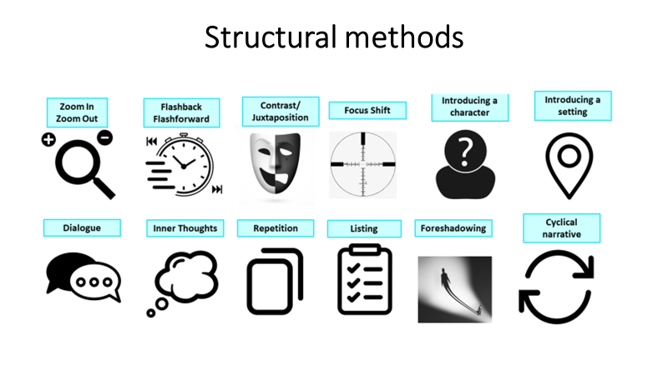

Example. This is the full insert from ‘A Sound of Thunder’

.

Q3 8/8

At the start of the text the writer focuses our attention on the jungle and their surroundings. The writer talks about how there is murmuring and sounds of the jungle but then suddenly it cuts to a single word sentence “silence” which really focuses your attention and changes the atmosphere. Right after the silence it is followed by a crack of thunder and that’s when the t-rex gets introduced. The writer shifts our attention from the jungle to the silence then to the T-rex so that it has a big atmospheric build up like a final boss. It goes a long in the beginning the atmosphere changes from focused to silence then to fear.

After the first few small paragraphs the writer then introduces a large paragraph of text dedicated to the beast. In this paragraph the writer instantly zooms in the t-rexes’ leg to giving it lots of detail and explaining exactly what they look like. The writer goes from body part to body part explaining why the creature is so terrifying and why it is so unbeatable. The writer does this so that we can see they are easily outmatched against this terrifying creature. The writer structured this in such a way that made it seem like it was from the view of one of the panicked hunters. I say this because perspectives are switched quickly and the focus is scanning the creature from toe to head. The text in the paragraph is also all bunched up together and it seems like these are all thoughts going through that hunter’s head quickly because of how terrified they are.

Have a go by completing the example above by focusing on how the text ends

Question 4
What: evaluate/to what extent do you agree with a statement
How:

- Worth the same as Q1, 2 and 3 added together.
- Box off the right line numbers
- Spend at least 25 minutes on this question
- Think about the arguments that could make for and against what the student has said
- Think about synonyms for the words in the question
- What are your key quotes and cluster words that best agree with the argument or argue against it?
- Do not contradict yourself. (I understand that some might argue ______ because…. However, this is not the case as…)

Example:

Introduction
- Subordinating conjunction (Although, despite, even though, on the surface and at first glance)
- Viewpoint 1 (the other side of the argument)
- Comma (used to split up the two different arguments)
- Viewpoint 2 (your main argument/ the other side of it)
Although it is easy to see why Pi is so frightened by the hyena and its actions, the hyena is ultimately more humorous and we even feel some sympathy towards it by the end of the extract. Funny
Even though it is revealed that hyena is not threatening by the end of the extract, it is completely understandable why Pi is so frightened and alarmed by the hyena. Frightening

Main Paragraph

- Topic sentence (one clear point)
- Evidence (best to use short quotes AND reinforce with extra evidence/individual words)
- **Explain how exactly the evidence you have selected backs up your topic sentence. Reinforced evidence could go here too)
- Zoom in at least one individual word
- *Could anyone else disagree with what you’ve said? How and why? (Some might argue that… however, this is wrong as…)
- Link it back to the question. (Therefore, this clearly shows that…)

Although the dinosaur is terrifying, Eckels did not need to panic as he was an experienced hunter and had knowledgeable guides.

I agree with this students state meant because the Tyrannosaurus Rex is described by the writer as similar to that of not just a monster but a “great evil god” emphasing great power because of the power that gods possess. The method of using the word “god” can be used to convey an idea of losing faith in your religion by automatically associating this creature as a god it replaces how the characters would feel about their god in their religion because the fact that they are seeing this creature makes them believe that they are unprotected by god as god cannot save them from this terror.

In Eckel’s reaction he seems to reach a conclusion immediately that “it can’t be killed” conveying to the reader that Eckels is seeing something so terrifying that he could not put It into words, However before he saw the creature Eckel’s seemed to be boasting about all the creatures he had killed “I’ve hunted tiger, wild boar, buffalo, elephants” leading to my own impression of Eckels reaction as; that this is a man, a great hunter, who is not afraid of anything, is genuinely terrified of this creature and for once in his life is scared for his life emphasising how he would not be very easily frightened but his reaction to the T-rex just shows us how unworldly and frightening the T-rex is / was.

Have a go by completing the rest of the above response

Using this similar paper, have a go at questions 1-4

Source A: In this extract, the world has been attacked by a variety of monsters. A new monster, one that has not been seen before, has emerged and has attacked a city. Veteran soldier, Jack, has been partnered with a group of elite soldiers to kill the monster.
The city was tall and the city was wide and the city felt like it stretched out, across the entire world, never ending, never stopping. A large fire burned across a number of streets and broken buildings. Everything was silent except for the strange flapping sounds from above; shadowy figures circling the blackened sky with expansive black wings, titanic birds of nightmare and terror. Jack, kneeling on the narrow path, pointed his gun impishly at the shapes above.
"Stop that!" snapped Sarah. "Don't even aim at them as a joke! If your gun should go off…" Jack flushed. "Where's our monster?"
They moved forward in the tar-like air of the night.
"Strange," murmured Jack. "The election, the referendum, the pandemic. Everything we worried about before, everything that seemed so important- for years on end-they don’t even matter anymore after they arrived-”
"Check your rifles!" Sarah cut in, with a look of contempt at Jack. "You, Jack, take the first shot, seeing as you’re so keen. Everyone else, have your rifles ready in case this one misses.”
“I’ve got this, don’t worry” Jack smiled, almost confidently, but a small quiver at the side of his mouth betrayed him. “I’ve been in Afghanistan, Iraq, killed hundreds. I was there when these monsters first appeared, and I’ve killed hundreds of them too. I’ll be fine, I’ll be fine-“
“Will you shut-“ Rachael began, but was cut off when Sarah raised her hand. Everyone fell silent and went completely still. They peered ahead, searching for any slight movement. Sweat dripped slowly down their foreheads as they waited.
"There," she whispered. "In the smoke, at the side of the fallen building. The devil itself.”

The city was still silent. Even the flapping above had ceased, as if the monstrous birds above had sensed something coming, something horrific, and had fled. Then, slowly at first, a deep rumbling could be heard, coming from the smoke ahead. It was like an earthquake beginning, or a distant wave rushing from the horizon.
Then it roared. A deafening, rending, earth shattering roar. The soldiers winced and stumbled back as if blasted by a violent wind.
Out of the smoke came the monster. "That’s impossible,” Jack muttered, “It’s, It’s-nothing could be that…”
"Sshh!"

It came on massive greased, inescapable, striding legs. It towered one-hundred feet above half of the buildings, a being that did not belong in the real world, a devil, a killing machine. It came on, folding its adroit surgeons claws close to its scaly chest. Each lower leg was a piston, a few thousand pounds of black bone, bolted in dense chains of muscle, sheathed over in a crust of pebbled skin like the armour of a terrible warrior. It’s cage-like chest heaved as it hurtled forward, its two adroit arms dangled out front, arms with hands which might pick up and examine men like a coroner examines a dead body. And the head itself, a mass of carved stone sat atop of a coiled neck, lifted effortlessly upon the dark sky. Its head was darker than the sky and seemed to block it out. Its jaws gaped, exposing a wall of scalpel like teeth. Its eyes rolled, black holes, empty of everything except a desire to consume everything into its infinite pupils. It ran, its sides smashing brick, decimating buildings, its clawed feet grinding up concrete, leaving prints thirty inches deep.
It ran with a tightrope walker’s precision, far too poised and balanced for its weight. It moved further into the open, away from the smoke, the light of the fire flashing nightmarish shapes onto its beautiful reptilian body.
Jack’s eye widened in fear and he stood up slowly. “It looks like it could reach up and devour the moon.”
"Sshh!" Sarah said, pulling Jack back down angrily. "He hasn't seen us yet."
"It can't be killed," Jack pronounced this verdict gently, calmly, as if there could be no argument. The rifle in his hands seemed a Nerf gun. "We were fools to come. This is impossible."
"Shut up!" hissed Sarah.
"Nightmare."
"Turn around," commanded Sarah. "Walk quietly back to the pick-up point.”
"I didn't realize it would be this huge," said Jack. "I underestimated it. I want out. I can’t do this…”
The despotic beast raised itself. Its armoured skin shone like thousands of pieces of gold in the firelight. The gold pieces, slick with sludge, steamed. In the slime, tiny parasites squirmed, so that the entire body seemed to bulge and undulate, even while the monster itself did not move. It exhaled. The stink of blood washes across the street.
"Get me out of here," said Jack. "It was never like this. I’ve always had good back-up, a good team, better equipment. I've met my match and admit it. This is too much for me to get hold of."
"Don't run," said Ernest. "Turn around, slowly. It can’t see you until you move. Go back to the pick-up point.”
"Yes." Jack seemed to be in some sort of dream. He looked at if wondering why they wouldn’t move.
"Jack!"
He took a few steps, blinking, shuffling.
“That’s the wrong way! It’s going to see-“
The monster, at the first motion, lunged forward with a roar that shook the earth. It covered one hundred yards in seconds. The rifles snapped up and erupted fire. A blast of air from the beast's mouth drowned them in the stench of rotten flesh and old blood. Fresh blood mingled with the old, a man’s scream pierced the air. Something fleshy and moist flew across Jack’s vision and landed with a thump.
The rifles exploded again, missiles crashed. Their sound was lost in shriek and monster thunder. The great monster tail swung up, writhed sideways. Buildings crumpled again and glass shattered. The monster twitched its surgeon’s hands down to in an attempt to caress the soldiers, to bend them in half, to pop them like balloons, to stuff them into its jaws and its screeching throat. Another man squealed, a needle like claw sliding effortlessly into his head, through his eye, his brains and blood squirting out like a spot being popped. Then, suddenly, its black eyes levelled with the men. They saw themselves mirrored. They fired at the metallic eyelids and the inexorable iris, its eyes now seeping with pus and blood.
Like a collapsing glacier, the monster fell.
Q1: Read again lines 1-8. List 4 things we learn about the city from this part of the source.
Q2: Look at the section of the extract that has been chosen for Q2. How does the writer use language to present the monster.
It came on massive greased, inescapable, striding legs. It towered one-hundred feet above half of the buildings, a being that did not belong in the real world, a devil, a killing machine. It came on, folding its adroit surgeons claws close to its scaly chest. Each lower leg was a piston, a few thousand pounds of black bone, bolted in dense chains of muscle, sheathed over in a crust of pebbled skin like the armour of a terrible warrior. It’s cage-like chest heaved as it hurtled forward, its two adroit arms dangled out front, arms with hands which might pick up and examine men like a coroner examines a dead body. And the head itself, a mass of carved stone sat atop of a coiled neck, lifted effortlessly upon the dark sky. Its head was darker than the sky and seemed to block it out. Its jaws gaped, exposing a wall of scalpel like teeth. Its eyes rolled, black holes, empty of everything except a desire to consume everything into its infinite pupils. It ran, its sides smashing brick, decimating buildings, its clawed feet grinding up concrete, leaving prints thirty inches deep.
Q3: How has the writer structured the extract to interest you as a reader?
Q4: Focus this part of your answer on the second part of the source, from lines 41 to the end.
A student said, “At this point in the story, where the men attempt to kill the monster, it seems like Jack is right to be panicking. The monster seems unbeatable.”
To what extent do you agree? (20 Marks)
Question 5
What: Creative Writing. 40 marks. Spend 45 minutes on it.
Basics you must include in each paragraph:
- Capital letter and full stops
- A variety of other punctuation ! ? () - : ;
- A range of sentence lengths
- HLV
- Well-selected adjectives, verbs and adverbs
- Use of colour
- A simile, metaphor or personification
- Inclusion of at least one aspect of the 5 senses
- Use of setting
- Use of characterisation

Things to include to stand out/things to include in your overall piece

- A cyclical structure
- A one sentence paragraph for effect
- Repetition of a key phrase/RQ/the one sentence paragraph
- Flashback/flashforward
- Paragraphs all start in different ways (Ly, Ing, Simile etc.)

Example. Inspired by a picture of snow. 37/40
White. Pure, uninterrupted white. The snow stretched beyond the horizon, an infinite sea of wonder and magnificence.
She wondered if the sea ever ended or if it was infinite. She began to walk, savouring the soft and crisp crunch of fresh snow that accompanied each footstep. She noticed a tree to her right. A maze of twisting and angular branches that swarmed each other. It seemed an unseen force had decorated this tree with snow, it now resembled icing sugar that a child would greedily dump onto fresh pancakes on a morning before school.
She made her way over to a nearby pond. This place was frozen in time. The flowers had a thin layer of frost preserving them, keeping their beauty alive for all to see. A robin fluttered by her head and landed on the ice. It whistled a little tune to itself as if it were a musical genius; crafting and shaping the music as it desired. She answered back with a whistle of her own and took a step towards the robin: onto the ice.
Her foot lingered over the ice. Mother always told her not to step on ice. That was one of the few things she remembered. Other things had begun to fade; like snow that waits to long to leave and is sheparded away by the new spring. She stared down at her reflection in the ice, observing the child-like wonder in her eyes. That wonder had also begun to fade.
She placed one foot on the ice. Nothing. No crack or crunch to be heard. She took another step. Now both her feet were on the ice, her life in the hands of the ice. She cautiously shuffled towards the robin, who still sat whistling on the ice. She was less than an arms length away from the robin now. She began to stretch out her hand until she heard it.
‘Crack!’
The sound she had been dreading. It was quiet, as if she wasn’t hearing it, like this was a dream and she could just wake up – But it was real.
She took slow and deliberate steps now. She didn’t savour the crunch that these steps made: she was petrified of them. She turned her head like an owl to see if salvation was in sight: but the shore lay far away. Nothing had ever felt further away, time and space operated differently here.
‘Crunch!’
The ice began to crumble beneath. She began to run. She could hear it catching up to her, her hopes and dreams cascading into the waters below. Her only hope was a final dive to the shore.
‘Crash!’
She arose and twisted to observe the damage. She’d created a scar in the pond. But what shocked her the most was what lay in the scar: a robin.
It was writhing uncontrollably in the perilous waters, begging for salvation from its impending doom. But hope was lost and she watched in horror and awe as the writhing subsided. She had killed the robin. She had murdered innocence, purity and true beauty in a living form; and she had to live with that for the rest of her life.

The rain falls in cold, hard drops onto the flimsy shield of her umbrella, each one hitting the black material with an icy ‘tut’ before ricocheting back into the damp night air. The clouds loom above in threatening hoards, releasing a relentless stream of icy water. She is huddled in the middle of the platform, her body curved into a question mark as she perches on the edge of her weathered suitcase, which lies dejected on the wet cobbles. Her umbrella casts a shadow over her, throwing her face into darkness, as if trying to shroud her from any prying passers-by.
She reflects on the strained interaction she had with a stranger just moments before. A man approached her. He had a friendly face but she was still wary. He asked when the next train was due, smiling. She shook her head and shrugged. He made some redundant comment about the painful wait times and tried smiling again. She didn’t bother to acknowledge him that time. She swivelled round to face the other way, longing to be left in solitude.
Now, she is blessed with the silence she so desperately craves. She hears a train approaching the platform, rumbling down the tracks into view. Its lights project a warm glow on the tracks, highlighting the blackened rubble, the greased metal, the spasms of colour provided by discarded pieces of rubbish. As the train moves closer, the light casts its net wider, throwing her petite frame into brightness. She thinks of the possibilities stretched out before her, thinks of abandoning her old life and leaping into her new one.
Her heart thunders inside her chest, rattling her fragile rib cage. She folds down her umbrella, flinching as the rain begins to pound her bruised face. Her breathing is quick and shallow. The adrenaline searing through her urges her to move her limbs. Her new life beckons her, alluring and captivating. The train moves closer, as if in slow motion, but the deafening sound it makes gives away its speed. She takes another step, approaching the platform edge. She casts a cursory glance back at her belongings, discarded on the cobbles, as the rain continues to fall on them in cold, hard drops. Her umbrella is sodden and flimsy as it rests against her suitcase.
She takes one last step, closing her eyes as her new life welcomes her with cold, metallic arms.

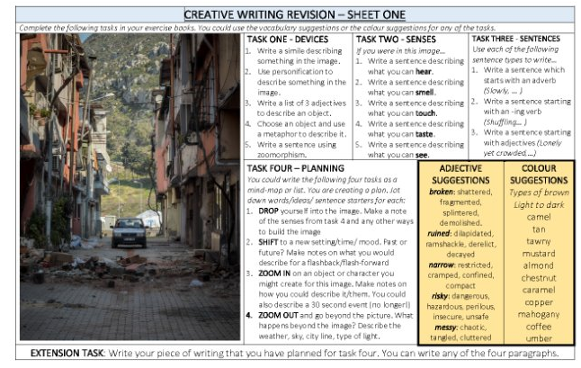
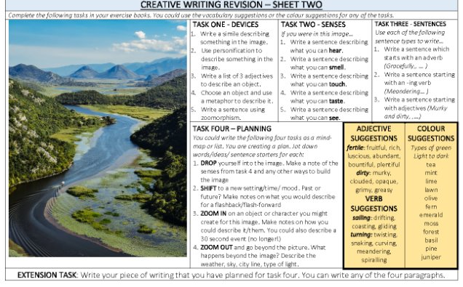
Have a go…

