Paper 1 – Physical Landscapes in the UK – the UK physical landscape, rivers, and coasts
GCSCE REVISION AT A GLANCE – GEOGRAPHY AQA TOPIC SUMMARIES
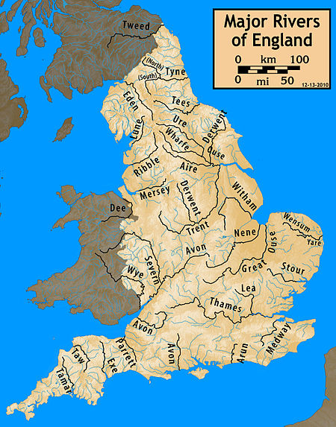
The UK physical landscape
Upland areas: Grampian Mountains (Scotland), Lake District (England), Snowdonia (Wales)
Lowland areas: The Fens (Eastern England), Clyde River Valley (Scotland)
Main UK rivers: R. Severn, R. Thames, R. Trent, R. Tyne
Main UK coastlines: Holderness Coast (NE England), Dorset Coast (SE England)

Coasts
Waves
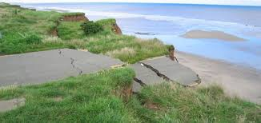
Constructive waves – powerful swash, weak backwash, builds the beach, low height, low frequency, gentle beach
Destructive waves – weak swash, powerful backwash, erodes the builds, high in height, high frequency, steep beach

Processes
Weathering – mechanical/physical (rain falls into cracks in the rock, freezes and expands; over time this repeats and the rock eventually shatters); chemical (weak acids in rain dissolve minerals in the rocks)
Mass movement – sliding (material shifts in a straight line), slumping (material shifts with a rotation); rock falls (material breaks & falls down a slope)
Erosion – hydraulic power (waves crash against the rocks and compress air into gaps causing it to break); abrasion (eroded particles scrape against the base of a cliff in the water); attrition (eroded particles collide and break into smaller pieces); solution (mineral particles dissolve in sea water)
Transport – longshore drift – prevailing wind swashes waves onshore at an angle; backwash flows out straight due to gravity; over time this moves sediment along the beach in a zig-zag motion
Deposition – occurs with gentle (constructive) waves, low wind speeds, when the water carries too much sediment

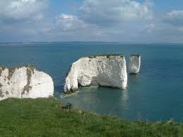
Landforms of erosion
Headlands and bays – form due to alternating bands of hard & soft rock; the soft rock erodes quicker creating an irregularly shaped coastline
Wave cut notches and wave cut platforms – waves erode most at the base of a cliff forming a wave-cut notch; the rock above becomes unstable and collapses; collapsed material is washed away and scours the rock below; the process repeats and over time a wave-cut platform is created
Caves, arches, stacks, stumps – waves attack & erode a weakness in the headland; over time this widens to form cave and then an arch; the top of the cave collapses to create a stack which erodes down to leave a stump
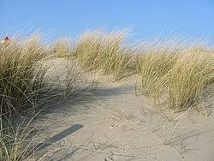
Landforms of deposition
Beaches – formed between the high tide and low tide; created by constructive waves; sand beaches are flat & wide; shingle beaches are steep and narrow
Spits – formed by longshore drift where the land changes direction; longshore drift pushes material past the bend and deposits it in the sea; strong winds create a recurve or hook at the end; saltmarshes and mudflats form behind
Bars – where a spit joins two headlands together; a lagoon form’s behind.
Sand dunes – form on a beach due to strong onshore winds that move sand up the beach; sand gets caught behind obstacles and is colonised by plants & grasses; the dunes gradually accumulate more plants & soil and become more established, eventually turning to mature dunes with oak woodland
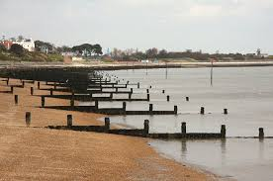
Managing the coastline
Hard engineering – man-made structures to control erosion & flooding
Sea walls –Provides a barrier between waves and the land, and placed along back of a beach. Recurved sea walls more
expensive than flat sea walls but more effective in reflecting waves and reducing overtopping.
Benefits: If well maintained, sea walls can last for many years. –A sea wall gives people a sense of security. It often has a
promenade on top of it which doubles up as a cycle route.
Costs: From the beach a concrete wall is ugly to look at. Sea walls can also destroy habitats. (very effective but expensive).
Gabions – Steel- wire mesh cages filled with pebbles or rocks. Placed at the back of a sandy beach to create a low, wall like structure. Water enters the cages and this absorbs and dissipates some of the waves energy, thus reducing the rate
of erosion.
Benefits: The blend in better than other methods of hard engineering (when sand is blown into them or they are covered with vegetation).
Cost: When damaged gabions are dangerous (people can cut themselves on broken steel wire mesh) (cheap & easy to build but can look ugly).
Rock armour/rip rap – Made up of thousands of tonnes of huge boulders of hard rock like Granite, to acts as a barrier between the sea and
the land. Their downward slope arrangement to the sea deflects the waves energy. As water enters gaps between boulders, pressure is released and this reduces the waves’ energy.
Benefits: the structure is quick to build and easy to maintain.
Costs: Highly resistant rocks from Norway/ Sweden often used in preference to rocks from local
quarries. This can cause resentment and also inflate the cost considerably. (cheap and defend against erosion & flooding but need to be replaced);
Groynes – fences trapping sand from moved by longshore drift (create bigger beaches but increase erosion further down the coast)

Soft engineering – schemes that work in harmony with the coast; look more natural
Beach nourishment: Broad term for the replacement of lost sediment. A nourished beach means fewer waves reach the
back of the beach. As more wave energy is absorbed and dissipated by the beach, the rate of erosion is reduced.
Benefits: A wider beach means more room for beach users.
Costs: Beach recycling may cause resentment from people living close to the donor area.
Beach reprofiling: The artificial reshaping of a beach using existing beach material. After winter storms bulldozers move shingle back up the beach to ensure the beach is large enough to be an effective buffer between land and sea.
Benefits: Many residential areas behind beach more protected are reprofiling, so residents
feel safe.
Costs: Bulldozers can restrict access to beaches especially in Winter. – A steep, high crested beach may look unnatural and uninviting to tourists.
Dune regeneration –The artificial creation of new sand dunes or the restoration of existing dunes. Sand dunes act as a
physical barrier between the sea and the land, absorbing wave energy and water, and therefore protecting us from the sea.
Benefits: Small planting projects (grasses) often use volunteer labour and local grass for transplants so costs are minimal. Sand dunes are also popular as picnic and walking areas. Fenced off sand dunes may also deter tourists.; do nothing/managed retreat – allow flooding to happen (cheap &easy but creates conflict)
Costs: Expensive systems have to be put in place to protect planted areas from trampling.

Coastal Realignment in Medmerry, West Sussex (Soft and Hard engineering strategy)
Why was the scheme needed?
Area of South East England most at risk of flooding due to climate change. A shingle ridge beach was the only protection from the sea.
From the 1990’s beach reprofiling took place every winter at an annual cost of £200,000 (cost becoming unsustainable). – If breached then 348 properties in Selsey and many holiday homes/ rental cottages would have been flooded.

What strategy was used?
Managed retreat was achieved by: - Building a new embankment up to 2km inland from the shore using clay from local area.
Embankment enclosed the future intertidal area and protected properties behind it. Behind embankment a channel was built along its whole length to collect draining water. Four outfall structures built into the embankment to take the water into the intertidal
area. Rock armour placed on seaward edges of embankment (60,000 tonnes of hard rock from Norway).

Controversy/Conflict
Cost £28 million (expensive scheme). –Habitats of existing species (i.e. badgers) would have been disturbed. Some local residents feel the EA should not have given up the land so easily and insist they should have looked into other options such as offshore reefs/continued beach realignment.

Positive effects
300 hectares of new intertidal habitats are forming seaward of embankment. Mudflats, salt marshes and transitional grasses have already attracted large numbers of ducks and lapwings. Area turning into huge nature reserve managed by the RSPB.
Tourism (main contributor to local economy) expected to increase. -Selsey now has a 1 in 1000 chance of coastal flooding, providing the best level of protection in UK.
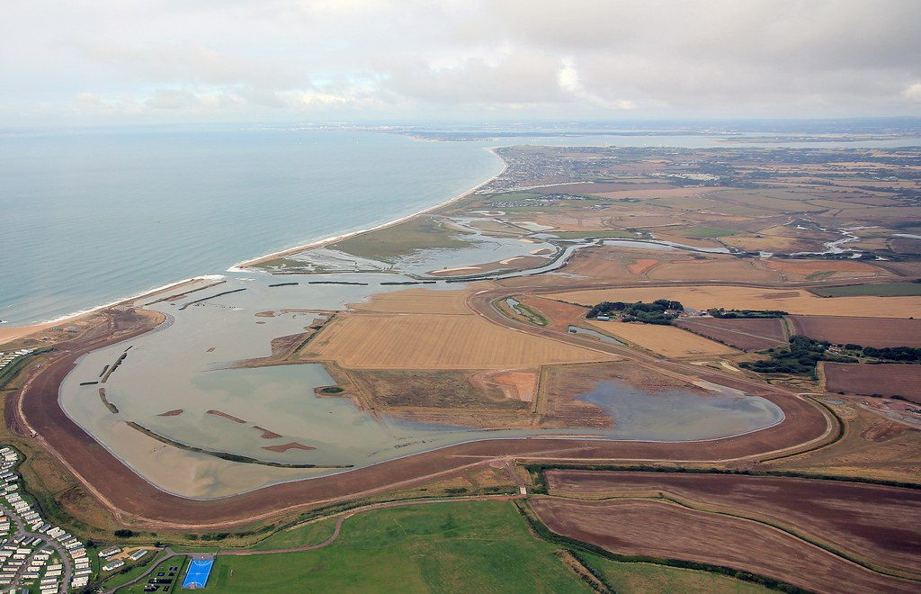

Rivers
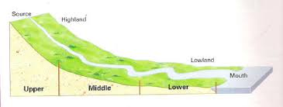
Long profile – change in gradient from source to mouth (steep & high in upper course; low & flat in lower course)
Cross profile – shape of a river valley and channel from side to side (V-shaped higher up; flatter lower down)
Features of upper course – steeper, higher, narrow channel, V-shaped valleys, waterfalls, gorges, interlocking spurs
Features of middle course – gentle, lower, wider & deeper channel, meanders, oxbow lakes
Features of lower course – flat, very wide & deep channel, floodplains, levees, estuaries

Processes
Erosion – hydraulic action (sheer force of the water breaks off pieces of rock); abrasion (rocks in the water scrape against the channel & wear it away); attrition (rocks in the water hit against each other & become gradually more rounded); solution (small minerals in the rock dissolve into the water); vertical erosion (water erodes downwards due to gravity & deepens the channel); lateral erosion (water erodes side to side and widens the channel)
Transport – traction (large pebbles rolled along the river bed); saltation (pebbles are picked up & dropped, bounced along river bed); suspension (pebbles carried suspended in flow); solution (dissolved minerals are carried invisibly)
Deposition – material is dropped due to there being less water or more sediment or reaching the end of the river
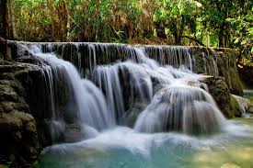
Landforms
Waterfalls & gorges – created where hard rock overlies soft rock; the soft rock is eroded via hydraulic action & abrasion creating an undercut; the overhanging rock weakens & eventually collapses; eroded material swirls around the plunge pool further deepening it; over time, these repeats and the waterfall retreats to leave a gorge
V-shaped valleys & interlocking spurs – created by weathering of topsoil and vertical erosion; hillsides interlock
Meanders & oxbow lakes – water flows faster around the outer of a river bend where the water is deeper due to more erosion and a river cliff is created; on the inside, the water is shallower and slower, resulting in deposition and the formation of a river beach (slip off slope); the meander neck narrows and during a flood is cut through; over time, deposition cuts off the old meander to leave an oxbow lake
Floodplains – a wide valley floor created by repeated flooding; flat and fertile, which makes it good for farming
Levees – formed during floods; largest/heaviest material is dropped first and closest to the river, creating a natural raised embankment; finer material is carried further away from the river
Estuaries – where the river meets the sea; water levels rise & fall due to the tide, creating mudflats from deposition
Example: The River Severn (source in the Plynlimon Hills in Wales, mouth at the Bristol Channel in England)

Flooding
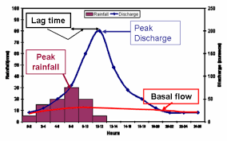
Factors affecting flooding – physical (heavy, prolonged rainfall, impermeable rocks, snowmelt, steep-sided valleys); human (urbanisation, deforestation, defences which can hold back and then suddenly release water)
Hydrographs – a graph showing a flood event; lag time shows the delay between rain falling & reaching river channel
Hard engineering – man-made structures built to control the flow of rivers and reduce flooding; dams and reservoirs (hold back the water to control floods & generate HEP); straightening (helps water flow faster); embankments (walls along river bank to contain water); flood relief channels (divert water from risk areas)
Soft engineering – works with a river’s natural processes; flood warnings (alerts people to danger); preparation (modify buildings or have emergency kits ready); floodplain zoning (build houses away from rivers); planting trees (increases interception of rainfall, roots soak up water); river restoration (return river to its natural state)

Example – flood management of Boscastle after the flash floods in August 2004
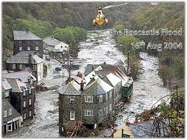
Reasons for the scheme – flash floods brought devastation to the village due to heavy rain & steep-sided valleys
Management strategy –new flood wall, deeper & wider channel, raised carpark, stronger embankments, new bridge
Issues – social (residents’ lives disrupted, some feel the look of the village is spoilt); economic (scheme cost £4million, insurance has gone down); environmental (biodiversity & wildlife habitats have improved)

