AT A GLANCE – AQA TOPIC SUMMARIES
Paper 2 – The Challenge of Resource Management – resource management and energy
Resources – things we use and need for basic human development
Importance of food – avoid malnourishment & disease, have energy & strength to work and go to school
Importance of (access to clean) water – needed for drinking, cooking, washing, growing crops; avoid cholera & typhoid; avoid walking to distances to get water
Importance of energy – needed for industry, transport, use in homes; crucial for development & job creation
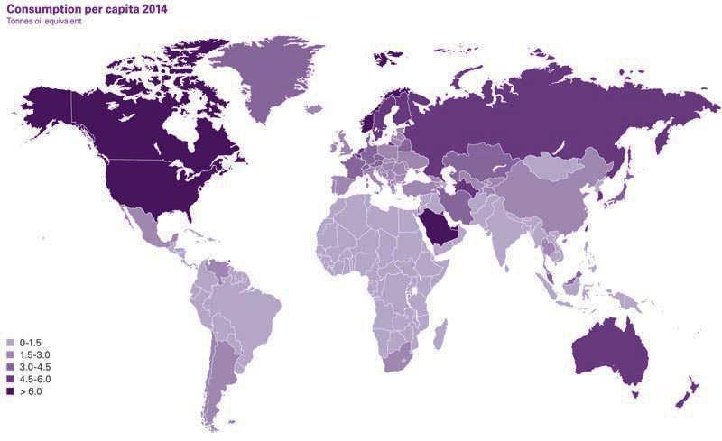
Distribution of resources – production and consumption is uneven; HICs produce & consume more resources because they have the money to develop resource technology, e.g. mining and drilling for oil; HICs often take resources from LICs because LICs do not have the money to obtain and export their own resources

Resources in the UK
Food in the UK
Demand for food – demand for all kinds of foods from around the world at any time of year; high quantities imported; increasing trend for organic or locally grown food as people become more environmentally aware
Carbon footprint – the carbon emitted from growing, harvesting, packaging, and transporting food around the world (also known as food miles)
Organic food – grown without pesticides & fertilisers; better for people & the environment
Agribusiness – a type of large-scale industrial farming which has grown in the UK; uses more pesticides which are harmful to the environment; more machinery results in job losses; loss of hedgerows leads to loss of biodiversity

Water in the UK
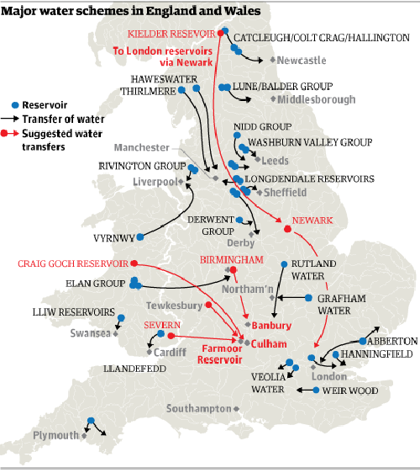
Demand for water – most rainfall (water supply) is in the north-west, but most usage (water demand) is in the south-east; usage has increased due to use of washing machines, dishwashers, and population increases
Water pollution – mainly from farming fertilisers, vehicle pollutants, chemical spills; regulated using better drainage systems and stricter regulations
Water transfer strategies – move water from areas of surplus to deficit, e.g. using dams and aqueducts; however, this can be expensive, affect wildlife, and be controversial

Energy in the UK
The energy mix – we used to rely on fossil fuels (e.g. gas from the North Sea); nuclear energy has now increased as has wind, solar, bioenergy and HEP usage; some coal power stations have now closed down
Supply of fossil fuels – North Sea oil and gas is nearly all used up; coal-mines are closing; shale gas is being considered (fracking – where fluid is pumped into shale rock to extract gas) but this is a controversial process
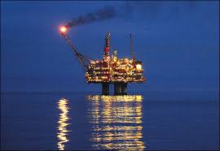
Issues of fossil fuel usage – economic (extracting & refining fossil fuels is expensive, but using renewables and nuclear is also costly; importing energy is a costly but possible option); environmental (burning fossil fuels gives off greenhouse gases and carbon causing climate change; fracking may pollute water and cause mini earthquakes; oil spills cause water pollution; renewables can cause damage to the environment, e.g. wind farms)

Energy
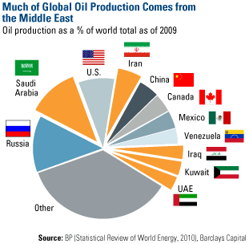
Energy security/surplus – when you have a reliable, uninterrupted, affordable supply of energy
Energy deficit – when you don’t have a reliable, affordable supply of energy
Global energy production – uneven; a small number of fossil-fuel rich countries produce most of the world’s energy, e.g. oil – Iran, Saudi Arabia; coal – China, Australia
Global energy consumption – uneven; HICs consume far more energy because they can pay for it and have lifestyles that demand more energy, e.g. use of cars, large houses, electronic gadgets
Reasons for growing energy use – economic development (some LICs and NEEs have developed faster and have an increased use of energy); rising population (over 7 billion, heading towards 9 billion); technology (there are now more devices that use electricity, e.g. phones, computers, tablets)

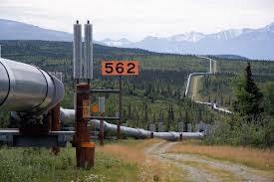
Factors affecting energy supply – physical (some countries simply have more fossil fuels than others, variations in climate will affect how much renewables are used, e.g. wind and solar); economic (cost of extraction, prices can vary due to wars and conflict, e.g. over oil, renewables are expensive); political (wars affect extraction, e.g. fighting in the Middle East; international climate change agreements reduce the use of fossil fuels in a bid to reduce carbon emissions)
Impacts of energy insecurity – exploration begins in difficult and environmentally sensitive areas, e.g. Alaska for oil; conflict between regions with different energy levels, e.g. Russia, Ukraine, the Middle East; industry declines as it cannot rely on intermittent or expensive energy; demand for biofuels increases which causes damage to farmland

Increasing energy supply
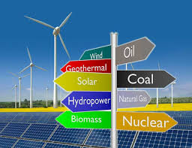
Renewables
Biomass – burn wood, plants or animal waste to produce biofuels; good for LICs
Wind – turbines spin to create electricity; depends on high wind speeds
Solar – photovoltaic cells trap sunlight; only works in sunny places
Hydro-electric power (HEP) – uses dams to hold water back and then releases it through a turbine; reservoirs can damage wildlife and communities
Tidal – turbines turned with changing water levels and tides; predictable energy due to regular tide patterns
Wave – waves turn turbines; don’t work in calm conditions
Geothermal – uses water heated by the earth’s mantle; only works in certain countries
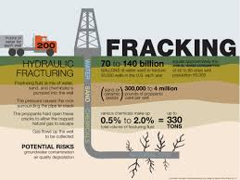
Non-renewables
Fossil fuels – search for new reserves; develop new technology, e.g. fracking
Nuclear – efficient way of making energy from small amounts of fuel; however, there are risks associated with safety and nuclear waste

Case study – natural gas in the Amazon, South America
Natural gas – made from the remains of sea creatures that lived long ago and are now buried under the sea
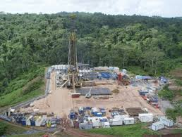
Reserve locations – main reserves found in Russia, Iran, Qatar and Saudi Arabia
Advantages – clean, low risk of accidents, provides employment, boosts local economies, easier to transport than other fuels, saves Peru US$4 billion in energy costs, Peru would no longer have to import fuel
Disadvantages – dangerous if mishandled, contributes to global warming, deforestation can destroy Peruvian habitats, indigenous tribes may be pushed off land or catch diseases from developers, pipelines are expensive

Energy conservation
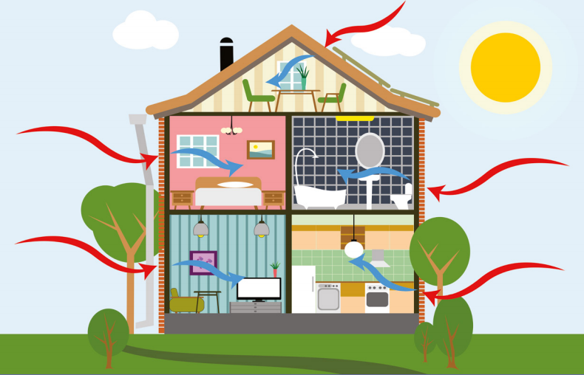
Sustainable futures – providing energy for the current generation without compromising the ability to future generations to meet their own energy needs
Carbon footprint – a measure of how much carbon you emit from various activities, e.g. eating, drinking, travelling, washing, using various appliances
Sustainable design – improve house insulation to keep heat in, double glazing, larger windows to increase natural lighting, use modern boilers, fit solar panels and wind turbines to the roof
Reduce demand – turn of lights when not in use, only boil water needed, improve and increase use of public transport, make safer cycle paths and footpaths
Increase efficiency – hybrid cars (diesel and electric), engine manufacturers required to make more efficient engines

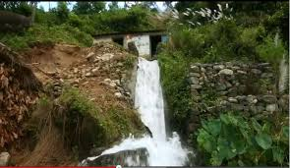
Case study of a renewable scheme in an LIC: micro-hydro plants in Nepal
Location – Himalayas; landlocked between China and India; has no natural energy reserves and is high up in the mountains
Micro-hydro plants – make use of fast flowing mountain streams; no need for dams/reservoirs – use diverted water; used to provide power or water for small-scale industry, agriculture and homes; small scale = cheaper
Benefits – electricity has enabled businesses to develop; medicines can be refrigerated meaning healthcare has improved; schools can function and students can study after dark; less trees cut down so forests are growing back; less people now need to move to cities; project can last for over 25 years

