Paper 2 – The Changing Economic World – development in Nigeria and the UK
AT A GLANCE – AQA TOPIC SUMMARIES

The development gap
Development – progress in economic growth, standard of living and quality of life; a positive change for the better
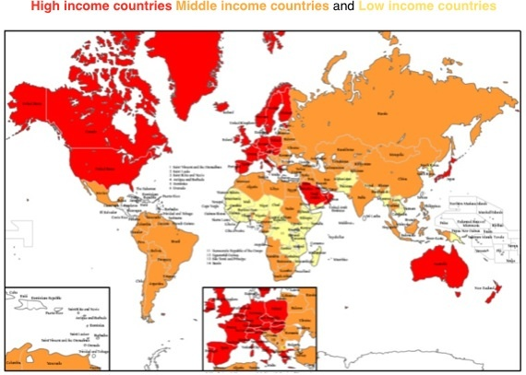
HICs = High Income Countries, e.g. UK, USA, Canada, Australia
LICs = Low Income Countries, e.g. Mali, Congo, Ethiopia
NEEs = Newly Emerging Economies, e.g. Nigeria

Measures of development – things that show how developed a country is, e.g. money, healthcare
Measure include:
GNI/GDP (Gross National Income/Gross Domestic Product) – a measure of wealth
Birth rate – live babies born per 1000 people per year
Death rate – deaths per 1000 people per year
Infant mortality rate – babies who die under 1 years old per 1000 babies born
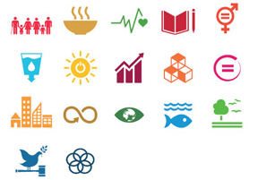
People per doctor – average people per doctor
Literacy rate - % adults who can read/write
Access to safe water - % people who can get clean water
Life expectancy – average age someone can expect to live to
HDI (Human Development Index) – a measure that includes life expectancy, literacy rate, education
Importance of using a variety of indicators – using one indicator can be misleading and give an inaccurate idea of development, e.g. a country may appear wealthy but the government may have most of the money (corruption); using a mixture is more reliable, such as the Human Development Index (HDI)
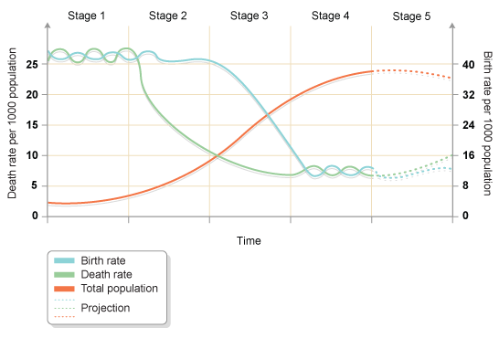
The Demographic Transition Model – line graph that shows changes in a population over time; contains data on births, deaths, and total population
Stage 1 – high births & deaths; poor healthcare, lots of disease, large families needed for farming, no access to contraception
Stage 2 – high births & decreasing deaths; improving healthcare, large families still needed for farming
Stage 3 – decreasing births & low deaths; good healthcare, smaller families as more people work in manufacturing, women start to get jobs and education, more access to contraception
Stage 4 – low births & deaths; good healthcare, high incomes, jobs in industry and services, having children becomes expensive, more women in the workplace
Stage 5 – higher deaths than births; elderly population, strain on healthcare, not enough young working population to pay taxes, immigrants welcome

Population pyramids – show the age and gender structure of a population; help governments to plan for the greatest need, e.g. childcare or elderly healthcare

Factors affecting development
Physical (natural)
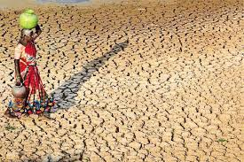
Poor climate and farmland– droughts, floods, extreme temperatures, diseases and pests – can ruin crops
Natural hazards – earthquakes, volcanoes, and hurricanes – can cause deaths and disruption
Few raw materials – lack of things such as coal or oil – no source of energy for industry
Historical
Colonisation – e.g. British Empire, Slave Trade – people/resources taken leaving them poorer
Conflict – wars – money spent on weapons and fighting instead of healthcare/education
Economic
Lack of trade – small/remote countries cannot trade and make money
Debt – over-borrowing leaves countries with lots of debts
Low value goods – countries with only wood/metal/stone cannot get much money from trade to develop

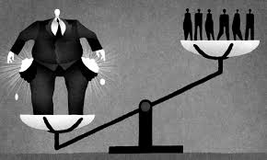
Impacts of uneven development
Wealth – a small number of countries hold the majority of the world’s wealth
Health – LICs have many more infectious diseases and shorter life expectancies; HICs have more cancers and diabetes but longer life expectancies overall
Migration – people move from LICs/NEEs to HICs in search of better jobs, higher wages, and better working conditions, e.g. from Eastern Europe to the UK
The development gap – where some countries are more developed than others

Strategies to reduce the development gap
Aid – given from one country to another, e.g. money, food, doctors
Debt relief – money owed is cancelled and forgotten about
Fair Trade – farmers in LICs get a fair price for their goods, e.g. bananas
Investment – where people or companies in one country buy property or set up business in another
Industrial development –governments put money into industry, e.g. oil
Using technology – e.g. installing solar energy in remote areas helps people see to work or study and increases their life chances
Tourism – gives local people jobs and income
Microfinance loans – small loans given to small businesses to get them started

Example – Tourism in Jamaica
Location – Caribbean, warm climate, beaches, lots of hotels, water sports, easy access from the USA
Benefits to economy – 24% of Jamaica’s income in 2014 was from tourism; tourists spend money which goes to the locals directly and also to the government in taxes
Benefits to infrastructure – new roads, railways, ports and airports have been built
Benefits to environment – conservation and landscaping projects provide job opportunities and keep the area looking nice so people will want to visit
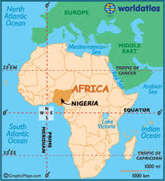
Nigeria
Location & climate – W. Africa, close to equator, long dry season inland (north), hot humid climate on coast (south)
Importance – fast growing economy, one of richest countries in Africa, 12th largest global oil producer
Context (political, social, cultural and environmental):
Political: gained independence from UK in 1960; civil wars followed; first free & fair elections held in 2011 & 2015
Social: contains a mixture of ethnic tribal groups and religions; tensions sometimes rise because of this, e.g. Boko Haram; wealth is much greater in urban than rural areas
Cultural: rich and varied culture with ‘Nollywood’ cinema and sporting events such as the African Cup of Nations
Environmental: dry Sahara to the north; tropical rainforest and mangroves to the south
Changing industrial structure – used to rely on agriculture & fishing (primary industry); now balances agriculture with industry and services; investment of oil has helped to make this change
TNCs – Trans National Corporations; large companies that operate in several countries
Shell – large oil company; heavily invested in oil in the Niger delta; has helped Nigeria make the most of its natural resources
Advantages of Shell – helps Nigeria to make money via taxes and selling oil; makes jobs for 65,000 workers; gives contracts to Nigerian companies; trains workers to make them skilled employers; builds schools and hospitals to help look after people
Disadvantages of Shell – oil spills have caused water pollution & soil degradation reducing the ability to farm; oil flaring sends toxic fumes into the air; militant groups cause disruption; oil theft and sabotage cost lots of money
Changes in trading relationships – Nigeria exports (sells) oil, gas, rubber, cocoa and cotton; it imports cars, telephones, rice and wheat; it mainly exported oil to the USA but India is now its main customer
Environmental impacts – industry has created water pollution, air pollution, problems of waste and litter, oil spills, and the development of squatter settlements
Aid/help for Nigeria – receives money from The World Bank, charities (UNICEF), and countries, e.g. UK and USA; this is spent on health programmes, mosquito nets (Nets for Life), and supporting businesses; corruption can stop money getting to where it needs to be
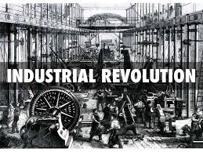
Changes to quality of life – some improvements including job security, access to healthcare, training, electricity supply etc.; but not everyone has benefitted and there are still a lot of poor people
The UK
Changing industrial structure – industrial revolution in the 1800s caused a shift from manual labour (primary) to machinery/factory jobs (secondary); people moved from rural areas to urban areas
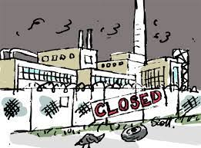
De-industrialisation – a decline in manufacturing (secondary) industry; caused by machinery taking the jobs of people, cheaper labour abroad, and the cost of machinery here being too high
Globalisation – helped the development of tertiary and quaternary industries, e.g. retail (shops), technology, research
Influence of government policies
1945-1979: focus on state-run industries, e.g. British Rail and British Steel Corporation
1979-2010: focus on privatisation (selling off state-run industries)
2010 onwards: balanced approach; focus on transport (e.g. CrossRail & HS2) and more investment in manufacturing

The UK’s post-industrial economy – developments have happened in the following ways:
Development of IT – highly developed technology, fast internet access, new businesses in manufacturing and designing software
Service industries and finance – increasing jobs in healthcare, education, engineering, banking, insurance & security
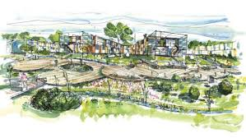
Research – universities, the NHS, Environment Agency, the BBC
Science parks – group of science & technology-based businesses located on a single site; close to universities; attractive locations; good transport links
Business parks – area of land occupied by a cluster of businesses; usually found on cheaper land on the edge of town; close to transport links; businesses benefit by being close to one another
Impacts of industry on the environment
Impacts – risk of water and air pollution; waste products go to landfill; noise pollution from industry
Sustainable modern development, e.g. Sheffield – used to be polluted from the steel industry; clean up works have enabled wildlife such as otters to return to the rivers in the city centre; factories can be fined for polluting or made to clean emissions before released to the atmosphere

Changes to UK rural landscapes
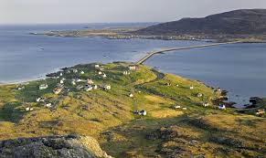
Rural growth, e.g. Cambridge; GOOD – brings in workers and helps to keep rural areas going;
BAD – pushes house prices up and increases traffic on the roads
Rural decline, e.g. Outer Hebrides; GOOD – less people to pay to support in a remote area and fishing & tourism have increased; BAD – governments have to pay a lot to keep a small area going, younger people keep moving away which makes it hard to keep farming & fishing industries alive

Improvements in transport
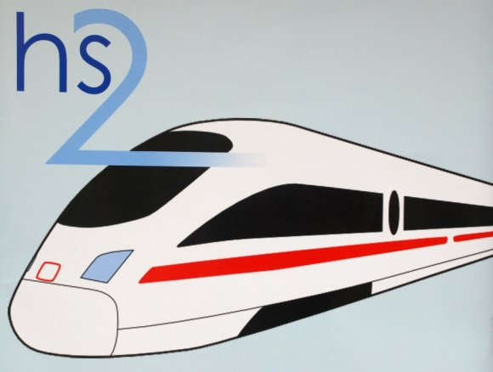
Road – 2014 Road Investment Strategy (£15 billion); 100 new roads by 2020; A303 ‘Super Highway’ linking London to the south-west; roads from this will link to other cities/towns, e.g. Portsmouth and Southampton
Rail – HS2 (high speed railway) linking north to the south; Crossrail linking east to west London
Ports – Liverpool2 (new container terminal) to increase capacity & help it compete with other ports
Airports – expand Heathrow (new runway) to bring goods & people in; controversial due to noise

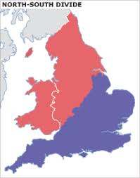
The North-South divide
The divide – north has lower population, more upland land, lower house prices, more jobs in primary & secondary industry; south has higher population, lowland, high house prices, & tertiary/quaternary sectors
Strategies to reduce the divide – financial investment (e.g. car factories such as Nissan and Mitsubishi); transport improvements (HS2, Liverpool2); Local Enterprise Partnerships (help local businesses); Enterprise Zones (help businesses set up with fast broadband and financial allowances)

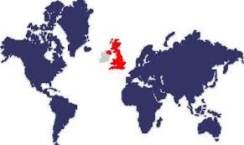
The UK in the wider world
Links – trade (of goods); culture (BBC, Notting Hill Carnival); transport (Heathrow, Channel Tunnel); electronic communication (trans-Atlantic high power cables; project Arctic Fibre)
Commonwealth – group of 53 countries working for human rights, social/economic development
The EU – trading group of 28 countries; enabled goods to move freely between countries and supported weaker countries; UK is now leaving so its links with EU countries is uncertain

