Paper 1 – The Living World – ecosystems, tropical rainforests, and cold environments
AT A GLANCE – AQA TOPIC SUMMARIES

Ecosystems
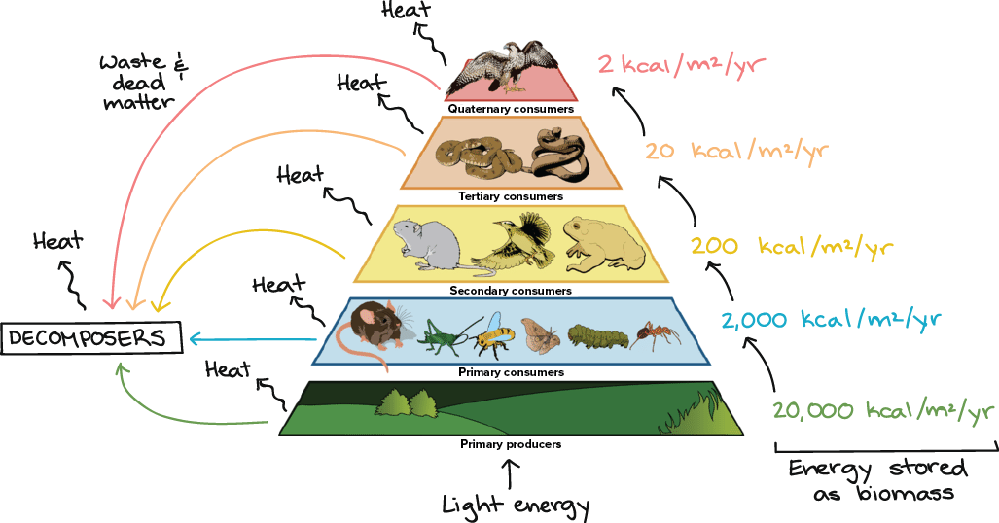
Ecosystems
Ecosystem – a system that contains biotic (living, e.g. wildlife) and abiotic (non-living, e.g. water and soil) things
Producers – e.g. plants, found at the bottom of a food chain or ecosystem and normally photosynthesise to create energy
Consumers – eat other plants/animals (insects, birds, mammals)
Decomposers – break down dead and decaying matter (bacteria, fungi)
Food chain/web – diagram that shows the connections between plants/animals
Nutrient cycling – the way nutrients move from the soil, to plants, to animals, and then back to the soil again
Trophic levels – levels at which energy (from the sun) is held in plants/animals

Biomes
Biome – a large-scale ecosystem that covers countries or continents
Tropical rainforest – on the equator; hot and humid all year round; lots of dense vegetation growing
Grassland (savannah) – between the tropics; dry & rainy seasons; no trees, just grasses
Hot desert – just north/south of the equator; very hot with little rainfall, cold at night; cacti and basic shrubs grow
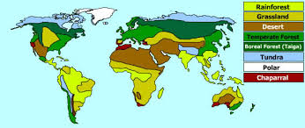
Deciduous forest – mid latitudes; four seasons (warm summers, cool winters); trees lose leaves in winter; grow back in summer
Tundra – high latitudes (close to poles); cold winters & brief summers; permafrost; shrubs are slow growing & low-lying
Polar – at north/south poles; very cold, icy and dry; not much grows at all; growing season is two months long

Tropical rainforests
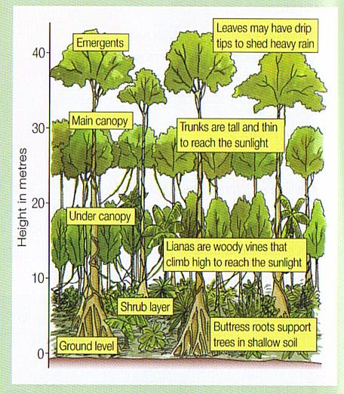
Location – on and around the equator, e.g. Amazon (South America) & Congo (Africa)
Climate – warm (20ºC – 28ºC); high rainfall (around 2000mm a year); rainfall is convectional and with daily thunderstorms
Soil – few nutrients; trees quickly take up nutrients; nutrients washed out by heavy rain
Layers – forest floor (at the bottom); shrub layer (lowest level vegetation, very dark); under canopy (vines and lianas grow); canopy (more sunlight, most leaves and animals live here); emergent layer (tallest trees – 50m high]
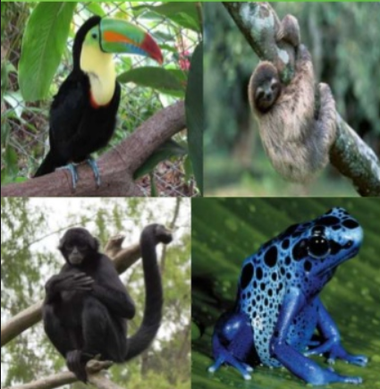
Plant adaptations – evergreen (don’t drop leaves at a particular time); buttress roots (to keep tall trees stable and collect nutrients from shallow soil); drip tips (channel heavy rainfall off leaves); large leaves (trap sunlight); tall, thin trunks with no lower branches (race to the top to trap sunlight, no wasted energy on branches lower down)
Animal adaptations – camouflage, e.g. chameleons (hide from predators/prey); strong beaks, e.g. parrots (to break into nuts and seeds); prehensile tails, e.g. spider monkeys (to grip onto branches in the canopy); amphibious, e.g. frogs & crocodiles (able to exist in water and on land); nocturnal, e.g. bats (use echolocation to find prey in dark)
Interdependence – all parts of a rainforest are connected; warm climate helps fast growth; fast growth means plants provide food for animals; warmth means fast decomposition, releasing nutrients for quick uptake; high rainfall provides water for growth; trees are water stores and CO₂ stores; deforestation upsets this balance & releases too much water and CO₂
Biodiversity – the variety of plants & animals living in a rainforest; Deforestation – the removal of trees
Causes of deforestation – increasing populations (land needed for housing); mining (gold, iron ore); energy (HEP dams on the large rivers); logging (wood, e.g. mahogany, or rosewood, for fuel or furniture); farming (cattle or soya)
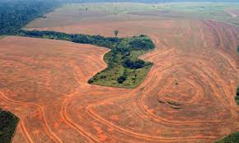
Environmental impacts – loss of species, possible extinctions, soil exposed and washed away, nutrients lost from soil leaching, increased CO₂ into the atmosphere (global warming)
Social impacts– people get jobs in new industries and have a better life than in the city; BUT native tribes may be moved off their own land, or may catch diseases from outsiders
Economic impacts – workers make lots of money from jobs, less money spent on energy as HEP used instead; BUT setting up new industries and HEP stations may cost a lot
Value of the rainforest – goods (paper, wood, cocoa, coffee, medicines, palm oil); services (cleans the atmosphere, stores CO_{2,} habitats for animals, biodiversity)
Sustainable management – using a rainforest in a way that allows us to take some things from it, but without destroying the rainforest as a whole, e.g. ecotourism
Ways of managing the rainforest – selective logging (only some trees removed to maintain forest structure); replanting trees (plant same variety of tree species to maintain variety and trap CO₂); ecotourism (allow tourists to visit but in a controlled way that limits damage and involves local people); International Hardwood Agreements (agreements to not cut down certain trees, e.g. mahogany and teak, e.g. Forest Stewardship Council); education (teach local people about the long-term impacts of deforestation, help them find other ways of making a living); reducing debt (cancel debt so that LICs don’t cut down trees to make money to pay back loans and the interest owed); conservation (set up national parks and reserves that restrict damaging activities, e.g. the Amazon Fund)
The Amazon Rainforest, Brazil
Location – South America; covering 8 million km² including parts of Brazil, Peru & Ecuador
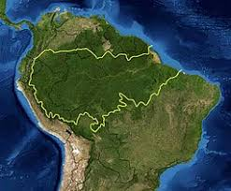
Rate of deforestation – since 1978, over 750,000km² has been cut down
Causes of deforestation – cattle ranching, farming, both subsistence (local scale) & commercial (large scale), logging, mining, road building, energy (HEP), new settlements; increasing pressure from Brazil’s growing population as it becomes an NEE/HIC
Impacts of deforestation – environmental (release of CO₂, climate change, soil erosion, reduced soil quality) & economic (increased wealth, mining jobs, BUT people, e.g. rubber tappers, lose jobs)

Cold environments
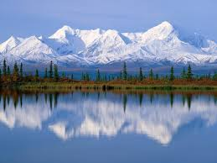
Location – high latitudes; near the north/south poles
Climate – polar (freezing temperatures from 0ºC down to -80ºC); tundra (cold temperatures from 10ºC down to -50ºC); both have very low rainfall (between 100m – 380mm a year)
Soil – very thin with hardly any nutrients; mainly covered by ice; permafrost (where ground is permanently frozen)
Plant adaptations – e.g. mosses, lichens, grasses; periods of being dormant (slow growing) to survive cold, dark winters; small, rounded and low to ground to have protection from wind; shallow roots that can’t go down into the permafrost; small leaves to limit transpiration
Animal adaptations – insulation, e.g. seals (to keep warm); hibernation, e.g. ground squirrels (to conserve energy & survive when there’s low food supply); specialised eating, e.g. reindeer (eat lichens in winter); migration, e.g. Arctic terns (fly to warmer areas during winter); camouflage, e.g. penguins (black & white to hide from predators/prey)
Interdependence – cold climate causes slow growth & slow decomposition; soil is low in nutrients further slowing down growth; herbivores migrate to find lichens & mosses to eat; carnivores follow them to hunt them as prey; climate change causes melting of permafrost which affects speed of plant growth – can change the whole balance
Biodiversity – low biodiversity; a change to one species in the food web can affect lots of other species in the food web; global warming is causing rapid climate change that plants cannot adapt to
Value of cold environments – they are unique wilderness environments; they provide valuable habitats for wildlife; they are places for scientific study; offer a useful comparison with managed areas; last remaining unaltered places
Ways of managing cold environments – technology (raise buildings or pipes above melting permafrost so they are not damaged, store servers in cold countries to reduce need for air conditioning); conservation (World Wildlife Fund or Greenpeace pressure governments to protect cold environments); international agreements (e.g. 1959 Antarctic Treaty limits visitor numbers to minimise damage, encourages scientific research, and bans all military and nuclear activities); role of governments (policies, e.g. 1964 Wilderness Act which protects large areas of wilderness in Alaska)

Alaska, USA
Location – north-west USA; west of Canada
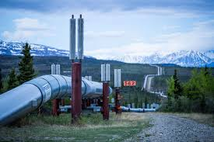
Opportunities for development – oil and gas (50% of Alaska’s income is from oil fields around Prudhoe Bay; the Trans-Alaskan oil pipeline links oil fields to ports where it can be shipped abroad); minerals (gold, silver, iron ore, copper; contributed $2.2bn to Alaska’s GDP in 2013); fishing (salmon & crab; employs 79,000 people & contributes $5bn to economy); tourism (2 million tourists attracted by wildness, beautiful scenery; brings in money & jobs)
Challenges of development – cold temperatures (difficult to move around & transport goods, mostly dark & long days); inaccessibility (far from the US, few roads, may be iced over, small populations); buildings & infrastructure (foundations built into permafrost which may melt, construction only happens in summer in short days, difficult to get all materials to remote locations)

