Paper 2 – Urban Issues and Challenges – urbanisation in Mumbai and Sheffield
AT A GLANCE – AQA TOPIC SUMMARIES

Urbanisation
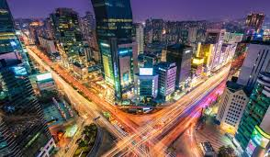
Urbanisation – the % increase in the number of people living in urban areas
Rate of urbanisation in HICs – slower; urbanisation happened during the industrial revolution; many people now move from urban to rural areas in search of a quieter life and there are better communication and transport links
Rate of urbanisation in LICs – faster; more happening now as poor countries rapidly develop; often people arrive and live in the edges of cities in slums, looking for working in the informal sector (unofficial jobs)
Rural-urban migration – movement of people from countryside (poor farming communities) to cities
Push factors – lack of jobs, healthcare and education; natural disasters, e.g. droughts and floods; crop failures
Pull factors – more jobs, healthcare and education; better pay and working conditions; family links
Megacities – a city with over 10 million residents, e.g. Mumbai

LIC city case study: Mumbai, India
Location – west coast of India; on Tropic of Cancer; bordering Arabian Sea & Indian Ocean; Himalayas to the north
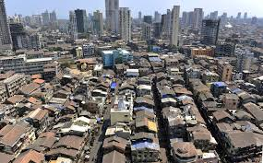
Importance – contributes to 4% of the country’s GDP; home to Bollywood and India’s largest financial centre

Causes of growth – migrants from poor farming areas; people seeking better quality of life, housing and jobs
Social opportunities – easier access to education & schools, healthcare, better range of housing
Economic opportunities – jobs in textiles, technology, call centres, online banking, software development; wages are higher and working conditions better than the countryside; Mumbai is a transport hub with the new airport creating opportunities for work and business
Social challenges – people live in slums which are crowded, unsafe, diseased (cholera & typhoid), toilets are shared between hundreds of people
Economic challenges – jobs are in the informal sector which means they are unskilled, uncontrolled, pay and conditions are not monitored, people have to find work however they can, e.g. scavenging in rubbish dumps, or turn to crime & prostitution

Managing the challenges
Slums – Independent Townships and Vision Mumbai (new housing areas for slum residents to be relocated into; provides cleaner, safer housing in a more spacious area)
Water and energy – rainwater harvesting (enables homes to collect their own water & purify it for use); the Mumbai electrification project (bring safe, legal electricity to all the homes and slums in Mumbai so that people don’t have to steal it or use dirty, unsafe fuels such as kerosene)
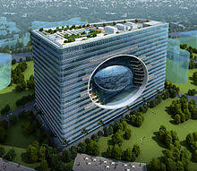
Health and education – The Slum Sanitation Project (bring safe, clean water and proper sewage pipes to people’s homes so that they don’t drink dirty water and become ill); Vision Mumbai - build new, accessible schools for children to attend to get qualifications
Unemployment and crime – Expansion of Bandra Kurla (a new commercial complex with plenty of job opportunities and secure wages for people to work)
Environmental issues – Urban Transport Project (build faster, safer transport links so people can move more efficiently around the city and not get caught in prolonged traffic jams)
Urban planning – Vision Mumbai
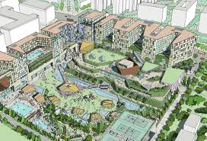
A plan to develop Mumbai into a more modern city; developers will buy the land and build high rise block for poor slum dwellers as well as new shopping malls, offices and apartment; it has a number of targets which include increasing housing availability, improving transport and infrastructure, and upgrading healthcare and education facilities
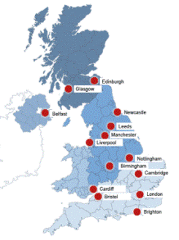

HIC case study: Sheffield, UK
Location – South Yorkshire
Importance (history) – booming cutlery trade in 16th and 17th centuries; in 1740 the
method for making crucible steel was invented and made Sheffield the centre for
steel making; steel industry declined due to the increase in use of machinery and the
importing of cheaper steel from abroad; areas such as Kelham Island were left to waste

Impact of migration – people have migrated from all over the world in search of work,
education, jobs in the cotton industry, and the need to get away from war and conflict;
this has led to areas of the city such as Burngreave becoming centres for migrants, who live together out of a shared need for cheaper housing, familiar culture, particular food shops and religious buildings, and a wish to be close to work in the city centre
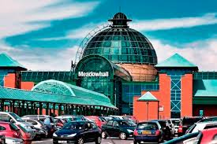
Opportunities of urban change
Social & economic opportunities – cultural mixing (twinning schools together to improve cultural understanding at an early age, having community centres that give migrants language skills to help them integrate, Abbeyfield Park Multicultural Festival celebrates different cultures); recreation and entertainment (Meadowhall, Sheffield Arena, the EIS, entertainment); employment (development of Fargate and the Moor in town which has brought new businesses and shoppers in); integrated transport systems (Park and Ride, the trams, buses and railways)
Environmental opportunities – urban greening (preserving green spaces around the city, e.g. the Winter Gardens, Weston Park, the Botanical Gardens)

Challenges of urban change
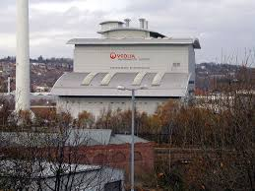
Social & economic challenges – urban deprivation and inequalities in housing, education, health and employment (some areas of the city are more developed than others; this is due to the impacts of deindustrialisation, the influx of migrants, and the lack of redevelopment and regeneration in some areas – see your fieldwork notes for more detail)
Environmental challenges – dereliction (some areas become abandoned and rundown if not developed; this increases crime and antisocial behaviour in these areas); brownfield sites (sites that have been previously built on, they are good to reuse but can be costly to clean up and rebuild on); greenfield sites (new sites, they are easier and cheaper to build on but destroy green space and bring pollution); waste disposal (cities create vast amount of rubbish unless recycled or sent to the waste recovery facility, it will go to landfill)
Urban sprawl and commuter settlements - (urban sprawl is the movement of people out of the city centre to live in towns, or commuter settlements, on the edges; this is more desirable as it is quieter and greener and people can drive their cars in to the city to work, but it brings pollution, noise, and a loss of a sense of community to residents already living there)

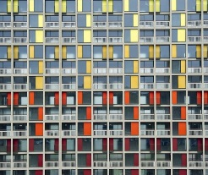
Urban regeneration – Parkhill Flats, Sheffield
Reasons needed – the flats were a pioneering housing project in the 1960s; they houses many families cheaply and had a good sense of community; over time, the flats were slowly abandoned by residents and attracted crime and antisocial behaviour; people thought they were an eyesore on the city skyline
Features – the flats were regenerated by Urban Splash beginning in 2007; they were given bigger windows, better insulation, new coasts of paint, and more space given to shops and workspaces; this would hopefully encourage more people to live and work there

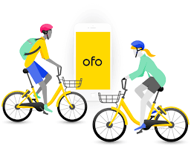
Ideas for sustainable urban living
Water & energy – invest in renewable energy, rainwater harvesting, energy efficient appliances
Waste – encourage recycling to ensure that less waste goes to landfill
Green space – plant trees to recycle the air or build cycle paths to encourage less vehicle usage
Transport – Congestion Charge in London (charge a fee to enter certain parts of the city at particular times); Santander Bike Hire Scheme or Ofo bikes (make it easy for people to hire a bike for free to cycle round the city)

