|  |  |  |  |
| --- | --- | --- | --- |
| Weather Resistance | **1** | **The Purpose of Weather Resistance** | |
| Keeping occupants in an acceptable environment | |
| Ensuring thermal comfort of occupants | |
| Humidity levels | |
| Preventing damage to finishes and water staining | |
| **Types and selection of waterproof and impervious materials, including** | | |
| 2 | Double Glazing | Windows which have two layers of glass with a space between them, designed to reduce loss of heat and exclude noise. |
| 3 | Use of falls | Angle the roof/drain so water can fall |
| 4 | Weather seals and sealants | Sealing doors and windows |
| 5 | Flashings | A strip of metal used to stop water penetrating the junction of a roof with another surface |
| 6 | Soffits | The underside of an architectural structure such as an arch, a balcony, or overhanging eaves. |
| The location of weather-resistant materials | | |
| 7 | Guttering, window and door openings, external walls, ventilation ducts, roof finishes and overhanging eves | |

|  |  |  |  |
| --- | --- | --- | --- |
| Fire resistance | **Fire resistance materials including** | | |
| 8 | Plasterboard | board made of plaster set between two sheets of paper, used especially to form or line the inner walls of houses. |
| 9 | Concrete | a building material made from a mixture of broken stone or gravel, sand, cement, and water, which can be spread or poured into moulds and forms a mass resembling stone on hardening. |
| 10 | Blockwork | Blocks of concrete, cement, or similar material in a wall or other structure. |
| 11 | Intumescent paint | a coating that reacts to heat by swelling in a controlled manner to many times its original thickness, producing a carbonaceous char formed by a large number of small bubbles that act as an insulating layer to protect the substrate. |
| **Fire-resistance techniques:** | | |
| 12 | Fire compartments and fire barriers )walls, separating floors, door closes, fire resistant doors |  |
| 13 | Fire escapes | a staircase or other apparatus used for escaping from a building on fire. |
| 14 | Refuge areas | a location in a building designed to hold occupants during a fire or other emergency, when evacuation may not be safe or possible. Occupants can wait there until rescued |
| 15 | Cavity fire barriers | In a concealed, hollow construction, a material or member which fills or seals the open construction to prevent or retard the spread of fire. |
| 16 | Fire alarm systems, smoke detections and sprinkler system |  |

|  |  |  |
| --- | --- | --- |
| Sustainability | The purpose of sustainability | |
| 17 | Reduction in building energy use |
| Conserving finite resources |
| Reducing CO2 emissions to the atmosphere |
| Reducing pollution and wastage |
| Methods of ensuring sustainability: | |
| 18 | ●orientating buildings for light and heat in the UK  ●reducing the use of greenfield sites and improving the re-use of brownfield sites  ●recycling waste materials into new products  ●using low embodied energy materials and green renewable natural materials  ●using local suppliers  ●utilising prefabrication of elements and reducing wastage of construction materials. |
| Materials | |
| 19 | ●hemp, lime (as rendering finishes)  ●sheep’s wool (as insulation)  ●straw (for the construction of walls)  ●timber (such as cedar cladding or softwoods in timber framing)  ●aluminium (as guttering and downpipes) |

|  |  |  |
| --- | --- | --- |
|  | **Strength and stability** There are three types of load acting on a building | |
| Name | Description | Example |
| 23 | Impact/live load | This is when something hits a building or falls on it | Rain, wind and snow |
| 24 | Dead load | These are loads that do not move such as the weight of the building itself | Walls, floors, windows and roofs |
| 25 | Dynamic load | These are the loads that can change during the use of a building | Weight of people and furniture |

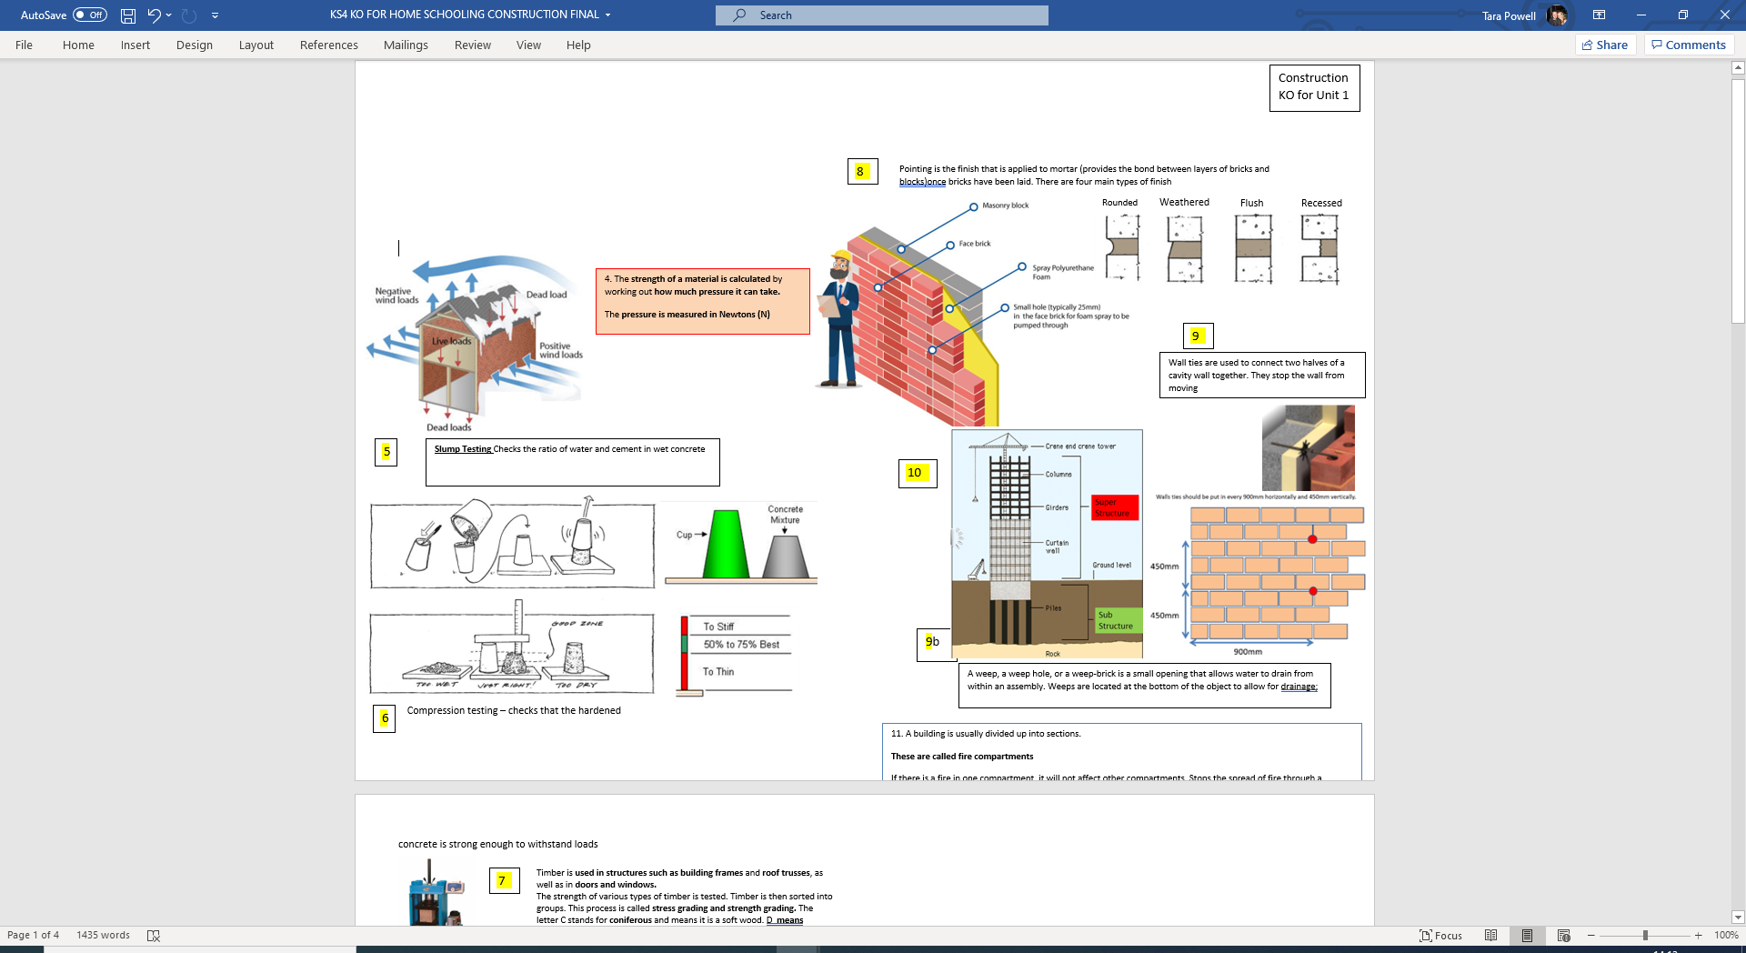

**Topic A.1 Construction knowledge organiser Performance Requirements**

20. Pointing is the finish that is applied to mortar (provides the bond between layers of bricks and blocks) once bricks have been laid. There are four main types of finish

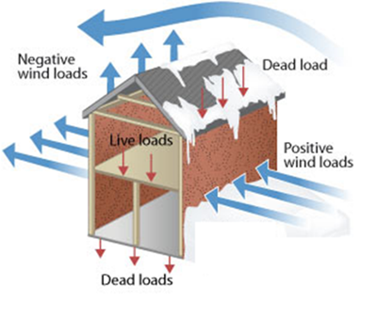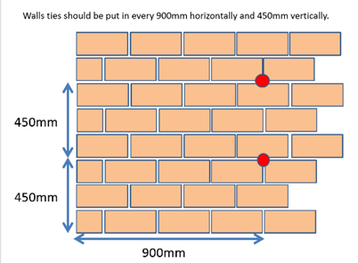

22. A weep, a weep hole, or a weep-brick is a small opening that allows water to drain from within an assembly. Weeps are located at the bottom of the object to allow for drainage;

21. Wall ties are used to connect two halves of a cavity wall together. They stop the wall from moving

27 A building is usually divided up into sections.

**These are called fire compartments**

If there is a fire in one compartment, it will not affect other compartments. Stops the spread of fire through a building.

**Fire barriers include:** Sprinklers ,Fire walls, Fire resistant doors – made from steel

Door closures, Separate floors made out of concrete

26 The **strength of a material is calculated** by working out **how much pressure it can take.**

The **pressure is measured in Newtons (N)**

|  |  |  |  |
| --- | --- | --- | --- |
| Thermal  Insulation | **28** | **The purpose of insulation** | |
| reduction of heat loss from a building | |
| reduction of energy use and costs | |
| prevention of the loss of heated air through gaps within a building or structure and providing an acceptable U-value in accordance with regulations | |
| **Types of insulation** | | |
| 29 | Sheep’s wool | Made from sheep wool fibres that are either mechanically held together or bonded using recycled polyester adhesive to form insulating batts, rolls and ropes. Natural wool insulation is effective for both thermal and acoustic insulation |
| 30 | mineral wool | Mineral wool is any fibrous material formed by spinning or drawing molten mineral or rock materials such as slag and ceramics. |
| 31 | glass fibre | A strong plastic, textile, or other material containing embedded glass filaments for reinforcement. |
| 32 | cellulose | An insoluble substance which is the main constituent of plant cell walls and of vegetable fibres such as cotton |
| 33 | foam | Spray foam insulation can be blown into walls, onto concrete slabs, on attic surfaces, or under floors to insulate and reduce air leakage. |
| Types of thermally resistant materials | | |
| 34 | aerated lightweight concrete blocks | An innovative type of concrete containing around 80 percent air. These special concrete blocks have several advantages: They're strong, light and provide better sound and thermal insulation than conventional blocks. |
| 35 | Timber | Wood prepared for use in building and carpentry. |
| 36 | Light weight screeds | A pre-blended, dry bagged lightweight screed for weight reduction and thermal insulation on floors and roofs. |
| Location of insulation including; | | |
| 37 | cavity insulation | used to reduce heat loss through a cavity wall by filling the air space with material that inhibits heat transfer. This immobilises the air within the cavity (air is still the actual insulator), preventing convection, and can substantially reduce space heating costs. |
| 38 | wall insulation | Involves fixing a layer of insulation material to the wall, then covering it with a special type of render (plasterwork) or cladding. |
| 39 | roofing insulation | A board-type product, usually of low or medium density, made of mineral fibres, cellular glass, foamed plastic, lightweight concrete, wood fibreboard,, one or both sides of which may be faced with another material; provides thermal insulation in a roofing system. |
| 40 | flooring insulation | Carpet, rugs and laminate flooring can all act as insulation |
| 41 | double glazing | Windows which have two layers of glass with a space between them, designed to reduce loss of heat and exclude noise. |
| 42 | draught strips | a narrow piece, comparatively long and usually of uniform width: a strip of cloth, metal, land, |

|  |  |  |  |
| --- | --- | --- | --- |
| **43** | | **The purpose of sound insulation** | |
| * Resisting the passage of sound through a structure | | | |
| * preventing nuisance and noise | | | |
| * reducing external infrastructure noise | | | |
| * reducing aircraft noise | | | |
| **Types of sound insulation which can be located in floors, walls, ceilings between adjacent rooms and flats/party walls** | | | |
| 44 | Triple glazing | | Made up of three panes of glass instead of one or two. The cavity between each pane of glass is usually filled with an inert gas – such as argon, xenon or krypton. |
| 45 | Heavy-density block work | | Consists of cement, sand and various aggregates, such as barite, magnetite, iron or lead pellets |
| 46 | Sound insulation quilt | | To achieve a high level of noise insulation, create a timber or metal stud wall and fill between the studs with a mineral wool such as Superglass or Rockwool quilt |
| 47 | Plaster board layers | | Consists of layers of paper that has been bonded to gypsum plastered core and is used mainly in the construction of wall |
| 48 | Flooring mats and carpeting | | There thickness and weave acts as insulation – absorbing the sound |
| 49 | Acoustic ceilings | | Tend to be made from fibrous materials that absorb sound energy, unlike plaster and gypsum ceilings. They do not necessarily reduce the transmission of sound between spaces, rather they reduce the amount that reflects back into the space and so can be used to tailor the acoustic character of a space. |

|  |  |  |
| --- | --- | --- |
| Sustainability | The purpose of sustainability | |
| 50 | Reduction in building energy use |
| Conserving finite resources |
| Reducing carbon emissions to the atmosphere |
| Reducing pollution and wastage |
| Methods of ensuring sustainability: | |
| 51 | ●orientating buildings for light and heat in the UK  ●reducing the use of greenfield sites and improving the re-use of brownfield sites  ●recycling waste materials into new products  ●using low embodied energy materials and green renewable natural materials  ●using local suppliers  ●utilising prefabrication of elements and reducing wastage of construction materials. |
| Materials | |
| 52 | ●hemp, lime (as rendering finishes)  ●sheep’s wool (as insulation)  ●straw (for the construction of walls)  ●timber (such as cedar cladding or softwoods in timber framing)  ●aluminium (as guttering and downpipes) |

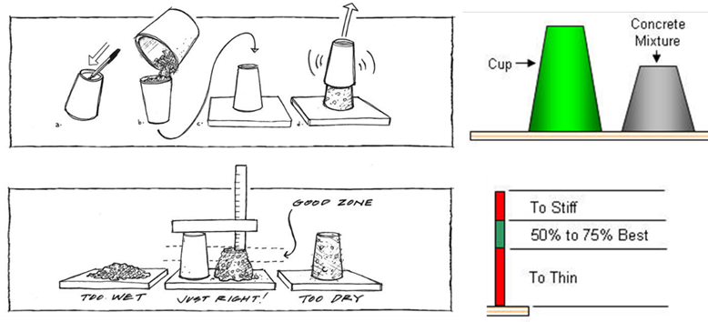

**53 Slump Testing** Checks the ratio of water and cement in wet concrete

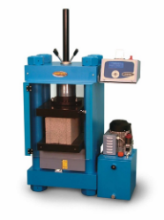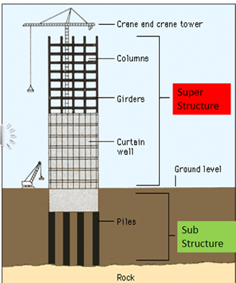

55

56. Timber is used in structures such as building frames and roof trusses, as well as in doors and windows. The strength of various types of timber is tested. Timber is then sorted into groups. This process is called stress grading and strength grading. The letter C stands for coniferous and means it is a soft wood. D means deciduous or the wood is hard. A C25 timber is a softwood with a strength of 25 Newtons. A D30 timber is a hardwood with a strength of 30 Newtons.

54.Compression testing – checks that the hardened concrete is strong enough to withstand loads

|  |  |
| --- | --- |
| **Cross-wall construction** | |
|  | The front and back of the building is constructed as non-loadbearing |
|  | While load bearing walls are at right angles to these walls |
|  | This lead to the name cross wall |
|  | The floor between these cross-walls is connected to all four wall and provides lateral restraint |
|  | There can be problems where the non-loadbearing claddings and the cross walls meet, as these junctions might not be weatherproof |

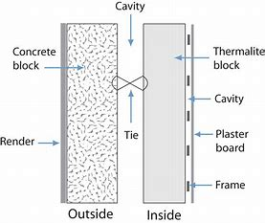

**Topic A.2** **Construction knowledge organiser – Common structural forms for low-rise construction**

**Topic A.2 Construction knowledge organiser**

Cross wall section

|  |  |  |
| --- | --- | --- |
| **Key Words** | | |
|  | **SIPS** | Structurally Insulated Panels – insulated timber panels that are strong enough to take loads |
|  | **Timber-framed construction** | Frame made of softwood and faced (or covered with plywood. Commonly used in houses. |
|  | **Lateral restraint** | When movement of building elements is stopped sideways. |
|  | **Box frame construction** | If both walls and floors are made using reinforced concrete, series of ‘boxes’ are formed. |
|  | **Load bearing** | (especially of a wall) supporting much of the weight of the overlying parts of a building or other structure. |
|  | **Claddings** | A covering or coating on a structure |
|  | **Render** | A type of plaster finish used on external as well as internal walls. It can improve a building’s insulation, |
|  | **Pointing** | Filling the joints in brickwork with mortar to improve appearance and weather proofing |
|  | **Aesthetics** | The appreciation of beauty or the appearance of something |
|  | **Shingles** | A roofing material, generally made of cedar wood |
|  | **uPVC cladding** | A covering made of unplasticised polyvinyl chloride |

|  |  |  |  |
| --- | --- | --- | --- |
| **The most common parts of timber-framed buildings and their functions are:** | | | |
|  | **Damp-proof course** |  | Moisture can penetrate the building from the foundations or under the floor A dpc stops moisture coming in from the foundations. |
|  | **Finishes** |  | Timber-framed buildings can even be given the look of a traditional building with a brickwork finish. These finishes are attached to the timber frame using flexible wall ties. |
|  | **Insulation** |  | Is provided between the timber studs – tied so there is no gaps. |
|  | **Lintels** |  | A small beam above where openings are provided for window and doors. Directs rainwater away and add strength. |
|  | **Studs** |  | The timber frame is made of a number of upright timbers called studs. |
|  | **Moisture resistance** |  | A polythene sheet, called a vapour check, is built in between the internal wall and the insulation to stop moisture penetration. |
|  | **Plywood sheets** |  | These are attached to the external walls to provide bracing |

|  |  |
| --- | --- |
| **Structurally insulated panels** | |
|  | They have a central layer of insulation, with plywood face on each side. |
|  | SIPS construction is similar to timber framed construction, but is faster and large panels can be made to speed up the process. |
|  | The method provides a light frame, is thermally efficient and helps to reduce site waste. |
|  | Because the panels are wooden, fire resistance could be an issue. |
|  | Finishes can be applied directly to the panels. |
|  | These include exterior brickwork, blockwork, tiling and rendered finishes as well as more suitable finishes such as timber cladding and hemp rendering |

|  |  |
| --- | --- |
| **Timber-framed construction** | |
|  | Commonly used in houses. |
|  | The frames are made of softwood and face (or covered) with plywood. |
|  | Loadbearing timber walls are made up of small timbers called studs |
|  | Short timber pieces called noggins are placed between them to give stability. |

|  |  |
| --- | --- |
| **Traditional cavity wall construction** | |
|  | In a traditional cavity wall construction. |
|  | the walls and foundations are usually the loadbearing elements of the construction. |
|  | the external walls are normally constructed as cavity walls while internal walls are solid or partition walls. |
|  | the external cavity walls have an outer skin of brickwork and an inner skin of block work. |
|  | the outer skin can also be rendered to provide extra insulation. |

|  |  |  |
| --- | --- | --- |
| **Key Words** | | |
|  | **Preconstruction** | The various activities that must be done before work can begin on site |
|  | **Sub-structure groundworks** | These works are activities that need to be completed below the ground e.g. adding a gas pipe |
|  | **Hazard** | Is something that has the potential to cause harm, such as the collapse of the sides of excavation |
|  | **Risk** | IS the results of any accident or event that happened because of the hazard, such as a broken arm resulting from the collapse of the excavation |
|  | **Foundations** | Usually poured concrete that provides stability by spreading the building load over a large area |
|  | **Musculoskeletal** | To do with the human frame and muscles that function to give movement |

|  |  |  |  |  |  |
| --- | --- | --- | --- | --- | --- |
| Hazards associated with groundworks | | | | | |
|  | **Hazard** |  | **Risk** |  | **Control measure** |
|  | **Gas** |  | Injury or death |  | Avoiding services such as the gas mains |
|  | **Collapse of the sides of the excavation (could be due to soil type)** |  | Injury or death |  | Trench support such as timbering is provided to hold back the sides of the excavation  Physical barriers can be put in place to stop machinery or people putting pressure on weak ground near the edge of the excavation  A different method could be used, such as trench fill foundation, which lets foundations be excavated and poured immediately, giving the soil no time to loosen. |
|  | **Presence of ground water** |  | Flooding or drowning |  | Pumping out excess water |
|  | **Confined space** |  | Crushing or musculoskeletal injuries |  | Using appropriate PPE and reducing the amount of work done in confined spaces |
|  | **Existing services such as gas mains, water pipes, or electricity cables** |  | Injury, flooding, death or power outages |  | Locate and protect all existing services before work begins |
|  | **Proximity of excavation plant** |  | Injury or death |  | Barriers stop moving machinery from going too close to excavation |

**Topic B.1/B.2 Construction knowledge organiser – Pre-construction and ground works**

|  |  |
| --- | --- |
|  | **Desk based pre-construction - before work start on site, a range of activities need to be carried out** |
|  | Legal requirements e.g. health and safety plan, method statements and risk assessment. |
|  | A scaled site layout plan is prepared. This needs to show site accommodation such as site offices and material storage and toilets for staff |
|  | A document showing the programme of work – also helps to plan delivery of resources and materials |
|  | Resources and materials are brought |
|  | Safety signs are set out and statutory notices are organised |
|  | Road crossings for plant and deliveries and traffic management are planned |

|  |  |
| --- | --- |
| **Pre-construction work on the site** | |
|  | First, the site is cleared of vegetation and trees. |
|  | Any existing structures are knocked down. |
|  | Then any existing services (water, gas, electricity) are protected from damage by the building work |
|  | Next, access and egress (exit) routes into and out of the site are constructed |
|  | Finally, the site is set up, providing site accommodation and temporary services including temporary lighting and roads. |
|  | Security arrangements are also installed at this point, including fences and gates |

|  |  |
| --- | --- |
| **Earthwork support** | |
|  | This is the support of the sides of excavation. |
|  | There are different methods earthwork support depending on the needs of the site and the type of the soil including: |
|  | Steel trench sheets |
|  | Timbering |
|  | Hydraulic trench supports |
|  | Aluminium walling |

|  |  |
| --- | --- |
| **Control of water** | |
|  | Sub-soil water is the water present below ground (ground water) |
|  | By law the sub-soil water must not be allowed to enter the building and damage it. |
|  | Sub-soil water and surface water might just need to be controlled temporarily during excavation. This is called simple sump pumping, because the water collects in a pool and is then pumped out. |
|  | Some sites night need permanent control of sub-soil water. This is known as land drainage. |

|  |  |
| --- | --- |
| **Foundations** | |
|  | A foundation is designed and constructed to safely transmit the loads of the building to the ground or sub-soil. |
|  | They should be able to support the loads of the building for its lifespan |
|  | The kind of foundation used depends on the load, type of structure, site requirements and the type of soil. |

|  |  |  |  |  |  |  |  |
| --- | --- | --- | --- | --- | --- | --- | --- |
|  | **Type of foundation** |  | **Uses** |  | **Advantages** |  | **Disadvantages** |
|  | Strip |  | Commonly used in low rise construction such as houses where the soil has the right strength |  | * Traditional well-known method * Involves doing brickwork and blockwork in trenches * Cheap |  | * Might take longer * Can be hazardous as the soil can get loosened * Might need trench support |
|  | Deep strip |  | Used for similar types of buildings, quick to construct |  | * No brick or blockwork needs * Faster method of construction |  | * Could be more expensive |
|  | Raft |  | Used where soil does not have the same strength or where heavy loads are expected |  | * Provides good foundation where soil is variable * Can be used as a floor * Can be used to fit in services |  | * Expensive to construct * Can crack if not constructed correctly * Needs formwork |
|  | Short bored piles |  |  |  | * Provides foundations when the soil is weak * Quick to construct |  | * Expensive to construct * Construction causes a lot of noise |
|  | Pad foundations |  |  |  | * Provides foundations for heavy loads * Quick to construct |  | * Needs formwork * Can move if loads are not balanced around it |

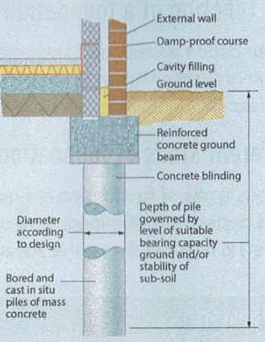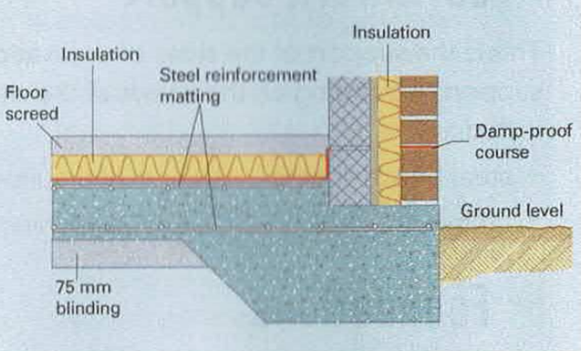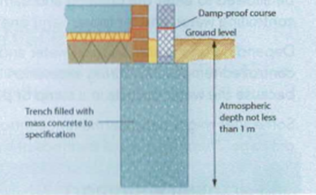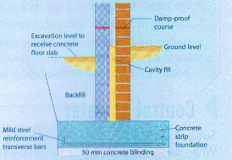`

Short bored piles

Strip

Raft

Deep strip

|  |  |  |  |  |  |
| --- | --- | --- | --- | --- | --- |
|  | **Ground floors** | | | | |
|  | **Solid floor** |  | **A suspended floor** |  | **Beam and block floor** |
|  | Bears directly onto the ground from which it gains its support. |  | Is one that is suspended above the ground |  | This is a type of suspended floor |
|  | Usually made of solid concrete  ***They are made up of:*** |  | It rests on beams spanning between supporting walls |  | It uses precast concrete beams with light weight concrete blocks as an infill |
|  | Sand blinding- a layer of sand to even off the surface of the hard-core |  | In the modern construction industry, suspended floors are generally built using the beam and block method |  | The method is becoming very popular as it is quick to construct and ensures a high quality |
|  | Damp- proof course (DPC) |  |  |  | These floors do not need any preparation and put less of a load on the foundations. |
|  | Damp-proof membrane (DPM) – this stops moisture transfer from the ground into the building by over lapping of sheets. |  | As they are precast, they can be laid in bad weather |
|  | Insulation – this should have good compressive strength |

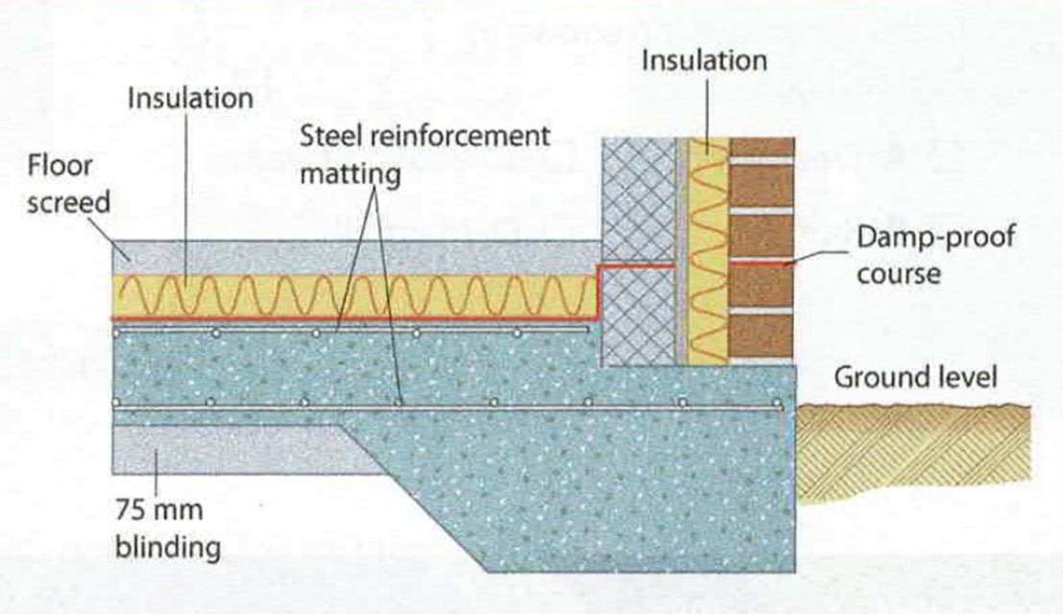

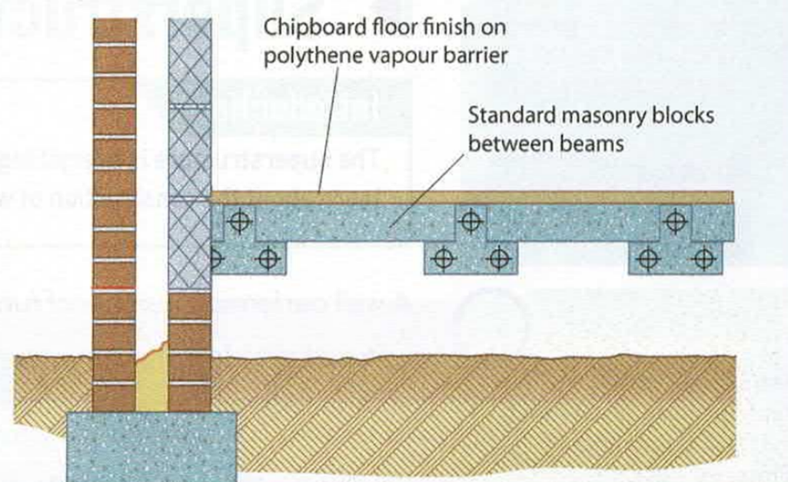

Typical solid floor details

A beam and block ground floor. The wall below DPC, often includes an airbrick. This ventilates the empty space below the suspended floor.

|  |  |  |
| --- | --- | --- |
| **Key Words** | | |
|  | **Pointing** | Filling the joints in brickwork with mortar to improve appearance and weather proofing |
|  | **Aesthetics** | The appreciation of beauty or the appearance of something |
|  | **Lintel** | A horizontal support across the top of a wall opening ,such as over a door or a window |
|  | **Sill** | A piece of material below a door or window to allow rainwater to run off, away from the opening |
|  | **Threshold** | A strip of metal forming the bottom of a doorway |
|  | **Cavity tray** | A damp-proof course inside a cavity wall, which funnels moisture out of the cavity through weep holes |
|  | **Cavity closer** | This closes off the cavity around a wall opening, reducing heat loss |
|  | **Weep hole** | A small opening in brickwork which allows moisture to escape |
|  | **Floor** | Horizontal surfaces that are designed to provide a level surface. They make our buildings functional |

|  |  |
| --- | --- |
| **Materials used to build walls** | |
|  | When finishing a wall in brickwork, care must be taken so that the colour and appearance of the brickwork does not vary too much. |
|  | Mortar is a mixture of sand and lime, or sand and cement with or without lime. |
|  | Lime makes mortar more workable but as it is more porous (letting moisture through),it allows frost to penetrate and cause damage |
|  | Thin joint masonry is a faster method of construction walls. As the name suggests, the joints between various layers are thin compared with traditional methods. |
|  | These joints are 2-3 mm thick. |
|  | A fast setting mortar is used, which can give the required strength very quickly. |
|  | This masonry depends on the accuracy of block sizes. Generally lightweight blocks are used, which also provide good thermal efficiency. |

**Topic C.1 and C.2 Superstructure – walls & floors**

|  |  |
| --- | --- |
| **Floor finishes** | |
|  | Solid floors can be finished in screed, which provides a level and even surface |
|  | Additional floor finishes such as carpets can be laid on top of this |
|  | Floor could be finished using ordinary chipboard, moisture-resistant chipboard to softwood. |
|  | A wooden board called a skirting board is provided along the bottom of the wall. |
|  | Skirts make it look more attractive and protects the base |

|  |  |
| --- | --- |
| **Materials used to build floors –made from a range of materials:** | |
|  | ***Concrete*** beam-and-block floors use pre-cast concrete beams with lightweight concrete blocks as an infill |
|  | ***Timber*** Suspended floors can be constructed using different types of timber joists, which are like beams and support the floor load.  Some joists are not solid and have open areas providing space for services. These are eco-joists and use less timber |
|  | ***Engineered timber*** newer buildings may have floors made of applied finishes such as laminate and engineered timber. These need less maintenance and are also less likely to be affected by moisture and defects such as rot |

|  |  |
| --- | --- |
| **Wall openings** | |
|  | Openings have to be included in walls to provide: |
|  | Ventilation – the circulation of fresh air in a building |
|  | Sunlight |
|  | Aesthetics |