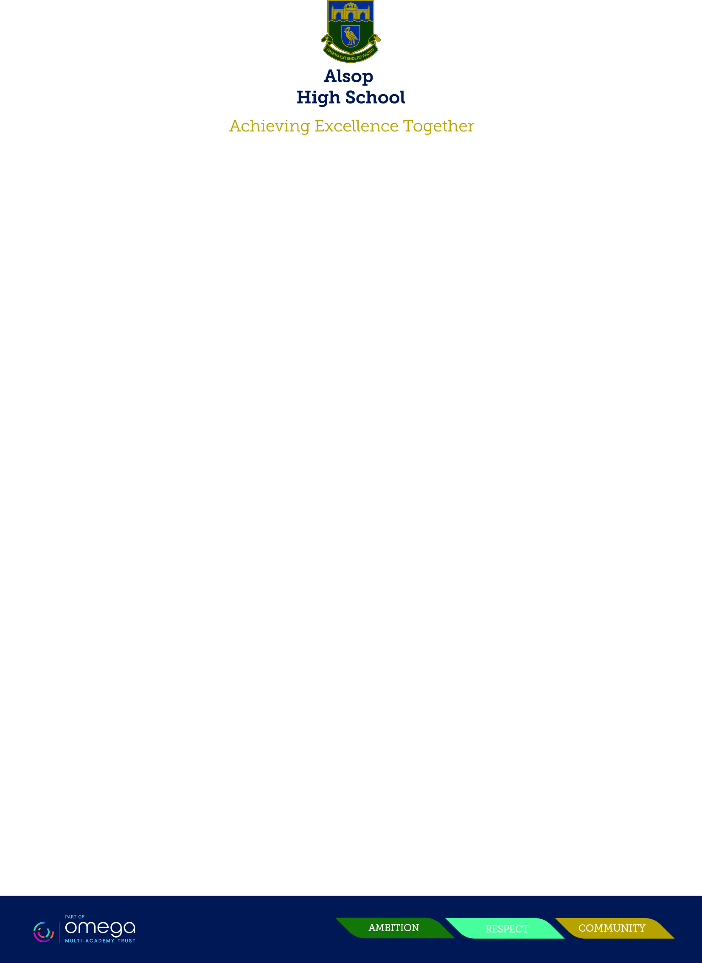

Dear Parents and Carers,

In response to our recent parent/carer survey, we are having a focus on relationships in the coming weeks. This is beginning with a look at a relational conflict, bullying, banter and baiting. During PDR and assemblies, we will be discussing the differences between what is ‘normal’ falling out amongst our young people and bullying. All our students will be encouraged to adopt positive and inclusive attitudes towards each other, alongside being reminded who they can go to for support within school if they feel they or people they know are being bullied and need some help.

In order to support at home, we have provided some advice, guidance and information for you, as parents and carers, and also a factsheet for our students, which also contains signposting for support outside of school. This information will also be put on our website.

Please don’t hesitate to contact your child’s form tutor or progress leader for further information and support,

Mrs. K. Begley

Assistant Headteacher

Designated Safeguarding Lead