AQA A-Level Physics Specification:
https://www.aqa.org.uk/subjects/science/as-and-a-level/physics-7407-7408/specification-at-a-glance

Revision list:
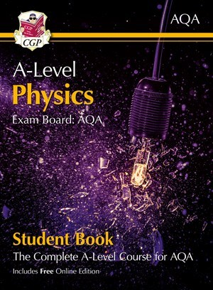
A-Level Physics for AQA: Year 1 & 2 Student Book with Online Edition
Product code: PATB73
ISBN: 9781789080483
Please complete the exam questions on the following pages in AQA A-Level Physics purple revision guide:
Topic | Page number
Particle Physics: Particle interactions | 19-23
Mechanics: Moments and projectile motion | 120-145
Materials: Young’s Modulus | 172-181
Electricity: Resistivity | 191-199
Further mechanics: Simple Harmonic Motion | 223-234
Gravitational Fields: Gravitational Potential | 276-282
Thermal Physics: Adiabatic and Isothermal | 536-541
Alternative revision resources:
- https://www.physicsandmathstutor.com/
- https://www.alevelphysicsonline.com
- https://mmerevise.co.uk/a-level-physics-revision/
- https://www.youtube.com/Scienceshorts (my personal favorite; it includes revision per module and walkthrough past papers)

