6. | Perspective drawing uses vanishing points | 7. | 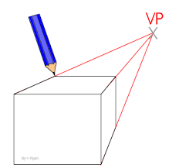
8. | Perspective drawing tries to show what something actually looks like in 3D – smaller in the distance, large closer up. It does this by using lines that appear to meet at points called vanishing points
9. | These points are in the distance on the horizon line | 10. | One-Point Perspective – for drawing objects head on  - Mark one vanishing point  - Draw the front view of the object head on  - The draw lines to the vanishing point
11 | Two-Point Perspective – for drawing objects edge on  - Draw a horizon line horizontally across the page.  - Mark two vanishing points near the ends of the horizon line  - Draw the object by starting with the front, vertical edge and the projecting lines to the vanishing points  - Remember that vertical line remain vertical and all horizontal lines go to the vanishing point | 12. | 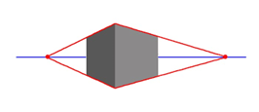
Year 11 DT KO Section C Drawing Techniques
Freehand Sketches
1. | Freehand means drawing without using any equipment (except a pen and pencil) | 2. | It’s the quickest method of drawing, so it’s handy for getting initial design ideas down on paper
3. | You can combine 2D and 3D sketches to explain details | 4. | You can annotate your sketches (add notes) to explain details further, e.g. describing the materials and processes you would use
5.
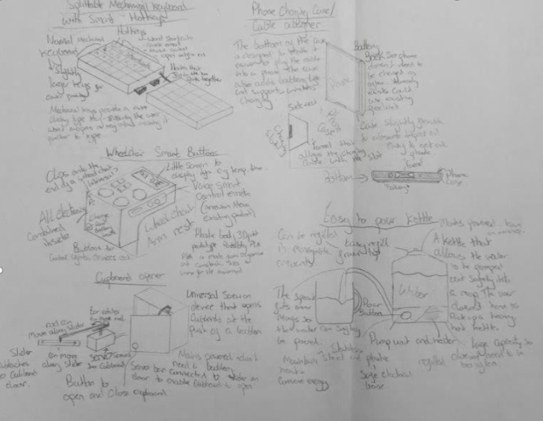

13. | Isometric Drawing Shows objects at 30°
14. | Isometric drawing can be used to show a 3D pictures of an object | 15. | It doesn’t show perspective (things don’t get smaller in the distance) but it is easier to get across the dimensions than in perspective drawing. | 18. | 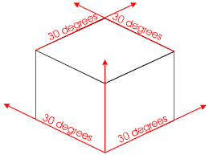
16. | There are three main rules when drawing in isometric | 17. | Rules  - Vertical edges are drawn as vertical lines  - Horizontal edges are drawn at 30° (from horizontal)  - Parallel edges appear as parallel lines

19 | Scale Drawings are Used to Draw Big Things (but smaller)
20 | To draw a big object on a small piece of paper, you have to scale it down | 26. | You can also scale things up. A scale of 2:1 means the drawing is twice the size of real object
21 | The object is still drawn in proportion – it’s just smaller | 27. | The scales needs to be clearly shown on the diagram. It’s a ratio, so it doesn’t have any units
22. | The scale is shown as a ratio. For example: | 28. | 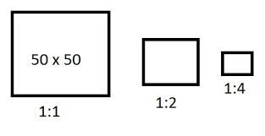
23. | - A scale of 1:2 means that the drawing is half the size of the real object
24. | - A scale of 1:4 means that the drawing is a quarter of the size of the real object
25. | - Anything down as 1:1 is full sizes
28 | - To check you’ve scales an object down properly, measure the lengths of the lines in your drawing. If you multiply those lengths by the scale, you should get the dimensions of the real object.

29 | Exploded diagrams show how parts fit together |  |  | 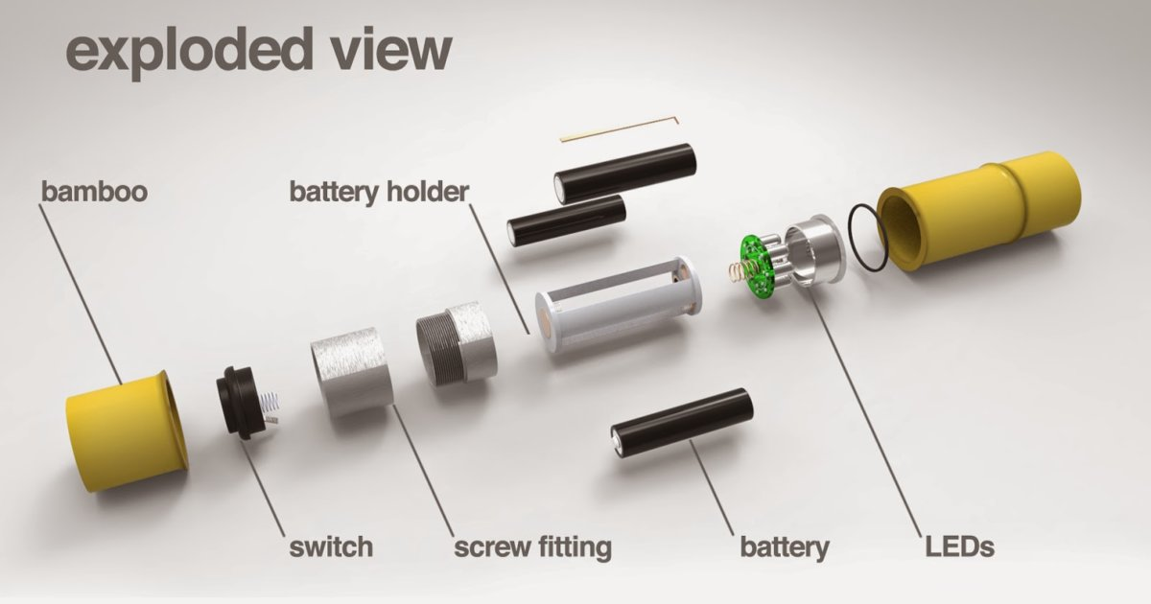
30 | Assembly drawings show how separate parts join together | 31 | An exploded diagram is a type of assembly drawing
32 | Exploded diagrams are always in 3D | 33 | You draw the product with each separate part of it moved out as if it’s been exploded
34 | Each part of the product is drawn in line with the part it’s attached to | 35 | Dotted lines show where the part has been exploded from and therefore where it fits into the overall product
36 | Exploded diagrams are designed so you can use them on their own – you don’t need many words to explain how to assemble something. | 37. | This means that as well as being sent to manufactures, they’re often used for flat-pack furniture instructions.
34
38 | Orthographic Projection shows 2D views of a 3D object | 40 | The symbol for 3rd angle orthographic projection is:  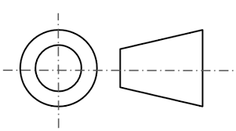 | 43 | To avoid confusion lines and dimensions must follow certain conventions:  ____________ outlines thick and continuous  ___________________ construction lines light and continuous  _ __ _ __ _ __ centre lines alternative long and short dashes, light  ------------------- hidden details (e.g.edges that you cant see) dashes, light  arrow heads and the dimensions written above the line in the middle (or to the left of the line if its angles or vertical)
38 | 3rd angle projections are used very widely in industry to help the manufacturer understand the design. | 41 | Each 2D view is drawn accurately to scale | 44 | There’s always a gap between the projection lines and the object
39 | They show a 3D object as a set of 2D drawings viewed from different angles – a front view, plan view (as seen from above) and an end view (as seen from the side) | 42 | The dimensions are always given in millimeters. | 45 | The diameter of a circle is shown by the symbol an an arrow inside the circle

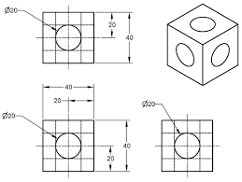
46 | To draw a 3rd angle orthographic projection you:
47 | Draw the front view | 52 | Now the projections have taken shape, it should be easier to figure out which edges are the hidden details in each of the views – mark these on the drawings
48 | Add construction and centre lines to the right – these help to draw the outlines of the end view, which you should now complete | 53 | Add the dimensions – don’t forget to use millimeters
49 | Add construction and centre lines going up from the front view | 54 | 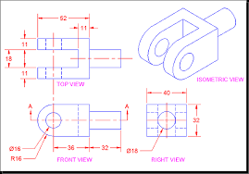
50 | Draw a line at 45° ( as shown in the diagram) in the top right hand corner of the front view
51 | Draw construction and centre lines going up from the end view. When they reach the 45° line, draw them going 90 ° and to the left – these lines and the ones coming up form the front view can be used to draw the plan view | 56

