I am being bullied
If you are being bullied it's important that you tell someone you trust.
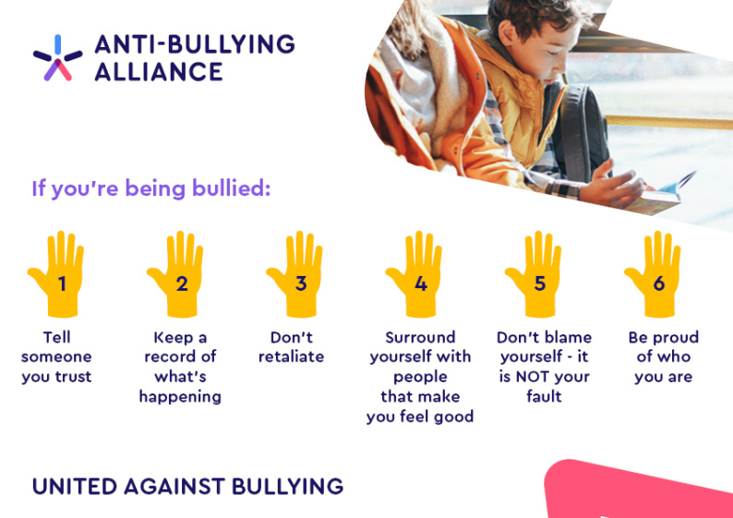
- It doesn’t matter what colour hair you have; what trainers you are wearing; how you speak; how you walk; how you talk – it is not your fault if you get bullied. We are all different in some way and that’s what makes us amazing.
- Whether you are a boy or a girl, old or young, big or small – bullying makes you feel rubbish and it’s okay to be upset about it. The important thing is that you tell someone about it.
- If you feel you can, talk to a teacher you trust or a family member. If you don’t want to do that you can always call Childline 0800 11 11 or visit www.childline.org.uk.
- Write down what happened, when it happened, and who was involved. If the bullying is online, keep the evidence – save or copy any photos, videos, texts, e-mails or posts.
- It can be tempting if you are being bullied to take revenge – for example to send a horrible message back to someone; to try and embarrass and hurt the other person, or to fight back. This is not a good idea – you might end up getting in trouble or get yourself even more hurt.
- Think about other ways you can respond to bullying. For example, practice saying ‘I don’t like it when you say that/do that – Stop.' Think about other people who can help you if you are being bullied – this could be other classmates, or a teacher.
- Only spend time with people who make you feel good about yourself. If someone constantly puts you down they are not a real friend/ boyfriend/ girlfriend and not worth your time.
- Be kind to yourself, and do things that make you feel good, relax and make new friends. You might make music; write lyrics; draw cartoons; dance; act or join a sports club. This is your life so make sure it’s the best life possible – don’t let anyone bring you down.
- Remember to respect other people! Just because someone is different to you and your friends – that doesn’t mean you are better than them or have a right to make them feel bad. If you mess up, say sorry. You don’t have to be friends with everyone – but you should always make it clear that you don’t like it when people bully others, and stick up for people who are having a hard time.

6 things to do if you’re being bullied
https://youtu.be/5Q70EAnFuD8

5 things to do if you’re being bullied online
https://youtu.be/XXrsuGbvKKI

4 top tips if you know someone is being bullied
https://youtu.be/h9Dn_S2DPhQ

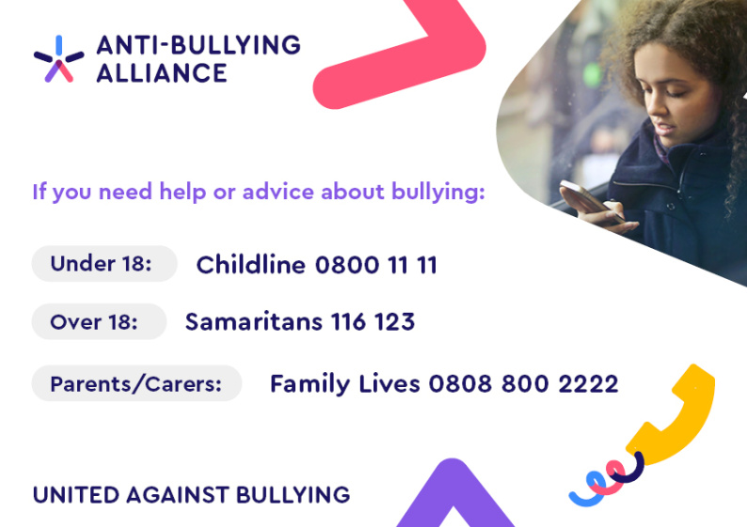

- EACH : EACH has a freephone Helpline for children experiencing homophobic, biphobic or transphobic bullying or harassment: 0808 1000 143. It’s open Monday to Friday 10am-5pm.

Websites
The websites below have lots of information and advice for anyone who has experienced bullying.
- The Child Exploitation and Online Protection Centre (CEOP) maintains a website for children and young people, and parents and carers about staying safe online: Think U Know
- Childline: information about bullying
- Kidscape: information for young people

