America’s expansion  1789–1838 ​ | • How and why the USA expanded, from 1789 to 1838 ​  • The expansion of southern cotton plantations and of slavery, 1793–1838 ​  • The removal of indigenous people from the east, 1830–1838 ​
The West  1839–1860 ​ | • The culture of the Plains Indians including a case study of the Lakota Sioux ​  • The journeys of the early migrants to California and Oregon; the Mormon settlement of Utah ​  • The nature and impact of the Californian Gold Rush (1848–1849) and the consequences of the Pikes Peak Gold Rush (1858–1859) ​
Settlement and conflict on the Plains  1861–1877 ​ | • The causes and nature of white American exploitation of the Plains: railroads, ranches and cow towns ​  • Homesteaders: living and farming on the Plains ​  • The Indian Wars including Little Crow’s War (1862), Red Cloud’s War (1865–1868) and the Great Sioux War (1876–1877) ​
Civil War and Reconstruction 1861–1877 ​ | • Divisions over slavery and the causes of the Civil War ​  • The African American experience of the Civil War, 1861–1865 ​  • Reconstruction and continuing limitations to African American liberty ​
American cultures  1877–1900 ​ | • Changes to the Plains Indians’ way of life including the impact of reservations and the destruction of the buffalo ​  • The impact of economic, social and political change on the lives of African Americans ​  • The growth of big business, cities and mass migration​
The Making of America, 1789-1900

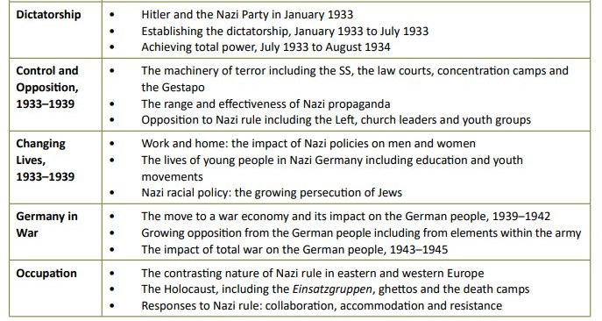
Life in Nazi Germany, 1933-1945

Tip: Type the following in on YouTube for useful revision playlists…

‘Pete Jackson Making of America’ AND ‘Pete Jackson Living under Nazi Rule’

