1 | A systems approach is a method to break down the stages of a process into a series of steps.  This enables designers to develop systems without going into the detail of each stage.
3
Inputs may be movement, such as pressing a switch, or volume control.
Process may be a device, such as an amplifier for sound or heater for water.
Output may be movement, such as a motor or sound from a speaker or light, etc.
9 | Flow charts | Systems can be represented in the form of a flow chart. A flow chart uses graphical representations to show a sequence of operations or actions in a complex system. The sequence follows a logical order and decisions are made using yes or no questions.
2 | Systems approach | Systems have three sections; Input, Process and output. They are connected together to give the desired function
4 | Open loop flow chart | Open loop is when the output IS NOT measured or fed back into the decisions made in the system.
5 | The heating system is switched on.
6 | The boiler heats the water.
7 | The hot water heats the radiators.
8 | This continues until the heating system is physically switched off.
The start and end of a process.
Direction of flow.
Process An input/ output or process
Decision A yes / no decision is made.
10
11 | Closed loop flow chart | Closed loop is when the output IS measured or there is feedback into the decisions made in the system. Decisions are automatically made. In this temperature controlled heating system.
12 | The heating system is switched on.
13 | The boiler heats the water.
14 | The hot water heats the radiators.
15 | A heat sensor (thermostat) measures the temperature and feeds back to switch the system off.

16 | An electronic system is the physical connection of components that uses a signal in the form of electrical energy from an input, which is processed to operate an output device. You need to know about four input devices.
17 | Light sensor (photoelectric devices) | The electrical resistance in a light sensor (known as a light dependent resistor (LDR) alters in response to changes in light, and gives a signal to the system. Light sensors have high resistance when dark and low resistance in light.
18 | Electrical resistance is a measure of how easy or difficult it is for electric current to pass through a wire or component. Resistance is measured in units of ohms (Ω)

Electronic systems – inputs
Decision
Flow line
Terminator
22 | Pressure sensors | Pressure sensors can be in the form of switches that are on or off or gauges that have a change in resistance when there is an applied pressure or force. In an electronic circuit, the pressure sensor will be able to sense a force and give a required signal.
28 | Microcontrollers | Microcontrollers make decisions and determine an output. They can be programmed using machine code (a programming language based on 0 and 1) , but in schools a simpler programming language called Basic is used.
29 | The program is written on a computer and transferred to a microcontroller, which is used to control an output such as a counter.

Electronic systems – outputs
24 | Toggle switch | A toggle switch (latched or ‘single throw’) has on and off positions and comes in a variety of shapes, such as light switches.
25 | A push to make switch | A push to make switch (PTM) which is Normally Open (NO) is used on door bells or keys on keyboard.
26 | Push to break switch | A push to break switch (PTB) which is Normally Closed (NC) is used on fire alarms and control systems.

Electronic systems – inputs
19 | Temperature sensor (thermistor) | The electrical resistance in a temperature sensor (thermistor) changes in response to changes in temperature and gives a required signal.
20 | Temperature sensors have high resistance when cold and low resistance when hot.
21 | Temperature sensor and graphical symbol.
23 | Switches | Switches are devices that are used to make a break an electrical connection in a circuit. There are many types of switches such as push, rotary, toggle or slide. Switches can be used in a number of ways.
27 | Microcontrollers are a single chip micro-computer component you can use for processing in circuit.
30 | PICs | Programmable interface controllers (PICs) are microcontrollers that can be programmed and used as counters, timers or for making decisions and give greater flexibility or functionality to projects.  They are inexpensive and are used in a wide range of commercial products such as cars, washing machines, remote controls or microwave ovens.
31 | The size of the circuit (board) can be reduced and functionality increased.
32 | Often more expensive than a dedicated integrated circuit (IC).

Electronic systems – outputs
33 | Timing can be carried out by integrated circuits (IC) such as the 555 timer, which produces single (monostable) or multiple (astable) pulses.
34 | Monostable devices produce a single output pulse that is either on or off. Uses include an alarm sensor system that operates an audible alarm once the sensor is triggered.
35 | Astable devices give an oscillating output that moves between off and on. Uses include flashing lights as an output to an alarm system.
36 | Decision making – logic gates and truth tables | AA logic gate is used for making a decision in a circuit. Most logic gates have two inputs that give a single output.

37 | AND gate | 38 | OR gate | 39 | NOT gate
For an output at Q there must be an input at both A AND B. |  | For an output at Q there must be an input at either one A OR B or at both of them. |  | There is an output at Q only if there is NOT an input at A
40 | Truth tables will have two binary inputs that can be either of two conditions – low (0) or high (1). The result is a single output value or low (0) or high (1).

AND gate  41 | OR gate  44 | NOT gate  47
42
A | B | Q
0 | 0 | 0
0 | 1 | 0
1 | 0 | 0
1 | 1 | 1
A | Q
O | 1
1 | 0
A | B | Q
0 | 0 | 0
0 | 1 | 1
1 | 0 | 1
1 | 1 | 1

48
45

There is an output at Q only if there are inputs at A and B

43
49

46
There is an output at Q if there is an input at A or B or at both of them.
There is an output at Q only if there is NOT an input at A.

50 | Electronic systems have three sections: input, process an output. The input is processed into an electronic signal, which drives the output device.
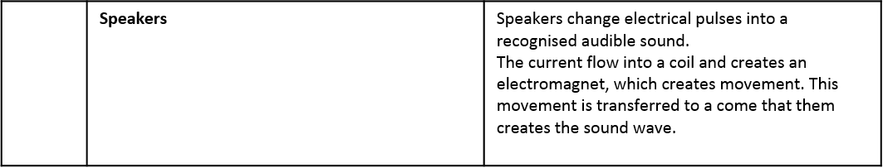
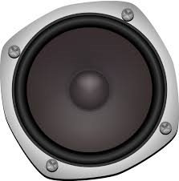
51
Electronic systems - outputs

52 | Graphical symbol for a speaker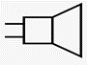
53 | Buzzers | Buzzers convert electric current into an audible buzz, normally used as an alarm. Electromagnets are switched on and off repeatedly to vibrate a metal disk between two magnetic poles.

54 | Lamp | Lamps give off light. Typical filament lamps have a thin wire (often coiled) The filament is made from metal, such as tungsten. This provides resistance, which makes the filament heat up as the electric current passes through. A the filament heats up it produces light.

56 | LEDs can be directly wired into a circuit. The positive (+) side is called the anode and the negative (-) side is called the cathode.

57 | LEDs and the graphical symbol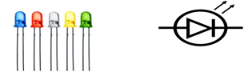

55 | Light-emitting diode (LED) | An LED is a component that gives off light. LEDs come in a range of colours. They are increasingly replacing bulbs in cars and torches because they have low power consumption and are long lasting. LEDs are normally grouped in a cluster to provide good levels of light and can still work when one of the LED fails.

