|  |  |
| --- | --- |
| 1 | **All mechanisms involve some kind of movement. There are four basic types of movement.** |

|  |  |  |
| --- | --- | --- |
| 2 | **Linear** | **Motion in a straight line, for example a train moving along a track or a lift travelling up in a high-rise building.**  **A train is an example of liner motion.** |

|  |  |  |
| --- | --- | --- |
| 3 | **Reciprocating** | **Motion that moves backwards and forwards in a straight line, for example the blade on a workshop jigsaw or a piston in a car engine.**  **A jigsaw blade**  **Uses reciprocating**  **Motion.** |

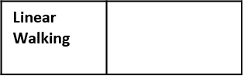

**1.5 Mechanical devices Types of movement**

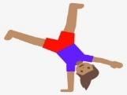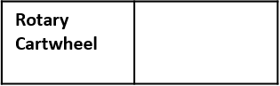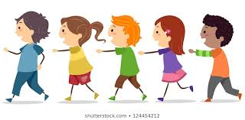

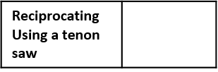

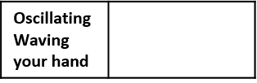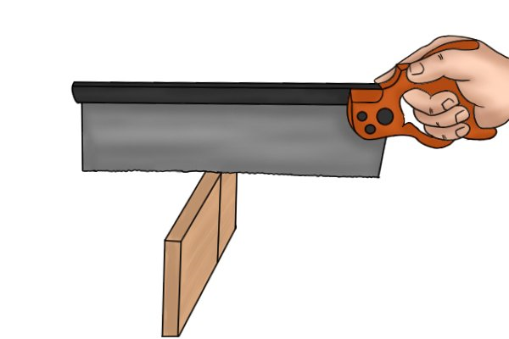

|  |  |  |
| --- | --- | --- |
| 4 | **Oscillating** | **Motion that swings backward and forward in an arc from a central point, for example a pendulum on a clock or a child on a swing.** |

|  |  |  |
| --- | --- | --- |
| 6 | **Parts of a lever** | **There are three parts to every lever.** |
| 7 | The **effort**, which is the amount of force put in by the user **(input)** | |
| 8 | The **pivot (fulcrum)** which is the point at which the lever pivots. | |
| 9 | The **load,** which is the **force** exerted by the load **(output**) | |

|  |  |  |
| --- | --- | --- |
| 10 | **First order** | This lever is used to lift greater loads but the effort has to move a greater distance than the load. The load and effort are on opposite sides of the pivot. |

|  |  |  |  |
| --- | --- | --- | --- |
| 11 | **Second order** | This lever is also used to lift greater loads with the effort moving a greater distance than the load. The load and effort are on the same side of the pivot. |  |

**Levers**

|  |  |  |
| --- | --- | --- |
| 5 | **Rotary** | **Motion goes around a central point, for example a wheel on a bicycle or fan blade.**  **A bicycle wheel has rotary motion** |

|  |  |  |
| --- | --- | --- |
| 12 | **Third order** | The effort in this lever is more than is applied to the load. This is used for precision work. |
|  | |

|  |  |
| --- | --- |
| 13 | **Systems where one or more levers are joined together are known as linkages. You need to know about three types of linkage.** |

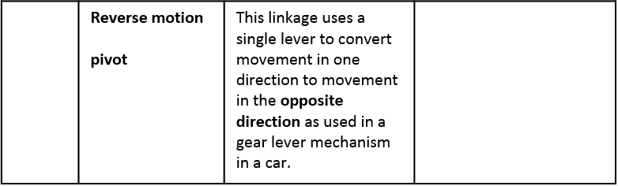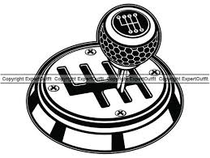

**Linkages**

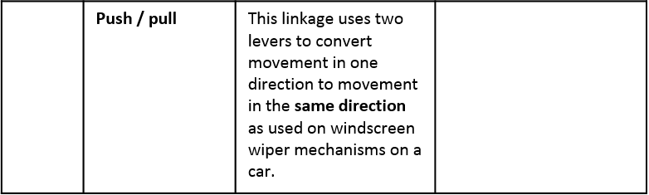

16

15

|  |  |  |  |
| --- | --- | --- | --- |
| 14 | **Bell crank** | A fixed angle lever converts motion through that angle to allow an input force to be transmitted around a corner, as used on a brake mechanism on a bicycle. |  |

**Specialist gears 1**

|  |  |  |
| --- | --- | --- |
| 19 | **Gears** | A gear is a toothed wheel fixed to a shaft that can mesh (connect) with other gears to produce changes in speed of drive mechanism. |
| 20 | A super **gear** is a rotating wheel that has teeth and can mesh with a second spur gear. | |
| 21 | The **drive gear provides** the input movement, which is transmitted to the other gear – the **drive gear.** | |
| 222 | A **simple gear train** is when two spur gears are meshed and are fixed on parallel shafts. | |

|  |  |  |
| --- | --- | --- |
|  | **Idler gear** | To make the driven gear rotate in the same direction, an **idler gear** has to be used**.** |
| 25 | **Compound gear train** | The speed change in simple gear trains is limited to the number of teeth on the two gears and space available for the gear system. It is possible to combine a number of simple gears trains to achieve higher speed changes. This is called a compound gear train. |

|  |  |
| --- | --- |
| 17 | Bell cranks are used on bicycles to allow the remote operation of brakes connected by a cable to the handlebars. |

|  |  |  |
| --- | --- | --- |
| 18 | **Changing forces** | The output motion of a linkage can change in three ways:   * **Direction** * **Distance** * **Force** |

|  |  |
| --- | --- |
| 23 | When two spur gears are connected, the **direction of rotation is reversed.** |

|  |  |
| --- | --- |
| 24 | Gears have an advantage over pulley systems because the meshing of the gears prevent any slip so that greater forces can be applied**.** |

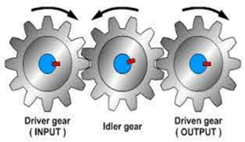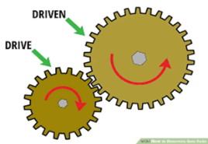

|  |  |  |
| --- | --- | --- |
| 26 | **Specialist gears**  **Specialist gears 2** | You need to know about alternative types of gear systems such as bevel gears and worm and wormwheels**.** |
| 27 | Bevel gears | These can transmit **rotary motion through 90 degrees.** The calculations for velocity ratio and output speed for bevel gears are the same as normal spur gears. |

|  |  |
| --- | --- |
| 29 | **Examples of bevel gears are found in hand drills and in a differential gearbox in a car.** |

|  |  |
| --- | --- |
| 28 | **Bevel gears can have different number of teeth to provide different velocity ratios and output speed.** |

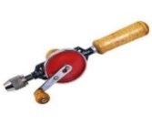

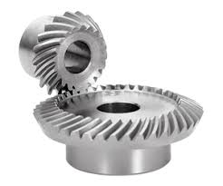

**Cams and followers**

|  |  |  |
| --- | --- | --- |
| 35 | **Types of cams** | Cams are mechanisms used for converting **rotary motion into reciprocating motion.** Cams can be shaped differently and attached to a rotating camshaft to provide different outputs that are transmitted to a **follower** held against it. |

|  |  |  |
| --- | --- | --- |
| 31 | **Rack and pinion** | **A gear wheel and change rotary motion to linear motion** and the other way around. Example of a rack and pinion are found in pillar drills and in a car steering system. |

|  |  |
| --- | --- |
| 32 | **Movement from a cam and follower:** |
| A | **Rise:** Moves the follower up. |
| B | **Fall:** Moves the follower down. |
| C | **Dwell:** Follower remains stationary. |
| D | **Stroke:** Range of movement of follower. |
| E | **Rotation:** Movement of cam. |

|  |  |  |
| --- | --- | --- |
| 30 | **Worm and worm wheel** | A worm and worm wheel (or worm gear) is used to make large reductions in speed. The gear wheel (worn wheel) meshes with the worm, which is the driver. Example of a worm and worm wheel are found on security gates and in which mechanism as it prevents and load fallback. |

|  |  |
| --- | --- |
| 33 | **Calculating velocity ratio: worm and worm wheel** |
| 34 | This formula is the same as a simple gears. However the worm has only one tooth – one  Whole revolution of the worm results in the worm wheel moving forward by only one tooth.  So the number of teeth on the drive wheel will always be 1. |

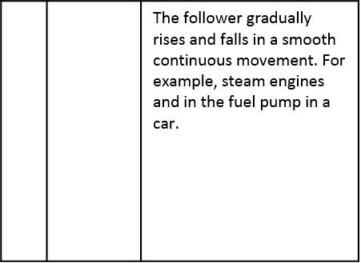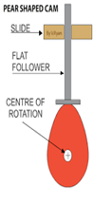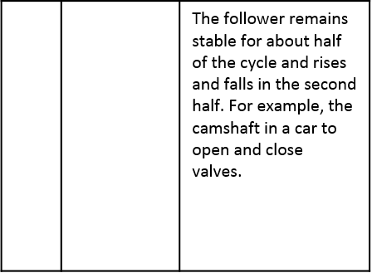3

36



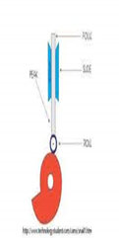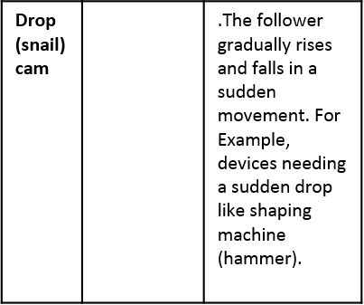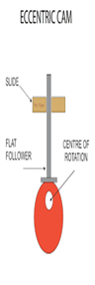

37

38

|  |  |
| --- | --- |
| 44 | Pulleys and belts are used to transmit **rotary motion** from a drive shaft to a driven a shaft. |

|  |  |  |
| --- | --- | --- |
| 45 | **Pulleys** | A pulley is a wheel with a shaped groove. Th belt fits in the groove connecting two pulleys and motion is transferred by friction. |

|  |  |  |
| --- | --- | --- |
| 46 | **A pulley system** | .In a **pulley system,** two pulley wheels on separate shafts are connected by belt. The motion and force are transmitted from the **drive pulley** to the **drive pulley.** The speed, direction and force of rotation can be changed. |

|  |  |
| --- | --- |
| 47 | Belts |
| **Round** – efficient, can be crossed to change direction | |
| **V-belt** – reduces slippage by wedging into the pulley wheel. | |
| **Fla**t – good grip at speed due to large surface area, can be crossed to change direction. | |
| **Toothed** – no slipping as belt fits into teeth of pully, but this could pose a safety risk if anything is trapped. | |

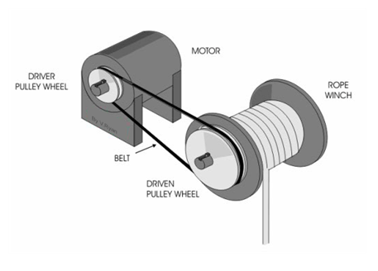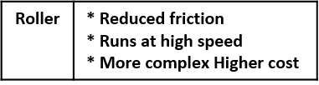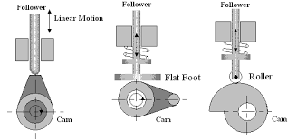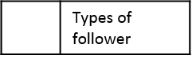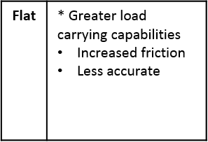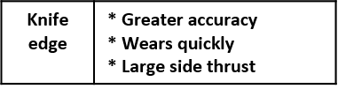

43

42

41

36

40

**Pulleys and belts**