**AQA English Language GCSE**

**Section A 1 hour**

**You will be given an extract from the 20th and 21st Century**

**Q1. List 4 things. 4 marks and 5 minutes**

**Q2. Analysis of language. 8 marks and 10-12 minutes**

**Q3. Analysis of structure. 8 marks and 10-12 minutes**

**\*Q4. Evaluate the validity of a statement. 20 marks and 25 minutes.**

**Section B 45 minutes**

**You will be given a choice of two questions. It could be a choice of narrative or description (it could be two narratives or two descriptions)**

**\*Q5. Creative writing. 40 marks and 45 minutes. 24 marks for content and 16 marks for SPaG**

**\*these two questions count for 60/80 marks for Paper 1. Make sure you spend enough time on them.**

**Use your knowledge organiser to revise.**

**Use ‘Look’ ‘Cover’ and ‘Check’**

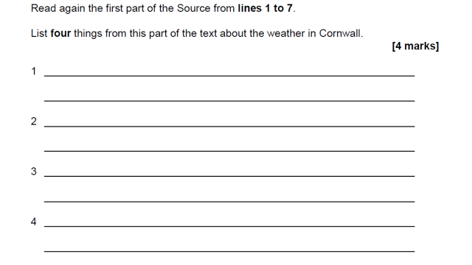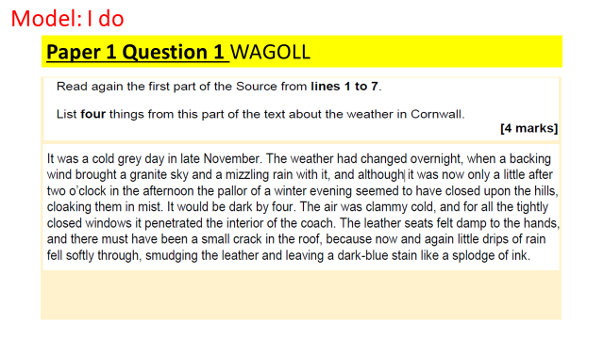**Q1 Example Question and Answer**

The weather in Cornwall is clammy and cold

It was raining in Cornwall

The weather in Cornwall had changed overnight

The weather in Cornwall was cold and grey.

**Q2 Example Question and Answer**

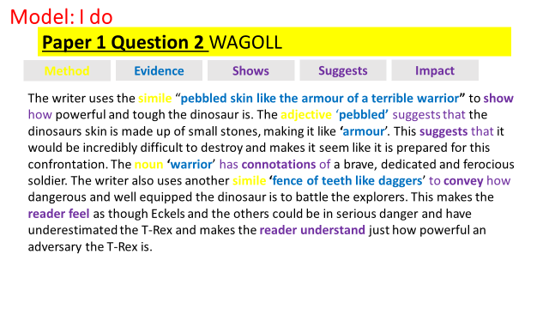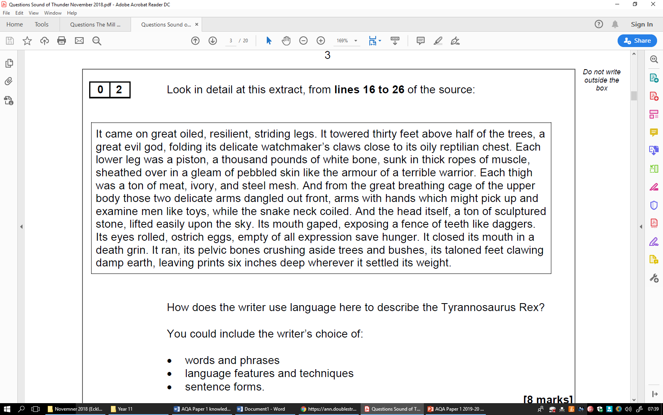

**Language Methods**

|  |  |
| --- | --- |
| Method | Definition |
| Simile | Comparing one thing to another using the words ‘like’ or ‘as’ *The teacher was like a snarling lion.* |
| Metaphor | Describing something by saying it is something else. *The teacher is a snarling lion* |
| Personification | Giving human characteristics to something that is non-human *The evil wind laughed in my face* |
| Imperatives | An order or command. *Sit down and be quiet!* |
| Emotive language | Language that has an emotional effect on the reader and makes them feel strong emotions. *The starving boy wiped the tears from his dirty face* |
| Rhetorical questions | A question designed to make the reader think carefully about the answers. What do you want from life? Success? Happiness? |
| Triplet | A number of connected items or words – commonly adjectives. The clouds were plump, dense and a miserable grey. |
| Juxtaposition | Two ideas that contrast each other. *It was the best of times, it was the worst of times* |
| Semantic field | A set of words (or [lexemes](https://www.thoughtco.com/lexeme-words-term-1691225)) related in [meaning](https://www.thoughtco.com/meaning-semantics-term-1691373). E.G Sailing: they will surely use words such as ocean, waves, sea, tide, blue, storm, wind, sails, mast etc. |
| Symbolism | An object representing another, to give an entirely different **meaning** that is much deeper and more significant. E.G. A dove is not just a white bird. It symbolises peace and purity. |
| Repetition | When a word, phrase or idea is deliberately repeated for effect |

**‘Big Methods’**

**‘Mini Methods’**

|  |  |
| --- | --- |
| Noun | Naming words that might refer to a person, place, thing or idea |
| Adjective | Describe a noun or pronoun. |
| Verb | Action/doing words |
| Adverb | Words which give extra information or describe a verb |
| Pronoun | A word used to replace a noun e.g. She, he, it, them. |
| Alliteration | A number of words, having the same first consonant sound, occur close together in a sentence |

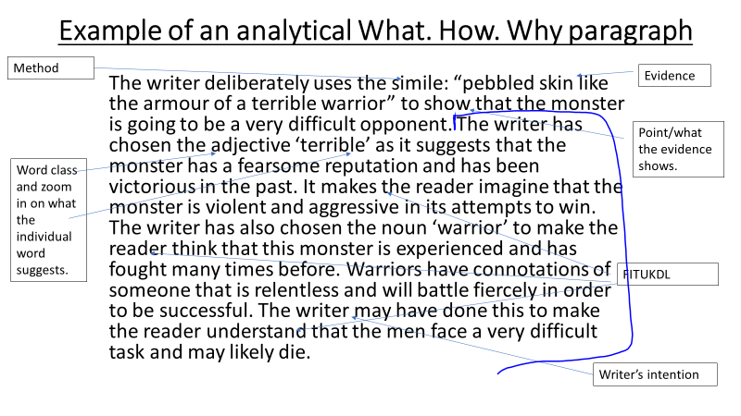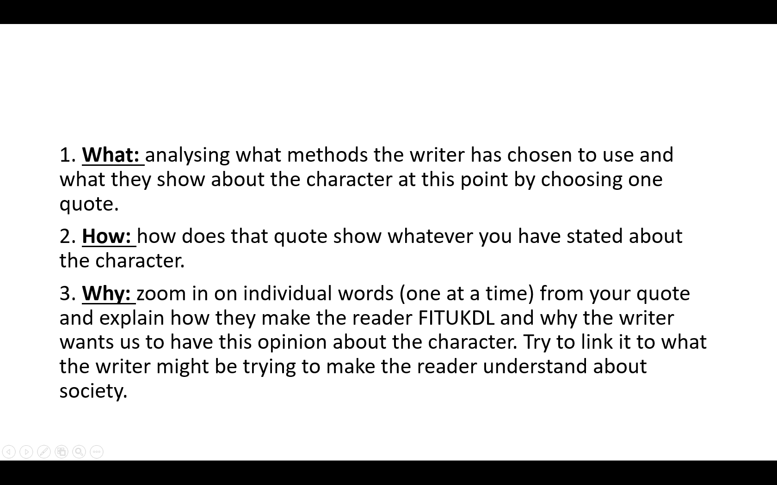**How to Structure an analytical paragraph using What? How? Why?**

**Q3 Example Question and Answer**

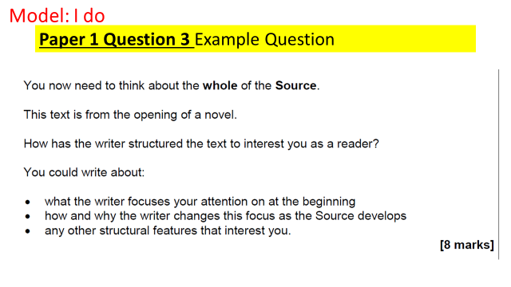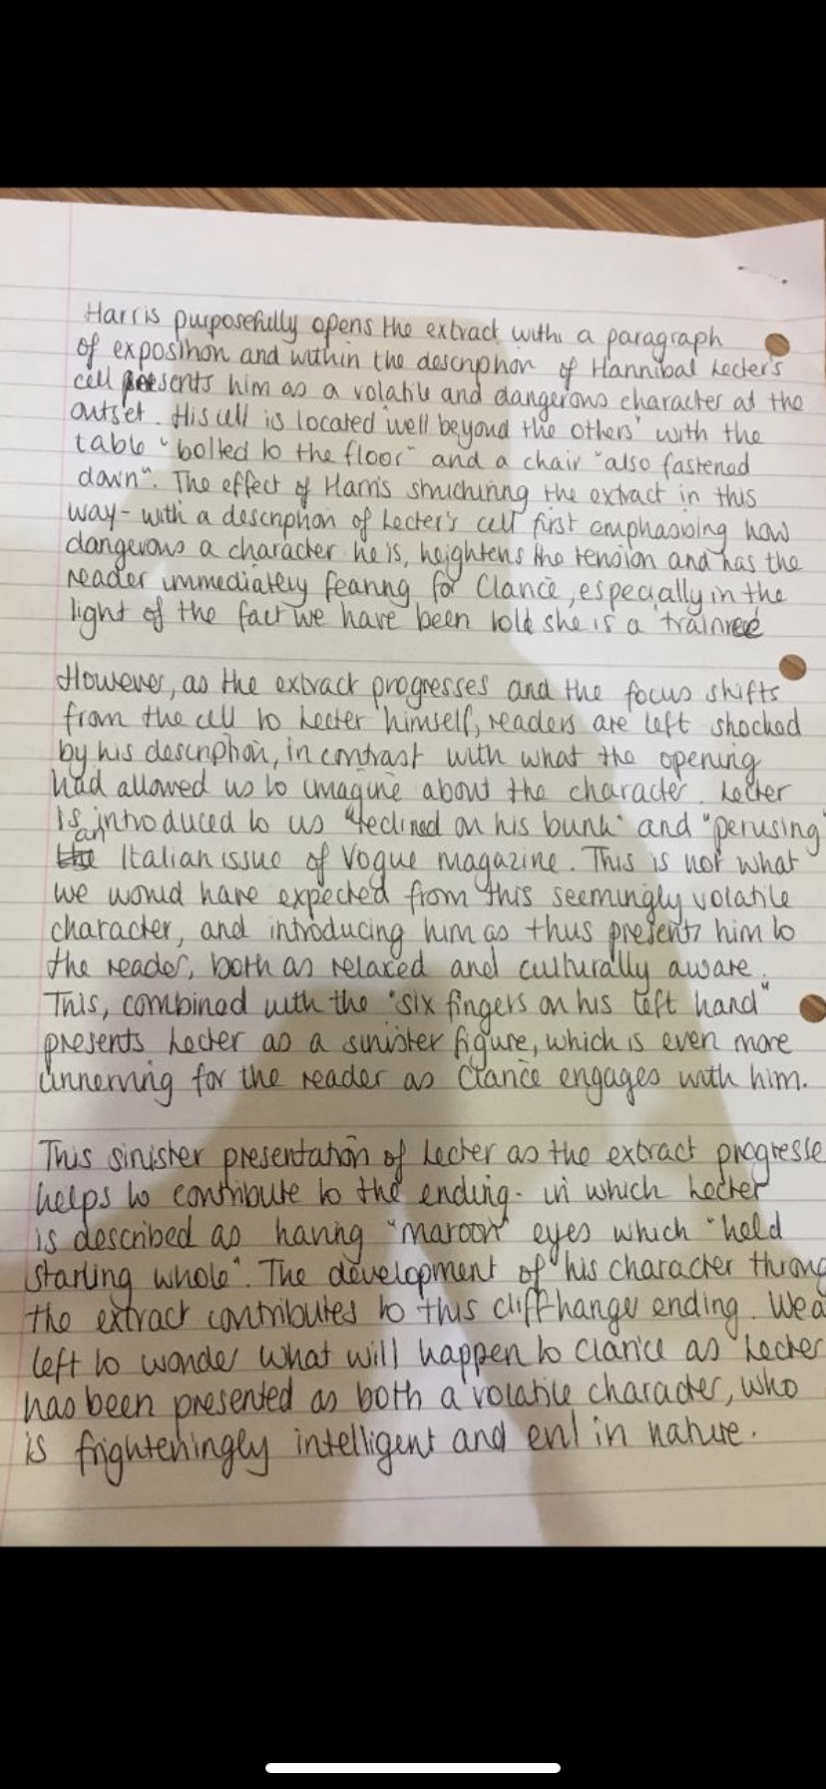

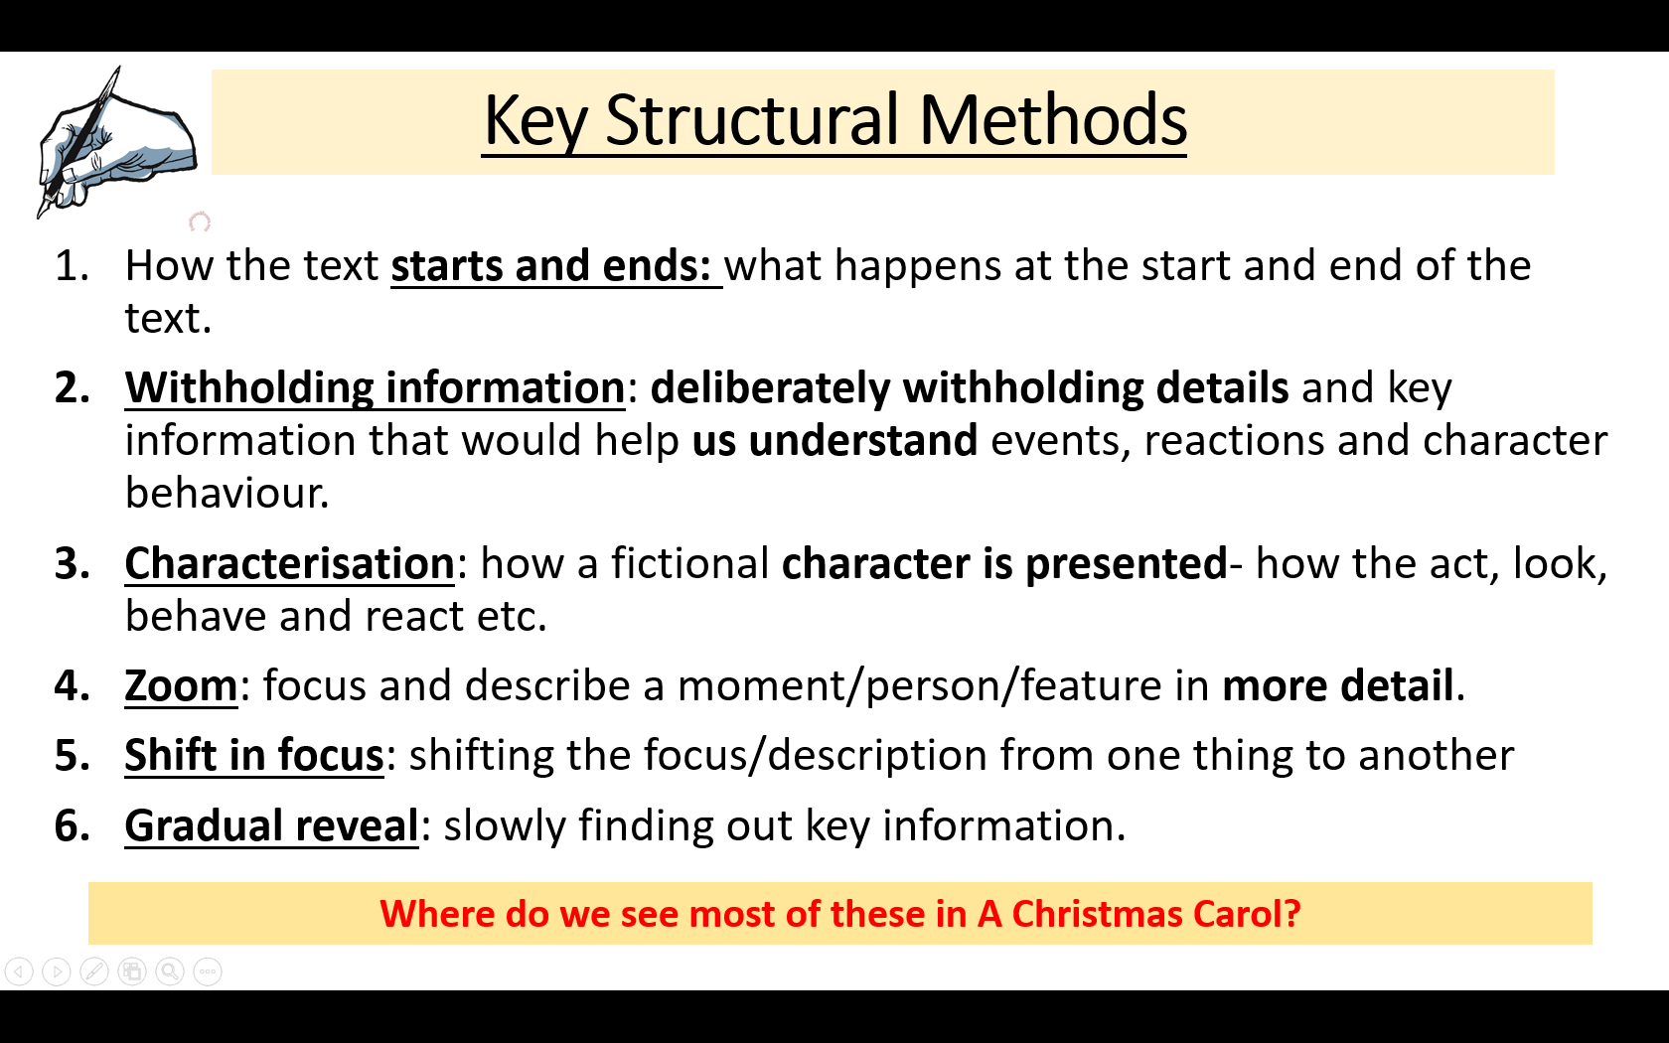**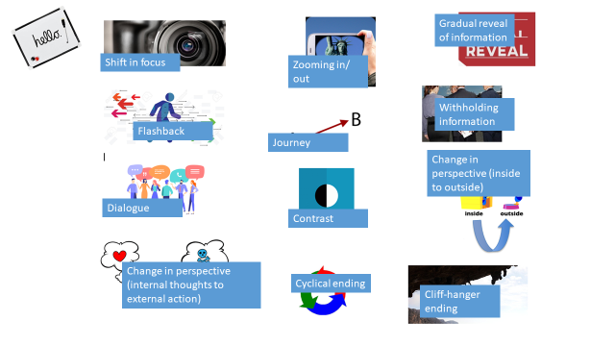Structural Methods**

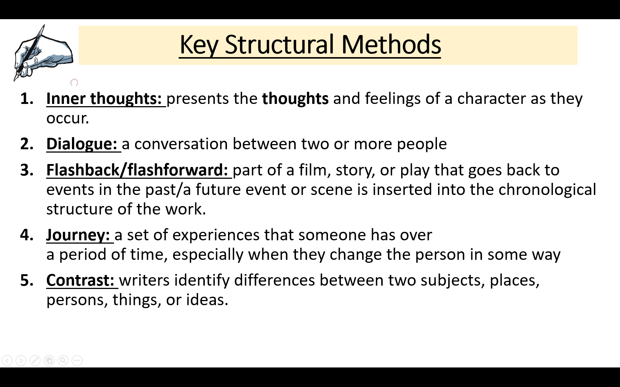

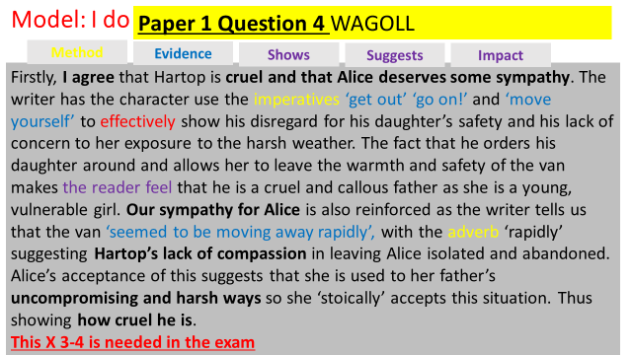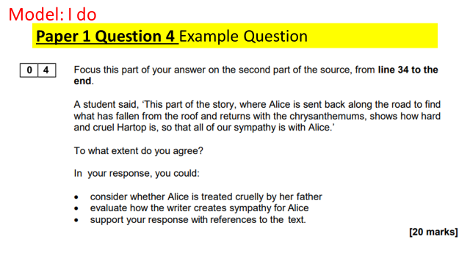**Q4 Example Question and Answer**

You can use any language, structural methods and comment on atmosphere and tone

**Q5 Example Question and Answer**

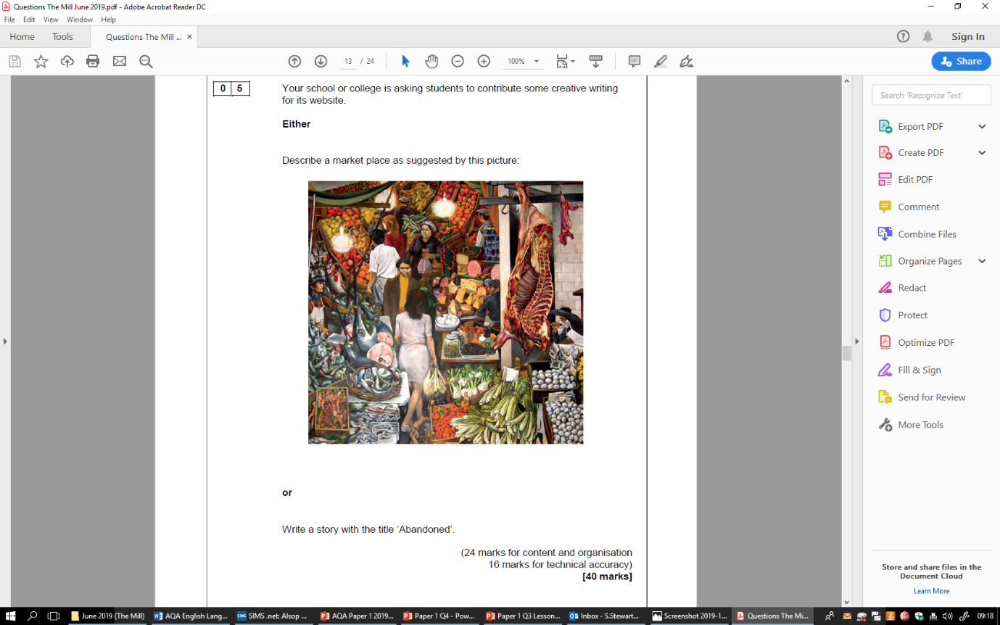

**Response 1 24+15= 39**

Fen returned to his seat beneath the palm trees and chirping birds he had become acquainted with in his time beneath them. The chair itself was not the pinnacle of relaxation he had been convinced of earlier on in his life; its creaks loudly filling the vast emptiness surrounding him. However, it was quite comfortable and his only source of relief from an otherwise disappointing, wasteful, ruthless, hopeless day.

He had been waiting for hours. Fen reached into the depths of his pocket and retrieved the phone his grandchildren had recently bought him in hopes of lightening his otherwise lonely life. “Surely,” he thought, “surely she has sent something,” but once again as he desperately tried to find some kind of message from the mysterious woman who’s presence had been promised to him…

Nothing.

Fen was shocked; he had thought that with the wisdom he had gained from his old age that he would know who he could trust. They had seemed so friendly at first. With an atmosphere of joy and eagerness following them wherever they went their connection had been instant. After talking with her for what felt like hours, Fen had promised to meet with her again and had vigilantly ensured that he would be available at a moments notice to have his dreams fulfilled once more by merely being in her presence. He had never dreamed of what happened but, upon his arrival, he was greeted by the same empty feeling that was present in him now.

Nothing.

As he sat back in his seat and reminisced on the past few days (like his life was flashing before his eyes) Fen realised that there would be no surprise arrival. No future hope. No enjoyment to feel.

Nothing.

Fen drowned in nostalgia as he rested, resigned in his chair, a tower which become enveloped by darkness at the disappearance of the sun.

Abandoned.

**Response 2 22+13= 35**

Every town has its heart. Every town has a pinpoint of life and community, and in this small town the market place was exactly that. Dozens of brightly decorated, organized stalls were scattered along the streets, smothering the town centre with colour and life. People bounced contently from stall to stall, never more than a couple of yards apart, but completely distant in character. Butchers, greengrocers, fish mongers alike all hustling in an attempt to sell their finest produce; causing a scene of mass mayhem, yet somehow calming and loveable. The sense of community really thrived amongst the carnage.

To the left, bright, vibrant fruits were stacked impossibly upon one another, grasping and holding the consumers attention in an effort to tempt them into spending some loose change. to the right, half a hog. Half a hog, hanging down from the market cieling along with chickens, and freshly cut sections of beef; as fresh as the seller desired them to be. The hog guarded the butchers stall, whilst looking down upon the range of eggs and meat that were slapped amongst the market stall. It did not fit in, but nothing really did in this place.

Further along, through the busy, bustling streets, fumes of delight filled the air. Wheels of cheese were particularly potent in the summers atmosphere, maybe a war with the perfect flowers and roses dazzling amongst a stall, attracting nature and customers hand in hand. A waft of shrimp and crayfish bought back memories of the sea, whilst fighting away the glorious scent of the bakery filling the air.

The people were just as animated. Stall owners who had a lifetime of experience drew in the public with an enticing smile or a unique deal only for them. Children stood in awe trying to decipher which ice cream to pick or what candy bar would be their favourite today. Coins clinked as cash exchanged hands throughout the community, and everyone felt a winner.

The market was crucial, the market was the heart of this town, and this small stretch of food and flowers and products meant more than just money, or sales.

**Response 3 19+14= 33**

It was silent, except for the soft hum of distant cars alongside the sound of the rain drops hitting cold concrete. And the odd rumble that her stomach made. The empty car park seemed to go on for miles and the rusting fence around it so tall it seemed to touch the sky.

Her face was stinging from the rain pelting her flushed cheeks. Her cascading golden locks were crushed by the hood of her lemon coloured raincoat. The was sure her mother would come soon, in the red mini, frantically rushing to come save her. It would happen soon.

The discomfort of sitting on the curb paired with the knot in her throat and the deep abyss in her stomach made her squirm.

Suddenly she saw a red hue amongst the thick permeating grey air that seemed to surround her. Was it mum?

Alas, the colour was soon gone and she was left alone again. Wet. In the car park by her school.

She couldn’t help but look down at her wellies. At least she was wearing her favourite wellies, illuminescent pink with a sunflower etched in the side. Her mother had let her buy them when she joined Year One. They were here pride and joy.

Tap. She tapped the tip of her toes together again. Tap. She stood up. The shallow pools of rainwater collecting by the curb were too tempting. Gently, she dipped her left toe in. Then her right. Left again. Abruptly, she jumped, both feet into an adjacent puddle. The water splashed, drenching her sparkly woollen tights and she gasped from the coldness of the water. Shocked she froze.

Still, it was better than sitting, frowning petulantly on the curb.

Stomp, after stomp she went; no one could stop her! The splashes accompanied her giggles as she danced around in the rain, alone, in an empty car park.

‘Ella!’

She spun around, almost slipping in the water. The red mini sat there and inside her worried and apologetic mum.

Grinning from ear to ear, Ella sprinted to the car, ready to go home and tell her mum all about her day.

**Response 4 14+9 23**

Abandoned. The silent echo’s down the long narrow corridors of the greats amount of people sat behind the huge iron doors. The sound of keys jingling day and night. As the officer in the padded black uniform with many steel gadgets dangling from each pocket turned around and slammed the doors shut. I could feel the fear in my body as i thought to myself ‘when am i ever going to see the daylight from behind these walls again.’ I looked at my surroundings... A blurred square window guarded by tight metal bars, a bed which looked as though it had been standing for centuries. A long mirror which hung on the wall. It had blotches of dirt all down it. I stood looking at myself. The look of guilt plastered all over my face. Sweat dripped of my face. I was alone. Abandoned with no chance to explain myself.

My ginger beard stood still. I closed my eyes and imagined what it would be like if i chose the right path to go down. A tear sheaded down my face, all my emotions poured out of me asif i was water running down a river stream. Helpless, I sat on the bed which felt as though i was sitting on a huge slab of rock. Wishing the ground would swallow me up at any given moment.

I opened my eyes… Praying this was all a vivid, traumatic nightmare. I was mistaken. The bumpy blue walls felt like they were closing in on me. I opened my mouth to let out a scream. Nothing would come out. The sound of the keys still ringing through my ears. Why me? Why now?

I just stood there, shaken, guilt was written all over me, i couldn’t escape it. ‘What have i done!’ I repeated to myself over and over. The feel of blood still covering my hands scrubbing as hard as possible it wouldn’t dissapear. If time could turn back now how things would be different. It was too late. There was no going back. Abandond forever, without a sound i turned round lay on the bed and fell asleep. Tossing and turning variously throughout, ‘No!’ ‘No!’ I screamed. Awoke quickley and jumped up onto the dirty lime green floor.

**How to revise:**

* Read as much as possible
* Read and annotate the model responses
* Have examples of similes, metaphors and personification ready
* Improve your vocabulary- use the HLV attached
* Plan a story that could be used for different titles
* Write your story over and over again
* Use the QR code link to past papers and complete them.