AQA English Language Paper 2 Revision Guide
Writers’ Viewpoints and Perspectives

Q1: True or false. 4 marks. 5 minutes

Q2: Summary of differences or similarities. 8 marks. 10 minutes. PEI X2

Q3: Analysis of language (same as Paper 1) 12 marks. 15 minutes. What. How. Why X3

Q4: Comparison of methods. 16 marks. 30 minutes. What. How. Why and comparison connectives X 3

Q5: Point of view writing task. 40 marks. 45 minutes.

Question 1: True or False
Try writing T or F next to the statements as you find the evidence that proves or disproves it and then shade the boxes.

Question 2

In Source A Eddie is presented as an independent student who does not require his father’s help with his homework. He only asks his father because he wants to prove that his father can’t do it and mockingly asks, ‘you can’t think of one, can you?’ This shows that Eddie is confident in his abilities and is not reliant on his father. In contrast, Henry is much more dependent and is almost begging for help from his father in his letter. He tells his father that he ‘would rather be obliged to work all my life time than remain here another year.’ This suggests that Henry is desperate to get away from school and is happy to accept the consequences from his father. This is very different to Eddie who seems to enjoy being good at his school work.
Q2. You need to refer to Source A and Source B for this question. Use details from both Sources. Write a summary of the differences between the working classes in each source

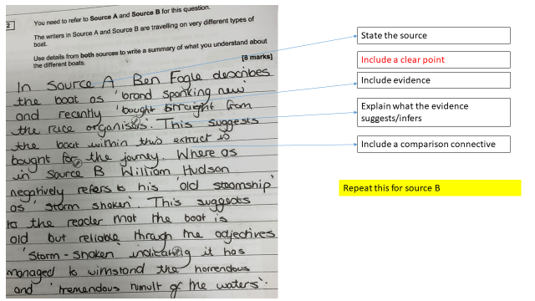

Question 3: Language
This is exactly the same as Paper 1 Q2. It is just worth 4 more marks.
Big Method | Definition
Simile | Comparing one thing to another using the words ‘like’ or ‘as’ The teacher was like a snarling lion.
Metaphor | Describing something by saying it is something else. The teacher is a snarling lion
Personification | Giving human characteristics to something that is non-human The evil wind laughed in my face
Imperatives | An order or command. Sit down and be quiet!
Emotive language | Language that has an emotional effect on the reader and makes them feel strong emotions. The starving boy wiped the tears from his dirty face
Rhetorical questions | A question designed to make the reader think carefully about the answers. What do you want from life? Success? Happiness?
Triplet | A number of connected items or words – commonly adjectives. The clouds were plump, dense and a miserable grey.
Juxtaposition | Two ideas that contrast each other. It was the best of times, it was the worst of times
Semantic field | A set of words (or lexemes) related in meaning. E.G Sailing: they will surely use words such as ocean, waves, sea, tide, blue, storm, wind, sails, mast etc.
Symbolism | An object representing another, to give an entirely different meaning that is much deeper and more significant. E.G. A dove is not just a white bird. It symbolises peace and purity.
Repetition | When a word, phrase or idea is deliberately repeated for effect
Language Methods
‘Mini Methods’
Noun | Naming words that might refer to a person, place, thing or idea
Adjective | Describe a noun or pronoun.
Verb | Action/doing words
Adverb | Words which give extra information or describe a verb
Pronoun | A word used to replace a noun e.g. She, he, it, them.
Alliteration | A number of words, having the same first consonant sound, occur close together in a sentence
F – Flattery/facts
I – Imperatives
R – Rhetorical questions
E – Emotive language/exaggeration
T – Triplet
R – Repetition
A – Alliteration/anecdote
P – Pronouns
S – Superlatives/statistics

Paper 2 Q3 10/12
On the cycling extract

The writer uses language to show the danger and fear she felt during her first experiences of cycling. The use of simile ‘as nervous as a hare that feels the greyhound’s breath’ is one example of this. This comparison between a small hare about to be hunted by a large deadly hound and her as a small, exposed cyclist being hunted by the large hansom cabs and omnibuses shows the danger of cycling. The hare that feels the greyhound’s breath is very close to being killed after trying to escape and run away which suggests that she also felt she was close to death as the horses and carriages approached her. This comparison gives the reader an image of this hare being hunted and chased down and so is a symbol of the thrill and danger felt by the hare or in this case the writer.

The writer also shows that her experience was very overwhelming. She uses exaggeration and hyperbole when describing how she felt after the experience ‘I shall never forget my terror’, and she was left in a state ‘bordering on collapse’. Saying she will never be able to forget suggests it was traumatising and too much for her to handle, as she was left almost about to faint. This is a clear reflection of how chaotic the road must have been as something as simple as cycling has left her so overwhelmed.

The writer’s use of metaphor comparing Sloane Street to ‘stormy oceans’ paints a picture in a reader’s head and enables them to imagine this hectic scene which was so chaotic they wouldn’t even be able to begin to imagine and so it must be compared to an ocean, something natural the reader will be more familiar with. A ‘stormy ocean’ is a reflection of the danger of being in the road.

What. How. Why X3

MESSI X3

Question 4: Comparison of Methods
How to answer:
X3-4
Source A Method (What)
Evidence
Effect on reader and writer’s intentions FITU (How)
Analysis/Inference (why)
Comparison connective
Source B Method (What)
Evidence
Effect on reader and writer’s intentions FITU (How)
Analysis/Inference (Why)

Paper 2 Q4 10/16

Both try to convey their perspectives in similar ways, however due to one narrative – source A being from 2016 and source B being written by a Countess in 1896 they are conveyed differently.

Susan, using the method of metaphoric language “prey” projects she feels uneasy cycling, however she shows her sarcastic humour to maybe demonstrate she wasn’t in mortal danger, “streets would be nicer” implying the streets aren’t that bad and there is room for improvement however the use of the hyperbole “try to kill me” comes back to the fact she felt like “prey” and something was trying to kill her.

Whereas Peter Walker’s viewpoint is incidents are also caused by “the deliberate” actions of road users, mirroring what source B felt. Peter then goes on to use statistics to backup his viewpoint “2 million miles” before an accident on a bike would occur. Peter shows his pro-bike attitude with the adverb “pathetically” placing emphasis on what his view on other users not on bikes.

Susan focus is mainly negative towards the other vehicle drivers “inflicting torture”, this leads us to believe she felt intimidated and vulnerable compared to the other drivers. Peter also agrees it is “about the person”, but not the form of transport using emotive language “grasp” to make you aware this is his main point.

Peter Walker writes this article to educate drivers of the road by using direct speech “next time you’ve” to encourage drivers to think about what cyclists will do next “potholes” may encourage to cyclist to go in (illegible) of road.

Paper 2 Q4 14/16
In source A and source B, it can be inferred that drivers enjoy the danger and chaos they cause to cyclists. Source A uses adverb ‘gambling’ and repeats this idea in the metaphor ‘roll of the dice’ to show that not only are they taking a chance on people’s lives but enjoy the thrill of it, however, it is always a losing game as overtaking the cyclist ‘had all been for nothing’ as it just puts the cyclists in danger. This shows the reader the huge risk the drivers are playing for the little reward, so the reader understands the frustration of the cyclists.

This idea is repeated in source B, where the opening starts with a short sentence that describes the cab drivers monstrous activities as a ‘new sport’, showing the fun and enjoyment the drivers seem to receive from putting the cyclist through a stressful situations for a game of cat and mouse, with the defenceless cyclist being the ‘prey’. This short, simple sentence increases the tension and gets the reader’s full focus to the barbaric minds of the ‘drivers of hansome cabs; and the sarcasm that it isn’t fun at all for the cyclist.

The stress of the cyclists is shown vividly in source B using the metaphor ‘burning my fate into the traffic’ contrasted with the simile ‘as nervous as a hare that feels the greyhound’s breath’. Burning is a powerful adverb that suggests the cyclist is making a bold influence on the traffic, or perhaps could suggest that there is no changing her fate as it is already burnt onto the pavement. The fact that she is nervous could be a foreshadowing to the events that would occur and how she is paralysed to stop them, as her life is in the driver’s hands.

Although not as vivid and descriptive, the writer in source A still shows the mental stress cyclists are open to, as they are described as, ‘vulnerable’ and road users are metaphorically ‘cocooned within a ton of metal’ to show how because they're protected, they are more likely to make risks and have a catastrophic effect on people. The writer helps back this up by using the statistics of the damage that can be caused by a driver at 120mph compared to 30mph, and tries to place the responsibility back on the drivers to show their effect on cyclers in the city.

Question 5: Viewpoint Writing

What you get marks for:
Mark out of 24
Mark out of 16

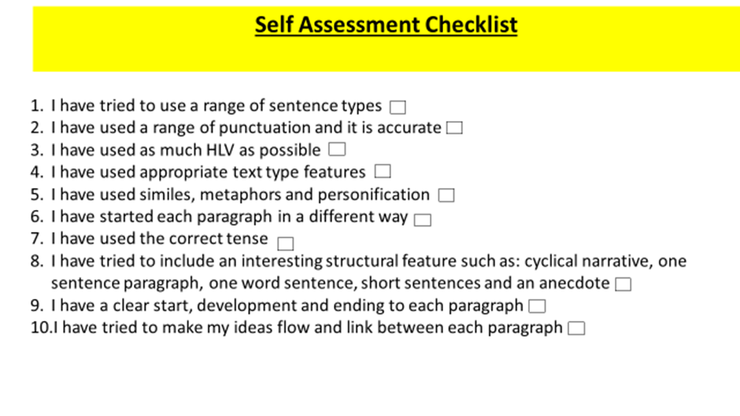
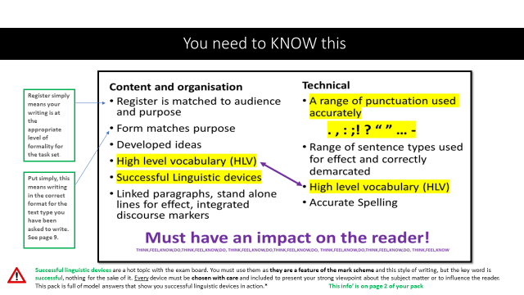

Response 2: 25/40
Question: ‘Snow seems like it is picturesque, exciting and fun but in reality it causes accidents, inconvenience and economic disruption.’
Write an article for a broadsheet newspaper in which you explain your point of view on this issue.

To a certain extent, I agree with the statement for several reasons - snow does look exciting and fun especially for younger children but it is mainly a hazard and dangerous for them too. For example many young children like to play in the snow but it causes accidents for them when they slip and bang their head on the floor. However, it is not just young children but older adults such as the elderly too. For example the elderly struggle to walk anyways on a daily basis and when it snows, it creates an even bigger hazard for them as they can’t step out the house for important reasons such as medical appointments. Therefore it creates a danger for both the elderly and young children.
It is proven that 48% of people have fallen in serious injuries due to the snow, so wouldn’t you say that it is a danger for them?

Another problem or distruption that it causes is about school: many schools like to be open when it snows as they clear it away and put grit on the roads for people to drive, However - I would still say that it causes a distruption as students find it difficult to attend this day. Many students who live further away from school come on a bus and most buses are shut on this day so it causes disruption for them. It is proven that 73% of schools in the UK continue to be open when it snows so the majority of students still have to attend this day. Also it causes a problem for those students who are able to attend as most students do not attend and less ons aren’t on as normal and so they miss out on their education. So wouldn’t you just agree and say that snow isn’t all a show; it causes more problems than excitement?

Linked to this, I would also say that it causes a problem for people who work. People who have important jobs are not able to take this day off such as doctors as they need to continue and fight for people’s lives and it causes a transport problem for them as roads don’t get cleared off early in the morning or during the night. I would say that it’s not fair for some people to work and for some people to not.

On the other hand, to a small extent I would disagree with the question because when it snows, young children like to play outside and have fun and it creates a little excitement in their life. It is proven that 77% of children have snowball fights and play with the snow. It only snows once or twice a year and so they don’t get this opportunity every day, so therefore I would say that snow is fun and exciting, wouldn’t you?

In conclusion, overall I would say that it causes more disruptions and problems for people rather than excitement and so I agree with the statement. Wouldn’t you also agree with me?

Response 4 36/40

Snow. The joy and/or sorrow that floods into our bodies when we wake up in the morning to see that cars are camouflaged into the driveway by a wash of a white substance.

Snow. Thinking of endless things to do on our bucket list of the day which somehow always manages to include the outdoors, i.e. building a new friendly snowman (before it melts into the ground later), sledging down a steep hill for a local (and free) exhilarating ride, and snowball fights with the ones you love.

Snow. It somehow excites you and motivates you for the most common thing associated with the cold weather; Christmas time. “I’m dreaming of a White Christmas”, unless of course the snow randomly comes in April time (which is no surprise for the British weather), and Christmas Day ends up looking like any other normal day. The snow makes the day special, no matter what the occasion.

It is also a tell-tale sign of the utterly ecstatic feeling of soon recieving the news that work or school is cancelled. That, my friends, is why you want to thank the snow. Work being cancelled for the day is the best possible outcome.

Snow. It isn’t just linked to brilliant events taking place, but what about its appearance? The crisp white colouring is the definition of picturesque, created by Mother Nature herself. Watching out of your window in your pyjamas as a five-year-old Kid, gazing at the aesthetically pleasing miniscule snowflakes that clump together, to create a gigantic wash of mouldable ground. The cars being camouflaged into the driveway by a wash of a white substance. The overall joy that floods into our bodies.

What about the negative aspects? Surely, after what I’ve just described you’d think that they don’t exist. But they do.

Snow. It is a force to be reckened with. You may think that we have the upper-hand but you are sadly mistaken. The snow can make your practical day a living nightmare. Let’s create a scenario. You have planned this day for weeks; visiting family down south in the hope to catch up before Christmas Day. Seems simple, right? Wrong. You have to catch two trains, with a fifteen-minute drive to the Station, and a 20 minute drive to your parents’ house. Of course on a normal day, this would be simple but tiresome. However, when you wake up and snow/a wash of white fills up in your eyes, suddenly annoyance creeps up your spine. It is now your enemy. The snow is too thick, therefore the trains and buses are cancelled, and traffic is never-ending doom. Inconvenient cars are the only option to travel, along with walking. Vehicles are dangerous in this weather; skidding, slipping and sliding. There is the risk of no control, leading to accidents.

When snow is fresh, it is fun most of the time. However, the real problem lies when it melts into thin ice. In my opinion, slippery roads and pavements are the worst conditions. Vehicles instantly have a loss of control which could lead to frightening events occuring. However, being a pedestrian, there is always the chance of falling over and being publically embarrassed. Although it is not much of a big deal, no one likes being laughed at. This is the sorrow that floods into our bodies.

Snow. You either love it, or hate it. You can decide.

Response 7: 40/40

TO FALL OR FLY

Every parent has experienced the indescribable joy when they see their child for the first time, and feelings of an uncontrollable protective nature are difficult to suppress. As a parent, it’s an undisputed duty to look after your child;- your kin; your flesh and blood – because their safety means everything in the world. You teach them how to cross a road; you teach them their abc’s, how to ask for help, what to do if they’re lost and don’t know where their mummy or daddy is. It’s an innate desire to protect, and it only becomes more difficult in those formative adolescent years when it’s expected for parents to let go. But nowadays, more than ever, it seems that parents have become more and more unwilling to allow their children to leave the nest.

It’s undisputed that the world is full of dangers, even more so now with the ever-present fear of discriminatory attacks or being in the wrong place at the wrong time falling victim to a bomb or a gunman. A study run by a child safety agency asked parents with children between the ages of 13-18 if they would allow their children to be outside with friends after six o’clock. Shockingly, only a meagre 29% said they would allow it: the other 71% spoke of the danger the evening may bring as well as the dangers of the dark. However, it’s honestly ridiculous, almost ludicrous, that such low numbers would approve something so small. Going out to meet friends is such an important part of building your child’s social skills: To be exposed to more people opens their mind to more opinions and worldviews and allow them to challenge old beliefs to discover who they are and what they believe in.

It’s certainly important not to turn a blind eye to the dangers of the world, but one must remember to be realistic. Modern parenting has become nearly synonymous with over-protectiveness and being overbearing. Though done with the best intentions, such parenting only paves the way for an uncultured, awkward generation terrified of leaving the house through an ingrained sense of fear. Every teen partakes in idiotic and sometimes dangerous activities once in a while, but lessons on safety and teamwork are always learned by the end of the experience.

True learning is through experience, not lectures, and a repression of your children’s true desires to have adventure will only work against you when they turn to adulthood, as a spiral of rebellion will begin once free of your chains of protection.

No parent wishes for their child to get injured, but sometimes they need to get hurt in order to learn how to heal. They’ll build strength, and an allowance of adventurous behaviour will only build a more trusting, truthful behaviour between parents and children and will only create more candid conversations about safety. This sense of honesty and trust will stay with them for the rest of their lives, and an allowance for risky behaviour will allow your children to assess difficult future situations with insight and experience in order to tackle the problem effectively.

This is not a notice to say to allow your children to do drugs or take part in a gang – such activities are undoubtedly dangerous and will add nothing to your child’s life. This is simply a reminder to reassess your parenting beliefs and let your child experience the world, as you had to when you were young.
Let your children be adventurous. Let your children make connections. Let your children rock climb: let your children bungee-jump. They’ll thank you for the opportunities, and for your understanding that sometimes you have to fall before you can fly.

