

Year 11 Revision 2020 21

Mastering Science
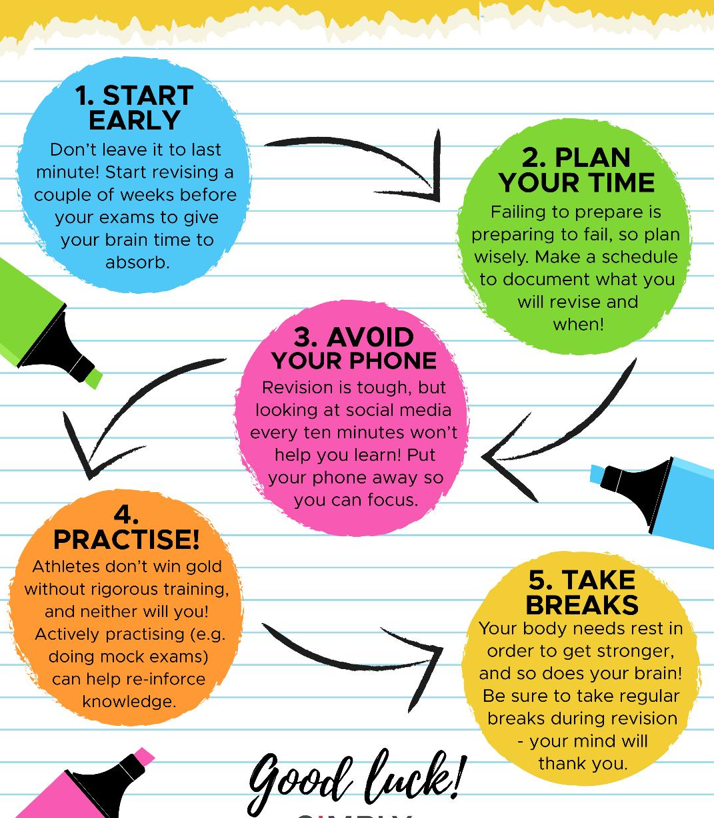

Paper 1 Revision Timetable 11–Science GCSE (Higher and Foundation)

Put in your own dates to map out your revision. You should spend about 15-45 minutes on revision each day. If you are stuck, ask a science teacher to go through the topic with you.
Foundation do not do work in bold or in red box in book

DATE | Paper | Topics | Revise | Practice | Review | Completed
 | 1 | Atomic structure and the periodic table | 88-93 | 110 | 128-129
 | 1 | Cell biology | 16-23 | 34-35 | 56-57
 | 1 | Energy | 170-173 | 181 | 201
 | 1 | Bioenergetics | 46-49 | 61 | 82
 | 1 | Chemical changes | 114-119 | 132-133 | 150-151
 | 1 | Organisation | 24-31 | 37-38 | 58-59
 | 1 | Structure bonding and the properties of matter | 94-101 | 111-112 | 129-130
 | 1 | Atomic structure  Particle model of matter | 212-217  210-211 | 224-225  222 | 228-229  227
 | 1 | Infection and response | 40-45 | 60 | 80-81
 | 1 | Quantitate chemistry | 102-105 | 112-113 | 131
 | 1 | Energy changes | 120-121 | 134 | 152
 | 1 | Electricity | 188-197 | 204-205 | 219-221

