Tess of the d’Urbervilles: Guided Reading
Use these questions to focus your independent reading: provide evidence that you have thought about these questions in relation to each Chapter. (These can be quick bullet points)
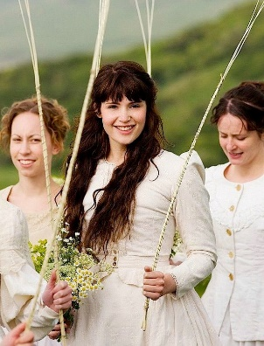
Phase the First: The Maiden
Ch1: To what does the title of the first Phase infer? What expectations does this title set up for us?
Ch2: What is the symbolism of the May day dance? What is the specific symbolism associated with Tess?
Ch6: What are the implications of the way in which Mrs Durbyfield prepares Tess for the journey? What does this show about her role in the family?
Ch11: What can you infer about Hardy’s depiction of The Chase and his narration? How does this relate to the novel’s time of publication?

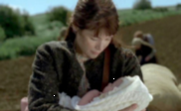
Phase the Second: Maid No More
Ch12: Try to identify characters’ different attitudes towards extra-marital sex (Alec, Joan, the local community, society at large and of course, Tess herself)
Ch13: Where do Tess’ feelings of shame come from? How and why does Hardy’s narrator undermine this judgement of her past?
Ch14: How is pathos created for Tess and Sorrow?
Ch15: How does Hardy use nature to convey the passing of time and also conclude this phase of Tess’ life?
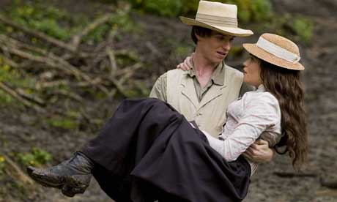
Phase the Third: The Rally
Ch16: How is pathetic fallacy used to reflect Tess’ more hopeful feelings about this new beginning in her life?
Ch18: How is religious doubt presented in this chapter? What omens are there of future violence/death?
Ch20: Do you think readers are aware of Angel’s idealised view of Tess of are also swept along by this romantic/optimistic development in Tess’ life?
Ch21: In Tess’ doubts, how is Hardy commenting on Victorian ideas about gender, class and marriage?

Phase the Fourth: The Consequence
Ch26: What can you infer from Angel’s meeting with his family and his telling them he intends to marry Tess?
Ch30: What troubling cues does Tess attempt to give Angel before their nuptials? Why does him calling her ‘Mistress Theresa d’Urberville’ so distress her?
Ch32: What old ballad occurs to Tess as she tries on her wedding garments. What do you think Hardy’s intent is here?
Ch34: What motivates Angel’s choice of honeymoon residence? Consequently, which aspect of the house does Tess find alarming?

Phase the Fifth: The Woman Pays

Ch35: How many different reasons does Angel give for rejecting Tess? In your opinion, is Tess too accepting of his decision or does she show some insight in this chapter?
Ch36: What faults surface in Angel’s character in this chapter? How can you compare Angel and Alec’s betrayal/mistreatment of Tess so far?
Ch41: Early critics were quite negative about the coincidences that abound in the novel: who reappears from Tess’s past? How does Tess’ pride increase her distress in this chapter?
Ch42: How does Hardy keep provoking our pity? What is the lowest point for Tess in this chapter?
Ch44: How does Hardy use the narrative voice to increase the tragic impact of events in this chapter?

Phase the Sixth: The Convert

Ch46: How convincing is Alec’s conversion? How does he still try to manipulate Tess, even when he is trying to find ’sanctification for them both’?
Ch47: Alec becomes aggressive and fixated upon Tess once again in this chapter. As a villain, can you find any appealing or redeeming characteristics or do you think we are meant to completely despise him?
Ch50: How does Hardy try to stop us condemning Tess for returning to Alec? Why do you think this was important to Hardy?
Ch52: Why is the setting of the d’Urberville Vault significant at this moment in the novel?

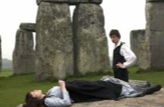

Phase the Seventh: Fulfilment
Ch54: This chapter can seem like a pilgrimage or a symbolic journey of penance for Angel. Why do you think it’s important for Angel to visit Flintcomb Ash, Marlott, Kinsbere, Joan’s new home and finally, Sandbourne?
Ch55: Is it really “too late”? What makes Tess think it is? Which key quotes would you choose that really encapsulate the heartbreaking nature of their situation? Tess and Angel’s appearance have both dramatically changed - what is the significance of this?
Ch56: Mrs Brooks is used as a narrative device in this chapter - is Hardy successful in building tension to this climactic event? Are we meant to condemn or sympathise with Tess’ actions?
Ch58: Why does Hardy locate the climax of his story at Stonehenge? Look carefully at the way the setting is described.
Ch59: Is the ending convincing? Satisfactory? Why?

