Year 10 Music AP1-Revision Material
Key Vocabulary
Tempo | The speed of a piece of music
Dynamics | The volume of a piece of music
Texture | The layers of sound and the way they are arranged
Metre | The time signature (how many beats per bar)
Instrumentation | The instruments you can hear and their specific instrumental techniques
Tonality | The tone of the music
Rhythm | The arrangement of long and short notes
Melody | The main tune
Structure | The layout of the music
Harmony | The chords used within the music-Consonant or disonant

Tempo
Adagio | Slow
Andante | At a walking pace
Allegro | Fast
Vivace | Lively
Presto | Very fast
Accelerando | Gradually getting faster
Rallentando | Gradually getting slower
Rubato | Free of time

Dynamics
pp | Pianissimo | Very quiet
p | Piano | Quiet
mp | Mezzo Piano | Moderately quiet
mf | Mezzo Forte | Moderately loud
f | Forte | Loud
ff | Fortissimo | Very loud
 | Crescendo | Gradually getting louder
 | Decrescendo | Gradually getting quieter

Tonality
Major | A term used to describe certain intervals within a piece of music that create a ‘happy’ sound to a piece of music.
Minor | A term used to describe certain intervals within a piece of music that create a ‘sad’ sound to a piece of music.
Atonal | The absence of functional harmony as a primary structural element. The music cannot be described as major or minor.

Types of Voice
Soprano | Highest female voice
Alto | Lowest female voice
Tenor | Highest male voice
Bass | Lowest male voice

Instrumentation-From highest to lowest instrument in each family
The String Family  Violin  Viola  Cello  Double Bass  Harp | The Woodwind Family  Piccolo  Flute  Clarinet  Oboe  Bassoon
The Brass Family  Trumpet  Trombone  French Horn  Tuba | The Percussion Family  Timpani Glockenspiel  Cymbals Xylophone  Triangle Woodblock  Maracas  Bongos  Congas

Time Signatures-Metre
2/4 or 4/4 | 2 or 4 crotchet beats per bar-typical of pop, rock and reggae music. Prevalent in classical music too.
3/4 | 3 crotchet beats per bar-waltz
6/8 | 6 quaver beats per bar. Typical of folk music and gigues.

Texture
Monophonic | Music with a single melody line only.
Homophonic | All parts moving together as chords or melody and chordal accompaniment.
Melody with Accompaniment | A melody with a chordal accompaniment e.g. a pop song
Polyphonic | Music that contains two or more melodic lines simultaneously.
Unison | One melody is performed by multiple voices or instruments simultaneously at the same pitch.
Octaves | The same melody is played simultaneously in different pitches 8 notes apart.
Acapella | Without instrumental accompaniment. Unaccompanied vocal music.
Canon | When voices or instruments sing or play the same music starting at different times. E.g. A round

Key Signatures-Sharps
C Major | 0 | N/A | 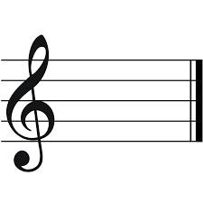 | A Minor
G Major | 1 | F# | 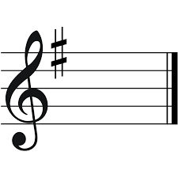 | E Minor
D Major | 2 | F# C# | 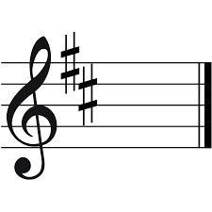 | B Minor
A Major | 3 | F# C# G# | 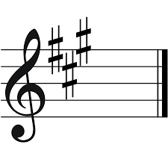 | F# Minor
E Major | 4 | F# C# G# D# | 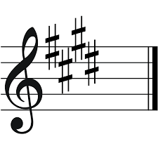 | C# Minor
B Major | 5 | F# C# G# D# A# | 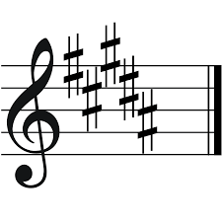 | G# Minor
The relative minor is worked out by moving down three semitones from the tonic of the major key.
We use the phrase ‘Father Christmas Gave Daddy An Electric Blanket’ to remember the order of the sharps in a key signature.
Key Signatures-Flats
C Major | 0 | N/A |  | A Minor
F Major | 1 | Bb | 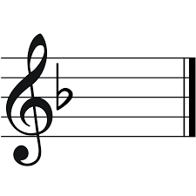 | D Minor
Bb Major | 2 | Bb Eb | 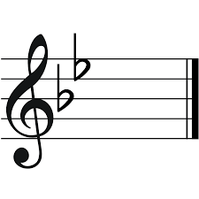 | G Minor
Eb Major | 3 | Bb Eb Ab | 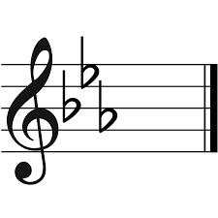 | C Minor
Ab Major | 4 | Bb Eb Ab Db | 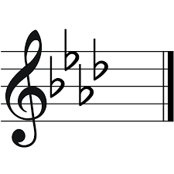 | F Minor
Db Major | 5 | Bb Eb Ab Db Gb | 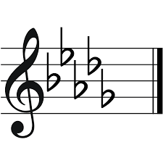 | Bb Minor
We use the phrase ‘Because Every Afternoon Daddy Gets Cold Feet’ to remember the order of the flats in a key signature.

Interval | Visual |  | Sound |  | Interval |  | Visual |  | Sound
Minor 2nd |  | 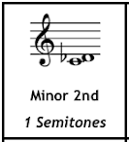 |  | Jaws (main theme from the movie soundtrack) |  | Minor 6th |  | 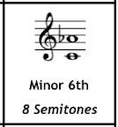 |  | The Entertainer (Scott Joplin)
Major 2nd |  | 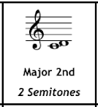 |  | Happy Birthday (the distance between ‘happy’ and ‘birth’) |  | Major 6th |  | 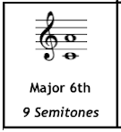 |  | My Bonnie lies over the Ocean (the distance between ‘My’ and ‘Bon’)
Minor 3rd |  | 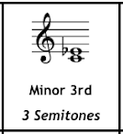 |  | Lullaby (Brahms) |  | Minor 7th |  | 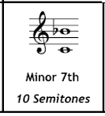 |  | Somewhere-West Side Story (the distance between ‘There’s’ and ‘a’)
Major 3rd |  | 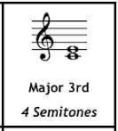 |  | Oh When the Saints (the distance between ‘Oh’ and ‘when’) |  | Major 7th |  | 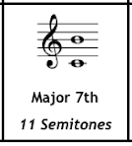 |  | Take on me (the diatance between ‘Take’ and ‘on’)
Perfect 4th |  | 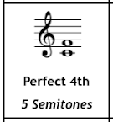 |  | Here Come the Bride (the distance between ‘here’ and ‘comes’) |  | 8ve |  | 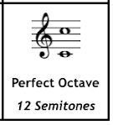 |  | Somewhere Over the Rainbow (the distance between ‘Some’ and ‘where’)
Perfect 5th |  | 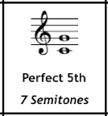 |  | Twinkle Twinkle Little Star (the distance between ‘Twinkle’ and ‘twinkle)

