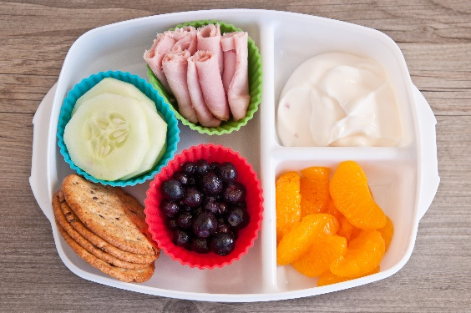
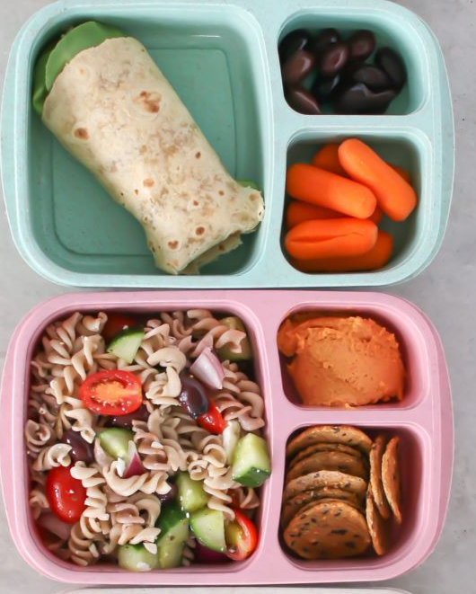
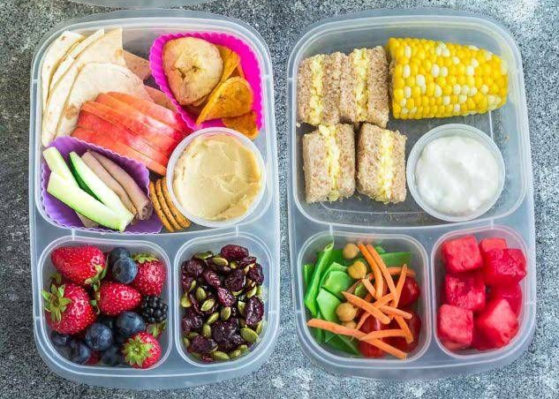
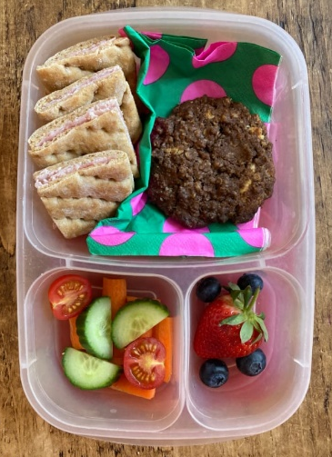
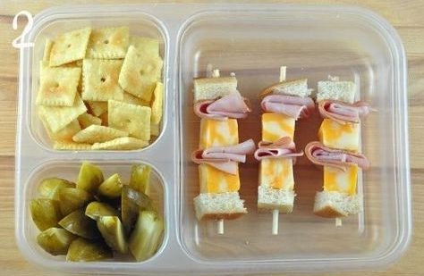
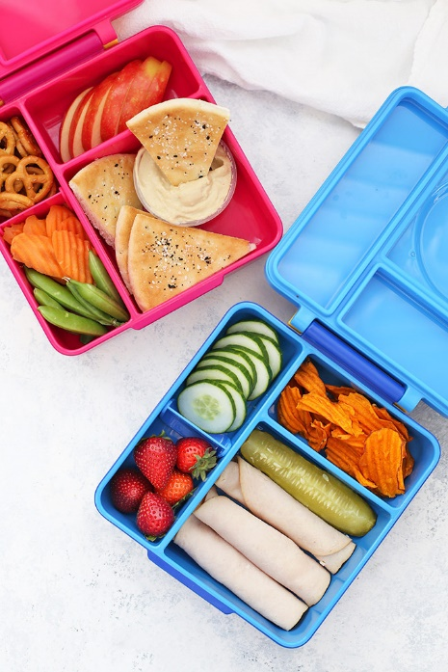
Can they open everything independently?
Being able to eat items in any order.
Lunch box ideas!
Manageable pieces- remember to cut food length ways to avoid choking.
Portion sizes- a variety of small amounts!
Websites with useful information
Lunchbox ideas and recipes – Healthier Families - NHS (www.nhs.uk)
Kids Eat in Color - Kids Eat in Color
First Steps Nutrition Trust

Colourful and appetising!

Limit the sugar intake.1 sugary item is enough e.g just 1 biscuit or just 1 yoghurt or just 1 pudding.

