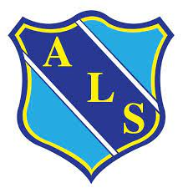
EYFS HALF TERMLY NEWSLETTER – Summer 2
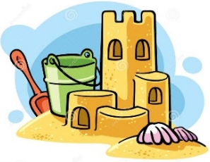
We hope you all had a wonderful break with your families. We are looking forward to all our exciting learning in our final half term.
Dairy Dates
Nursery
Monday 10th June- Healthy Eating Week
Wednesday 12th June- Parents meeting for school starters at 6pm
Wednesday 19th June- Nursery Sports Day 9:15-10:15am
Tuesday 25th & Wednesday 26th June- transition afternoons
Tuesday 2nd & Wednesday 3rd July- transition afternoons
Monday 8th July- Kandinsky Week
Stay & Play, all 2-3pm- 9th Zebra’s/ 10th Elephant’s/ 11th Tiger’s
Tuesday 16th July- Box Day
Wednesday 17th July- Pre-school leavers assembly 9:15-10am/ party in the afternoon
Reception
Monday 17th June- Class worship 3pm
Tuesday 18th June- Sports Day (Infants) 2:30pm
Monday 1st July- Move up Day (Year 1)
Friday 5th July – Pirate Day

Nursery

This half term our theme is
‘Let me entertain you’
The children will be learning about famous singers and dancers. We will be performing songs and poems as well as trying to write our own. If any of our parents have a talent that they would like to share with us then please let us know!
We will also be looking at different occupations. We will be inviting parents in to talk about their jobs. Email Miss Rushton if you are interested.

Reception

This half term our theme is
‘Sandcastles and Suitcases’
The children will be learning all about the seaside, now and in the past. We will make puppets and perform an Under the Sea themed puppet show. We will learn about summer and talk about going on holiday. We will also learn about life under the sea and how we can look after our environment. We will enjoy listening to and talking about lots of stories.
We will finish off our topic with a special pirate day!

