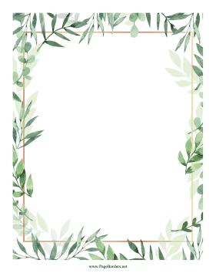
Expressive Art and Design
In Music, the children will listen to and appraise Funk music. Through fun games, they will develop and embed the foundations of the interrelated dimensions of music using voices and instruments. They will enjoy learning to sing Big Bear Funk and revisiting other nursery rhymes and action songs previously learnt. They will improvise using their voices and instruments and they will learn a riff-based composition which they will perform to a wider audience.
Physical Development
Our PE lesson will continue to be on a Tuesday morning. Our topic in PE is Seaside. The children will take part in lots of races and activities on Sports Day. The children will also learn to draw pictures with increased accuracy and detail.

Personal, Social and Emotional Development
The children will work and play cooperatively and be confident to try new activities.
Our focus this half term in PSHE is ‘Growing and Changing.’
Understanding the World
The children will be learning all about the seaside, now and in the past. We will learn about the seasons and talk about going on holiday. The children will know signs of summer and talk about the changes in the seasons throughout the year. We will also learn about life under the sea and how we can look after our environment.

Core Stories
The Lighthouse Keeper’s Lunch by David Armitage
The Sea Saw by Tom Percival
Somebody Swallowed Stanley by Sarah Roberts

Literacy
We will make puppets and perform an Under the Sea puppet show. The children will learn how to use a non-fiction text to find information about the seaside. We will write a short story about a sea creature.

EYFS Summer 2 Topic Overview – Sandcastles and Suitcases
Maths
In Maths, we will enjoy playing lots of problem-solving games and explore the relationship between numbers.
We will continue our learning about doubling and identifying odd and even numbers. We will learn how to share and group objects in different ways. We will use positional language to describe where an object is.
Communication and Language
The children will be encouraged to listen attentively and respond to what they hear with relevant questions and comments. They will offer explanations for why things might happen, making use of recently introduced vocabulary from stories, non-fiction, rhymes, and poems. The children will have lots of opportunities to share experiences from their lives using full sentences including use of past, present and future tenses. We will explore our talking basket in the first week of the half term.
Please visit our class page on the website for weekly updates of our learning in school.

