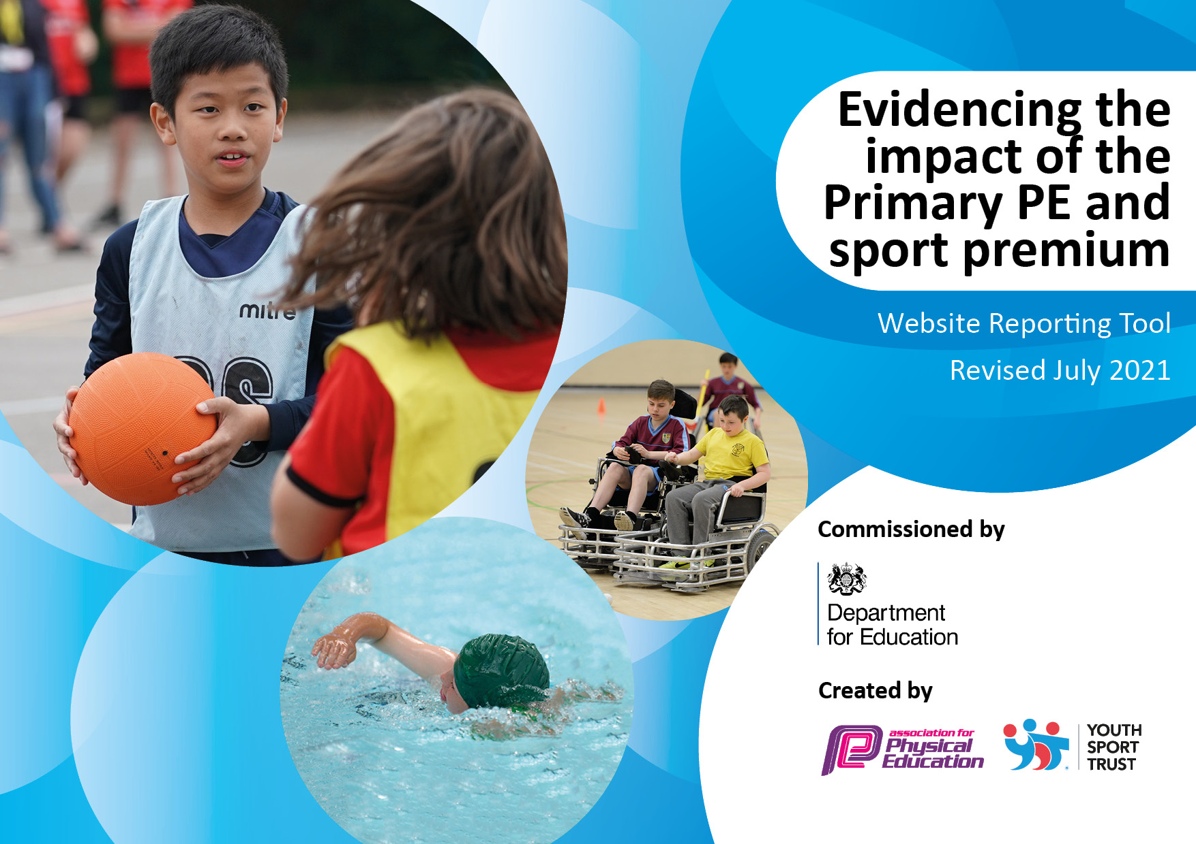
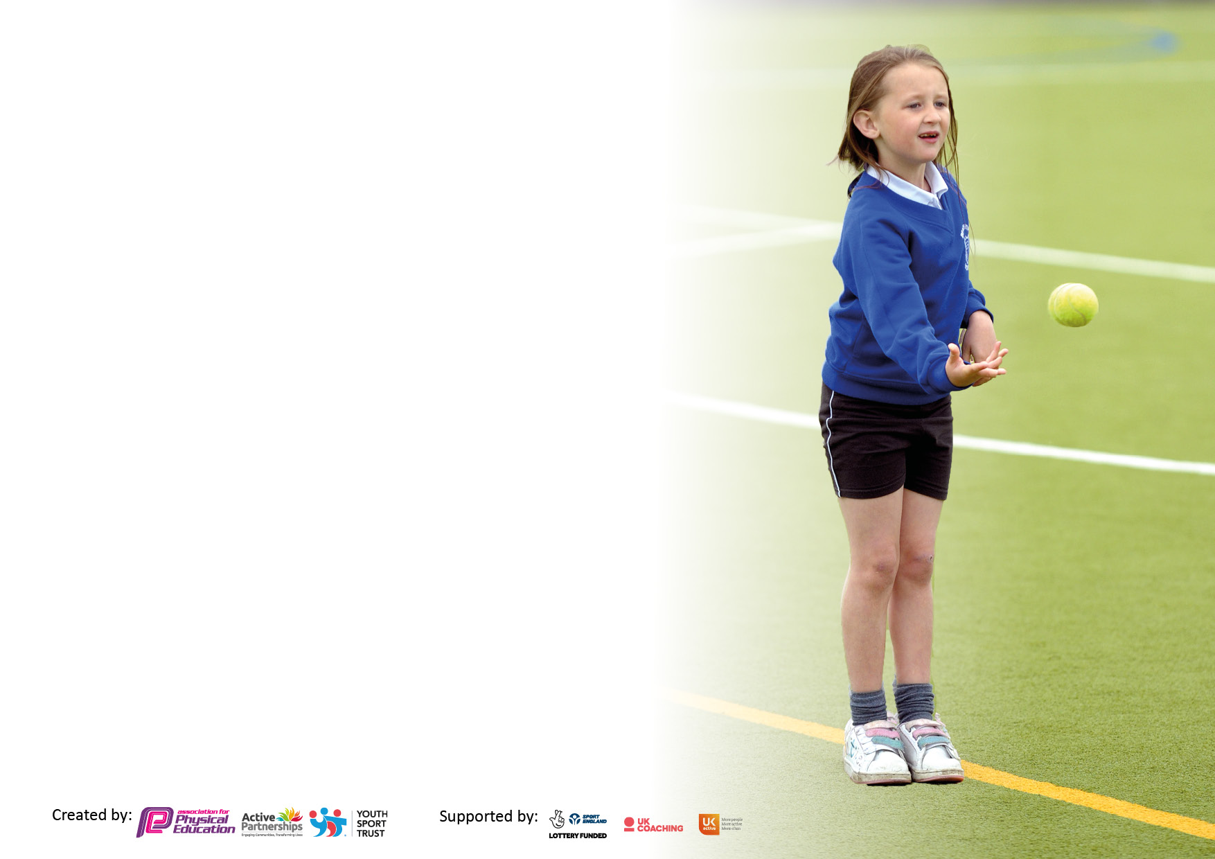

It is important that your grant is used effectively and based on school need. The Education Inspection Framework makes clear there will be a focus on ‘whether leaders and those responsible for governors all understand their respective roles and perform these in a way that enhances the effectiveness of the school’.

Under the Quality of Education Ofsted inspectors consider:
Intent - Curriculum design, coverage and appropriateness
Implementation - Curriculum delivery, Teaching (pedagogy) and Assessment
Impact - Attainment and progress

To assist schools with common transferable language this template has been developed to utilise the same three headings which should make your plans easily transferable between working documents.

Schools must use the funding to make additional and sustainable improvements to the quality of Physical Education, School Sport and Physical Activity (PESSPA) they offer. This means that you should use the Primary PE and sport premium to:

- Develop or add to the PESSPA activities that your school already offer
- Build capacity and capability within the school to ensure that improvements made now will benefit pupils joining the school in future years
- The Primary PE and sport premium should not be used to fund capital spend projects; the school’s budget should fund these.

Pleasevisitgov.ukfortherevisedDfEguidanceincludingthe5keyindicatorsacrosswhichschoolsshoulddemonstrate animprovement.Thisdocumentwillhelpyoutoreviewyourprovisionandtoreportyourspend.DfEencouragesschools to use this template as an effective way of meeting the reporting requirements of the Primary PE and sport premium.

We recommend you start by reflecting on the impact of current provision and reviewing the previous spend.

Schools are required to publish details of how they spend this funding, including any under-spend from 2019/2020, as well as on the impact it has on pupils’ PE and sport participation and attainment. All funding must be spent by 31st July 2022.

We recommend regularly updating the table and publishing it on your website throughout the year. This evidences your ongoing self-evaluation of how you are using the funding to secure maximum, sustainable impact. Final copy must be posted on your website by the end of the academic year and no later than the 31st July 2021. To see an example of how to complete the table please click HERE.
Created by: Supported by:

Details with regard to funding
Please complete the table below.

Total amount carried over from 2019/20 | £0
Total amount allocated for 2020/21 | £14983
How much (if any) do you intend to carry over from this total fund into 2021/22? | £2824
Total amount allocated for 2021/22 | £16830
Total amount of funding for 2021/22. To be spent and reported on by 31st July 2022. | £19654
Swimming Data
Please report on your Swimming Data below.

Meeting national curriculum requirements for swimming and water safety.  N.B. Complete this section to your best ability. For example you might have practised safe self-rescue techniques on dry land which you can then transfer to the pool when school swimming restarts.  Due to exceptional circumstances priority should be given to ensuring that pupils can perform safe self rescue even if they do not fully meet the first two requirements of the NC programme of study | 33%
What percentage of your current Year 6 cohort swim competently, confidently and proficiently over a distance of at least 25 metres?  N.B. Even though your pupils may swim in another year please report on their attainment on leaving primary school at the end of the summer term 2021.  Please see note above | 42%
What percentage of your current Year 6 cohort use a range of strokes effectively [for example, front crawl, backstroke and breaststroke]?  Please see note above | 42%
What percentage of your current Year 6 cohort perform safe self-rescue in different water-based situations? | 33%
Schools can choose to use the Primary PE and sport premium to provide additional provision for swimming but this must be for activity over and above the national curriculum requirements. Have you used it in this way? | Yes

Action Plan and Budget Tracking
Capture your intended annual spend against the 5 key indicators. Clarify the success criteria and evidence of impact that you intend to measure to evaluate for pupils today and for the future.

Academic Year: 2020/21 | Total fund allocated: | Date Updated:
Key indicator 1: The engagement of all pupils in regular physical activity – Chief Medical Officers guidelines recommend that primary school pupils undertake at least 30 minutes of physical activity a day in school |  |  |  | Percentage of total allocation:
 |  |  |  | 13%
Intent | Implementation |  | Impact
Your school focus should be clear what you want the pupils to know and be able to do and about  what they need to learn and to  consolidate through practice: | Make sure your actions to achieve are linked to your intentions: | Funding allocated: | Evidence of impact: what do pupils now know and what can they now do? What has changed? | Sustainability and suggested next steps:
Pupils will develop their skills in specific sports through accessible lunchtime, breakfast and after school clubs.  Increase enjoyment of physical activity and access to physical activity during break times.  Trips: Tyne willows walks | NUFC Multi Sport Breakfast club – open to all KS2  After school club – Girls football  Multi sports  Training of playground leaders  New Playground Equipment  Playground markings  Curriculum walks for all KS around local area | £2,656.74 | A range of pupils across the KS accessed the club and have increased fitness levels and skill mastery within different sports such as football, basketball and other invasion games.  Pupils are more confident in attending clubs and increased team skills.  Designated playground leaders whose roles are to get the new playground equipment out and run activities with supervision from lunchtime staff.  Pupils are aware of the beautiful local walks available to them and their family. Families have reported going on these walks at weekends. | Continue next year, alternating clubs with KS1 and 2 children.  Ensure equipment is safe and purchase new when required.  Provide stronger storage boxes to keep equipment.
Key indicator 2: The profile of PESSPA being raised across the school as a tool for whole school improvement |  |  |  | Percentage of total allocation:
 |  |  |  | 11%
Intent | Implementation |  | Impact
Your school focus should be clear what you want the pupils to know and be able to do and about  what they need to learn and to  consolidate through practice: | Make sure your actions to achieve are linked to your intentions: | Funding allocated: | Evidence of impact: what do pupils now know and what can they now do? What has changed? | Sustainability and suggested next steps:
Children take part in ‘Mile a day’  Develop a sports Noticeboard  Sporting accomplishments raised in assembly | Teachers are trained in mile a day and regularly use it in lesson time as a ‘brain break’  safety of playground checked regularly  Sports noticeboard up and around school to celebrate sporting achievements and involvement.  Deputy headteachers regularly mention any sporting accomplishments to help raise the profile, produce role models and increase self-esteem of pupils. | £2,195 | Pupils enjoy the mile a day. Fitness, behaviour and readiness for learning have all improved.  Sports noticeboard up and has a high profile in school, children are pleased to share their accomplishments  Children are proud to share and grow in confidence talking about their accomplishments. | Continue next year  Continue next year  Continue next year – develop to share on our social media as well.

Key indicator 3: Increased confidence, knowledge and skills of all staff in teaching PE and sport |  |  |  | Percentage of total allocation:
 |  |  |  | 41%
Intent | Implementation |  | Impact
Your school focus should be clear  what you want the pupils to know  and be able to do and about  what they need to learn and to  consolidate through practice: | Make sure your actions to  achieve are linked to your  intentions: | Funding  allocated: | Evidence of impact: what do  pupils now know and what  can they now do? What has  changed? | Sustainability and suggested  next steps:
Staff’s physical education subject knowledge for their year group is improved through shadowing and modelling of qualified NUFC coaches.  PE Lead to become more confident in how a range of activities can make children feel empowered to take part in PE. | NUFC in school  Time given to staff to shadow  Resources shared between coaches and staff  PE Lead to oversee events at Action Ants. | £8,033.56 | Staff are becoming more confident in their subject knowledge of physical education  PE Lead has grown confident in how a range of activities can enable all children to be engaged and succeed. | Continue NUFC coaching next year  Obtain some resources to pre-teach skills needed and provide clubs at school

Key indicator 4: Broader experience of a range of sports and activities offered to all pupils |  |  |  | Percentage of total allocation:
 |  |  |  | 10%
Intent | Implementation |  | Impact
Your school focus should be clear  what you want the pupils to know  and be able to do and about  what they need to learn and to  consolidate through practice: | Make sure your actions to  achieve are linked to your  intentions: | Funding  allocated: | Evidence of impact: what do  pupils now know and what  can they now do? What has  changed? | Sustainability and suggested  next steps:
Additional achievements:  Pupils will have the opportunity to travel to engage in new and interesting activities.  For pupils to access OAA above and beyond what they would access in PE lessons. | Pupils travel to Culgaith and surrounding area to work with Action Ants and neighbouring schools to try new and excting activities.  Pupils travel to Weardale Adventure Centre and Robin Wood tp take part in exciting OAA activites | £2,065 | Pupils have really engaged and enjoyed the session with all pupils having attended at least two sessions. Pupils have tried fencing, archery, cross country running, slacklining, obstacle courses and more!  Pupils really enjoyed these sessions and they got the opportunity to try rock climbing, canoeing, gorge walking and more | Continue to engage with these sessions and take the pupils. Double our membership of this so more pupils can go more often.  Continue to go on these trips next academic year. Subsidise overnight residentials for students to increase engagement.

Key indicator 5: Increased participation in competitive sport |  |  |  | Percentage of total allocation:
 |  |  |  | 20%
Intent | Implementation |  | Impact
Your school focus should be clear  what you want the pupils to know  and be able to do and about  what they need to learn and to  consolidate through practice: | Make sure your actions to  achieve are linked to your  intentions: | Funding  allocated: | Evidence of impact: what do  pupils now know and what  can they now do? What has  changed? | Sustainability and suggested  next steps:
Fixtures against others schools  Purchase of sports kit to be worn at competitive events  We will join with the Action Ants Inter school partnership.  We will take part in competitive fixtures against other schools | Purchase T Shirts from Sam Scotts with school logo  Travel to Culgaith each half term to take part in the competitive events against other schools  Fixtures for football, rounders and other sports against other schools. | £3,767.60 | Pupils wear the T Shirts to each sporting events so that all students are recognisable and feel part of the team.  Pupils are used to travelling to Culgaith for fixtures. Pupils are able to engage in the competitive element of this.  Pupils have taken part in football, rounders and tennis against Schools from the Eden Valley. The pupils are taken on the mini bus in order to do this. | To order the pupils specific sports kits for different events.  Overalls for EYFS at Action Ants.  Continue to travel to action ants events and to engage with the new activities.  Continue to arrange and take pupils on trips to fixtures. Try and use school mini bus to do this to help keep the cost down.

Other Indicator identified by school: |  |  |  | Percentage of total allocation:
 |  |  |  | 5%
Intent | Implementation |  | Impact
Your school focus should be clear  what you want the pupils to know  and be able to do and about  what they need to learn and to  consolidate through practice: | Make sure your actions to  achieve are linked to your  intentions: | Funding  allocated: | Evidence of impact: what do  pupils now know and what  can they now do? What has  changed? | Sustainability and suggested  next steps:
For pupils to be able to receive high quality swimming tuition. | Living in an isolated area means travelling to swimming expensive and inaccessible to children from low income families. We will provide free transport to the swimming pool for all. | £1,050 | All children have enjoyed swimming lessons and have made progress from a mainly low start point. | To enable all children (including Reception) to become water confident and have quality swimming lessons.  Find a new swimming provider

Signed off by
Head Teacher: | Gill Jackson
Date: | 15th July 2022
Subject Leader: | Helen Allinson
Date: | 15th July 2022
Governor: | Natalie Hewett
Date: | 15th July 2022

