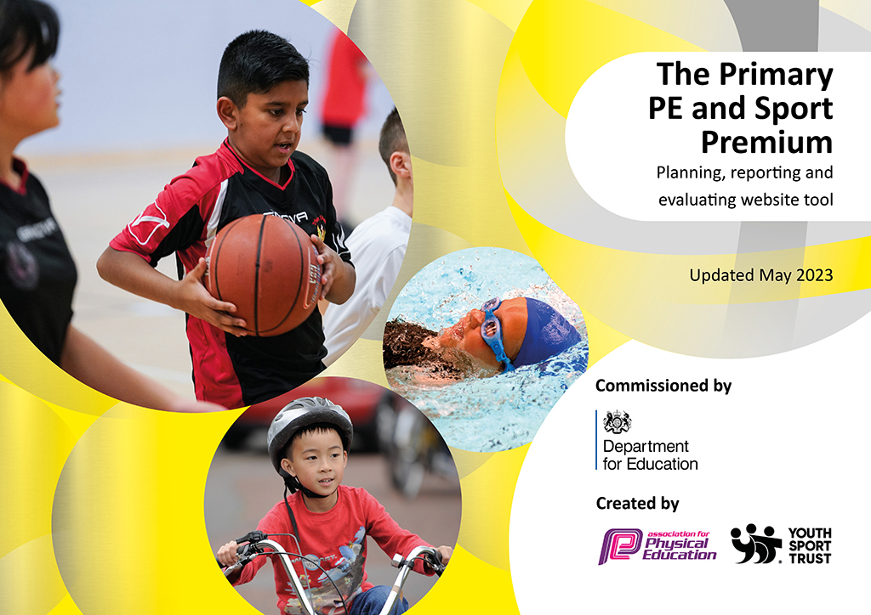
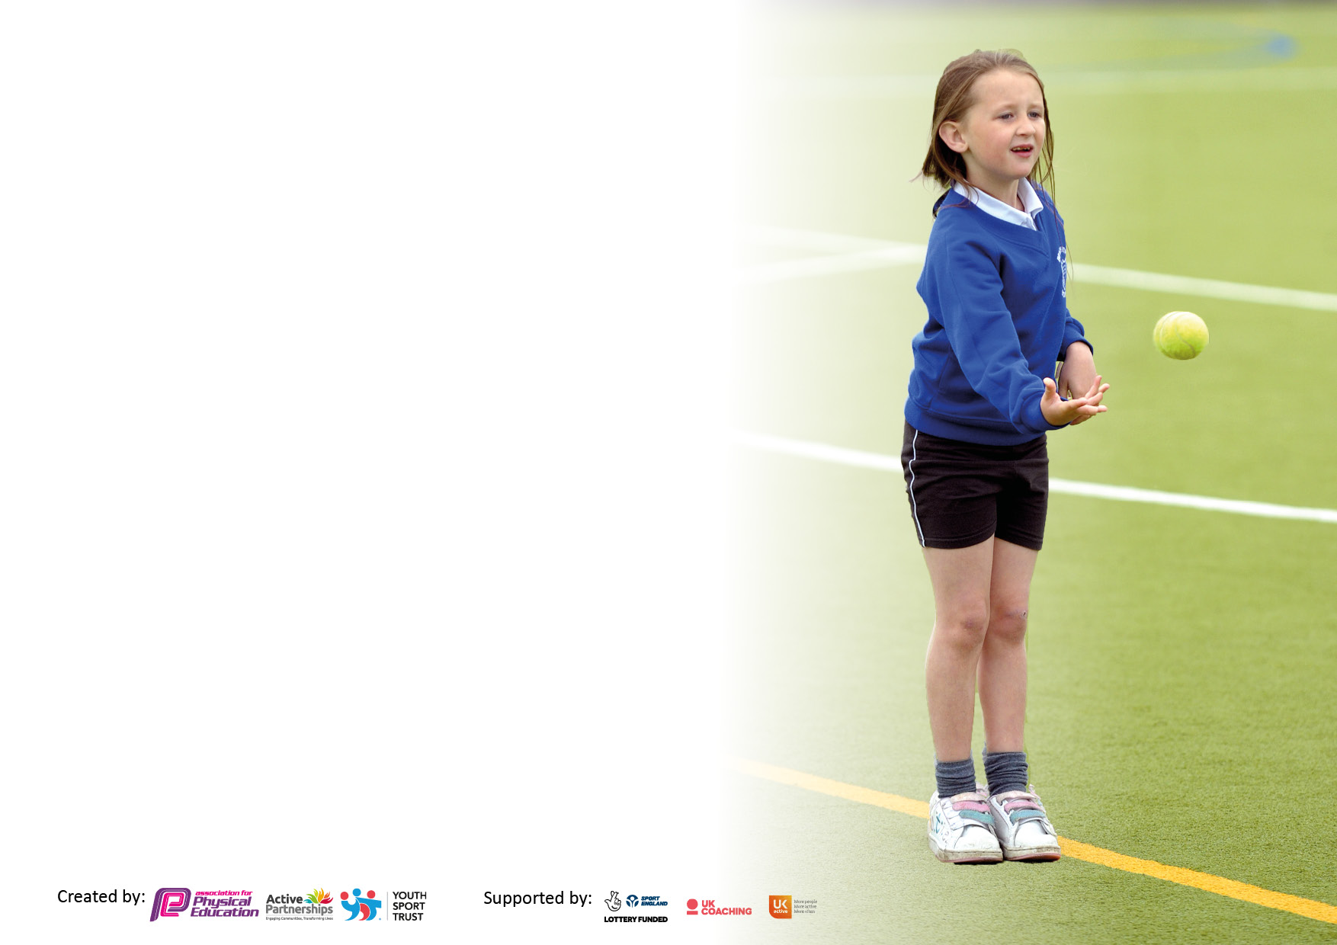

It is important that your grant is used effectively and based on school need. The Education Inspection Framework makes clear there will be a focus on ‘whether leaders and those responsible for governors all understand their respective roles and perform these in a way that enhances the effectiveness of the school’.

Under the Quality of Education Ofsted inspectors consider:
Intent - Curriculum design, coverage and appropriateness
Implementation - Curriculum delivery, Teaching (pedagogy) and Assessment
Impact - Attainment and progress

To assist schools with common transferable language this template has been developed to utilise the same three headings which should make your plans easily transferable between working documents.

Schools must use the funding to make additional and sustainable improvements to the quality of Physical Education, School Sport and Physical Activity (PESSPA) they offer. This means that you should use the Primary PE and sport premium to:

- Develop or add to the PESSPA activities that your school already offer
- Build capacity and capability within the school to ensure that improvements made now will benefit pupils joining the school in future years
- The Primary PE and sport premium should not be used to fund capital spend projects; the school’s budget should fund these.

Pleasevisitgov.ukfortherevisedDfEguidanceincludingthe5keyindicatorsacrosswhichschoolsshoulddemonstrate animprovement.Thisdocumentwillhelpyoutoreviewyourprovisionandtoreportyourspend.DfEencouragesschools to use this template as an effective way of meeting the reporting requirements of the Primary PE and Sport Premium.

We recommend you start by reflecting on the impact of current provision and reviewing the previous spend.

Schools are required to publish details of how they spend this funding, including any under-spend from 2021/2022, as well as on the impact it has on pupils’ PE and sport participation and attainment. All funding must be spent by 31st July 2023.

We recommend regularly updating the table and publishing it on your website throughout the year. This evidences your ongoing self-evaluation of how you are using the funding to secure maximum, sustainable impact. Final copy must be posted on your website by the end of the academic year and no later than the 31st July 2023. To see an example of how to complete the table please click HERE.

Details with regard to funding
Please complete the table below.

Total amount carried over from 2021/22 | £0
Total amount allocated for 2021/22 | £16830
How much (if any) do you intend to carry over from this total fund into 2022/23? | £0
Total amount allocated for 2022/23 | £16830
Total amount of funding for 2023/23. To be spent and reported on by 31st July 2023. | £ 16158.53
Swimming Data
Please report on your Swimming Data below.

Meeting national curriculum requirements for swimming and water safety.

N.B. Complete this section to your best ability. For example you might have practised safe self-rescue techniques on dry land which you can then transfer to the pool when school swimming restarts.
Due to exceptional circumstances priority should be given to ensuring that pupils can perform safe self rescue even if they do not fully meet the first two requirements of the NC programme of study
What percentage of your current Year 6 cohort swim competently, confidently and proficiently over a distance of at least 25 metres?  N.B. Even though your pupils may swim in another year please report on their attainment on leaving primary school at the end of the summer term 2022.  Please see note above | 57%
What percentage of your current Year 6 cohort use a range of strokes effectively [for example, front crawl, backstroke and breaststroke]?  Please see note above | 57%
What percentage of your current Year 6 cohort perform safe self-rescue in different water-based situations? | %
Schools can choose to use the Primary PE and sport premium to provide additional provision for swimming but this must be for activity over and above the national curriculum requirements. Have you used it in this way? | Yes

Action Plan and Budget Tracking
Capture your intended annual spend against the 5 key indicators. Clarify the success criteria and evidence of impact that you intend to measure to evaluate for pupils today and for the future.

Academic Year: 2022/23 | Total fund allocated: | Date Updated:
Key indicator 1: The engagement of all pupils in regular physical activity – Chief Medical Officers guidelines recommend that primary school pupils undertake at least 30 minutes of physical activity a day in school |  |  |  | Percentage of total allocation:
 |  |  |  | 19%
Intent | Implementation |  | Impact
Your school focus should be clear what you want the pupils to know and be able to do and about  what they need to learn and to  consolidate through practice: | Make sure your actions to achieve are linked to your intentions: | Funding allocated: | Evidence of impact: what do pupils now know and what can they now do? What has changed? | Sustainability and suggested next steps:
Pupils will develop their skills in specific sports through accessible clubs after school.  Sports equipment for clubs | All children throughout the school will take part in sports such as football, multi skills, table tennis, archery and girl’s football. | £3117.78 | KS 2 have accessed two terms of NUFC club  KS 1 have accessed one term of NUFC  We have 15 girls take part in the girl’s football  We have introduced taster sessions of archery  Breakfast club use table tennis tables | continue next year, to include regular archery and table tennis sessions for all age groups.
Key indicator 2: The profile of PESSPA being raised across the school as a tool for whole school improvement |  |  |  | Percentage of total allocation:
 |  |  |  | 1%
Intent | Implementation |  | Impact
Your school focus should be clear what you want the pupils to know and be able to do and about  what they need to learn and to  consolidate through practice: | Make sure your actions to achieve are linked to your intentions: | Funding allocated: | Evidence of impact: what do pupils now know and what can they now do? What has changed? | Sustainability and suggested next steps:
Regular recognition of both achievement and attendance of school sports competitions  Sports leaders having a voice as to what sports children have opportunity to take part in  Whole School Sports day | Children share photographs of the sports they play and any awards they get on the sports leaders board. In assembly we recognize this and children talk about what they have done.  Sports leaders take their ‘house’ group onto the MUGA once per week, they have asked for a range of resources to aid this.  All children to participate in all races, competing against children of similar ability in a fun, safe and inclusive environment.  Local SPAR to donate resources eg banner, badges and bottled water | £162.76  see above  free | children are engaging in a range of activities and are proud to share their successes. This means younger children are asking about sports such as golf and rugby.  Children enjoy engaging with their ‘House’ group and leaders play a range of games e.g. duck duck goose, egg and spoon race, tag, dance, multi skills circuits.  Parents and children have enjoyed the traditional sports day races with stickers and house points for the winners. Connection with local shop aids community engagement | to look at coaching and resources to provide these to younger children.  Look at a refresher of the playground leaders training for UKS2 children  continue next year

Key indicator 3: Increased confidence, knowledge and skills of all staff in teaching PE and sport |  |  |  | Percentage of total allocation:
 |  |  |  | 19%
Intent | Implementation |  | Impact
Your school focus should be clear  what you want the pupils to know  and be able to do and about  what they need to learn and to  consolidate through practice: | Make sure your actions to  achieve are linked to your  intentions: | Funding  allocated: | Evidence of impact: what do  pupils now know and what  can they now do? What has  changed? | Sustainability and suggested  next steps:
Provide resources and coaches to support teacher’s ability to plan and teach engaging lessons. | Staff shadow NUFC coach during sessions  Lancashire PE scheme of work purchased to enable effective planning of multi skills, gymnastics and dance | £2550  £460 | Staff are more confident in delivering a range of PE, they are beginning to feel confident with gymnastics | Look at alternative PE e.g. gymnastic coach, wheel chair basketball
Key indicator 4: Broader experience of a range of sports and activities offered to all pupils |  |  |  | Percentage of total allocation:
 |  |  |  | 21%
Intent | Implementation |  | Impact
Your school focus should be clear  what you want the pupils to know  and be able to do and about  what they need to learn and to  consolidate through practice: | Make sure your actions to  achieve are linked to your  intentions: | Funding  allocated: | Evidence of impact: what do  pupils now know and what  can they now do? What has  changed? | Sustainability and suggested  next steps:
KS1 and KS2 Children take part in Action Ants  KS! To take part in UDance  Resources purchased to enable children to take part in new activities | Children are transported to Culgaith to take part in activities such as golf, archery, cross country, uni hockey, water skeleton, indoor curling etc  Coaching from dance specialist and transport to Carlisle for all KS1 children to take part in UDance.  Purchase Sureshot Cross bows, sucker darts and targets | £1232.50  £1930  £214.80 | all children, excluding reception, have taken part in at least one session per term. They return to school ‘buzzing’.  Children thoroughly enjoyed being on the big stage and watched by many other schools too  Children have had taster sessions with the archery sets. | To provide a wider range of sports through after school clubs e.g wheel chair basket ball  look into this again in 2 years’ time  Run a lunch time club for all children to access.

Key indicator 5: Increased participation in competitive sport |  |  |  | Percentage of total allocation:
 |  |  |  | 25%
Intent | Implementation |  | Impact
Your school focus should be clear  what you want the pupils to know  and be able to do and about  what they need to learn and to  consolidate through practice: | Make sure your actions to  achieve are linked to your  intentions: | Funding  allocated: | Evidence of impact: what do  pupils now know and what  can they now do? What has  changed? | Sustainability and suggested  next steps:
Girls to take part in small competitive football event  Children will visit Culgaith for Action ants and compete against other schools in a range of activities.  All UKS2 children have the opportunity to attend the Outdoor education trip at PGL Newby Whisk  School puddle suits to enable children to stay dry during competitive sports. | We have 15 girls who take part in weekly football club, seek out neighboring schools to start competing against.  Children play against other schools to win medals and points  Provide a partially funded outdoor residential to enable as many UKS2 children to attend as possible.  Provide clothing which means the younger children are ready for activities in poor weather and water based events eg slip and slide. | £0  £ as above  £3644.09  £446.60 | children were excited to play against other schools  Children are more confident and showing resilience when things do not go their way.  24 out of 32 children attended the 3 day residential to Newby Whisk. They took part in a variety of games and sports.  All Reception and KS1 children have a waterproof puddle suit for events where they may get wet, this means they are happier to try the events and take part when the weather is poor. | seek more of these events  Continue to attend, but see how Reception children can get involved  Provide children with this opportunity every 2 years  purchase school set of school coloured fleeces for when weather is cold but dry.
Other indicators identified by school |  |  |  | percentage of total allocation
 |  |  |  | 15%
intent | Implementation |  | impact
For pupils to be able to receive high quality swimming tuition. | Move to Woggle Goggle swimming provider and work in smaller groups to enable more children to reach expected levels of achievement.  Living in an isolated area means travelling to swimming expensive and inaccessible to children from low income families. We will provide free transport to the swimming pool for all. | £2400 | The progress children have made since starting with Woggle Goggle is amazing. The non-swimmers in particular. | Continue with the same provider but also to provide catch up swimming lessons to non-swimming year 5/6 children and KS1 children in preparation for KS2.

Signed off by
Head Teacher: | Gill Jackson
Date: | July 2023
Subject Leader: | Sally Hill
Date: | July 2023
Governor: | Jim McCarry
Date: | July 2023

