Alston Primary School Behaviour Policy
Our Vision
At Alston Primary School, through our relational approach, children develop self-efficacy through a wide range of experiences that build resilience, independence, and a sense of belonging. We value reflection on both successes and failures as part of learning and growth.

Policy Statement
Alston Primary School is committed to creating a safe, inclusive, and respectful environment where exemplary behaviour underpins productive learning. All members of our community are expected to maintain the highest standards of personal conduct, take responsibility for their behaviour, and encourage others to do the same.
Our behaviour policy is relational rather than punitive. It supports the teaching of self-discipline, not blind compliance, and reflects our core values of Respect, Resilience, and Teamwork. We work in partnership with children and families to manage behaviour through emotion coaching, restorative practice, and the explicit teaching of emotional literacy, including targeted ELSA support.

Policy Aims
This policy aims to:
- Promote an ethos where children and staff strive for the highest standards of learning and teaching.
- Unite the school community around a consistent and shared approach to behaviour.
- Ensure all learners are treated fairly and relationships are positive and respectful.
- Avoid giving attention or status to poor conduct.
- Establish excellent behaviour as the minimum expectation for all.
- Build a strong, connected, and supportive school community.
Our ethos is captured in our motto:
Learning with respect, growing with resilience, achieving through teamwork.

Our Approach to Behaviour
At Alston Primary School, we believe that behaviour is a form of communication, often reflecting unmet need.
Our approach is grounded in the following principles:
- Connection before correction, using the rupture–repair cycle.
- Staff respond positively, calmly, and consistently.
- Respect is shown for self, others, and the school environment.
- Restorative conversations are used to repair relationships and teach expected behaviour.
- We are trauma-informed and prioritise regulation, resilience, and wellbeing.

Roles and Responsibilities
Behaviour is a shared responsibility and part of the learning process for everyone in our community. All adults are expected to model exemplary behaviour and act as positive role models.
All Staff Will:
- Meet and greet children at classroom doors.
- Remain calm, regulated, and consistent.
- Pay first attention to positive behaviour.
- Refer explicitly to the school values of Respect, Resilience, and Teamwork.
- Build and maintain positive relationships.
- Use a visible recognition board in every lesson.
- Teach and reference the Zones of Regulation vocabulary.
- Allow take-up time and prioritise prevention before sanctions.
- Follow up behaviour consistently and engage learners in reflective dialogue.
- Never ignore behaviour that falls below expectations.
- Use PIP and RIP: Praise in Public, Remind in Private.

Headteacher and Senior Leadership Team Will:
- Maintain a visible and approachable presence throughout the school.
- Meet and greet pupils in classrooms and shared spaces.
- Support staff with managing complex or challenging behaviour.
- Use CPOMS data to monitor patterns and target interventions.

Positive Behaviour Recognition
Verbal praise is given for positive behaviour in the classroom and around school.
House/Dojo Points
Children are split into four houses Red, Blue, Green and Yellow. Children can be given team points at any point in the day for adhering to school practices, having a positive attitude, taking part in house events and showing our core values of ‘Respect, Resilience and Teamwork’ inside and outside of school. The winning team for the year have a reward. House points are celebrated each week during Celebration Assembly.
Jar of Joy
Each class has a Jar of Joy. When pupils demonstrate positive learning behaviours as a team, a marble is added. Once full, the class earns 10 minutes of additional playtime.
Postcards
Postcards recognise pupils who go above and beyond expectations. They may be written by any member of the school community and are sent home after being shared by SLT. Phone calls or letters from the Headteacher may also be used to celebrate exceptional behaviour.
Celebration Assembly
Achievements and Headteacher Awards are shared and celebrated in weekly Celebration Assemblies.
Dip in the box
Dip in the box can be given to pupils who have been deemed to have produced an exceptional piece of work or display consistent core values of ‘Respect, Resilience and Teamwork’.

Steps for Supporting Behaviour
Staff follow these graduated steps, adapting them to individual needs:
- Positive reinforcement – Notice and narrate success; use Dojos, awards, postcards, and praise.
- Private reminder – Calm, neutral prompt to reset behaviour.
- 30-second scripted conversation – Brief reflection on expectations.
- Time-In – Supported calming within the classroom.
- Wellbeing Space – Short, supported break with a trusted adult.
- Repair and Restore – Restorative conversation.
- Monitoring and Support Plan – Behaviour tracking and home-school communication.
- Personalised Support – Individual Emotional Regulation Plans and ELSA intervention.
Suspension is only used as a last resort when safety is at risk, serious harm has occurred, or behaviour has not improved despite extensive support. Reintegration and reflection are prioritised. It can also be used when the learning of others is seriously and negatively impacted.

Relational and Restorative Practice
We focus on:
- Building trust before addressing behaviour.
- Listening to understand feelings and experiences.
- Repairing harm rather than punishing.
- Applying expectations consistently and fairly.
Strategies include positive reinforcement, restorative conversations, calm spaces, and collaborative problem-solving.

Zones of Regulation
The Zones of Regulation curriculum supports children in understanding and managing emotions:
- Blue Zone – Sad, tired, bored.
- Green Zone – Calm, focused, ready to learn.
- Yellow Zone – Heightened emotions.
- Red Zone – Intense emotions.
Zones are embedded in daily practice, with children taught strategies to regulate and return to learning.

Recording and Reporting
Behaviour incidents are logged on Arbor. All safeguarding incidents are recorded on CPOMS. Records on both systems should include.
- The behaviour observed.
- Triggers or antecedents.
- De-escalation strategies used.
- Follow-up actions.

Wellbeing Space
The Wellbeing Space / Sensory room is used when children need additional support to regulate or when incidents cannot be managed safely in class. Staff must check availability before referring a child.

Extreme and Unacceptable Behaviour
Some children require additional support due to early experiences or trauma. Bespoke Positive Handling Plans may be used, and Team Teach strategies are only applied by trained staff as a last resort.
Unacceptable behaviours include violence, persistent defiance or bullying, stealing, spitting, swearing, and child-on-child abuse. These may be escalated directly to SLT.

Positive Handling
On the rare occasions when a student’s behaviour may require the use of physical intervention, every effort will be made to use de-escalation strategies before any reasonable force is considered. Certain members of staff have received training in Team Teach techniques and are authorised to use these methods where necessary. Staff who have not received this training are not expected to use reasonable force unless it is absolutely necessary in line with DfE guidance Use of Reasonable Force.
There are circumstances in which staff may have appropriate physical contact with students, including:
- to comfort a student who is distressed, where appropriate to their age and needs;
- to gently guide or direct a student;
- for curriculum-related activities, such as but not exclusively Physical Education or Drama;
- in emergency situations where action is required to prevent injury or danger.
Physical intervention will only be used to restrain a student when there is an immediate risk of harm to themselves or others, a risk of serious damage to property, persistent and serious disruption to learning, or where a student is attempting to leave the school site and placing themselves in danger.
The school follows Department for Education guidance on the Use of Reasonable Force (DfE advice template, publishing.service.gov.uk). Following any such incident, both students and staff will be given the opportunity to reflect and identify alternative strategies for managing challenging situations. Where appropriate, a positive behaviour management plan may be put in place.

Permanent Exclusion
Exclusion is an extreme measure and used only when all other strategies have failed or safety is compromised. Permanent exclusion is always a last resort, and managed moves are explored where appropriate. The best interests of the child remain central to all decisions.

Policy Review
This policy is a working document and will be reviewed annually or as required to reflect best practice and the evolving needs of our school community.

Version amended on 12.01.26
Created by: | Headteacher
Approved by: | Full Governing Body
Date approved on: | TBC
Next review due by: | TBC

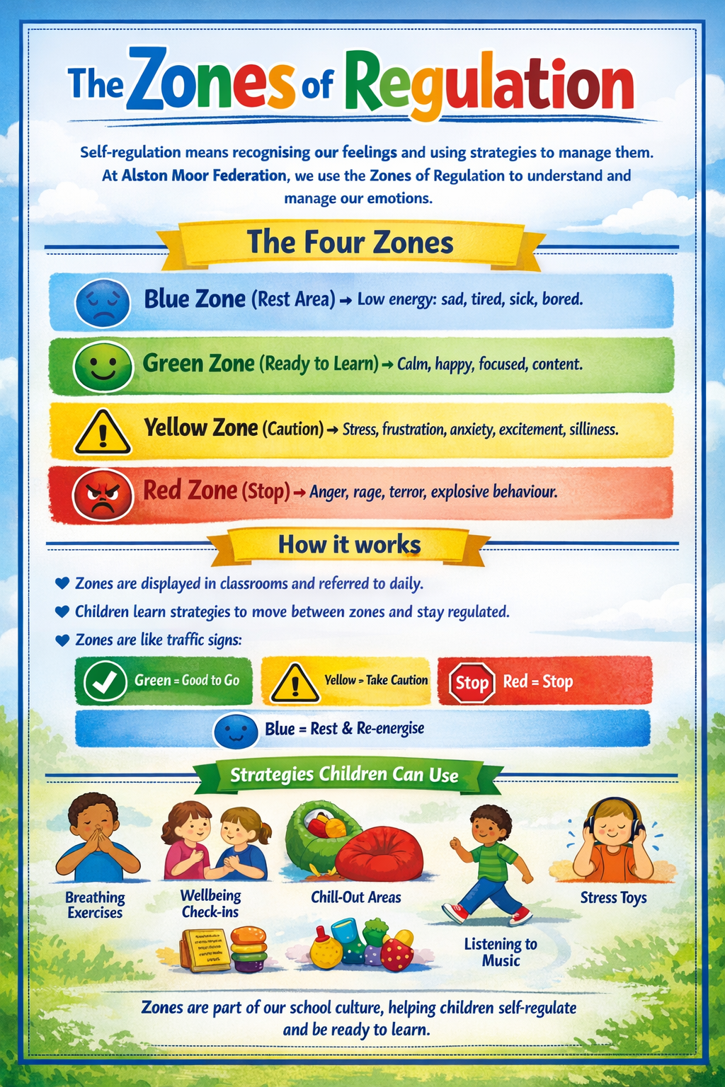
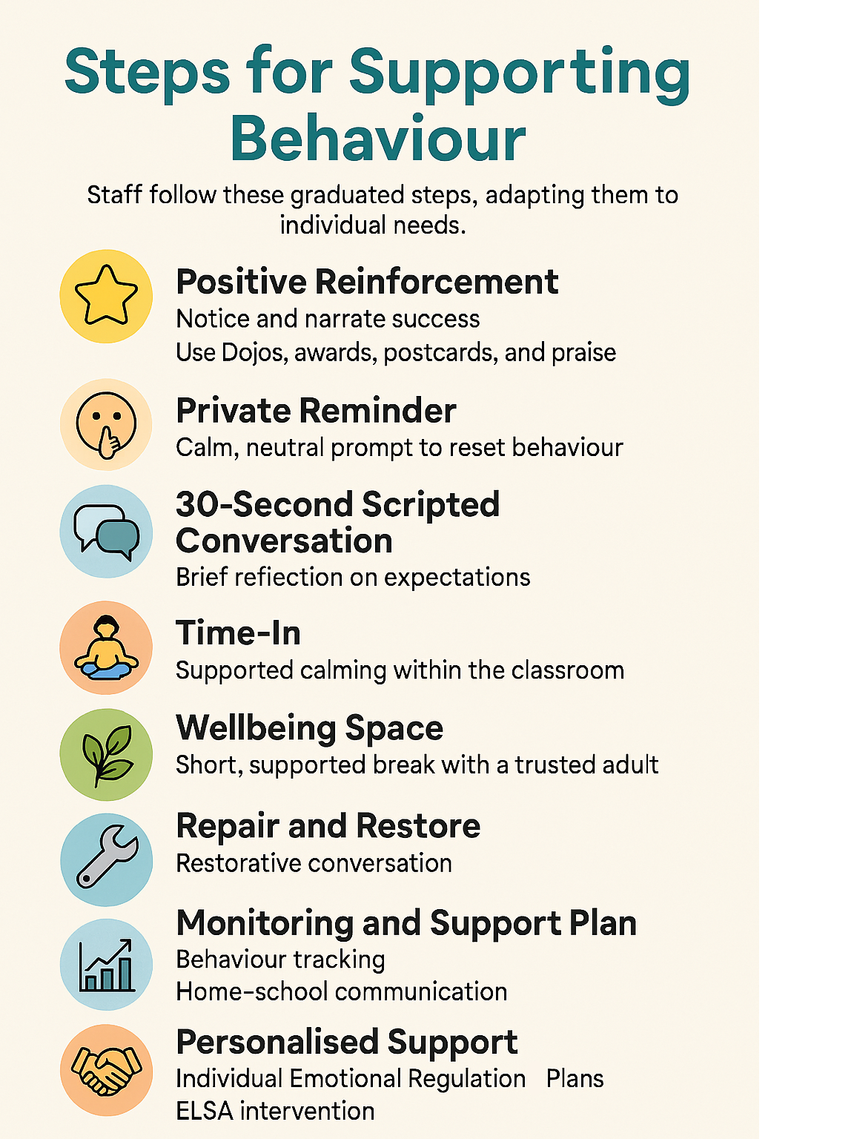
Version:
Date:

Emotional Regulation Plan – (Pupil name & class)
All about me

I am in a class of __ children with a full time teacher, ___. I am supported by __ (if has TA support). I live at home with __ I have (pets?)

What do I like and enjoy?

I am good at __

What don’t I like? What causes me stress or anxiety?

- When

Risk Factors
Proactive Interventions
Start of the day

Classroom timetable & routines

Break and lunchtimes

Developing Emotional Regulation Skills

Sensory & medical needs

Communication with home

My Emotional Profile
When I am… | What do I look like and what do I do? | Support Strategies
Happy and settled.
Starting to find it challenging to regulate my emotions.  Starting to feel unsettled or anxious. |  | Physical Intervention – to be used for the shortest amount of time (uncommon)  - Guide __ to a place that is safe to give him time out using Caring C’s.
Feeling anxious,  Feeling angry or frustrated.  I need adult help to stay safe. |  | Physical Intervention – to be used for the shortest amount of time
Recovering from a period of high anxiety or frustration. | - Incidents may lead to a physical intervention if __ tries to exit the ‘safe’ place or performs actions which may be deemed unsafe such as lashing out repeatedly at peers or misusing equipment.

____ School Behaviour Risk Assessment

To be read alongside the Emotional Regulation Plan
Name of Pupil: |  |  |  |  |  | Class/Group

Name of Assessor(s):
Date of Assessment: |  |  |  | Proposed Review Date:
Initial Risk Rating: |  |  |  | Residual Risk Rating:
Who or what is likely to be harmed or damaged: Give details of individuals who might be harmed as a result of the behaviour e.g. staff, other children, self, or property, especially people who are at increased risk or particularly targeted.
- (pupil’s name)
- Other pupils
- Staff members
- Classroom / school property

See Emotional Regulation Plan for ‘What I look like and what I do’, proactive interventions and support strategies
Positive physical intervention and handling strategies: Describe the preferred staff physical responses/holds (see also Part C: Positive Handling Plan)
- All staff have had Level 1 Team Teach training.
- To discuss with parents. Plan to be made alongside __ (Team Teach Tutor) if appropriate .

Additional or proposed control measures required: Describe any other measures required e.g. training, extra staff, support during identified high risk activities, gates/barriers to reduce absconding, weapons searching etc.
- Individual risk assessment will be carried out in relation to off-site activities.
- If ___ was to leave the school grounds of his own accord by climbing over a gate or fence, the police and his parents would be called. Staff would follow and observe from a distance – they would not chase after ___
- All staff have had ‘Emotion Coaching’ training.
Incident de-briefing: Describe what post-incident care is required and the debriefing arrangements for the individual, staff, peers etc. involved and parents/carers.
- Discussion with ___ in school, as soon after the incident as appropriate.
- Staff involved to discuss incident / have debrief with __
- Emotional Regulation Plan and Risk Assessment to be adapted as necessary after any incident.
Recording and notification required:
- Incident details are recorded systematically on school’s CPOMs system.
- Parents are notified of each incident.
- An accident/incident form must be completed and reported to the appropriate authority if anyone sustained an injury during an incident.

Emotional Regulation Plan and Risk Assessment agreed by: (name, signature and date)
Pupil (where appropriate): |  |  | Signed: |  |  |  |  | Date:
Parent/carer: |  |  | Signed: |  |  |  |  | Date:
SENCo: |  |  | Signed: |  |  |  |  | Date:
Headteacher: |  |  | Signed: |  |  |  |  | Date:
Name(s) of any other people who have influenced this plan:

Please note: Some or all of this information may be shared on a confidential, need to know basis, with adults other than school staff who may be working with young people in a voluntary or professional capacity. Such adults are bound by the school’s code of conduct on confidentiality.

