Cross Fell Knowledge Organiser-
Everyday Materials

Prior Knowledge  What should I already know? | Key vocabulary for us to learn |  | What will I know by the end of the unit?
Children know about some similarities and differences in relation to materials.  E.g. Objects look and feel different based upon the materials they are made from.  Different materials can be used when creating art and crafts | absorbent Material that soaks up liquid easily  bendy An object that bends easily into a curved shape.  shiny Things that are bright and reflect light.  dull A colour or light that is not bright.  elastic A rubber material that stretches when you pull it and returns to its original size and shape when you let it go.  stretchy Slightly elastic  rough Uneven and not smooth.  smooth No roughness, lumps or holes.  waterproof Does not let water pass through  opaque If an object or substance is opaque you cannot see through it.  man-made Things that are created by people  natural Things that exist In nature and are not made by people.  transparent If an object is transparent you can see thought it. |  | Year 1: Distinguish between an object and the material from which it is made. Identify and name a variety of everyday materials, including wood, plastic, glass, metal, water, and rock. Describe the simple physical properties of a variety of everyday materials. Compare and group together a variety of everyday materials on the basis of their simple physical properties.  Year 2: Identify and compare the suitability of a variety of everyday materials, including wood, metal, plastic, glass, brick, rock, paper and cardboard for particular uses. Find out how the shapes of solid objects made from some materials can be changed by squashing, bending, twisting and stretching  Working scientifically  Asking simple questions and recognising that they can be answered in different ways Observing closely, using simple equipment Performing simple tests Identifying and classifying Using their observations and ideas to suggest answers to questions Gathering and recording data to help in answering questions.
Which materials are some objects made from? |  | How can I group materials?
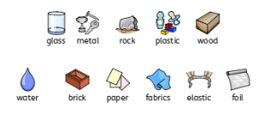 |  | These materials are all the same because they are shiny.  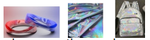  These materials are all the same because you can stretch them.  Wood and paper are the same because they are transparent. They are different because wood stiff but paper is bendy.

Can you label these materials? | Knowledge checker
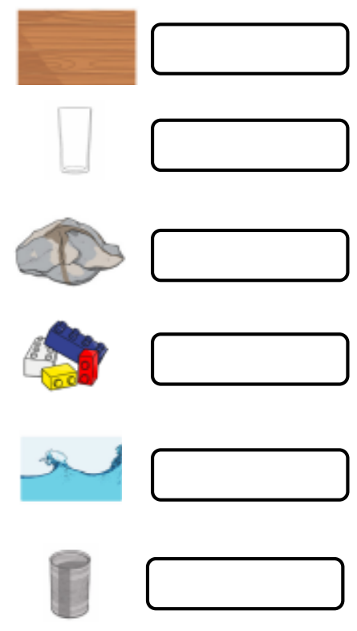  Wood, metal, plastic, rock, glass, water. | 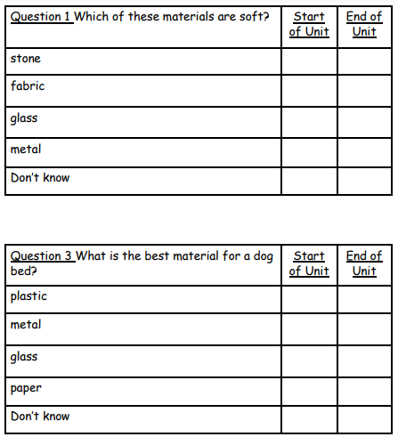 | 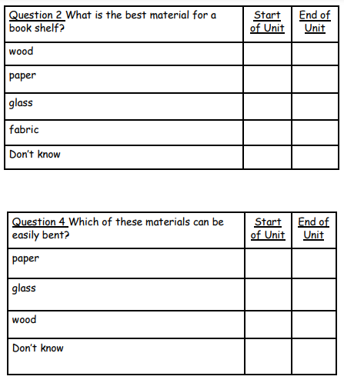
 | What would I like to find out? | Answers to my questions.

