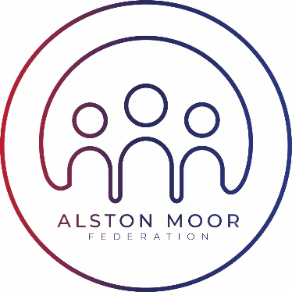Approved by Governors: Awaiting Approval

Review date: June 2025

***Curriculum Statement 2024-25: SKS***

***Curriculum Aims***

At Samuel King’s School we have always believed in delivering a broad and balanced, knowledge-based curriculum that prepares students to face the academic rigours of GCSE exams at the end of their Year 11, while also developing the wider skills, knowledge and interests that will help to prepare them to face their studies and training at College or Sixth Form, at 16+, and set them on course for a successful and fulfilling life beyond.

At Key Stage Three (Years 7-9) we aim to provide a sound foundation in English, Maths and Science as well as a range of other academic subject areas. Our Year 9 curriculum is designed to help students to decide what might be good GCSE options for them in Years 10/11. We are keen that as many students as possible qualify for the Ebacc by taking academically challenging subjects through to GCSE, therefore we encourage students to study History and/or Geography and an MFL.

In Years 10/11 (Key Stage Four), the core GCSE curriculum centres on English, Maths and Science, continues but is extended with students choosing four additional options subjects, all to be examined at the end of year 11. Although, just for this academic year the Year 11s will be completing their GSCE options in one year as we are transitioning across to a two-year GSCE model for the Year 10s, and onwards. From 2022 all students have been taking the triple science qualification at GCSE (either at higher or foundation tier), as long as they are able to. We are able to provide a wide range of choices, enabling students to pick subjects that are of particular interest to them and in some cases directly relevant to future areas of study and employment.

The diagrams below indicate the curriculum and choices available to students in each Year Group.

***Key Stage Three***

|  |  |  |
| --- | --- | --- |
| ***Year 7,8 and 9 Subjects*** | ***No. of Lessons***  ***Each Week*** |  |
| * English | 3 (+2 half lessons) |  |
| * Maths | 3 (+2 half lessons) |  |
| * Science | 3 |  |
| * Languages | 2 |  |
| * History / Geography | 4 |  |
| * Religion, Philosophy & Ethics | 1 |  |
| * Performing Arts | 1 |  |
| * Music | 1 |  |
| * Computing | 1 |  |
| * Art and Design | 1 |  |
| * Design Technology | 1 |  |
| * Catering | 1 |  |
| * PSHE and Citizenship | 1 |  |
| * Physical Education | 2 |  |
| ***Total*** | ***25*** |  |

***Key Stage Four***

|  |  |  |  |  |
| --- | --- | --- | --- | --- |
| ***Year 10/11 Core Subjects*** | ***No. of Lessons***  ***Each Week*** |  | ***Year 11 Options Subjects for 2024/2025*** | |
| * English | 4 |  | ***Option 1*** | ***Option 2*** |
| * Maths | 4 |  | History | Business Studies |
| * Science | 6 |  | PE/Sports Studies | Statistics |
| * Physical Education | 2 |  | Music | French |
| * Careers/RE/PSHE | 1 |  | Statistics |  |
|  |  |  | Students choose one subject from each column and have four lessons in each choice making their 25-period week. | |
| ***Total*** | ***17*** |  |
|  |

|  |  |  |  |
| --- | --- | --- | --- |
| ***Year 10/11 Options Subjects for 2024/2026*** | | | |
| ***Option 1*** | ***Option 2*** | ***Option 3*** | ***Option 4*** |
| Geography | Computer Science | MFL | History |
| Food Technology | Art | Statistics | RPE |
| Health & Social Care | Animal Care | Business Studies | Sport Studies |
|  |  | Dance/Drama | Music |
| Students choose one subject from each column and have two lessons in each choice making their 25-period week. | | | |