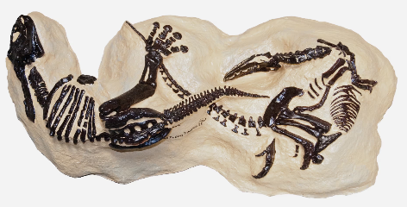

Previous Knowledge
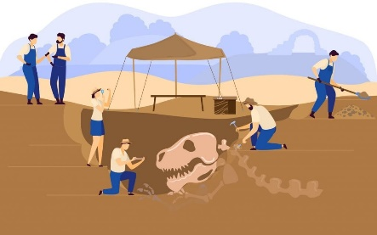
You have learnt to use timelines effectively; make historical comparisons; and about significant historical events. You have learnt to identify the impact of historical events; use sources to support your knowledge; and began to understand sequencing on a timeline.

Timeline of Important Events/Concepts
1.Paleozoic Era (542-251 million years ago):
-Ancient marine life such as trilobites and brachiopods.
-Early amphibians emerge, adapting to life on land.
2.Mesozoic Era (251-65 million years ago):
3.Triassic Period (251-201 million years ago):
-Dinosaurs emerge, evolving from early reptiles.
-The first mammals appear.
4.Jurassic Period (201-145 million years ago):
-Dinosaurs become dominant.
-Birds emerge from theropod dinosaurs.
5.Cretaceous Period (145-65 million years ago):
-Dinosaurs continue to dominate but face mass extinction at the end of the period.
-Flowering plants begin to evolve.
6.Fossil record and the study of dinosaurs:
-People begin to discover and study dinosaur fossils during the 19th century.
-Significant discoveries include the first known dinosaur (1824) and the first T-Rex (1902).
-Continued research and excavations contribute to our understanding of dinosaurs and prehistoric life.

History Knowledge Organiser - Palaeontology – Dinosaurs and Fossils  Key Vocabulary  Fossil: The remains or impression of a prehistoric plant or animal that is preserved in rock.  Palaeontologist: A scientist who studies fossils to learn about prehistoric life.  Extinct: No longer existing or alive on Earth.  Herbivore: An animal that only eats plants.  Carnivore: An animal that only eats the flesh of other animals.  Omnivore: An animal that eats both plants and other animals.  Triassic Period: The first period of the Mesozoic Era, known for the emergence of dinosaurs.  Jurassic Period: The second period of the Mesozoic Era, known for the dominance of dinosaurs.  Cretaceous Period: The third and final period of the Mesozoic Era, known for the extinction of dinosaurs.  Paleozoic Era: The era before the Mesozoic Era, characterized by the existence of marine life and early amphibians.  Pangaea: A supercontinent that existed during the late Paleozoic and early Mesozoic Eras, which eventually broke apart to form the continents we know today.  Fossil record: The collection of all known fossils on Earth that provides evidence of past life. | Year 5/6 | Alston Primary School

Useful Websites
Natural History Museum - Dinosaurs: www.nhm.ac.uk/dinosaurs
BBC Bitesize - Dinosaurs and Fossils: www.bbc.co.uk/bitesize/topics/z62mn39
National Geographic Kids - Dinosaurs: www.natgeokids.com/uk/discover/science/general-science/dinosaurs
The Dinosauria - A Complete list of Dinosaurs: www.ucmp.berkeley.edu/diapsids/dinosaur

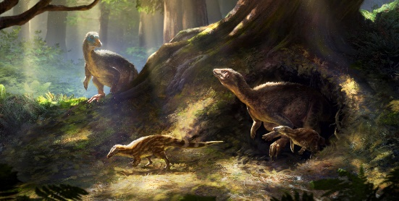

Interesting Facts
The word "dinosaur" comes from the Greek words 'deinos', meaning terrible or fearfully great, and 'sauros', meaning lizard.
The largest dinosaur ever discovered is the Argentinosaurus, which measured over 100 feet long and weighed up to 100 tons.
Some dinosaurs had feathers! Archaeopteryx, for example, had both feathers and teeth and is considered a missing link between birds and dinosaurs.
Fossilized dinosaur footprints, eggs, and nests have been found, providing evidence of dinosaur behaviour and parenting habits.
The first complete dinosaur skeleton ever found was a herbivore called Hylaeosaurus, discovered in England in 1832.
By the end of this topic, students should know:
- The meaning of key vocabulary terms related to dinosaurs and fossils, such as fossil, palaeontologist, herbivore, carnivore, and omnivore.
- The timeline of important events and concepts related to the Paleozoic and Mesozoic Eras, including the Triassic, Jurassic, and Cretaceous Periods.
- The significance of the fossil record in understanding prehistoric life, including the existence and extinction of dinosaurs.
- The names and characteristics of some well-known dinosaurs and their classification as herbivores, carnivores, or omnivores.
- That the study of fossils by palaeontologists helps us learn about the Earth's history and the evolution of life forms.
- The role of significant websites, such as the Natural History Museum and the BBC, in providing reliable information about dinosaurs and fossils.

