Topic | Homework Grid -Summer Term - 2024 - ‘Feel the Force!’
English and Communication | Create a crossword using key vocabulary on Forces.  Force, Gravity, Mass, Weight, Friction, Resistance, push and pull,  attract, measure.  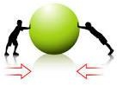 | Research the biography of Isaac Newton. What theory did he discover? Present this in an interesting way.  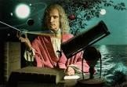 | Write a short story about an astronaut stepping on the moon and discovering the effects of no gravity in space.  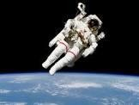
Maths and Problem Solving | Paper helicopter investigation.  Use your knowledge of air resistance and gravity to create a paper helicopter that will fall as slowly as possible. Record the timings on a chart or graph.  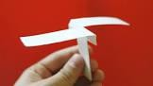 | Create your own maths word problems using the 4 different operations.  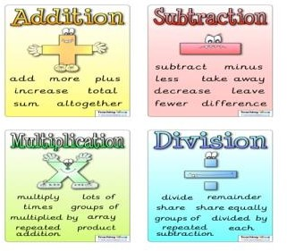 | Using the knowledge of FRACTIONS form Spring 1. Create a sheet to explain the different strategies you have learnt.  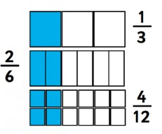
Science and the outside environment | Make a parachute using different material and describe how gravity and surface area affect their landing?  You need to drop the object from the same height for a fair test.  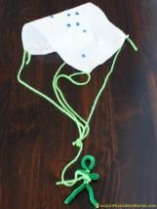 | How do surfaces affect friction?  Move an object across different surfaces and record your findings. Which surface is fastest and why?  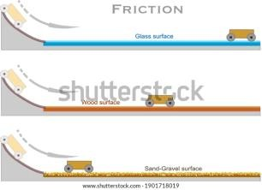 | Investigate different swimming styles used by professional swimmers. Can you explain why some techniques may be faster than others.  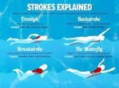
DT and Art | What are gears and how do they work?  Find objects around your house that use gears make things move in different directions, more quickly or slowly. | James Dyson was the inventor of which appliance and how did he get his idea?  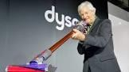 | Find examples of how a pulley can make it simpler for humans to move objects.  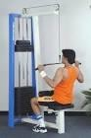

Early Islamic Civilisation Home Learning Activities

Science  Experiment with chocolate, coffee and ice. With an adult heat or cool these and see if it creates reversible or irreversible changes. Take a photo and write about what you find out.  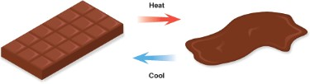 | History  Use the link to the website below to help you to find out about Baghdad in 900AD. Create a multiple choice quiz for your friends. https://www.youtube.com/watch?v=WVM1xEdp83Q  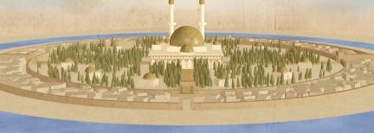 | 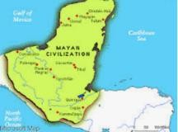  Geography Research in which countries Islamic civilisation  developed and label these countries on a world map. | 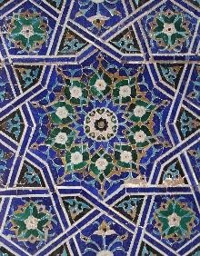  Art Investigate Islamic Art patterns and try drawing some.
DT  Use resources to create coins similar to those in the early Islamic Civilisation era.  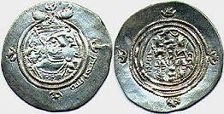 | Computing  Create your own Podcast. Make up some questions about a subject your family is interested in – the development of maths and science during the 7th century under the Islamic Civilization, the devastation of the  rainforests, the threat of global warming…  Ask a member of your family or a friend if you can interview them. Record the interview on to the computer (or phone). Listen to the interview – how could you improve the questions you  ask so that you get more interesting answers? | RE  Research about the Mosque. Find out the key features and what takes place there. Create a poster to display what you have found out.  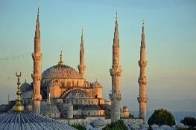 | PSHE  Watch Newsround, write your own version of a news story that interested you.

