**Great Explorers**

**Cross Fell – Spring 2**

Felicity Aston:

-Felicity Aston’s polar exploration is part of recent history.

-In 2012, Felicity became the first person to ever travel alone across Antarctica, just using her own power and walking with skis

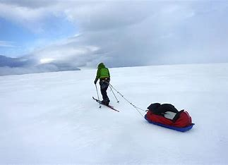

Neil Armstrong:

-Neil Armstrong took the first steps on the moon in July 1969.

-He was joined by Buzz Aldrin.

-Another astronaut, Michael Collins, stayed in the main spacecraft during the Moon landing. The astronauts were helped by many other people down on Earth.

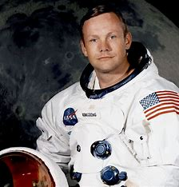

Matthew Henson:

-It is not certain whether Matthew Henson and the other explorers with him were the first to reach the North Pole in April 1909.

-Even so, Matthew Henson should be remembered as a skilled polar explorer.

-It was very different to exploring now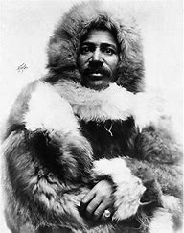

Ibn Battuta:

-Born in 1304.

-He spent around 30 years travelling

-He travelled over 78,000 miles visiting the same as 44 modern countries.

-In 1354, he told a writer what happened on his journeys and these stories were written up. 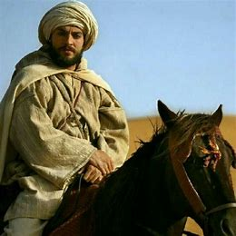

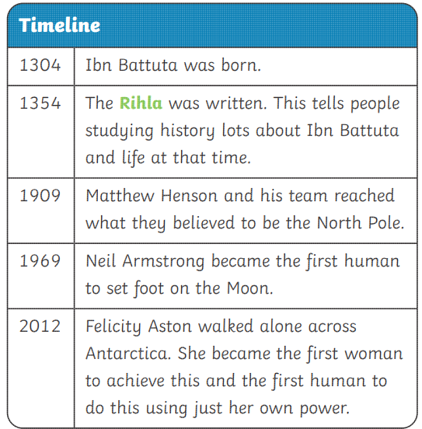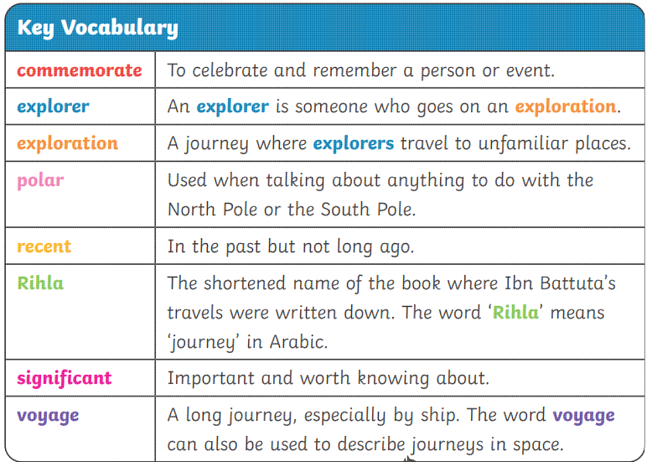

Some people are considered as significant in history. This is because their actions have changed things for people or that they have achieved something amazing.

They can be remembered by statues, places named after them or stamps to commemorate them.