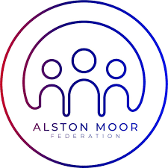
ALSTON MOOR FEDERATION

Homework Policy

Aim

To provide guidance and support to children and students, and clarify for parents/carers with regard to homework.

Objectives

- Homework is set to give students the chance to work independently and to really extend the time they spend on tasks that interest them.

- Children in Reception can expect daily reading or phonics tasks. From the Summer Term Reception children can expect practical topic-based homework tasks.

- Children in KS1 and KS2 can expect daily reading and weekly spellings and maths homework. Children can also expect long-term homework linked to their class topic. These activities are varied and include a range of tasks to be completed alongside their families at home e.g. exploring their local area or baking. These tasks are designed to celebrate, enhance and extend the learning in school.

- Students in Years 7&8 can expect half an hour of homework from English, Maths, Science, Humanities and Languages each week. Homework may also be set for creative and practical subjects.

- In Years 9-11 homework students can expect an hour or more of weekly homework for each of their subjects.

- SKS homework should always completed to the absolute best of a youngster’s ability; it is not something to be rushed. Sub-standard work may well have to be improved during a break, lunch time or after school.

- Students failing to complete homework may be asked to complete a catch up.

- Teachers should allow plenty of time in class to explain the homework. Pupils might be required to write down the task in their exercise book.

- All SKS homework will be available on Edulink which can be viewed by students and parents.

- Homework tasks should challenge students to think but not be at a level that is too difficult for them. Often this means that students within a class are set slightly different tasks.

- SKS Parents should take an interest in their child’s homework, checking what needs to be done on Edulink and ‘encouraging’ its completion.

- Like other work, homework should be marked in line with the marking policy.

Monitoring Arrangements
This policy will be reviewed every three years by the Governing Board.
Version Control
Created by: | Headteacher
Approved by: | Education sub committee
Date approved on: | November 2025
Next review due by: | November 2028

