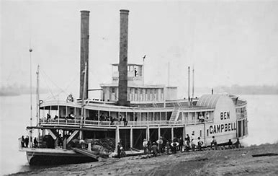
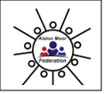
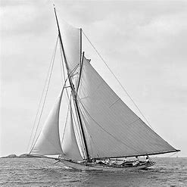
Cross Fell - Boats and ships
How are boats and ships used?
Ships have got different jobs such as transporting goods, travel, sport, warfare and fishing. We can identify a boat’s job by features such as, the warship carries guns; the aircraft carrier has a landing strip; the fishing boat has a small crane to haul in its fishing nets; the cruise liner is stylish and has lots of small cabin windows and a swimming pool; the rowing/sailing ships only have space for the sportspeople competing and may have numbers on their sails.
Life at sea:
Life at sea in the past was different to now, facing conditions such as cramped conditions, no fresh food, and a lack of medical attention.
How could you communicate with another ship or with someone on shore? (Nowadays: internet, mobile phone, radio etc.) But what about hundred years ago? If they were close by: shout, fire flares, wave flags, flash torches, even send up smoke signals.
Morse code is also used where the dots and dashes make up letters.
Boats in the past:
before about 1920 – travel and transportation to foreign countries was by boat only.
We know when a ship was made by the materials of which the ships are made, their power mechanisms, size, shape, the activities happening, the type of image (grainy, black and white/ clear, in colour) and the names of the ships.
Ships were only wind/ human powered a long time ago, then paddle and steam powered, then powered by diesel engines, outboard motors, gas turbine engines or nuclear reactors.

Key word | Definition
Boat | A small vessel.
Ship | A large vessel.
Transporting | Taking or carrying goods from one place to another.
Sail | A piece of material extended on a mast to catch the wind to move the boat.
Mast | A tall upright post on a vessel.
Bow | The front of a vessel.
Stern | The back of a vessel.
Cruise ship | A type of ship that carries people for a holiday.
Container ship | A type of ship that transports goods.
Motor | A machine that supplies power for a vehicle.
Engine | A machine that uses the power to make the vehicle move.
Vessel | A ship or large boat.
Morse code | A way of communicating using dots and dashes to create letters.
Marconigram | A message sent using morse code.
Communication | Giving information through speech, writing etc.
Float | Resting or moving on the surface of the water.
Sink | When something goes below the surface of water.

