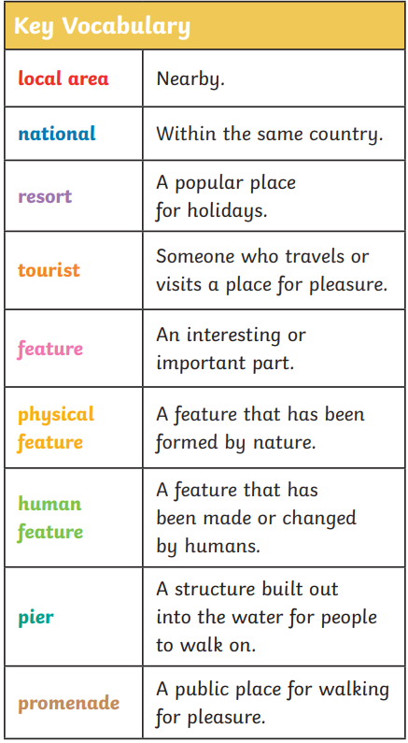Cross Fell – By the seaside

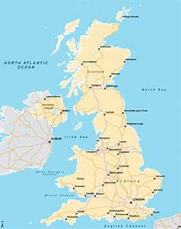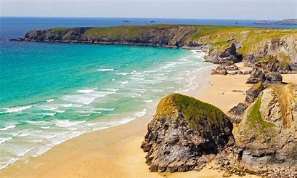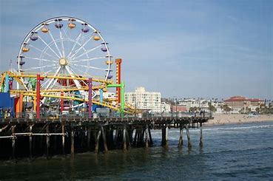

At the Seaside you will find physical features and human features.

Physical features have been formed by nature such as the sea, beach, cliffs and caves.

Human features are features that have been made or changed by humans such as a pier and a lighthouse.

Seasides are found around the coastlines of the UK.

There are lots of resorts that have been popular for many years.

If you went to the seaside now, you may find activities such as cafes, ice cream parlours, boat trips and fairgrounds.

In Victorian times people would travel to the seaside to go to a puppet show, walk along the promenade or sea bathing.