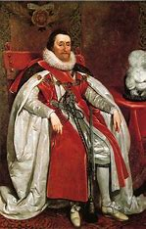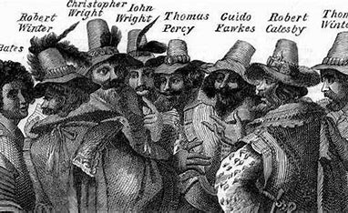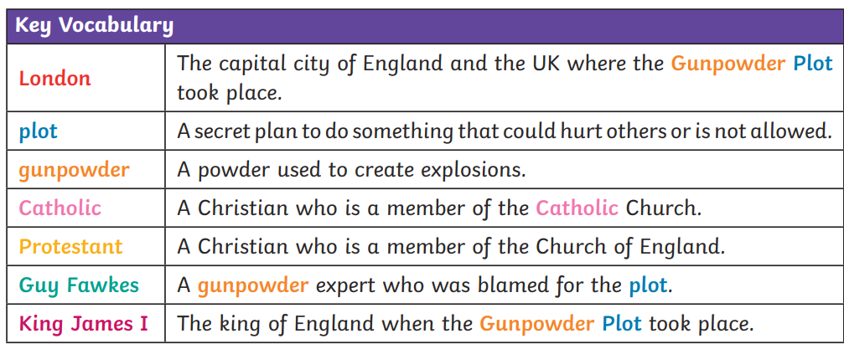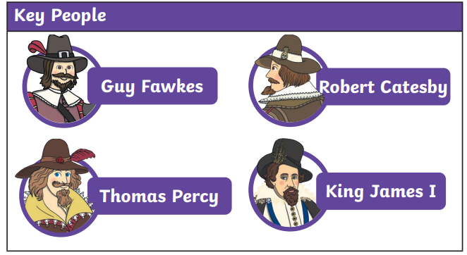Cross Fell – The Gunpowder Plot

**Key Information**

-A group of Catholics plotted to blow up the Houses of Parliament in London with King James I inside and take control of the country.

-The leader of the plot was Robert Catesby, with Guy Fawkes being in charge of blowing it up.

-It was stopped when a letter to warn about the plot got to the king. The cellars were searched and Guy Fawkes was arrested. Soon after the other plotters were also arrested.

**Bonfire Night**

‘*Remember remember the fifth of November…’*

Every year on Novemeber 5th (the day the plot was going to happen), bonfires are lit and fireworks are set off to remember what happened.

**Timeline of events**

26th October 1605

A Lord receives a letter warning him not to go to the opening of Parliament on 5th November.

20th May 1604

Guy Fawkes, Robert Catesby and others began to discuss their plan to blow up Houses Of Parliament

4th November 1605

A search of the Houses Of Parliament is ordered.

31st January 1606

Guy Fawkes is killed.

**What will I learn?**

-The key events and people involved in the gunpowder plot.

-Why the gunpowder plot happened.

-To sequence the events that happened.

-The differences in ways of living in 1605 compared to the present.

-How the gunpowder plot has impacted present life.

-To role play events that happened.

24th March 1603

King James I is crowned.

5th November 1605

Guy Fawkes is arrested from the cellar and is taken to the Tower Of London.

1st November 1605

King James I is shown the letter.

13th April 1570

Guy Fawkes was born in York.

March 1605

Group rent a cellar to hide 36 barrels of gunpowder under House Of Lords.



**What should I already know?**

-Begin to recognise what was different in the past to the present from photographs.

-Personal experiences of bonfire night.

-Historical enquiry and questioning.