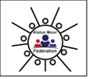

**Cross Fell – Our local area**

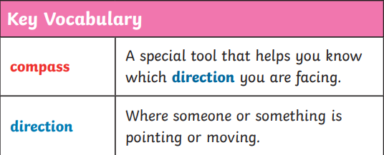

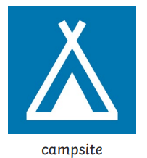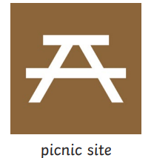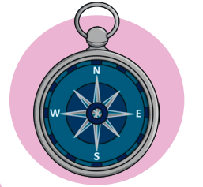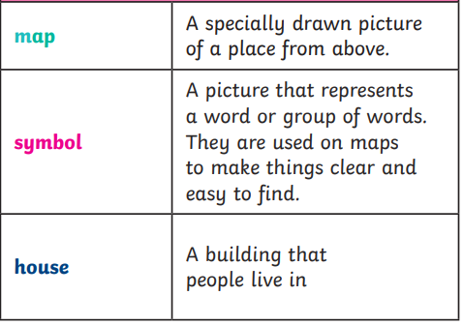

**The compass**

A compass has 4 main directions – North, East, South and West. The needle will always point north. You have to work out which direction you are facing depending on where north is.

**Map symbols**

To make it easier, maps use symbols instead of words so that you can find things quickly. Some examples are...

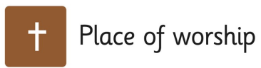 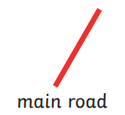 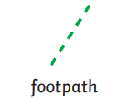





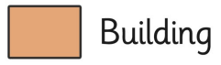



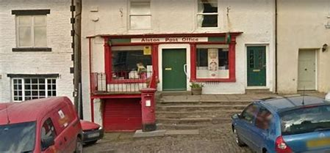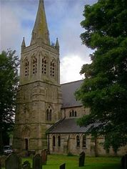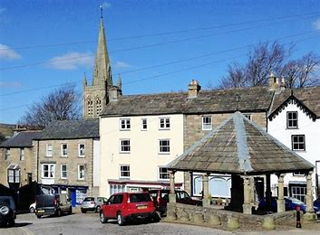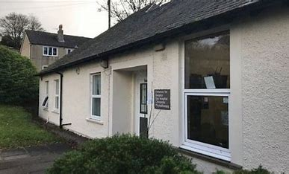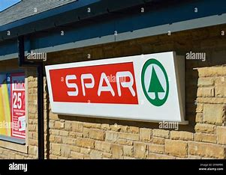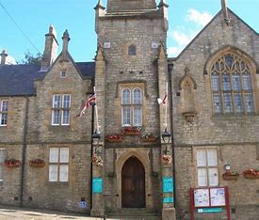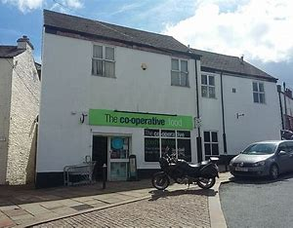

**What should I already know?**

-Recognise some familiar places in our local area.

-Use simple directional language (right, left, before, after etc).

-Recognise some housing types around our local area.

**What will I learn?**

-Recognise familiar places in our local area.

-Use maps to gather information about the local area and locate places.

-Use simple compass directions.

-Recognise basic map symbols.

-Plan a simple route on a map.

-Recognise different housing types and jobs in our local area.

-Explore geographical issues, use subject specific vocabulary and ask geographical questions.

There are also people who do lots of different jobs in our local area.

There are different buildings in our local area. Some of these are…

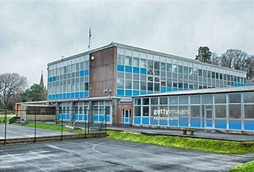

You might see lots of different houses in your local area, these could be…

